**Module 1 – Overview of IT Industry**

* **What is a Program?**
* **LAB EXERCISE:** Write a simple "Hello World" program in two different programming languages of your choice. Compare the structure and syntax.

**Example 1:** Python:

# Hello World program in Python

print ("Hello, World!")

**Example 2:C**:

#include <stdio.h>

// Hello World program in C

int main () {

    printf ("Hello, World!\n");

    return 0;

}

**Comparison**

* Structure: C requires a main function and includes libraries explicitly, while Python runs directly with a single line, no function or library imports needed.
* Syntax: C uses semicolons and braces to structure code, whereas Python relies on indentation and avoids semicolons for simplicity.
* **THEORY EXERCISE:** Explain in your own words what a program is and how it functions.
* A program is a set of instructions that a computer follows to perform a task. These instructions are written in a programming language, like Python, Java, or C, that a computer can understand after some processing.
* **What is Programming?**
* **THEORY EXERCISE:** What are the key steps involved in the programming process?

1. **Define the Problem**

* Understand what you want the program to do. Identify the goal, requirements, and constraints.

1. **Plan the Solution**

* Design how the program will work. Use tools like flowcharts or pseudocode to outline the steps.

1. **Write the Code**

* Use a programming language to translate your plan into a program. Write the actual instructions for the computer.

1. **Compile or Interpret**

* Translate the code into machine language. A compiler processes the entire code at once, while an interpreter runs it line by line.

1. **Test the Program**

* Run the program to see if it works. Check for errors (bugs) and ensure it produces the correct results.

1. **Debug and Refine**

* Fix any errors or issues found during testing. Make improvements to the program for better performance or readability.

1. **Deploy and Maintain**

* Use the program in the real world and monitor its performance. Update it as needed to fix issues or add features.
* **Types of Programming Languages**
* **THEORY EXERCISE:** What are the main differences between high-level and low-level programming languages?
* **High-Level Languages**
* Abstraction: Easy to read and write, closer to human language.
* Examples: Python, Java, C++, JavaScript.
* Portability: Platform-independent; can run on different systems with minimal changes.
* Ease of Use: Simplifies complex tasks; uses libraries and built-in functions.
* Translation: Requires a compiler or interpreter to convert into machine code.
* Performance: Slightly slower due to the overhead of abstraction.
* **Low-Level Languages**
* Abstraction: Closer to machine language, harder for humans to understand.
* Examples: Assembly Language, Machine Code (binary).
* Portability: Platform-specific; tied to hardware architecture.
* Ease of Use: Requires detailed knowledge of the hardware.
* Translation: Machine code runs directly; assembly requires an assembler.
* Performance: Extremely fast and efficient; directly interacts with hardware.
* **World Wide Web & How Internet Works**
* **LAB EXERCISE:** Research and create a diagram of how data is transmitted from a client to a server over the internet.

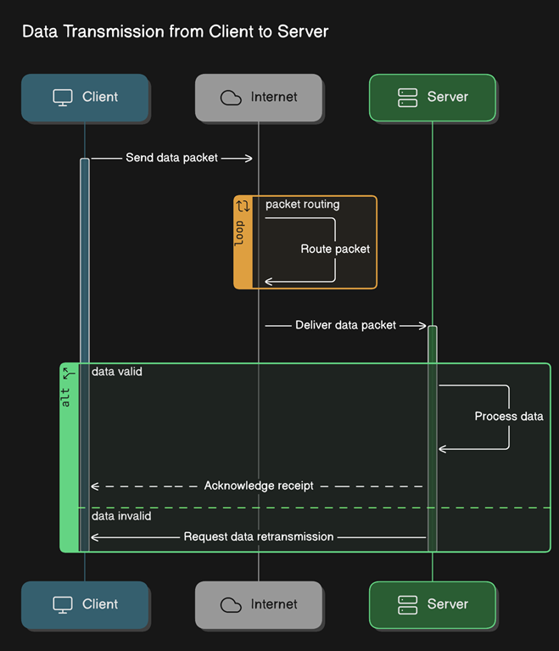

* **THEORY EXERCISE:** Describe the roles of the client and server in web
* **Client:** The client is usually your device, like a computer, phone, or browser. It asks for information or services, like when you open a website or click a link. Think of it as the one making requests.
* **Server:** The server is like a powerful computer that stores and manages information, such as websites, files, or databases. It listens for requests from the client and sends back the information needed, like a webpage or an image.
* **Network Layers on Client and Server**
* **LAB EXERCISE:** Design a simple HTTP client-server communication in any language.

Let's design a simple HTTP client-server communication using **Python** in very easy terms. The server will listen for requests, and the client will send a request to the server, then get a response back.

**Step 1:** Create the Server

The server listens for requests on a specific port (we'll use port 8080). It sends a response back to the client.

**Server Code (Python):**

from http.server import BaseHTTPRequestHandler, HTTPServer

# Handle HTTP GET requests

class SimpleRequestHandler(BaseHTTPRequestHandler):

    def do_GET(self):

        # Send an OK response (status code 200)

        self.send_response(200)

        self.send_header('Content-type', 'text/plain')

        self.end_headers()

        # Send a simple message back to the client

        self.wfile.write(b"Hello, Client! This is the server's response.")

# Set up the server

def run_server():

    server_address = ('', 8080)  # Server listens on port 8080

    httpd = HTTPServer(server_address, SimpleRequestHandler)

    print("Server is running at http://localhost:8080")

    httpd.serve_forever()  # Keep the server running

# Run the server

if __name__ == "__main__":

    run_server()

**Explanation:**

* The server listens on http://localhost:8080.
* When it gets a GET request, it sends a 200 OK response and a simple message back to the client.

Step 2: Create the Client

The client will send a request to the server, and then it will print the server's response.

Client Code (Python):

import requests  # Import the requests library to make HTTP requests

# Send a GET request to the server

response = requests.get('http://localhost:8080')

# Print the server's response

if response.status_code == 200:

    print("Server says:", response.text)

else:

    print("Failed to get a response from the server")

**Explanation:**

* The client uses the requests.get method to ask the server for data.
* The client will then print out what the server sent back.
* How to Run the Example:

1. Start the Server:
   * Open your terminal or command prompt.
   * Run the server code by typing: python server.py (assuming you saved it as server.py).
   * The server will start running and will be waiting for client requests.
2. Run the Client:
   * Open a new terminal window.
   * Run the client code by typing: python client.py (assuming you saved it as client.py).
   * The client will connect to the server, get a response, and print it.

**Expected Output:**

* **Server:** The server will show:

Server is running at http://localhost:8080

* **Client: The client will print:**

Server says: Hello, Client! This is the server's response.

* **THEORY EXERCISE:** Explain the function of the TCP/IP model and its layers.

The TCP/IP model is a framework that defines how data is transmitted over the internet. It organizes communication into layers, each with specific tasks, to ensure reliable and efficient data transfer between devices.

* **Layers of the TCP/IP Model**

1. **Application Layer**
   * **Function**: Provides user services, like email, web browsing, and file transfers.
   * **Examples**: HTTP (web), FTP (file transfer), SMTP (email).
2. **Transport Layer**
   * **Function**: Ensures reliable communication between devices by managing data flow, error detection, and retransmission if necessary.
   * **Protocols**: TCP (reliable, connection-based), UDP (faster, connectionless).
3. **Internet Layer**
   * **Function**: Handles addressing and routing of data packets to ensure they reach the correct destination.
   * **Protocols:** IP (Internet Protocol), ICMP (for errors and diagnostics).
4. **Network Access Layer (also called Link or Data Link Layer)**
   * **Function**: Manages the physical transmission of data over the network (e.g., cables, Wi-Fi). It also ensures data is formatted and sent correctly over hardware.
   * **Protocols**: Ethernet, Wi-Fi, ARP.

* **Client and Servers.**
* **THEORY EXERCISE:** Explain Client Server Communication.

Client-server communication is how two computers (or devices) talk to each other when they want to share information or perform tasks.

* **Client**: This is like a customer. It’s the computer, app, or device that asks for something. For example, when you open a website on your phone, your browser acts as the client.
* **Server**: This is like a shop or a service provider. It’s a computer or system that stores information or offers services. The server listens to the client’s request and provides the needed information or performs the requested task.
* **How It Works.**

1. **Request:** The client sends a request to the server. For example, "Give me the homepage of this website."
2. **Process**: The server processes the request. It checks what the client wants and prepares the right response.
3. **Response**: The server sends the requested information back to the client. For example, it sends the website’s homepage to your browser.

* **Real-Life Example**
* You (the client) walk into a restaurant and order a pizza.
* The waiter (like the server) takes your order to the kitchen.
* The kitchen prepares your pizza and gives it to the waiter.
* The waiter brings the pizza to your table.
* **Types of Internet Connections.**
* **LAB EXERCISE:** Research different types of internet connections (e.g., broadband, fiber, satellite) and list their pros and cons**.**

When choosing an internet connection, it's important to understand the different types available, each with its own advantages and disadvantages. Here's a breakdown of the most common types.

**1. Fiber Optic Internet**

Pros:

* **High Speeds**: Offers the fastest internet speeds, suitable for streaming, gaming, and large downloads.
* **Reliability**: Less prone to interference and signal degradation.
* **Low Latency**: Provides quick response times, beneficial for real-time applications.

Cons:

* **Availability**: Not widely available in all areas, especially rural regions.
* **Cost**: Installation and monthly fees can be higher compared to other types.

**2. Cable Internet**

*Pros:*

* **High Speeds**: Offers fast internet speeds suitable for most household needs.
* **Availability**: Widely available in urban and suburban areas.

*Cons:*

* **Shared Bandwidth**: Speeds can decrease during peak usage times when many users are online simultaneously.
* **Limited Upload Speeds**: Typically slower upload speeds compared to fiber.

**3. Digital Subscriber Line (DSL)**

*Pros:*

* **Availability**: Available in many areas, including rural regions.
* **Cost**: Generally more affordable than fiber and cable.

*Cons:*

* **Speed**: Slower speeds compared to fiber and cable.
* **Distance Sensitivity**: Speed and reliability can decrease with distance from the service provider's equipment.

**4. Satellite Internet**

*Pros:*

* **Availability**: Accessible in remote and rural areas where other types aren't available.

*Cons:*

* **High Latency**: Signal must travel to space and back, causing noticeable delays.
* **Weather Sensitivity**: Performance can be affected by weather conditions like rain or snow.
* **Data Caps**: Many providers impose data limits, potentially leading to additional charges or throttled speeds.

**5. Fixed Wireless Internet**

*Pros:*

* **Availability**: Useful in areas where laying cables is difficult or expensive.
* **Installation**: Quicker to deploy compared to wired connections.

*Cons:*

* **Line-of-Sight Requirement**: Requires a clear line of sight between the antenna and the service provider's tower.
* **Weather Sensitivity**: Performance can be affected by weather conditions.

**6. Mobile Broadband (4G/5G)**

*Pros:*

* **Mobility**: Allows internet access on the go with compatible devices.
* **Availability**: Widely available in urban areas and expanding in rural regions.

*Cons:*

* **Data Limits**: Many plans have data caps or may throttle speeds after a certain usage.
* **Speed Variability**: Speeds can fluctuate based on network congestion and signal strength.

When selecting an internet connection, consider factors like your location, budget, required speed, and reliability needs. Fiber optic internet offers the best performance but may not be available everywhere. Cable and DSL are more widely accessible but may have limitations in speed and reliability. Satellite and fixed wireless are good alternatives for remote areas but come with their own set of challenges. Mobile broadband provides flexibility but may not be suitable for heavy data usage.

* **THEORY EXERCISE:**How does broadband differ from fiber-optic internet?

Broadband and fiber-optic internet are both ways to connect to the internet, but they work differently and offer different speeds and reliability. Here's the difference in simple terms

* **Broadband**
* **What it uses**: Typically uses cables made of copper (like the ones used for telephone lines or TV cables).
* **Speed**: Fast, but not the fastest. Speeds can slow down if many people in your area are using the internet at the same time.
* **Reliability**: Works well, but can sometimes be affected by bad weather or long distances.
* **Common Types**: DSL (uses phone lines) and Cable (uses TV lines).
* **Fiber-Optic Internet**
* **What it uses**: Special cables made of glass or plastic that carry data using light.
* **Speed**: Extremely fast—faster than most broadband connections. Great for streaming, gaming, or downloading big files.
* **Reliability**: Very reliable because it isn’t affected by weather or distance as much.
* **Bonus**: Fiber can handle a lot of users at once without slowing down.
* **Simple Comparison**
* Broadband = A regular car on a busy road (fast but can slow down in traffic).
* Fiber-optic = A high-speed bullet train on a dedicated track (super-fast and consistent).
* Protocols
* **LAB EXERCISE: Simulate HTTP and FTP requests using command line tools (e.g., curl).**

**You can simulate HTTP and FTP requests using command-line tools like curl. Below are examples of how to use curl for HTTP and FTP requests.**

1. **Simulate HTTP Requests Using curl**

**GET Request (Retrieve Data)**

**A GET request is used to fetch data from a server. This is the most common HTTP request.**

curl http://example.com

GET Request with Specific Headers

You can also send custom headers with your GET request.

curl -H "User-Agent: CustomUserAgent" http://example.com

POST Request (Send Data)

A POST request is used to send data to a server (for example, form submissions).

curl -X POST -d "name=JohnDoe&age=25" http://example.com

POST Request with JSON Data

You can also send JSON data with a POST request.

curl -X POST -H "Content-Type: application/json" -d '{"name":"JohnDoe","age":25}' http://example.com

Save Response to a File

You can save the server's response to a file instead of displaying it in the terminal.

curl -o response.html http://example.com

1. **Simulate FTP Requests Using curl**

**Download a File from FTP Server**

**To download a file from an FTP server:**

curl -u username:password ftp://example.com/file.txt -o file.txt

**Upload a File to FTP Server**

**To upload a file to an FTP server:**

curl -u username:password -T localfile.txt ftp://example.com/remotefile.txt

**List Files on an FTP Server**

**You can also list files on an FTP server.**

curl -u username:password ftp://example.com/

**Use Passive Mode for FTP**

**If the FTP server requires passive mode:**

curl --ftp-pasv -u username:password ftp://example.com/

**Additional Useful curl Options:**

* **-v: Show detailed information about the request/response (verbose mode).**
* **-L: Follow redirects automatically (useful for URLs that redirect to other pages).**
* **-I: Fetch only the headers of a request (without the response body).**

**For example, to fetch only the headers of a GET request:**

curl -I http://example.com

* **THEORY EXERCISE:** What are the differences between HTTP and HTTPS protocols?

HTTP and HTTPS are protocols that allow your browser to communicate with websites, but they differ in security and how they handle data. Here's a simple breakdown.

**1. HTTP (HyperText Transfer Protocol)**

* **What it does**: It's the standard way for websites and your browser to exchange data.
* **Security**: Not secure. Data sent between your browser and the website can be seen or intercepted by others (like hackers).
* **Example**: If you type http://example.com, the data isn't protected.
* **Usage**: Used for non-sensitive websites where security isn't a big concern (like blogs or public information pages).

**2. HTTPS (HyperText Transfer Protocol Secure)**

* **What it does**: It's like HTTP but with added security.
* **Security**: Very secure. It encrypts (scrambles) the data being exchanged, so hackers can’t read it, even if they intercept it.
* **Example**: If you type https://example.com, the data is protected.
* **How it works**: HTTPS uses something called SSL/TLS certificates, which act like digital locks to protect your data.
* **Usage**: Used for websites that handle sensitive information like passwords, credit cards, or personal data.
* **Key Differences**

|  |  |  |
| --- | --- | --- |
| **Feature** | **HTTP** | **HTTPS** |
| **Security** | Not secure | Secure (uses encryption) |
| **Speed** | Slightly faster | Slightly slower (because of encryption) |
| **Data Protection** | None | Protects sensitive data |
| **Use Case** | General websites | Banking, shopping, or login pages |

* **LAB EXERCISE: Identify and explain three common application security vulnerabilities. Suggest possible solutions.**

**1. SQL Injection**

**What it is:**

* **SQL Injection happens when an attacker inserts malicious SQL code into a web application's input fields (like search bars or login forms). The attacker can then manipulate the database to retrieve, modify, or delete sensitive data.**

**Example:**

* **If an application doesn't properly filter user inputs, an attacker could input something like ' OR 1=1 --, which would change the SQL query logic and give them unauthorized access to data.**

**Solution:**

* **Use Prepared Statements: Always use prepared statements (also known as parameterized queries) to ensure user inputs are treated as data, not part of the SQL code.**
* **Input Validation: Validate and sanitize all inputs to ensure they only contain expected data (e.g., numbers, letters).**
* **Least Privilege Principle: Limit database user permissions so even if an injection happens, the attacker can't do much harm.**

**2. Cross-Site Scripting (XSS)**

**What it is:**

* **Cross-Site Scripting (XSS) occurs when an attacker injects malicious scripts into webpages that are viewed by other users. These scripts can steal cookies, session tokens, or perform actions on behalf of the user without their knowledge.**

**Example:**

* **If a web application allows users to submit text (like comments) without properly sanitizing it, an attacker could insert a malicious JavaScript code that runs when another user views the comment.**

**Solution:**

* **Sanitize User Inputs: Ensure that all user input is sanitized to remove potentially harmful scripts.**
* **Content Security Policy (CSP): Use CSP headers to restrict which scripts are allowed to run on your pages.**
* **Escape Outputs: When displaying user input, make sure to escape characters like <, >, and & to prevent them from being treated as HTML or JavaScript.**

**3. Cross-Site Request Forgery (CSRF)**

**What it is:**

* **Cross-Site Request Forgery (CSRF) tricks a user into unknowingly submitting a request (like changing their password) while they are logged into an application. This is done by embedding malicious links or forms into websites or emails that the user may click while authenticated.**

**Example:**

* **If a user is logged into their online bank account, and they click a malicious link (e.g., a link that transfers money), the bank’s system might execute the transaction because it appears to come from the user.**

**Solution:**

* **Use Anti-CSRF Tokens: Generate unique tokens for every request that requires a change (like submitting a form). If the token doesn't match, the request is rejected.**
* **SameSite Cookies: Use the SameSite cookie attribute to ensure cookies are only sent with requests originating from your own site.**
* **Re-authentication: Require users to re-authenticate when performing sensitive actions (like changing passwords or transferring funds).**
* **Summary of Solutions:**
* **SQL Injection: Use prepared statements and input validation.**
* **XSS: Sanitize inputs, use Content Security Policy, and escape outputs.**
* **CSRF: Use anti-CSRF tokens, SameSite cookies, and re-authentication.**
* **Application Security.**
* **THEORY EXERCISE:** What is the role of encryption in securing applications?

Encryption plays a crucial role in keeping applications secure by protecting sensitive information. Here's how it works and why it's important.

* **What is Encryption?**
* Encryption is like putting your data (like messages, passwords, or files) into a secret code that only authorized people can read. It turns readable information into something that looks like gibberish to anyone who doesn’t have the "key" to unlock it.
* **Role of Encryption in Securing Applications.**

1. **Protecting Data in Transit.**
   * When you send data (like a message or payment info) over the internet, encryption makes sure that even if someone intercepts it, they can’t understand it.
   * Example: When you shop online, your credit card info is encrypted so hackers can’t steal it.
2. **Protecting Stored Data.**
   * Encryption keeps data safe even when it's stored on a server or your device. If someone steals the data, they’ll only see scrambled information.
   * Example: Your passwords saved in an app are encrypted to prevent misuse.
3. **Ensuring Privacy.**
   * Encryption ensures that sensitive data remains private and is only accessible to authorized users.
   * Example: Apps like WhatsApp use encryption to make sure only you and the person you're chatting with can read the messages.
4. **Preventing Data Tampering**
   * Encryption can detect if someone has tried to alter the data. If the data doesn’t match the encryption key, it’s rejected as tampered.
   * Example: Digital signatures use encryption to confirm that documents or messages are authentic.
5. **Compliance with Regulations**
   * Many laws require apps to encrypt sensitive information like health or financial data to protect users’ privacy.
   * Example: Banks and healthcare apps must encrypt data to meet these rules.

* **LAB EXERCISE: Identify and classify 5 applications you use daily as either systemsoftware or application software.**

**1. Operating System (e.g., Windows, macOS, Linux)**

* **Type: System Software**
* **Explanation: The operating system (OS) is essential software that manages your computer’s hardware and provides a platform for running other software. It handles memory, processes, input/output devices, and more.**

**2. Google Chrome (or any other web browser)**

* **Type: Application Software**
* **Explanation: Web browsers like Google Chrome are considered application software because they allow users to access websites and browse the internet. They are designed for specific tasks (browsing) and run on top of the operating system.**

**3. Microsoft Word (or any word processor)**

* **Type: Application Software**
* **Explanation: Word processors are applications used to create, edit, and manage text documents. They are designed for specific user tasks, such as writing essays or creating reports.**

**4. Antivirus Software (e.g., Norton, McAfee)**

* **Type: System Software**
* **Explanation: Antivirus software is a type of system software designed to protect your computer from malware, viruses, and other security threats. It runs in the background and interacts directly with your operating system to safeguard your device.**

**5. Spotify (or any music streaming app)**

* **Type: Application Software**
* **Explanation: Spotify is an application that allows you to stream music, podcasts, and other media. It is designed for entertainment purposes and runs on top of the operating system, making it application software.**
* **Software Applications and Its Types.**
* **THEORY EXERCISE:** What is the difference between system software and application software?

System software and application software are two types of programs on a computer, but they serve different purposes. Here's the difference in simple terms

**1. System Software**

* **What it does**: Manages and controls the computer's basic functions.
* **Purpose**: It helps the computer itself work properly and provides a platform for other software to run.
* **Examples**:
  + Operating System (e.g., Windows, macOS, Linux, Android).
  + Utility programs (e.g., antivirus, file managers).
  + Drivers (software that helps hardware like printers or keyboards work with the computer).
* **Analogy**: It’s like the engine and tools of a car that make it run.

**2. Application Software**

* **What it does**: Helps you perform specific tasks or activities.
* **Purpose**: Designed for users to complete specific jobs like writing, browsing, or gaming.
* **Examples**:
  + Microsoft Word (for writing documents).
  + Google Chrome (for browsing the internet).
  + WhatsApp (for messaging).
  + Games (like Minecraft or Candy Crush).
* **Analogy**: It’s like the features inside the car, such as the radio, GPS, or air conditioning, that let you do specific things.
* **Key Differences.**

|  |  |  |
| --- | --- | --- |
| **Feature** | **System Software** | **Application Software** |
| **Purpose** | Runs the computer and supports other software. | Helps users perform specific tasks. |
| **Dependency** | Works in the background and is essential for the computer. | Runs on top of system software. |
| **Examples** | Operating systems, drivers, utilities. | Browsers, word processors, games. |
| **Who Uses It?** | Mostly works automatically for the computer. | Used directly by the user. |

* **In Short**
* **System software** is for running the computer.
* **Application software** is for helping you get things done.
* **LAB EXERCISE: Design a basic three-tier software architecture diagram for a web application.**

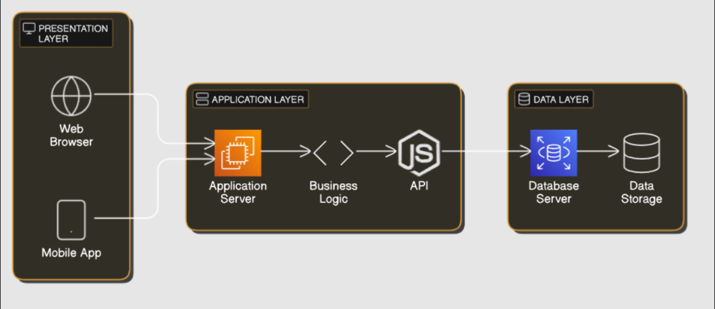

* **Software Architecture.**
* **THEORY EXERCISE:** What is the significance of modularity in software architecture?

Modularity in software architecture means breaking a big software system into smaller, manageable parts called **modules**. Each module does one specific job. This approach is very useful for building and maintaining software. Here’s why it’s important.

**1. Easier to Understand.**

* Smaller parts are easier to understand than one big, complicated system.
* Example: Instead of one huge program, you have a login module, a payment module, and a profile module.

**2. Easier to Build.**

* Different teams or developers can work on separate modules at the same time without stepping on each other’s toes.
* Example: One team works on the search module, while another works on the shopping cart.

**3. Easier to Maintain.**

* Fixing or updating one module doesn’t require changing the entire system.
* Example: If there’s a bug in the payment module, you can fix it without touching the rest of the software.

**4. Reusability.**

* Modules can be reused in other projects or parts of the system, saving time and effort.
* Example: The login module you build for one app can be used in another app.

**5. Scalability.**

* You can add new features by creating new modules without disturbing existing ones.
* Example: If you want to add a recommendation system to your app, you can build it as a separate module.

**6. Easier Testing.**

* Testing one small module is faster and simpler than testing the whole system at once.
* Example: You can test the search function alone without worrying about the rest of the app.
* **LAB EXERCISE: Create a case study on the functionality of the presentation, business logic, anddataaccess layers of a given software system.**

**Case Study: E-commerce Web Application**

**Introduction:**

In this case study, we will look at a typical e-commerce web application that allows users to browse products, add them to the shopping cart, and make a purchase. We will break down the functionality of the Presentation Layer, Business Logic Layer, and Data Access Layer within the application**.**

1. Presentation Layer (User Interface)

**Role:** The presentation layer is responsible for everything the user interacts with directly in the e-commerce application. It is the frontend part of the application.

**Components:**

* Web Pages (HTML, CSS, JavaScript): These make up the design and layout of the application. They show product details, the shopping cart, and checkout options.
* **User Interaction:** Buttons, search bars, product images, and forms that allow users to interact with the system.

**Functionality:**

* Displaying Products: When a user visits the homepage or product pages, the presentation layer fetches and displays the available products (names, prices, images).
* **User Inputs:** It accepts user inputs like selecting a product, adding items to the cart, or entering payment information.
* **Communicating with Business Logic:** Once the user adds an item to the cart, the presentation layer sends this information (e.g., item ID and quantity) to the business logic layer for processing.

**Example:**

* A user opens the e-commerce website on their browser. They see a list of products, each with a "Buy Now" button. When they click on the button to add a product to their cart, the frontend communicates with the server to update the shopping cart.

**2. Business Logic Layer (Application Layer)**

**Role:** The business logic layer handles the application's core functionality. It processes data, applies business rules, and manages user requests.

**Components:**

* **Application Server**: The server where the logic for processing user requests and managing workflows is stored. It is typically built using technologies like Node.js, Java, or Python.
* **Business Rules:** This is where the rules of the business are applied, such as pricing calculations, inventory checks, and order processing.

Functionality:

* **Processing User Actions:** After receiving user input from the presentation layer (e.g., adding a product to the cart), the business logic layer processes the action. It might check if the item is available in stock or calculate the total cost.
* **Cart Management:** It manages the shopping cart, including adding or removing items, updating quantities, and calculating taxes and discounts.
* **Order Placement:** When the user is ready to check out, the business logic layer verifies payment details, updates inventory, and prepares the order for final processing.

Example:

* A user adds a product to their cart. The business logic layer checks if the item is still in stock, updates the cart, and sends the updated cart information back to the presentation layer to be shown to the user.

**3. Data Access Layer (Database Layer)**

**Role:** The data access layer is responsible for interacting with the database to store and retrieve data. It ensures that all the necessary data, like product information, user details, and orders, are available for the business logic layer.

Components:

* **Database:** This is where all application data is stored. It could be a relational database (e.g., MySQL) or a NoSQL database (e.g., MongoDB).
* **Data Queries:** The data access layer contains the queries that retrieve, update, or delete data in the database.

**Functionality:**

* Storing Product Information: The data access layer stores product details (name, price, stock quantity) in the database. When a user browses the products, this information is fetched from the database.
* **Processing User Orders:** After the user completes a purchase, the data access layer stores order details (product, quantity, shipping information) in the database.
* **User Authentication:** When a user logs in, the data access layer checks the database for their credentials and returns their user profile information.

**Example:**

* When a user places an order, the business logic layer communicates with the data access layer to store the order in the database. The data access layer updates the stock quantity for each product purchased.

**Summary of Functionality in the E-commerce System:**

* **Presentation Layer:**
  + Displays products.
  + Allows user interaction (e.g., adding items to the cart).
  + Sends user actions (like adding to cart) to the business logic layer for processing.
* **Business Logic Layer:**
  + Validates user actions (e.g., checks if products are in stock).
  + Manages the shopping cart and applies business rules (e.g., calculating total cost, applying discounts).
  + Handles the order placement process and sends relevant data to the data access layer.
* **Data Access Layer:**
  + Retrieves and stores data in the database (e.g., product details, order history, user accounts).
  + Supports the business logic layer in processing orders and updating inventory.
* **Layers in Software Architecture.**
* **THEORY EXERCISE: Why are layers important in software architecture?**

Layers in software architecture are like organizing a cake into separate layers, each with a specific purpose. They help make the software easier to build, understand, and maintain. Here’s why layers are important.

**1. Clear Organization.**

* Layers separate different parts of the software based on their role, making it clear who does what.
* Example: The top layer (user interface) shows what the user sees, while the bottom layer (data) manages the database.

**2. Easier Maintenance.**

* If you need to fix or update one layer, you don’t have to mess with the others.
* Example: Changing how the database works won’t affect the user interface.

**3. Reusability.**

* You can reuse a layer across different projects.
* Example: A payment processing layer can be used in multiple apps or websites.

**4. Scalability.**

* Layers make it easier to add new features without breaking the whole system.
* Example: You can add a new service layer for sending notifications without changing the rest.

**5. Better Teamwork**

* Different teams can work on separate layers at the same time.
* Example: The design team works on the user interface while the backend team focuses on the logic layer.

**6. Security.**

* Layers can act as barriers to protect sensitive parts of the system.
* Example: The logic layer can prevent unauthorized access to the database.
* **Common Layers in Software.**

1. **Presentation Layer**: What the user sees (e.g., website or app screen).
2. **Business Logic Layer**: The rules and processes (e.g., calculate discounts).
3. **Data Layer**: Stores and retrieves data (e.g., databases).

* **Software Environments.**
* **LAB EXERCISE: Explore different types of software environments (development, testing, production). Set up a basic environment in a virtual machine.**
* **Types of Software Environments:**

**When working on a software application, different environments are set up to handle specific stages of development. Each environment is designed for a particular purpose in the software lifecycle. Below are the three common types of software environments:**

1. Development Environment

Purpose: This is where developers write, test, and debug their code. It is typically set up on a developer’s computer or in a local server.

Tools and Components:

* Code Editor/IDE: Tools like Visual Studio Code, Eclipse, or IntelliJ IDEA help developers write code.
* Version Control: Git helps manage and track changes to the codebase.
* Local Server: A local server environment like XAMPP or Docker is used to run and test the application.
* Libraries and Dependencies: Tools like npm (for Node.js) or pip (for Python) to manage libraries or frameworks.

2. Testing Environment

Purpose: This environment is used for testing the application to ensure that the code works as expected. Testing includes unit tests, integration tests, and user acceptance tests.

Tools and Components:

* Automated Testing Tools: Tools like Selenium, JUnit, or Postman for testing the functionality of the application.
* Staging Database: A copy of the production database with sample data to test how the application behaves with real-world data.
* Continuous Integration (CI): CI tools like Jenkins or Travis CI to automatically run tests when new code is pushed.

3. Production Environment

Purpose: The production environment is where the application is live and used by end-users. It is the real-world environment where users interact with the software.

Tools and Components:

* Web Server: A server that hosts the live version of the website, such as Apache, Nginx, or IIS.
* Database: The live database that stores user data, application settings, and other critical information.
* Monitoring Tools: Tools like New Relic or Datadog that help monitor the health and performance of the application in real-time.

**Setting Up a Basic Software Environment in a Virtual Machine**

A Virtual Machine (VM) is an emulation of a computer system that allows you to run multiple operating systems (OS) on a single physical machine. It's a great way to set up isolated environments for development, testing, or production.

Here’s a simple guide to setting up a basic development environment in a virtual machine:

* **Steps to Set Up a Development Environment in a Virtual Machine:**

**1. Install VirtualBox**

VirtualBox is a free and open-source VM software that allows you to create and run virtual machines. You can download it from [VirtualBox’s website](https://www.virtualbox.org/).

**2. Download an Operating System (OS)**

For this example, let's set up an Ubuntu-based Linux system (popular for development).

* Go to [Ubuntu’s download page](https://ubuntu.com/download/desktop) and download the ISO file for Ubuntu.

**3. Create a New Virtual Machine**

1. Open **VirtualBox** and click "New."
2. Set the **Name** (e.g., “Ubuntu Development Environment”).
3. Select the **Operating System Type** (e.g., Linux → Ubuntu 64-bit).
4. Allocate at least **2GB RAM** (more if your system allows it).
5. Create a **virtual hard disk** (10GB or more is recommended).

**4. Install the Operating System**

1. With the new virtual machine selected, click "Start."
2. Choose the **Ubuntu ISO file** you downloaded when prompted to select the startup disk.
3. Follow the instructions on-screen to complete the installation of Ubuntu. Choose the default settings for most options.

**5. Install Development Tools**

Once Ubuntu is installed, you can install basic development tools:

* **Install Git** (for version control):

sudo apt update

sudo apt install git

* **Install a Code Editor** (e.g., Visual Studio Code): You can install Visual Studio Code by following the instructions on the [Visual Studio Code website](https://code.visualstudio.com/Download).
* **Install Node.js** (for web development)

sudo apt install nodejs

sudo apt install npm

* **Install Docker (if you need containers):**

sudo apt install docker.io

**6. Set Up a Local Web Server (Optional)**

If you're working on a web development project, you can install a local server (e.g., Apache or Nginx) to test your website.

**For Apache:**

sudo apt install apache2

* Then, you can access the server by visiting http://localhost in your browser.

**7. Test Your Environment**

After setting up the tools, test your development environment by creating a simple "Hello, World!" project in your preferred programming language.

For example, with Node.js:

1. **Create a new file: hello.js**
2. **Add the following code:**

console.log("Hello, World!");

1. **Run it with Node.js:**

node hello.js

* **THEORY EXERCISE:** Explain the importance of a development environment in software production.

A development environment is a special setup where developers build, test, and improve software before releasing it to users. It's like a workshop where tools, materials, and safety measures are in place to create and refine a product. Here's why it's important.

**1. Safe Space for Experimenting.**

* Developers can try new ideas, write code, and test features without affecting the live system used by real users.
* Example: If a bug appears in the development environment, it won’t break the app for customers.

**2. Tools and Customization.**

* It provides the right tools (like code editors, debuggers, and testing frameworks) to make coding easier and more efficient.
* Example: A developer uses a debugger in the environment to find and fix errors quickly.

**3. Testing Features.**

* Developers can test how the software behaves with different inputs, settings, or scenarios to ensure everything works as expected.
* Example: Testing how a shopping app handles a sale with 10,000 customers at once.

**4. Collaboration.**

* A development environment often includes tools for teamwork, where multiple developers can work on the same project without conflicts.
* Example: One developer updates the payment system while another improves the login feature.

**5. Mimicking Real Conditions.**

* The environment can simulate the real-world setup (like server settings or databases) to see how the software will perform once released.
* Example: Testing how the app runs on different devices and internet speeds.
* **Source Code.**
* **LAB EXERCISE: Write and upload your first source code file to Github.**

**Step 1: Write Your First Source Code File**

1. **Open a code editor (e.g., VS Code, Code::Blocks, Notepad++).**
2. **Write a simple C program. Here's an example:**

// my_first_code.c

*#include <stdio.h>*

int main() {

printf("Hello, GitHub!\n");

*return* 0;

}

Save the file as my_first_code.c.

## Step 2: Create a GitHub Repository

1. Go to [GitHub](https://github.com/) and log in.
2. Click on the **+** icon in the top-right corner and select **New repository**.
3. Fill in the repository details:
   * **Repository name**: my-first-c-repo
   * **Description**: "This repository contains my first C source code file."
   * Choose visibility: Public or Private.
   * (Optional) Check **Add a README file**.
4. Click **Create repository**.

## Step 3: Upload Your C Source Code to GitHub

1. **Using the GitHub Website:**

* Open your GitHub repository.
* Click **Add file > Upload files**.
* Drag and drop my_first_code.c or click **choose your files** to upload it.
* Add a commit message (e.g., "Added my first C source code file").
* Click **Commit changes**.

## Step 4: Verify

1. Go to your GitHub repository and ensure the file my_first_code.c is visible.
2. Open the file to check its content.

* **THEORY EXERCISE: What is the difference between source code and machine code?**

Source code and machine code are two forms of computer instructions, but they’re very different in how they look and who can understand them. Here’s an easy explanation.

**1. Source Code.**

* **What it is**: Instructions written by a programmer in a human-readable language like Python, Java, or C++.
* **Who understands it**: Humans (programmers) can read and write source code.
* **Purpose**: It’s the starting point where programmers tell the computer what to do.
* **Example**:
  + print("Hello, World!")
* **Analogy**: It’s like a recipe written in a language you understand.

**2. Machine Code.**

* **What it is**: Instructions translated into binary (1s and 0s) that the computer’s hardware can understand and execute.
* **Who understands it**: Only the computer can process machine code—humans can’t read it easily.
* **Purpose**: It’s the final form of the program that the computer runs.
* **Example**: A portion of machine code might look like this: 10101100 00011001.
* **Analogy**: It’s like the exact cooking steps the chef follows, written in an unbreakable code only they understand.
* **Key Differences.**

|  |  |  |
| --- | --- | --- |
| **Feature** | **Source Code** | **Machine Code** |
| **Readability** | Easy for humans to read and write. | Only understood by computers. |
| **Language** | Written in programming languages. | Written in binary (1s and 0s). |
| **Conversion** | Needs to be converted to machine code. | Already executable by the computer. |
| **Purpose** | To describe what the program should do. | To execute tasks directly on hardware. |

* **Github and Introductions.**
* **LAB EXERCISE: Create a Github repository and document how to commit and push code changes.**

**Create a Repository**:

* Log in to GitHub, click the **+** icon, and select **"New repository"**.
* Name your repository, choose visibility (Public/Private), and click

**"Create repository"**.

**Clone the Repository**:

git clone <repository_url> cd <repository_name>

**Make and Commit Changes**:

* + Edit or add files in the repository folder.

git add .

git commit -m "Your commit message"

## Push Changes:

git push origin main

* **THEORY EXERCISE: Why is version control important in software development?**

Version control is super important in software development because it helps developers keep track of changes, work together smoothly, and avoid problems when building software. Here’s why it matters, explained simply.

**1. Tracks Changes.**

* Version control keeps a record of every change made to the code.
* Example: If you accidentally delete a feature, you can go back to an earlier version and restore it.

**2. Allows Collaboration.**

* Multiple developers can work on the same project at the same time without overwriting each other’s work.
* Example: One person can work on the login feature, while another updates the user profile section.

**3. Helps Fix Problems.**

* If a bug appears after a change, you can see what was changed, when, and by whom. This makes finding and fixing problems faster.
* Example: "Oops! The app broke after yesterday’s update. Let’s check the changes and fix it."

**4. Safeguards the Code.**

* Your work is saved in a secure place (like GitHub or GitLab), so you won’t lose it if your computer crashes.
* Example: Your code is safe even if your laptop gets stolen or breaks.

**5. Manages Multiple Versions.**

* Version control allows you to work on different versions of the software at the same time.
* Example: You can build a new feature in one version while keeping the current version stable for users.

**6. Speeds Up Collaboration.**

* Teams can merge their work easily and resolve conflicts if two people change the same part of the code.
* Example: A version control tool lets you combine changes like magic!
* **Popular Tools for Version Control.**
* **Git**: The most common tool.
* **Platforms**: GitHub, GitLab, Bitbucket.
* **Student Account in Github.**
* **LAB EXERCISE: Create a student account on Github and collaborate on a small project with a classmate.**

**Create a Student Account on GitHub**:

* + Visit [GitHub](https://github.com/).
  + Click on "Sign up" and fill in the required details.
  + If you're a student, apply for the GitHub Student Developer Pack for extra benefits.

## Collaborate on a Small Project:

* + Create a new repository or fork an existing project on GitHub.
  + Invite your classmate as a collaborator by going to the "Settings" tab of your repository and adding their GitHub username.
  + Both you and your classmate can now make changes, commit, and push code to the repository.
* **THEORY EXERCISE: What are the benefits of using Github for students?**

GitHub offers a lot of benefits for students, especially if you're learning to code or work on projects. Here's why it's great.

**1. Learn Version Control**

* **GitHub teaches you how to use version control, which tracks changes in your code and helps you go back to previous versions if something goes wrong.**
* **Why it’s useful: You can fix mistakes without losing your work.**

**2. Collaborate with Others**

* **GitHub makes it easy to work with classmates or teammates on group projects.**
* **Why it’s useful: Everyone can contribute to the same project without overwriting each other’s work.**

**3. Build a Portfolio**

* **You can showcase your coding projects publicly on GitHub.**
* **Why it’s useful: Future employers or schools can see your skills and projects.**

**4. Access to Learning Tools**

* **With the GitHub Student Developer Pack, you get free or discounted access to helpful tools and services like coding platforms, cloud services, and design software.**
* **Why it’s useful: It saves you money while you learn.**

**5. Learn Real-World Tools**

* **GitHub is used by professionals worldwide, so learning it now prepares you for real-world software development.**
* **Why it’s useful: It gives you a head start in your career.**

**6. Practice Open Source**

* **You can contribute to open-source projects, where people from around the world work together on software.**
* **Why it’s useful: You learn teamwork, improve your skills, and network with others.**

**7. Backup Your Work**

* **All your projects are safely stored online, so you won’t lose them if your computer crashes.**
* **Why it’s useful: Your work is secure and accessible anywhere.**

**8. Track Your Progress**

* **GitHub helps you keep track of what you’ve done and how your skills have improved over time.**
* **Why it’s useful: You can see how far you’ve come and stay motivated.**

**9. Join a Community**

* **GitHub has a huge community where you can learn from others, ask questions, or even get help with your projects.**
* **Why it’s useful: You don’t have to figure everything out alone.**

**10. Free Hosting for Your Projects**

* **You can host websites or portfolios using GitHub Pages.**
* **Why it’s useful: You can show off your work online for free!**
* **Types of Software.**
* **LAB EXERCISE: Create a list of software you use regularly and classify them into the followingcategories: system, application, and utility software.**

**System Software:**

1. **Windows 10 (Operating System)**
2. **macOS (Operating System)**
3. **Linux (Operating System)**
4. **Device Drivers (Hardware management)**

**Application Software:**

1. **Microsoft Word (Word Processor)**
2. **Google Chrome (Web Browser)**
3. **Spotify (Music Streaming)**
4. **Photoshop (Image Editing)**

**Utility Software:**

1. **Antivirus Software (e.g., Norton, Avast)**
2. **CCleaner (System Optimization)**
3. **WinRAR (File Compression)**
4. **Backup Tools (e.g., Time Machine, Acronis)**

* **THEORY EXERCISE: What are the differences between open-source and proprietary software?**

Open-source software and proprietary software are two types of software with different rules about how they can be used, modified, and shared. Here’s an easy comparison.

**1. Open-Source Software**

* **What it is**: Software whose code is freely available for anyone to view, use, modify, and share.
* **Examples**: Linux, Firefox, WordPress.
* **Key Features**:
  + **Free to use**: You can download and use it without paying.
  + **Customizable**: You can change the code to suit your needs or improve it.
  + **Community-driven**: Developers from around the world contribute to its improvement.
  + **No restrictions**: You can share the software with others and use it for any purpose.

**2. Proprietary Software**

* **What it is**: Software that is owned by a company or individual, and its code is kept private. You only get to use it under certain rules.
* **Examples**: Microsoft Windows, Adobe Photoshop, Netflix app.
* **Key Features**:
  + **Paid software**: You usually need to buy or pay for a license to use it.
  + **Not customizable**: You cannot change or modify the software’s code.
  + **Closed-source**: The source code is hidden and only the creator or company can modify it.
  + **Usage restrictions**: You can only use the software in ways allowed by the owner (e.g., only on specific devices).
* **Key Differences.**

|  |  |  |
| --- | --- | --- |
| **Feature** | **Open-Source Software** | **Proprietary Software** |
| **Cost** | Free to use, or very low cost | Usually requires purchase or subscription |
| **Source Code** | Accessible and editable by anyone | Code is hidden and cannot be modified |
| **Modification** | You can modify it to your needs | No changes allowed; you use it as is |
| **Distribution** | Can be freely shared and distributed | Restricted; cannot freely distribute |
| **Support** | Community-based, may be limited | Professional customer support available |

* **GIT and GITHUB Training.**
* **LAB EXERCISE: Follow a GIT tutorial to practice cloning, branching, and merging repositories.**

**Clone the repository:**

git clone <repository-url>

**Create a new branch:**

git checkout -b <branch-name>

**Make changes, then commit:**

git add .

git commit -m "your message"

**Push the new branch:**

git push origin <branch-name>

**Switch to the main branch:**

git checkout main

**Merge the feature branch into main:**

git merge <branch-name>

**Push the merged changes to remote:**

git push origin main

**Optional: Delete the feature branch:**

git branch -d <branch-name>

git push origin --delete <branch-name>

* **THEORY EXERCISE: How does GIT improve collaboration in a software development team?**

Git is a powerful tool that helps teams of developers work together smoothly on software projects. Here's how it improves collaboration in simple terms.

**1. Keeps Track of Changes**

* **Git tracks every change made to the code. This means everyone can see what changes were made, when, and by whom.**
* **Benefit: It’s easy to see who worked on what, and you can go back to earlier versions if needed.**

**2. Allows Multiple Developers to Work at the Same Time**

* **Git allows developers to work on different parts of the project at the same time. Each developer works in their own branch, which is like a copy of the code.**
* **Benefit: No one overwrites each other’s work, and everyone can work on their own tasks without disturbing others.**

**3. Combines Work from Different People**

* **After making changes, developers can merge their work back into the main codebase. Git helps combine everyone’s contributions smoothly, even if they were working on different parts.**
* **Benefit: It’s easy to combine all the changes made by different team members into one final version of the software.**

**4. Helps Resolve Conflicts**

* **Sometimes, two developers might change the same part of the code. Git can help identify these conflicts and lets the team decide how to fix them.**
* **Benefit: It prevents confusion and mistakes when multiple people are working on the same section of the code.**

**5. Provides a Safe Backup**

* **Every change made is saved in Git, so even if something goes wrong, the team can roll back to a previous version of the code.**
* **Benefit: It’s like having a safety net that protects your work.**

**6. Encourages Team Communication**

* **With features like pull requests, team members can ask for feedback on their changes before they are merged into the main project.**
* **Benefit: Team members can discuss changes, suggest improvements, and review each other’s work before finalizing.**

**7. Keeps the Code Organized**

* **Git organizes the project’s code and keeps track of which version is the most up-to-date.**
* **Benefit: Everyone is working with the latest version, so there's no confusion about which version of the code to use.**
* **Application Software.**

* **LAB EXERCISE: Write a report on the various types of application software and how they improve productivity.**

**Report: Types of Application Software and How They Improve Productivity**

**Introduction**

Application software helps users perform tasks more efficiently. These tools are essential in various fields like business, education, and personal use, improving productivity in many ways. Below are different types of application software and how they enhance productivity.

## Word Processing Software

**Examples:** Microsoft Word, Google Docs

Helps in creating and editing documents. Features like spell check and templates save time and improve document quality.

## Spreadsheet Software

**Examples:** Microsoft Excel, Google Sheets

Used for organizing, analyzing, and calculating data. It speeds up tasks like budgeting and data analysis.

## Presentation Software

**Examples:** Microsoft PowerPoint, Google Slides

Creates visually engaging slideshows. It helps present ideas effectively and saves time with pre-built templates.

## Database Management Software

**Examples:** Microsoft Access, MySQL

Organizes and stores large amounts of data, making it easy to retrieve and analyze information.

## Email & Communication Software

**Examples:** Gmail, Slack, Zoom

Facilitates fast communication and collaboration through messaging, emails, and video calls, improving workflow.

## Graphic Design Software

**Examples:** Adobe Photoshop, Canva

Helps design visuals like logos and ads. It speeds up the design process and improves creativity.

## Project Management Software

**Examples:** Trello, Asana

Organizes tasks, tracks progress, and improves team coordination, ensuring projects stay on schedule.

## Accounting Software

**Examples:** QuickBooks, Xero

Simplifies financial tasks like invoicing and budgeting, reducing errors and saving time.

## Accounting Software

**Examples:** QuickBooks, Xero

Simplifies financial tasks like invoicing and budgeting, reducing errors and saving time.

## Internet Browsers & Search Engines

**Examples:** Google Chrome, Safari

Helps users access information online quickly and easily, improving research and decision-making.

## Cloud Storage & File Management

**Examples:** Google Drive, Dropbox

Allows remote file storage and sharing, enabling access from anywhere and improving collaboration.

## Conclusion

Application software boosts productivity by automating tasks, organizing information, and improving communication. These tools save time and

help users perform tasks more efficiently across various fields.

* **THEORY EXERCISE:** What is the role of application software in businesses?

Application software plays a crucial role in businesses because it helps them perform specific tasks more efficiently and effectively. Here’s how it works and why it’s important.

**1. Increases Productivity**

* **What it does**: Application software helps employees get work done faster and with less effort. For example, word processors help write documents, and spreadsheets help with calculations.
* **Why it’s important**: It speeds up daily tasks and allows workers to focus on more important parts of their jobs.

**2. Improves Communication**

* **What it does**: Tools like email, messaging apps, and video conferencing software help teams communicate, even if they’re in different locations.
* **Why it’s important**: Good communication keeps teams connected and helps them make decisions quickly.

**3. Manages Data**

* **What it does**: Application software helps businesses organize, store, and analyze data. For example, customer relationship management (CRM) software helps keep track of customer information.
* **Why it’s important**: Businesses need to keep data organized and accessible to make better decisions and improve services.

**4. Supports Financial Management**

* **What it does**: Accounting and financial software helps businesses track expenses, manage budgets, and create financial reports.
* **Why it’s important**: It ensures businesses can manage their money properly and comply with regulations.

**5. Enhances Customer Service**

* **What it does**: Application software like help desk or ticketing systems allow businesses to respond to customer inquiries and issues more quickly and effectively.
* **Why it’s important**: Good customer service helps businesses build trust and loyalty with customers.

**6. Automates Repetitive Tasks**

* **What it does**: Business software can automate routine tasks like scheduling, inventory management, and payroll.
* **Why it’s important**: Automation saves time and reduces human error, allowing employees to focus on higher-value tasks.

**7. Supports Sales and Marketing**

* **What it does**: Sales and marketing software helps businesses track sales leads, create marketing campaigns, and analyze their performance.
* **Why it’s important**: It helps businesses reach more customers and boost sales.

**8. Facilitates Collaboration**

* **What it does**: Project management tools allow team members to work together on tasks, share files, and keep track of project progress.
* **Why it’s important**: It ensures everyone is on the same page and helps teams stay organized and focused.
* **Software Development Process.**
* 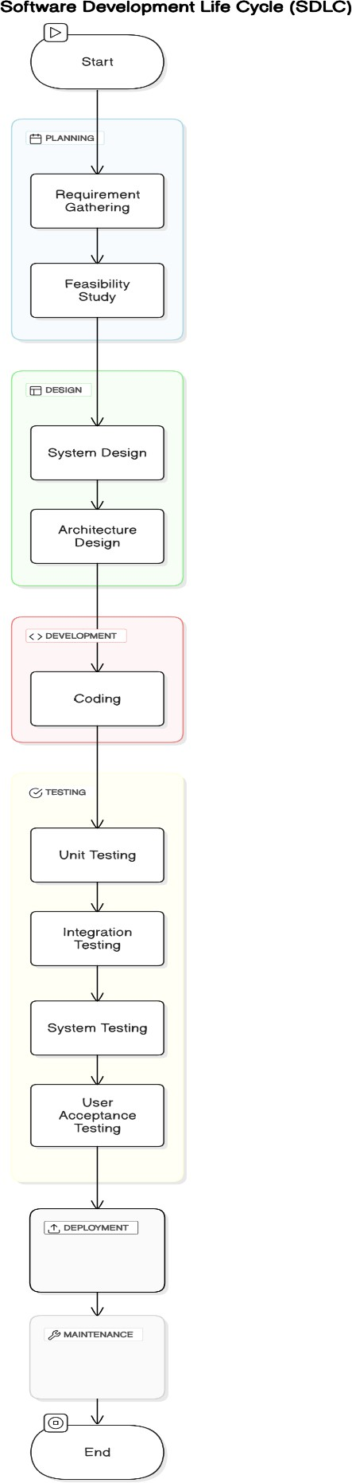**LAB EXERCISE:** Create a flowchart representing the Software Development Life Cycle (SDLC).
* **THEORY EXERCISE:** What are the main stages of the software development process?

The software development process is like building a house — it follows a series of steps to ensure the final product works well. Here are the main stages, explained simply.

**1. Planning**

* **What it is**: In this stage, you figure out what the software needs to do, who will use it, and what resources you need.
* **Why it’s important**: It helps set clear goals and ensures everyone knows what they’re working on.
* **Example**: Deciding that you want to build a mobile app for tracking fitness activities.

**2. Designing**

* **What it is**: This is when you plan how the software will look and how it will work. You create blueprints and user interfaces (UI) designs.
* **Why it’s important**: It gives you a clear idea of how the software will function and how users will interact with it.
* **Example**: Creating wireframes or mockups for the app’s screens.

**3. Development (Coding)**

* **What it is**: In this stage, developers write the code to make the software work according to the design.
* **Why it’s important**: This is the stage where the actual product starts to take shape.
* **Example**: Writing the code for the app’s features, like logging activities or tracking calories.

**4. Testing**

* **What it is**: Here, you check the software to make sure it works properly and is free of bugs (errors).
* **Why it’s important**: Testing ensures that the software is reliable and doesn’t cause problems for users.
* **Example**: Testing the app to see if it crashes or if the features work as expected.

**5. Deployment (Launch)**

* **What it is**: This is when the software is released to users, either by publishing it online, distributing it, or installing it on devices.
* **Why it’s important**: It's the moment when people can start using the software.
* **Example**: Launching your fitness app on app stores like Google Play or Apple App Store.

**6. Maintenance**

* **What it is**: After the software is launched, you need to continue fixing bugs, improving features, and adding updates.
* **Why it’s important**: Software needs ongoing care to keep it running smoothly and meet users' changing needs.
* **Example**: Fixing bugs that users report or adding a new feature like syncing with smartwatches.
* **In Simple Terms**

The software development process is like making a product.

1. **Planning** sets the goals.
2. **Designing** creates the blueprint.
3. **Development** builds it.
4. **Testing** makes sure it works.
5. **Deployment** releases it to the world.
6. **Maintenance** keeps it running smoothly after launch.

Each step helps ensure the final software is useful, functional, and reliable.

* **Software Requirement.**
* **LAB EXERCISE: Write a requirement specification for a simple library management system.**

**Library Management System Requirements**

1. **Overview**

The Library Management System helps manage books, members, and borrowing/returning activities in a simple and efficient way.

## Features

**User Management:**

* + Members can register, log in, and update their profiles.
  + Admins have full control over the system.

## Book Management:

* + Add, edit, or remove books.
  + Search for books by title, author, or genre.
  + Check book availability.

## Borrow and Return:

* + Members can borrow and return books.
  + The system tracks due dates and overdue fines.

## Reports and Notifications:

* + Admins can see reports of borrowed books and member activity.
  + Members get reminders for due dates and fines.

## Technical Details

* + **Platform:** Web-based system accessible via any browser.
  + **Database:** Stores book and user information securely.
  + **Scalability:** Can handle more members and books as needed.

## Assumptions

* + Members can borrow up to 5 books at a time.
  + Fines are $1 per day for overdue books
* **THEORY EXERCISE: Why is the requirement analysis phase critical in software development?**

The requirement analysis phase is critical in software development because it sets the foundation for the entire project. Think of it like planning a trip—if you don’t know where you’re going or what you need, you’ll end up lost or unprepared. Here’s why this phase is so important.

**1. Understands the Problem.**

* **What happens**: This phase helps the team clearly understand what the software needs to do and why it’s being created.
* **Why it’s important**: Without understanding the problem, the solution might not work for users.
* **Example**: If you’re building a shopping app, you need to know if users want to search products, pay online, or track orders.

**2. Sets Clear Goals.**

* **What happens**: The team defines what the software should achieve and how it should perform.
* **Why it’s important**: Clear goals ensure everyone knows what to build, avoiding confusion.
* **Example**: Deciding that the app should handle up to 1,000 users at the same time.

**3. Prevents Mistakes.**

* **What happens**: Potential issues, risks, and misunderstandings are identified early.
* **Why it’s important**: Fixing mistakes later in the project is harder, more expensive, and time-consuming.
* **Example**: Discovering during planning that users also want a feature to save favorite items, instead of adding it last-minute.

**4. Saves Time and Money.**

* **What happens**: The team plans the resources, timeline, and costs needed for the project.
* **Why it’s important**: A clear plan avoids wasted effort and ensures the project stays on track.
* **Example**: Knowing in advance that the app will need payment integration helps allocate time and developers for it.

**5. Aligns Everyone.**

* **What happens**: Developers, designers, testers, and clients all agree on what will be built.
* **Why it’s important**: Everyone works towards the same goals, reducing confusion and disagreements later.
* **Example**: Agreeing upfront on what "easy-to-use" means for the app design.

**6. Improves User Satisfaction.**

* **What happens**: The team gathers input from users or clients to ensure the software meets their needs.
* **Why it’s important**: If users are happy, the software will be more successful.
* **Example**: Learning that users want one-click checkout can make the app more convenient.
* **Software Analysis.**
* **LAB EXERCISE: Perform a functional analysis for an online shopping system**

**1.User Management**

* **Register/Login: User registration, authentication, and profile management.**
* **User Roles: Differentiation between customers, admins, and guest users.**

**2. Product Management**

* **Product Catalog: Display products with details like name, description, price, and image.**
* **Search & Filter: Enable users to search and filter products by categories, price range, etc.**
* **Product Details: Detailed view of individual products.**

**3. Shopping Cart**

* **Add/Remove Items: Add items to the cart or remove them.**
* **Update Quantity: Change the quantity of items in the cart.**
* **View Cart: Show cart summary, including item details, quantity, and total price.**

**4. Order Management**

* **Checkout: Collect shipping address, payment method, and order confirmation.**
* **Order Tracking: Allow users to track order status (e.g., pending, shipped, delivered).**
* **Order History: View past orders for registered users.**

**5. Payment System**

* **Payment Integration: Support for multiple payment methods (credit/debit cards, UPI, wallets).**
* **Payment Security: Implement secure payment gateways and encryption.**

**6. Notification System**

* **Order Updates: Email/SMS notifications for order placement, dispatch, and delivery.**
* **Promotions: Inform users about sales, discounts, and new arrivals.**

**7. Administration Features**

* **Product Management: Add, update, and delete products from the catalog.**
* **Order Management: Monitor and update the status of user orders.**
* **User Management: Manage user roles and permissions.**

**8. Additional Features**

* **Reviews & Ratings: Allow users to review and rate products.**
* **Wishlist: Enable users to save products for future purchase.**
* **Recommendations: Suggest products based on user preferences and history.**

**This high-level functional breakdown provides an overview of core features for an online shopping system.**

* **THEORY EXERCISE**: What is the role of software analysis in the development process?

Software analysis is like creating a detailed plan before building something. It helps understand what the software needs to do, why it’s needed, and how to make it work. This stage is essential in the software development process for several reasons.

**1. Understand the Problem**

* **What it does**: Software analysis helps figure out what the software should solve or accomplish.
* **Why it’s important**: Without understanding the problem, the software might not meet the user’s needs.
* **Example**: If you’re building a fitness app, software analysis identifies that users want to track workouts and calories.

**2. Gather Requirements**

* **What it does**: This step involves collecting details about what the software should do, how it should behave, and any specific features it needs.
* **Why it’s important**: It ensures the development team knows exactly what to build.
* **Example**: Deciding that the fitness app should include reminders for daily workouts.

**3. Identify Constraints**

* **What it does**: Analysis highlights any limitations, such as budget, timeline, or technical challenges.
* **Why it’s important**: Knowing these constraints helps plan realistically and avoid problems later.
* **Example**: Realizing the app needs to work offline but has limited storage space on devices.

**4. Create a Blueprint**

* **What it does**: Software analysis produces diagrams, models, or documents that outline how the software will work.
* **Why it’s important**: It serves as a guide for developers and ensures everyone is on the same page.
* **Example**: Creating a flowchart that shows how a user signs up, logs in, and tracks their workout.

**5. Detect Problems Early**

* **What it does**: Analysis helps spot potential issues or conflicts in the software’s design before development begins.
* **Why it’s important**: Fixing problems early saves time and money compared to fixing them after the software is built.
* **Example**: Realizing during analysis that the app's design might confuse users, so you improve it before coding.

**6. Ensure User Satisfaction**

* **What it does**: By understanding user needs and expectations, software analysis ensures the final product will make users happy.
* **Why it’s important**: If users are satisfied, the software is more likely to succeed.
* **Example**: Including features like calorie tracking because users specifically asked for it.
* **System Design.**
* **LAB EXERCISE: Design a basic system architecture for a food delivery app.**

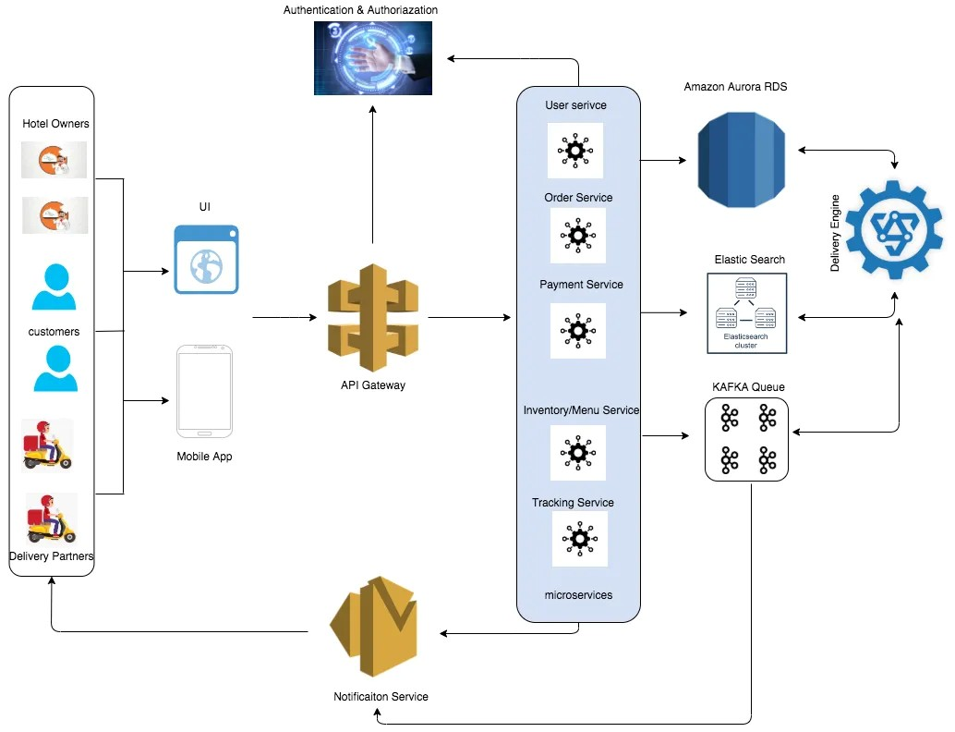

* **THEORY EXERCISE: What are the key elements of system design?**

System design is the process of planning how a system (like a software application or a large network) will work. It focuses on breaking down complex ideas into manageable parts. Here are the **key elements of system design**, explained in simple terms.

**1. System Requirements**

* **What it is**: A clear list of what the system should do and the goals it should achieve.
* **Why it’s important**: It ensures the system is built to meet the users’ needs.
* **Example**: For an e-commerce system, the requirements might include user registration, shopping carts, and secure payment options.

**2. Architecture Design**

* **What it is**: The overall structure or blueprint of the system, showing how different parts fit together.
* **Why it’s important**: It helps ensure the system is organized and scalable.
* **Example**: Deciding whether the system will be a web app, mobile app, or both, and how the database connects to the application.

**3. Data Design**

* **What it is**: Planning how data will be stored, organized, and accessed.
* **Why it’s important**: Proper data design ensures the system runs smoothly and handles data efficiently.
* **Example**: Designing a database for storing customer details, orders, and inventory for an online store.

**4. User Interface (UI) Design**

* **What it is**: Designing how users will interact with the system, including screens, buttons, and workflows.
* **Why it’s important**: A good UI makes the system easy and enjoyable to use.
* **Example**: Creating a clean and simple checkout page for an online store.

**5. Security Design**

* **What it is**: Adding features to protect the system and its data from unauthorized access or attacks.
* **Why it’s important**: Security keeps user information safe and builds trust.
* **Example**: Implementing encryption for passwords and secure payment methods.

**6. Performance Design**

* **What it is**: Ensuring the system works quickly and efficiently, even when many people use it at the same time.
* **Why it’s important**: A fast and reliable system improves user experience.
* **Example**: Optimizing the system to handle thousands of users during a sale.

**7. Scalability**

* **What it is**: Designing the system so it can grow as the business or user base expands.
* **Why it’s important**: A scalable system saves time and money as the organization grows.
* **Example**: Building the system to support future features like international shipping or more users.

**8. Integration**

* **What it is**: Planning how the system will work with other tools or platforms.
* **Why it’s important**: Many systems need to connect to external services, like payment gateways or email tools.
* **Example**: Integrating a payment processor like PayPal into an e-commerce site.

**9. Reliability**

* **What it is**: Making sure the system is stable and functions without crashing.
* **Why it’s important**: A reliable system builds user trust and reduces downtime.
* **Example**: Regularly testing the system to handle errors gracefully.

**10. Maintenance and Updates**

* **What it is**: Designing the system so it can be easily updated or fixed in the future.
* **Why it’s important**: Technology and user needs change, so the system must adapt.
* **Example**: Creating clear documentation for developers to understand and modify the system later.
* **Software Testing.**
* **LAB EXERCISE: Develop test cases for a simple calculator program.**

def test_calculator():

*# Test Addition*

*assert* (5 + 3) == 8

*assert* (-5 + (-3)) == -8

*assert* (5 + (-3)) == 2

*assert* (5 + 0) == 5

*# Test Subtraction*

*assert* (5 - 3) == 2

*assert* (3 - 5) == -2

*assert* (5 - 0) == 5

*assert* (-5 - 3) == -8

*# Test Multiplication*

*assert* (5 * 3) == 15

*assert* (-5 * (-3)) == 15

*assert* (5 * (-3)) == -15

*assert* (5 * 0) == 0

*# Test Division*

*assert* (6 / 3) == 2

*assert* (-6 / 3) == -2

*assert* (6 / -3) == -2

*try*:

*assert* (5 / 0)  *# Division by zero*

*except* ZeroDivisionError:

*pass*

*assert* (0 / 5) == 0

*# Edge Cases*

*assert* (1000000000 + 999999999) == 1999999999

*assert* (5.5 + 3.2) == 8.7

*assert* (7 / 3) == 2.3333333333333335

*# Invalid Input*

*try*:

*assert* (5 @ 3)  *# Invalid operation*

*except* TypeError:

*pass*

*assert* ("" == "")  *# Empty input check*

*# Multiple Operations*

*assert* (5 + 3 * 2) == 11

*assert* ((5 + 3) * 2) == 16

    print("All test cases passed!")

*# Run the test*

test_calculator()

* **THEORY EXERCISE: Why is software testing important?**

Software testing is very important because it helps ensure that the software works as it should and meets the needs of the users. Here's why testing matters, explained in simple terms.

**1. Finds Bugs and Errors**

* **What it does**: Testing helps identify mistakes in the software, such as crashes, incorrect calculations, or missing features.
* **Why it’s important**: Fixing these issues before users find them prevents frustration and bad reviews.
* **Example**: Discovering during testing that a shopping cart in an app doesn't save selected items.

**2. Improves Quality**

* **What it does**: Testing checks if the software meets high-quality standards, including reliability, speed, and usability.
* **Why it’s important**: High-quality software makes users happy and keeps them coming back.
* **Example**: Ensuring an app loads quickly and doesn't freeze when switching screens.

**3. Saves Time and Money**

* **What it does**: Testing early in the development process catches problems before they become bigger and harder to fix.
* **Why it’s important**: Fixing small issues is faster and cheaper than fixing big ones after release.
* **Example**: Finding a problem in the login system early prevents rewriting large parts of the code later.

**4. Ensures Security**

* **What it does**: Testing checks for vulnerabilities that hackers could exploit.
* **Why it’s important**: Protecting user data builds trust and prevents legal problems.
* **Example**: Testing to make sure passwords are encrypted and cannot be easily stolen.

**5. Confirms Compatibility**

* **What it does**: Testing ensures the software works on different devices, browsers, or operating systems.
* **Why it’s important**: Users access software in many ways, and it needs to work for everyone.
* **Example**: Making sure a website works on both mobile phones and desktop computers.

**6. Enhances User Experience**

* **What it does**: Testing helps ensure the software is easy to use and meets user expectations.
* **Why it’s important**: If users find the software difficult or confusing, they won’t want to use it.
* **Example**: Testing an app to confirm that menus and buttons are easy to navigate.

**7. Builds Confidence**

* **What it does**: Developers and clients feel confident in the software when it has been thoroughly tested.
* **Why it’s important**: Confidence in the product leads to successful launches and satisfied customers.
* **Example**: A company confidently launching a new app after testing shows it works perfectly.
* **Maintenance.**
* **LAB EXERCISE: Document a real-world case where a software application required critical maintenance.**

**Case Study: Boeing 737 MAX Software Maintenance Issue**

**Background**

**The Boeing 737 MAX aircraft required critical software maintenance following two tragic crashes in 2018 and 2019. The crashes were linked to issues in the Maneuvering Characteristics Augmentation System (MCAS), a software system designed to prevent the aircraft from stalling.**

**Problem**

1. **Flawed Logic in MCAS:**
   * **The system relied on data from a single angle-of-attack (AOA) sensor. A faulty sensor caused the system to repeatedly push the aircraft’s nose down.**
2. **Inadequate Alerts:**
   * **Pilots were not adequately informed about the system or trained to handle MCAS-related malfunctions.**
3. **System Override:**
   * **MCAS repeatedly overrode pilot input, leading to catastrophic failures.**

**Critical Maintenance**

1. **Software Update:**
   * **Boeing developed a software patch to:**
     + **Use data from two AOA sensors instead of one.**
     + **Prevent repeated MCAS activation if the data is inconsistent.**
   * **Included an override mechanism allowing pilots to disable MCAS if needed.**
2. **Pilot Training:**
   * **Comprehensive training programs were introduced to familiarize pilots with MCAS behavior and failure recovery procedures.**
3. **Regulatory Approval:**
   * **The Federal Aviation Administration (FAA) and other global aviation bodies thoroughly tested and approved the updated software.**

**Outcome**

* **The updated software was successfully implemented across all Boeing 737 MAX aircraft.**
* **The aircraft resumed service in 2020 after regulatory clearance.**
* **This case highlighted the importance of robust software design, continuous monitoring, and effective training in mission-critical applications.**

**Key Lessons**

1. **Redundancy:**
   * **Systems relying on single points of failure pose significant risks.**
2. **Transparency:**
   * **Informing and training end-users on system behavior is crucial.**
3. **Proactive Maintenance:**
   * **Identifying and addressing potential issues during design and testing stages is vital to avoid critical failures.**

**This real-world example underscores the importance of timely and effective software maintenance in critical systems.**

* **THEORY EXERCISE: What types of software maintenance are there?**

Software maintenance is about keeping software running smoothly after it’s released. There are four main types of software maintenance, each serving a specific purpose. Here’s an easy explanation.

**1. Corrective Maintenance**

* **What it is**: Fixing bugs and errors in the software.
* **Why it’s important**: Even with thorough testing, some problems only show up after users start using the software.
* **Example**: Fixing a login issue where users can't reset their passwords.

**2. Adaptive Maintenance**

* **What it is**: Updating the software to work with changes in the environment, like new operating systems, hardware, or regulations.
* **Why it’s important**: Technology and rules change, and the software needs to stay compatible and relevant.
* **Example**: Updating an app to work on the latest version of iOS or Android.

**3. Perfective Maintenance**

* **What it is**: Improving or adding new features to make the software better for users.
* **Why it’s important**: It keeps users happy by meeting their evolving needs and preferences.
* **Example**: Adding a dark mode feature to an app because users requested it.

**4. Preventive Maintenance**

* **What it is**: Making changes to prevent future problems or improve system performance.
* **Why it’s important**: It reduces the chances of failures and extends the software's life.
* **Example**: Optimizing the database to handle more users without slowing down.
* **Development.**
* **THEORY EXERCISE:** What are the key differences between web and desktop applications?

Web and desktop applications are types of software, but they work differently and are used in different ways. Here are the key differences explained in simple words.

**1. Where They Run**

* **Web Applications**: Run in a web browser (like Chrome, Safari, or Firefox). You don’t need to install them on your computer.
  + **Example**: Gmail, Google Docs, and Facebook.
* **Desktop Applications**: Installed and run directly on your computer or laptop.
  + **Example**: Microsoft Word, Photoshop, and VLC Media Player.

**2. Internet Connection**

* **Web Applications**: Usually need an internet connection to work because they run online.
  + **Example**: You need the internet to use Google Docs.
* **Desktop Applications**: Can often work without an internet connection because everything is stored on your computer.
  + **Example**: You can use Microsoft Word offline.

**3. Access**

* **Web Applications**: Accessible from any device with a browser and internet connection. You can log in from a phone, tablet, or computer.
  + **Example**: You can access your Gmail account from any device.
* **Desktop Applications**: Only accessible on the device where they are installed.
  + **Example**: If Photoshop is installed on your PC, you can't use it from another computer.

**4. Updates**

* **Web Applications**: Updates happen automatically, and you always use the latest version.
  + **Example**: You don’t have to update Facebook; it’s updated by the developers.
* **Desktop Applications**: You often need to manually download and install updates.
  + **Example**: You might need to download the latest version of Photoshop.

**5. Storage**

* **Web Applications**: Data is usually stored in the cloud (online servers).
  + **Example**: Google Drive stores your files online.
* **Desktop Applications**: Data is often stored on your computer’s hard drive.
  + **Example**: Microsoft Word saves files directly to your PC unless you choose otherwise.

**6. Performance**

* **Web Applications**: Performance depends on your internet speed and browser capabilities.
  + **Example**: A slow internet connection can make a web app laggy.
* **Desktop Applications**: Usually faster and more powerful because they use your computer’s hardware.
  + **Example**: Video editing software like Premiere Pro runs smoothly because it uses your computer's full power.

**7. Cost**

* **Web Applications**: Often free or subscription-based. You don’t pay for installation.
  + **Example**: Canva has a free version, but premium features require a subscription.
* **Desktop Applications**: Often require a one-time purchase or license fee.
  + **Example**: You buy a license for Microsoft Office or Adobe Photoshop.
* **Web Application.**
* **THEORY EXERCISE:** What are the advantages of using web applications over desktop applications?

**1. Access from Anywhere**

* **What it means: You can use web apps on any device with a browser and internet connection.**
* **Why it’s useful: You’re not tied to a specific computer.**
* **Example: You can check your email or edit documents from your phone, tablet, or laptop.**

**2. No Installation Needed**

* **What it means: Web apps don’t require downloading or installing on your device.**
* **Why it’s useful: It saves storage space and time.**
* **Example: You can use Google Docs directly in your browser without installing anything.**

**3. Automatic Updates**

* **What it means: Web apps are updated automatically by the developers.**
* **Why it’s useful: You always have the latest version without needing to manually download updates.**
* **Example: Facebook or YouTube updates itself without you doing anything.**

**4. Cost-Effective**

* **What it means: Many web apps are free or have affordable subscription plans.**
* **Why it’s useful: You don’t have to pay for licenses or upgrades.**
* **Example: Canva has a free version, while desktop design software might require a one-time purchase.**

**5. Cross-Platform Compatibility**

* **What it means: Web apps work on any operating system (Windows, macOS, Linux) as long as you have a browser.**
* **Why it’s useful: You don’t need different versions for different devices.**
* **Example: You can use Gmail on a MacBook or a Windows PC without any changes.**

**6. Cloud Storage**

* **What it means: Web apps often save your data online instead of on your device.**
* **Why it’s useful: You don’t lose your data if your device is damaged or lost.**
* **Example: Google Drive automatically saves your files online.**

**7. Easy Collaboration**

* **What it means: Multiple people can work together on the same file in real time.**
* **Why it’s useful: It simplifies teamwork and communication.**
* **Example: Google Docs allows several people to edit a document at once.**

**8. Lower System Requirements**

* **What it means: Web apps don’t need powerful hardware because they run in the browser.**
* **Why it’s useful: Even older computers can use them.**
* **Example: You don’t need a high-end computer to run a web app like Trello.**
* **Designing.**
* **THEORY EXERCISE:** What role does UI/UX design play in application development?

UI/UX design plays a big role in making applications user-friendly and enjoyable to use. Here’s how it helps in simple words.

**1. Makes the App Easy to Use (UI - User Interface)**

* **What it does**: UI design focuses on how the app looks and feels, like buttons, menus, and colors.
* **Why it’s important**: A clear and attractive interface makes it easy for users to navigate the app.
* **Example**: A simple, well-labeled button for “Buy Now” helps users quickly complete a purchase.

**2. Creates a Positive Experience (UX - User Experience)**

* **What it does**: UX design focuses on the overall experience, ensuring the app is intuitive and meets users' needs.
* **Why it’s important**: A good experience keeps users happy and coming back.
* **Example**: An app that remembers your preferences and suggests helpful options improves your experience.

**3. Saves Time for Users**

* **What it does**: Good design ensures users can complete tasks quickly and without confusion.
* **Why it’s important**: People want apps that save time, not waste it.
* **Example**: A banking app that lets users transfer money in just a few steps is convenient.

**4. Builds Trust and Credibility**

* **What it does**: A well-designed app looks professional and reliable.
* **Why it’s important**: Users trust apps that feel polished and secure.
* **Example**: A clean, error-free design in an e-commerce app makes users comfortable entering payment details.

**5. Attracts and Retains Users**

* **What it does**: A visually appealing and easy-to-use app attracts new users and keeps them using it.
* **Why it’s important**: If the app is frustrating or unattractive, users might stop using it.
* **Example**: Social media apps like Instagram invest heavily in UI/UX to keep users engaged.

**6. Reduces Errors and Frustration**

* **What it does**: Good design ensures users don’t get stuck or make mistakes while using the app.
* **Why it’s important**: Less frustration means happier users.
* **Example**: Clear error messages and guidance when a password is entered incorrectly.

**7. Supports Accessibility**

* **What it does**: UI/UX design considers users with disabilities, like those who need larger text or voice commands.
* **Why it’s important**: Makes the app usable for everyone.
* **Example**: Adding a feature to increase text size for visually impaired users.

**8. Increases Business Success**

* **What it does**: Happy users are more likely to recommend the app, leading to more downloads and success.
* **Why it’s important**: A great design can give an app a competitive edge.
* **Example**: Apps like Airbnb and Spotify succeeded partly because of their excellent UI/UX.
* **Mobile Application.**
* **THEORY EXERCISE: What are the differences between native and hybrid mobile apps?**

**1. How They Are Built**

* **Native Apps: Made specifically for one platform (like iOS or Android) using platform-specific programming languages.**
  + **Example: iOS apps are built with Swift or Objective-C, while Android apps use Java or Kotlin.**
* **Hybrid Apps: Built using web technologies like HTML, CSS, and JavaScript, then wrapped to work on multiple platforms.**
  + **Example: Hybrid apps use tools like Flutter or React Native to run on both iOS and Android.**

**2. Performance**

* **Native Apps: Faster and more efficient because they are designed specifically for one platform.**
  + **Why: They can fully use the device’s hardware and features.**
* **Hybrid Apps: Slightly slower because they rely on an extra layer (a web view) to work on different platforms.**
  + **Why: They don’t interact directly with the device as native apps do.**

**3. Appearance and User Experience**

* **Native Apps: Look and feel exactly like other apps on the platform because they use platform-specific design guidelines.**
  + **Why: They follow the standards of iOS or Android.**
* **Hybrid Apps: May look less consistent with the platform’s native style, though modern tools are improving this.**
  + **Why: They use a single codebase for all platforms, which can lead to slight differences.**

**4. Cost and Time to Develop**

* **Native Apps: More expensive and time-consuming because separate apps must be developed for iOS and Android.**
  + **Why: You need two teams or developers skilled in different languages.**
* **Hybrid Apps: Cheaper and faster because the same code can be used for both platforms.**
  + **Why: Developers only write the app once and adjust for minor differences.**

**5. Access to Device Features**

* **Native Apps: Can easily access device features like the camera, GPS, and notifications.**
  + **Why: They are directly integrated with the platform.**
* **Hybrid Apps: Can access device features but may need extra plugins or might not be as seamless.**
  + **Why: They rely on third-party tools to bridge the gap.**

**6. Updates and Maintenance**

* **Native Apps: Updates must be done separately for iOS and Android.**
  + **Why: They are two distinct apps.**
* **Hybrid Apps: Easier to update because changes in the single codebase apply to both platforms.**
  + **Why: One update works for all.**

**7. Examples**

* **Native Apps: Instagram (iOS and Android built separately).**
* **Hybrid Apps: Uber and Pinterest (use a single codebase for multiple platforms).**
* **DFD (Data Flow Diagram).**
* 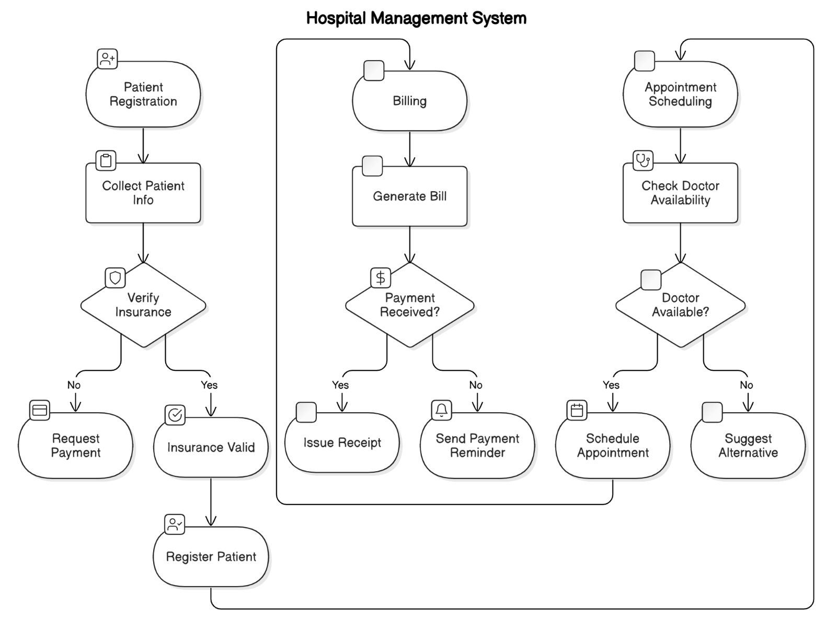**LAB EXERCISE: Create a DFD for a hospital management system.**
* **THEORY EXERCISE:** What is the significance of DFDs in system analysis?

**1. Visual Representation**

* **What it means**: DFDs use simple symbols (circles, arrows, and rectangles) to show how data flows between different parts of a system.
* **Why it’s useful**: It’s easier to understand a diagram than reading long, technical descriptions.
* **Example**: A DFD can show how customer information flows from a website to a database.

**2. Helps Understand the System**

* **What it means**: DFDs break down the system into smaller, easy-to-understand parts.
* **Why it’s useful**: Everyone, even non-technical people, can understand how the system works.
* **Example**: A DFD can show how an order management system processes an order step by step.

**3. Identifies Problems**

* **What it means**: DFDs can highlight where the system might have bottlenecks, inefficiencies, or missing parts.
* **Why it’s useful**: Finding problems early saves time and money later.
* **Example**: A DFD can show if there’s missing data flow between the payment system and order confirmation.

**4. Communication Tool**

* **What it means**: DFDs are a universal way to communicate system processes and data flow between team members.
* **Why it’s useful**: Developers, designers, and stakeholders can all use the same diagram to discuss the system.
* **Example**: A DFD helps explain the system requirements to both the client and the developers.

**5. Supports System Design**

* **What it means**: DFDs provide a foundation for creating detailed system designs.
* **Why it’s useful**: They guide the team on how to structure the system.
* **Example**: A DFD for an e-commerce website helps designers and developers know how to connect the shopping cart, payment gateway, and inventory.
* **Desktop Application.**
* **LAB EXERCISE: Build a simple desktop calculator application using a GUI library.**
* *import* tkinter *as* tk
* *from* tkinter *import* messagebox
* *# Function to handle button clicks*
* def button_click(*number*):
* current = entry.get()
* entry.delete(0, tk.END)
* entry.insert(0, current + str(number))
* *# Function to clear the input field*
* def clear():
* entry.delete(0, tk.END)
* *# Function to evaluate the expression*
* def calculate():
* *try*:
* result = eval(entry.get())
* entry.delete(0, tk.END)
* entry.insert(0, str(result))
* *except* Exception *as* e:
* messagebox.showerror("Error", "Invalid Expression")
* *# Create the main window*
* window = tk.Tk()
* window.title("Calculator")
* window.geometry("300x400")
* window.resizable(False, False)
* *# Entry widget for the display*
* entry = tk.Entry(window, *width*=25, *font*=('Arial', 16), *justify*='right')
* entry.grid(*row*=0, *column*=0, *columnspan*=4, *padx*=10, *pady*=10)
* *# Button layout*
* buttons = [
* ('7', 1, 0), ('8', 1, 1), ('9', 1, 2), ('/', 1, 3),
* ('4', 2, 0), ('5', 2, 1), ('6', 2, 2), ('*', 2, 3),
* ('1', 3, 0), ('2', 3, 1), ('3', 3, 2), ('-', 3, 3),
* ('C', 4, 0), ('0', 4, 1), ('=', 4, 2), ('+', 4, 3),
* ]
* *# Create buttons dynamically*
* *for* (text, row, col) *in* buttons:
* *if* text == '=':
* button = tk.Button(window, *text*=text, *width*=5, *height*=2, *font*=('Arial', 14),
* *command*=calculate)
* *elif* text == 'C':
* button = tk.Button(window, *text*=text, *width*=5, *height*=2, *font*=('Arial', 14),
* *command*=clear)
* *else*:
* button = tk.Button(window, *text*=text, *width*=5, *height*=2, *font*=('Arial', 14),
* *command*=lambda *t*=text: button_click(t))
* button.grid(*row*=row, *column*=col, *padx*=5, *pady*=5)
* *# Run the application*
* window.mainloop()
* **Output:**

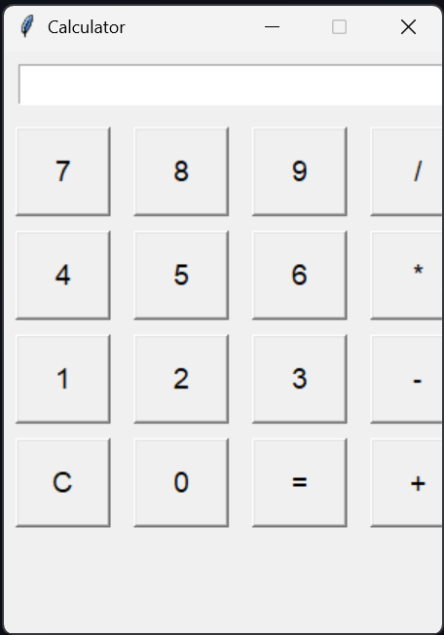

* **THEORY EXERCISE:** What are the pros and cons of desktop applications compared to web applications?

Desktop applications and web applications have different strengths and weaknesses. Here’s a simple comparison of the pros and cons of each.

* Desktop Applications.
* Pros.

1. **Access from Anywhere**

* **What it means**: You can use the app from any device with a browser and internet connection.
* **Why it’s useful**: No need to install anything or be tied to one device.
* **Example**: Google Docs can be accessed from any phone, tablet, or computer.

1. **Automatic Updates**

* **What it means:** Web apps update automatically, so you always have the latest version.
* **Why it’s useful**: No need to worry about downloading updates.
* **Example**: Facebook updates itself without you having to do anything.

1. **No Need for Installation**

* **What it means**: You don’t have to install anything on your device.
* **Why it’s useful**: Saves storage space on your device.
* **Example**: Using a web app like Trello doesn’t take up space on your phone or laptop.

1. **Cross-Platform Compatibility**

* **What it means**: Web apps work on any device or operating system, like Windows, macOS, iOS, or Android.
* **Why it’s useful**: You don’t need separate versions for different platforms.
* **Example**: You can use an online photo editor on both Android and iOS.
* Cons

1. **Needs Internet Connection**
   * **What it means**: Most web apps require a stable internet connection to work.
   * **Why it’s a problem**: You can’t use the app without the internet.
   * **Example**: You can’t access Gmail or YouTube without being online.
2. **Slower Performance**
   * **What it means**: Web apps can be slower than desktop apps, especially with slow internet connections.
   * **Why it’s a problem**: May not perform well for tasks that need high-speed processing.
   * **Example**: Online video editing tools might lag if you have a slow connection.
3. **Less Access to Device Features**
   * **What it means**: Web apps may not have access to all the features of your device (like the camera or GPS).
   * **Why it’s a problem**: Limited functionality compared to desktop apps.
   * **Example**: A web-based game might not use your computer’s graphics card as well as a desktop version would.
4. **Security Concerns**
   * **What it means**: Data is stored online, so there’s a risk of being hacked.
   * **Why it’s a problem**: Your information is exposed to online threats.
   * **Example**: If a web app has a security flaw, your personal data might be at risk.

* Flow Chart.
* **LAB EXERCISE: Draw a flowchart representing the logic of a basic online registration system.**

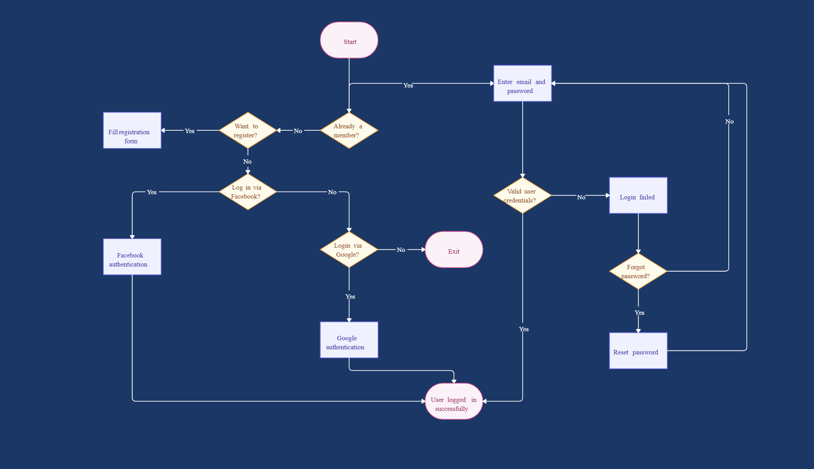

* **THEORY EXERCISE: How do flowcharts help in programming and system design?**

**1. Visualizing the Process**

* **What it means: A flowchart is a diagram that uses shapes (like arrows, rectangles, diamonds) to represent different steps in a process.**
* **Why it’s helpful: It makes it easier to understand and plan out how something works.**
* **Example: A flowchart can show the steps in a login process—checking if the username and password are correct, and if so, logging the user in.**

**2. Breaking Down Complex Problems**

* **What it means: Flowcharts break a big task into smaller, manageable steps.**
* **Why it’s helpful: It’s easier to solve smaller problems than a big, complicated one.**
* **Example: If you’re building an app, a flowchart can break down the process of submitting a form into steps like “enter data,” “validate data,” and “submit to server.”**

**3. Helping With Debugging**

* **What it means: Flowcharts can show exactly where things might go wrong in a process.**
* **Why it’s helpful: When something goes wrong, you can look at the flowchart to find which step caused the issue.**
* **Example: If a login isn’t working, the flowchart can show if the problem is in checking the password or something else.**

**4. Guiding System Design**

* **What it means: In system design, flowcharts map out how different parts of the system interact.**
* **Why it’s helpful: It shows the flow of data and decisions in the system, helping the team understand and design it better.**
* **Example: In an online store, a flowchart can show how a user’s order goes from browsing products to paying for them, to receiving an order confirmation.**

**5. Communicating Ideas**

* **What it means: Flowcharts make it easier to explain how something works, especially to people who might not be familiar with the technical details.**
* **Why it’s helpful: They act as a visual language that everyone can understand.**
* **Example: You can show a flowchart to a team member to explain how a feature in your app should function without needing to use complicated words.**

**6. Planning and Organizing**

* **What it means: Flowcharts help organize the steps in a logical order before you start programming or building the system.**
* **Why it’s helpful: Having a clear plan helps you avoid mistakes and confusion during development.**
* **Example: Before starting to code, a flowchart helps you figure out the order of operations for a feature, like sorting a list of items.**