NAME: Khanya Ngema
STUDENT NUMBER: 20240948
CLASS PROJECT: StudentManagementDB
DEMO AND TESTS
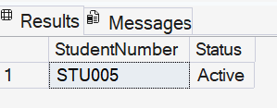
1.

2.
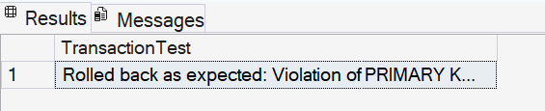

3.
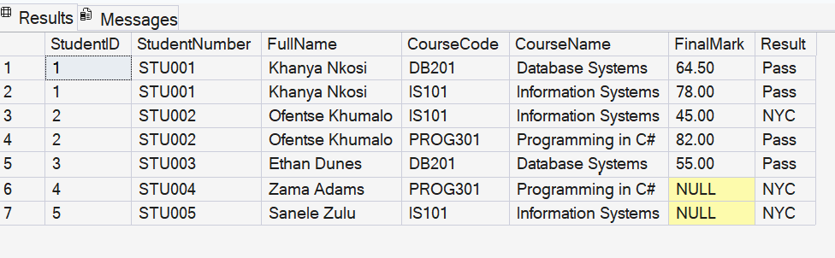

4.
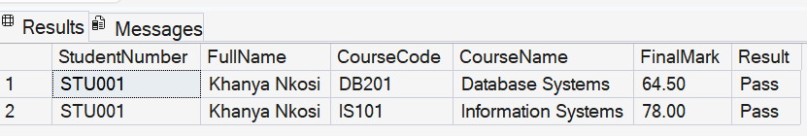

5.
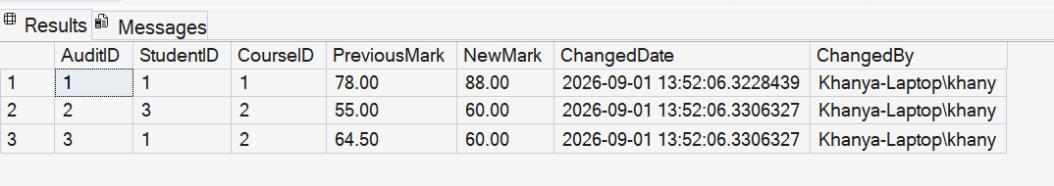

6.
