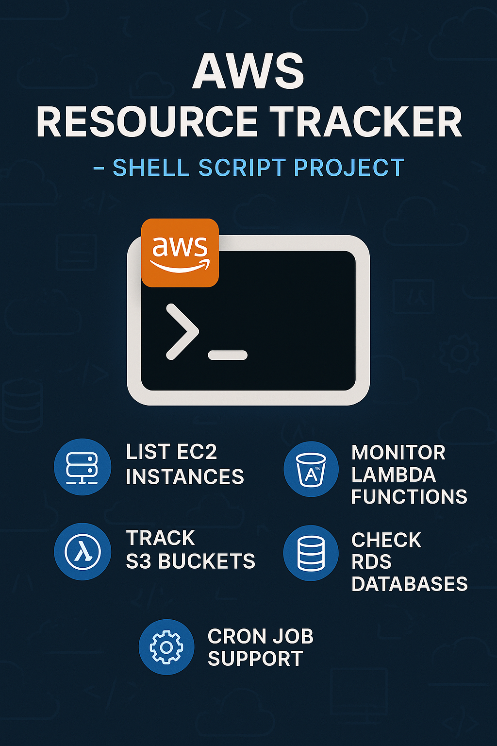

****Project: AWS Resource Tracker****

****– Shell Script****

The **AWS Resource Tracker** is a lightweight and efficient shell script designed to help DevOps engineers and cloud administrators quickly **list, monitor, and audit all active AWS resources** in a region. It leverages the AWS CLI to fetch details such as **running instances, resource types, statuses, and counts** across services like EC2, S3, Lambda, RDS, and more.

This project provides:

A real-time snapshot of your AWS infrastructure

Clear visibility into resource usage and availability

Automation-ready output for monitoring and reporting

Compatible with cron jobs for scheduled reporting

It simplifies cloud resource tracking and helps maintain **cost control, compliance, and infrastructure health** across environments.

### ****Built With:****

**Shell Script (Bash)**

**AWS CLI**

**jq** (optional for JSON parsing)

### ****Benefits:****

Simple and easy to use

Works on any Linux/Unix machine with AWS CLI configured

Saves time by automating resource tracking

Enhances visibility and accountability of AWS usage.

**Create a shell file :**

**Command : vim aws_resource_tracker.sh**

**When vim is opened copy and paste this code in the vim .**

**#!/bin/bash**

**##########################################################**

**# Author : Mohammed Yasir Khan #**

**# Date : 12/04/2025 #**

**# Project_name: AWS Resource Tracker #**

**# Description : this script is used to track the aws resources. #**

**# Version : v1 #**

**##########################################################**

**echo "AWS Resource Tracker"**

**echo "----------------------------"**

**# EC2 Instances**

**echo -e "\n EC2 Instances:"**

**aws ec2 describe-instances \**

**--query 'Reservations[*].Instances[*].[InstanceId,State.Name,InstanceType,AvailabilityZone]' \**

**--output table**

**# S3 Buckets**

**echo -e "\n ️ S3 Buckets:"**

**aws s3 ls**

**# Lambda Functions**

**echo -e "\n Lambda Functions:"**

**aws lambda list-functions --query 'Functions[*].[FunctionName,Runtime,LastModified]' --output table**

**# RDS Instances**

**echo -e "\n RDS Instances:"**

**aws rds describe-db-instances \**

**--query 'DBInstances[*].[DBInstanceIdentifier,DBInstanceStatus,Engine]' \**

**--output table**

**# EKS Clusters**

**echo -e "\n ️ EKS Clusters:"**

**aws eks list-clusters --output table**

**# CloudFormation Stacks**

**echo -e "\n️ CloudFormation Stacks:"**

**aws cloudformation describe-stacks --query 'Stacks[*].[StackName,StackStatus]' --output table**

**# IAM Users**

**echo -e "\n IAM Users:"**

**aws iam list-users --query 'Users[*].[UserName,CreateDate]' --output table**

**# Route 53 Hosted Zones**

**echo -e "\n Route53 Hosted Zones:"**

**aws route53 list-hosted-zones --query 'HostedZones[*].[Name,Id]' --output table**

**# CloudWatch Alarms**

**echo -e "\n CloudWatch Alarms:"**

**aws cloudwatch describe-alarms --query 'MetricAlarms[*].[AlarmName,StateValue]' --output table**

**echo -e "\n✅ Resource scan completed."**

**Change the permission of the file :**

**Command : chmod 755 aws_resource_tracker.sh**

**ec2 instance in aws :**

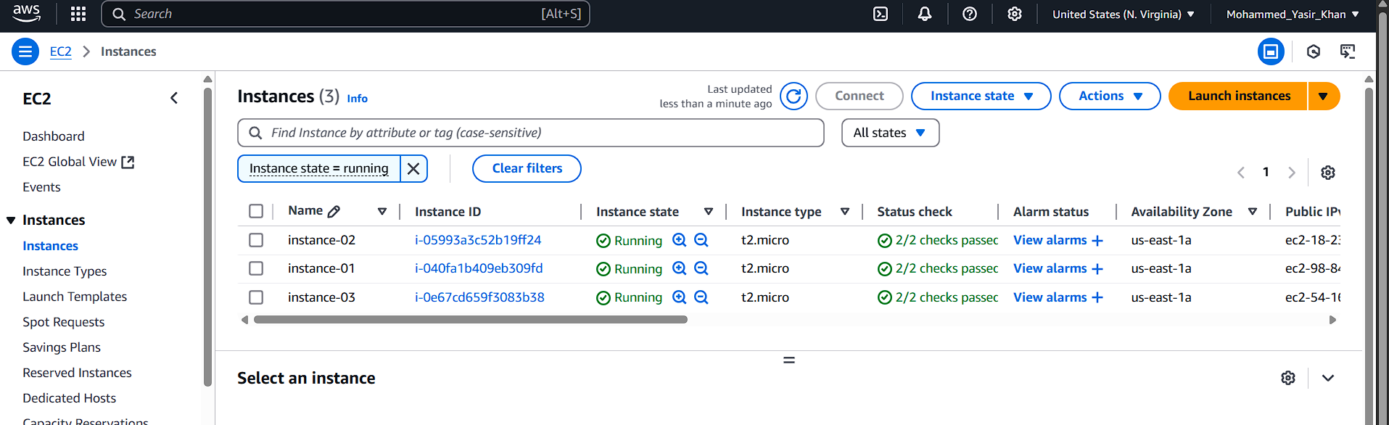

s3 bucket in aws :

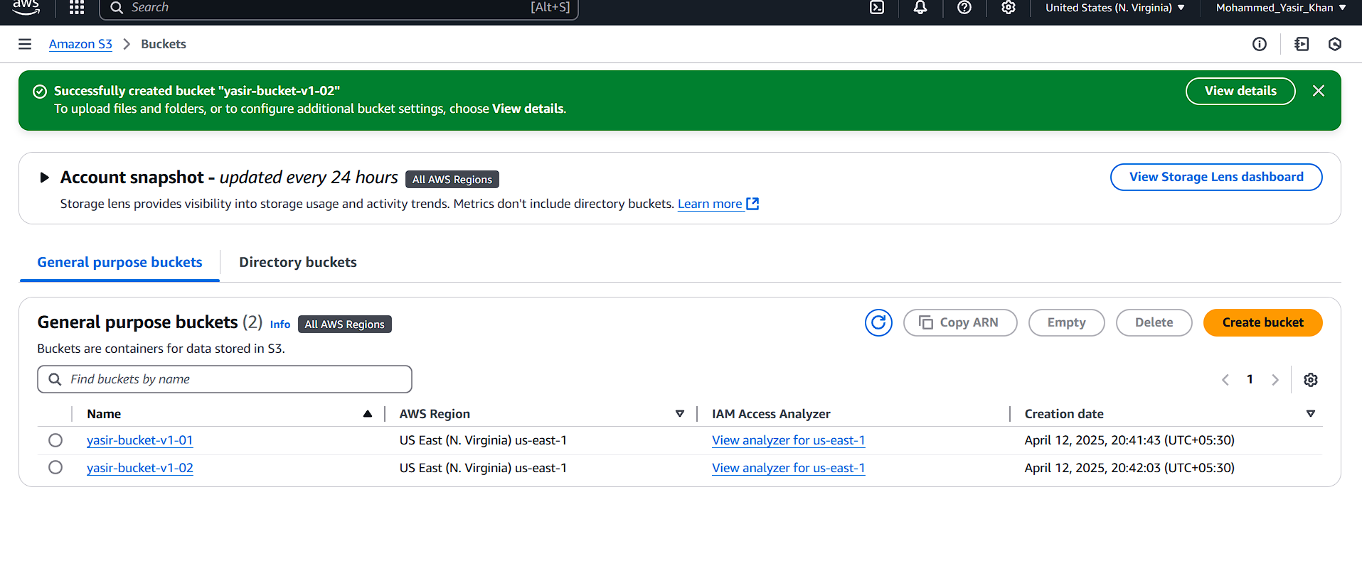

**iam users in aws :**

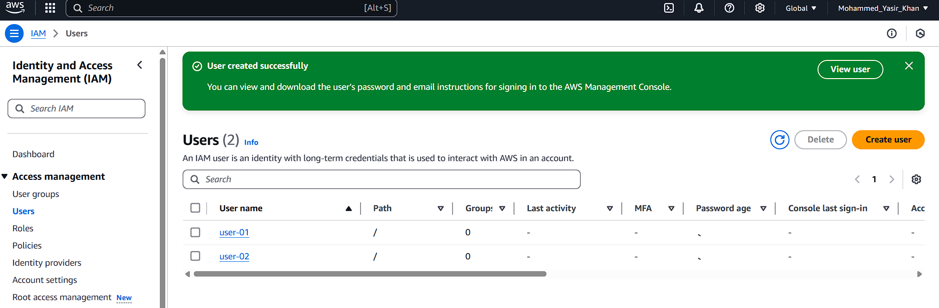

No cluster is created :

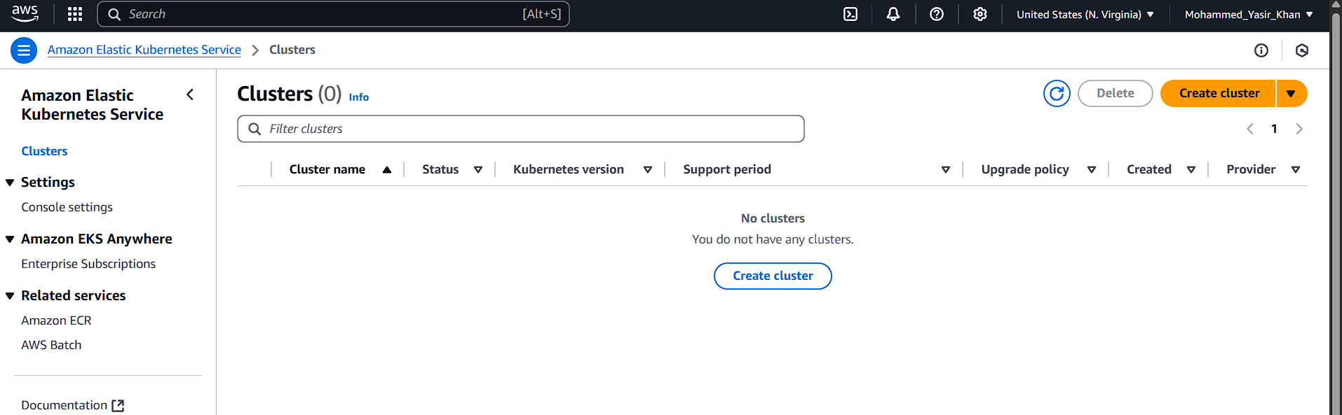

No Amazon RDS :

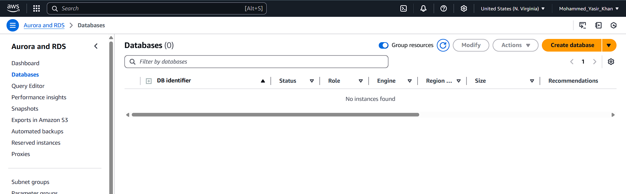

No AWS Lambda Function :

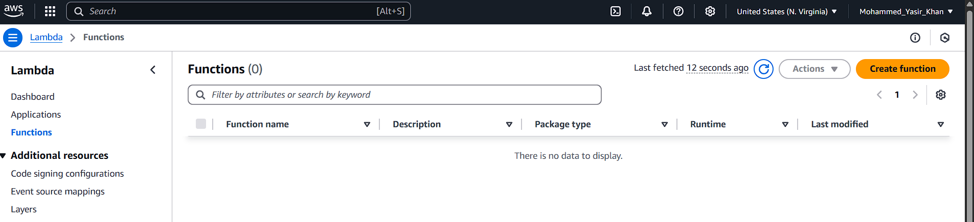

No aws cloudFormation :

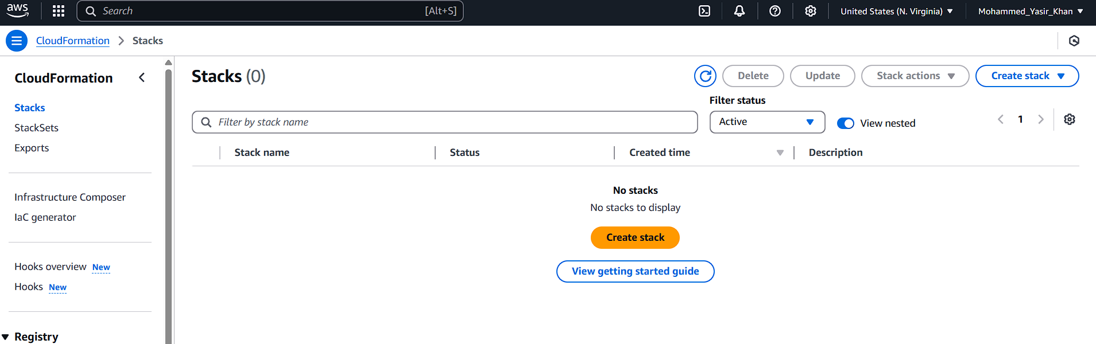

No aws cloudWatch :

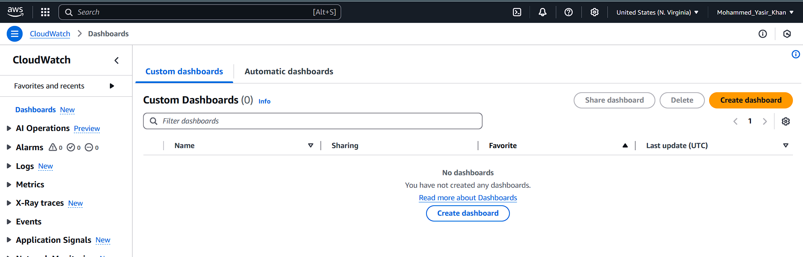

No Route53 hosted-zones :

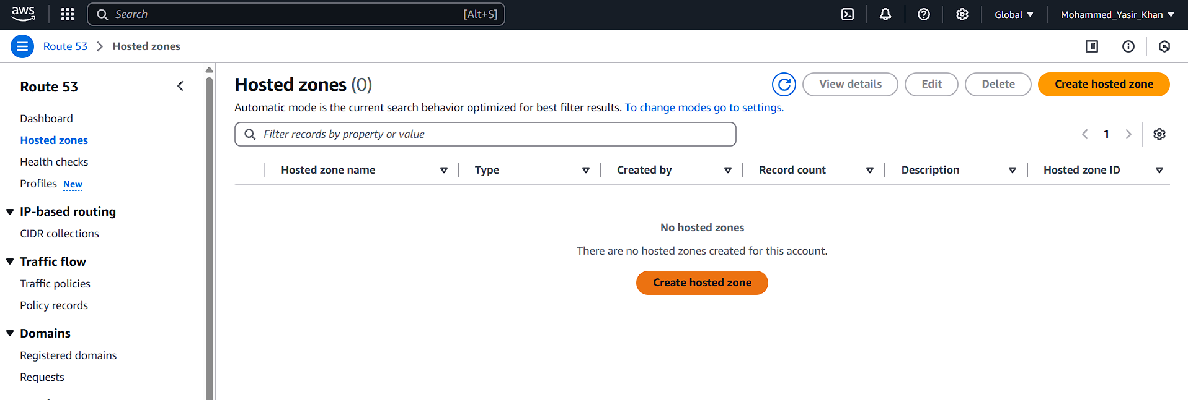

No cloudWatch :

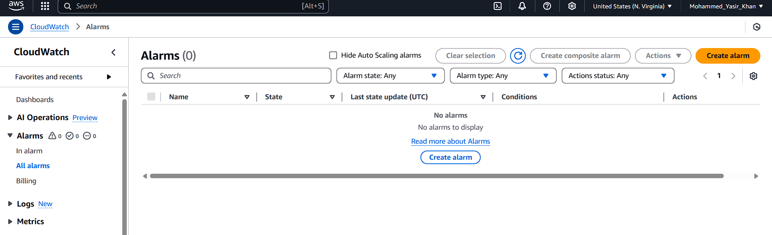

**Output :**

