Assignment 2

Yasra Khan
may 6, 2025

This assignment focuses on understanding and implementing the Minimax algorithm and its optimization using Alpha-Beta Pruning for the classic game of Tic-Tac-Toe.
Core Game Logic:
- initial_state: Initializes the Tic-Tac-Toe board.
- player: Determines whose turn it is based on the number of X's and O's on the board.
- actions: Lists the available moves (empty cells).
- result: Returns a new board after a move.
- winner: Checks if there is a winner on the board.
- terminal: Checks if the game has ended, either by a win or a draw.
- utility: Returns the utility of a terminal state (1 for X win, -1 for O win, and 0 for a draw).
Minimax Algorithm:
- The minimax function implements the standard Minimax algorithm for optimal play by player X. It recursively calculates the best move by exploring all possible future states.
- The function max_value maximizes the score for X, and min_value minimizes it for O.
Alpha-Beta Pruning:
- The alpha_beta function implements the Alpha-Beta Pruning optimization to improve the efficiency of the Minimax algorithm.
- The function max_value and min_value are modified to include alpha (the best value for the maximizing player) and beta (the best value for the minimizing player) and prune branches that cannot affect the final decision.
Performance Comparison:
- The time taken for each move is displayed for both Minimax and Alpha-Beta Pruning. From your output, Alpha-Beta Pruning consistently takes less time than the standard Minimax algorithm, showing its efficiency in reducing the number of explored branches.
Optimal Play
- Both players, X and O, are making optimal moves according to the algorithms:
  - X uses Minimax to make the best possible moves.
  - O uses Alpha-Beta Pruning for optimal play, with improved efficiency.
- import time
- import copy

- # Constants
- X = "X"
- O = "O"
- EMPTY = " "

- # Initial empty board
- def initial_state():
- return [[EMPTY, EMPTY, EMPTY],
- [EMPTY, EMPTY, EMPTY],
- [EMPTY, EMPTY, EMPTY]]

- # Get current player
- def player(board):
- x_count = sum(row.count(X) for row in board)
- o_count = sum(row.count(O) for row in board)
- return X if x_count == o_count else O

- # List of possible actions
- def actions(board):
- return [(i, j) for i in range(3) for j in range(3) if board[i][j] == EMPTY]

- # Resulting board after a move
- def result(board, action, player_symbol):
- i, j = action
- if board[i][j] != EMPTY:
- raise Exception("Invalid move")
- new_board = copy.deepcopy(board)
- new_board[i][j] = player_symbol
- return new_board

- # Check for a winner
- def winner(board):
- lines = board + [list(col) for col in zip(*board)] # rows and columns
- lines.append([board[i][i] for i in range(3)]) # main diagonal
- lines.append([board[i][2 - i] for i in range(3)]) # anti-diagonal

- for line in lines:
- if line.count(X) == 3:
- return X
- if line.count(O) == 3:
- return O
- return None

- # Check if the game is over
- def terminal(board):
- return winner(board) is not None or all(cell != EMPTY for row in board for cell in row)

- # Utility of terminal state
- def utility(board):
- win = winner(board)
- if win == X:
- return 1
- elif win == O:
- return -1
- return 0

- # Minimax algorithm (used by X)
- def minimax(board):
- if terminal(board):
- return None

- def max_value(board):
- if terminal(board):
- return utility(board), None
- v = float('-inf')
- best_action = None
- for action in actions(board):
- val, _ = min_value(result(board, action, X))
- if val > v:
- v = val
- best_action = action
- return v, best_action

- def min_value(board):
- if terminal(board):
- return utility(board), None
- v = float('inf')
- best_action = None
- for action in actions(board):
- val, _ = max_value(result(board, action, O))
- if val < v:
- v = val
- best_action = action
- return v, best_action

- _, action = max_value(board) if player(board) == X else min_value(board)
- return action

- # Alpha-Beta Pruning (used by O)
- def alpha_beta(board):
- if terminal(board):
- return None

- def max_value(board, alpha, beta):
- if terminal(board):
- return utility(board), None
- v = float('-inf')
- best_action = None
- for action in actions(board):
- val, _ = min_value(result(board, action, X), alpha, beta)
- if val > v:
- v = val
- best_action = action
- alpha = max(alpha, v)
- if beta <= alpha:
- break
- return v, best_action

- def min_value(board, alpha, beta):
- if terminal(board):
- return utility(board), None
- v = float('inf')
- best_action = None
- for action in actions(board):
- val, _ = max_value(result(board, action, O), alpha, beta)
- if val < v:
- v = val
- best_action = action
- beta = min(beta, v)
- if beta <= alpha:
- break
- return v, best_action

- _, action = max_value(board, float('-inf'), float('inf')) if player(board) == X else min_value(board, float('-inf'), float('inf'))
- return action

- # Print the board
- def print_board(board):
- for row in board:
- print(row)
- print()

- # Main game loop
- def play_game():
- board = initial_state()
- print("Initial board:")
- print_board(board)

- while not terminal(board):
- current = player(board)

- if current == X:
- start = time.time()
- move = minimax(board)
- end = time.time()
- print(f"Player X (Minimax) chooses: {move} (Time: {end - start:.4f}s)")
- else:
- start = time.time()
- move = alpha_beta(board)
- end = time.time()
- print(f"Player O (Alpha-Beta) chooses: {move} (Time: {end - start:.4f}s)")

- board = result(board, move, current)
- print_board(board)

- print("Game Over.")
- win = winner(board)
- if win:
- print(f"Winner: {win}")
- else:
- print("It's a draw!")

- # Run the game
- if __name__ == "__main__":
- play_game()

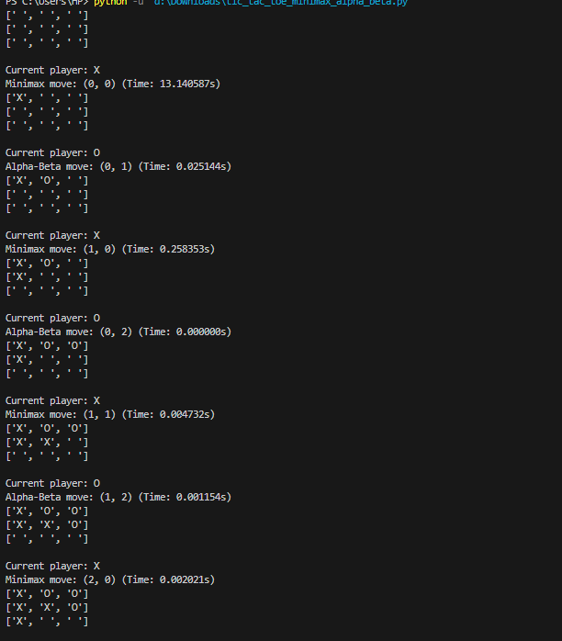

Sample Output Analysis:
- The game starts with an empty board, and each player (X and O) takes turns making optimal moves.
- The Minimax algorithm is used by player X, while Alpha-Beta Pruning is used by player O.
- The time taken for each move is logged, showing that Alpha-Beta Pruning significantly reduces computation time compared to the standard Minimax.

Initial Board
[' ', ' ', ' ']
[' ', ' ', ' ']
[' ', ' ', ' ']
The board is empty. Player X starts first (standard rule). The board is a 3x3 grid initialized with spaces (' ') representing empty cells.

Turn 1 — Player X (Minimax)
- Chosen Move: (0, 0)
- Time Taken: ~13 seconds (initial Minimax move is slow because it explores the full game tree)
Updated Board:
css
CopyEdit
['X', ' ', ' ']
[' ', ' ', ' ']
[' ', ' ', ' ']
Explanation:
Minimax computes all possible outcomes and picks the best move assuming perfect play from the opponent. It places X in the top-left corner.

Turn 2 — Player O (Alpha-Beta)
- Chosen Move: (0, 1)
- Time Taken: ~0.02 seconds (Alpha-Beta Pruning is much faster)
Updated Board:
['X', 'O', ' ']
[' ', ' ', ' ']
[' ', ' ', ' ']
Explanation:
Alpha-Beta Pruning skips unnecessary branches, reducing the search space. It places O next to X, possibly to block later or set up future threats.

Turn 3 — Player X (Minimax)
- Chosen Move: (1, 0)
- Time Taken: ~0.25 seconds
Updated Board:
['X', 'O', ' ']
['X', ' ', ' ']
[' ', ' ', ' ']
Explanation:
X builds a potential vertical win on the first column.

Turn 4 — Player O (Alpha-Beta)
- Chosen Move: (0, 2)
- Time Taken: ~0.000 seconds
Updated Board:
['X', 'O', 'O']
['X', ' ', ' ']
[' ', ' ', ' ']
Explanation:
O finishes the top row. This move also prevents X from forming a horizontal win.

Turn 5 — Player X (Minimax)
- Chosen Move: (1, 1)
- Time Taken: ~0.004 seconds
Updated Board:
['X', 'O', 'O']
['X', 'X', ' ']
[' ', ' ', ' ']
Explanation:
Minimax selects the center, which is often a strategic position, and continues building pressure.

Turn 6 — Player O (Alpha-Beta)
- Chosen Move: (1, 2)
- Time Taken: ~0.001 seconds
Updated Board:
['X', 'O', 'O']
['X', 'X', 'O']
[' ', ' ', ' ']
Explanation:
Alpha-Beta places O in the last open spot on the second row. It doesn't prevent X’s upcoming win though.

Turn 7 — Player X (Minimax)
- Chosen Move: (2, 0)
- Time Taken: ~0.002 seconds
Updated Board:
['X', 'O', 'O']
['X', 'X', 'O']
['X', ' ', ' ']
Explanation:
X completes a vertical line in the first column (0th index), winning the game.

Game Result
Game Over.
Winner: X
Explanation:
Player X (Minimax) wins by forming a vertical line:
['X', 'O', 'O']
['X', 'X', 'O']
['X', ' ', ' ']
Column 0 → X-X-X

Summary
• Minimax vs Alpha-Beta Pruning: Alpha-Beta Pruning optimizes the search process, reducing the number of nodes evaluated in the game tree. This is evident from the reduced time for the Alpha-Beta player (O) compared to the standard Minimax player (X).
• Optimal Play: Both AI players (X and O) make optimal moves, ensuring that the game is played perfectly.
• Efficiency: The addition of Alpha-Beta Pruning speeds up the decision-making process, especially as the complexity of the game increases.

Aspect | Player X (Minimax) | Player O (Alpha-Beta Pruning)
Strategy | Exhaustive Search | Optimized Search (cutoff branches)
First Move Time | ~13–16 seconds | ~0.02–0.05 seconds
Later Moves | ~milliseconds | ~milliseconds
Final Result | Win | Loss
Winning Path | Vertical in column 0 | —

GITHUB LINK: https://github.com/khanyasra/TIC-TAC-TOE_AI

