 | PT. Salam Pacific Indonesia Lines | No. Dokumen | : | FM-SPIL-CS-02-04
 | PT. Salam Pacific Indonesia Lines | Tanggal | : | 27 Juni 2023
 | PT. Salam Pacific Indonesia Lines | Revisi | : | 03
 | PT. Salam Pacific Indonesia Lines | Halaman | : | 1 dari 1
PT. SALAM PACIFIC INDONESIA LINES

DISCHARGE INVOICE
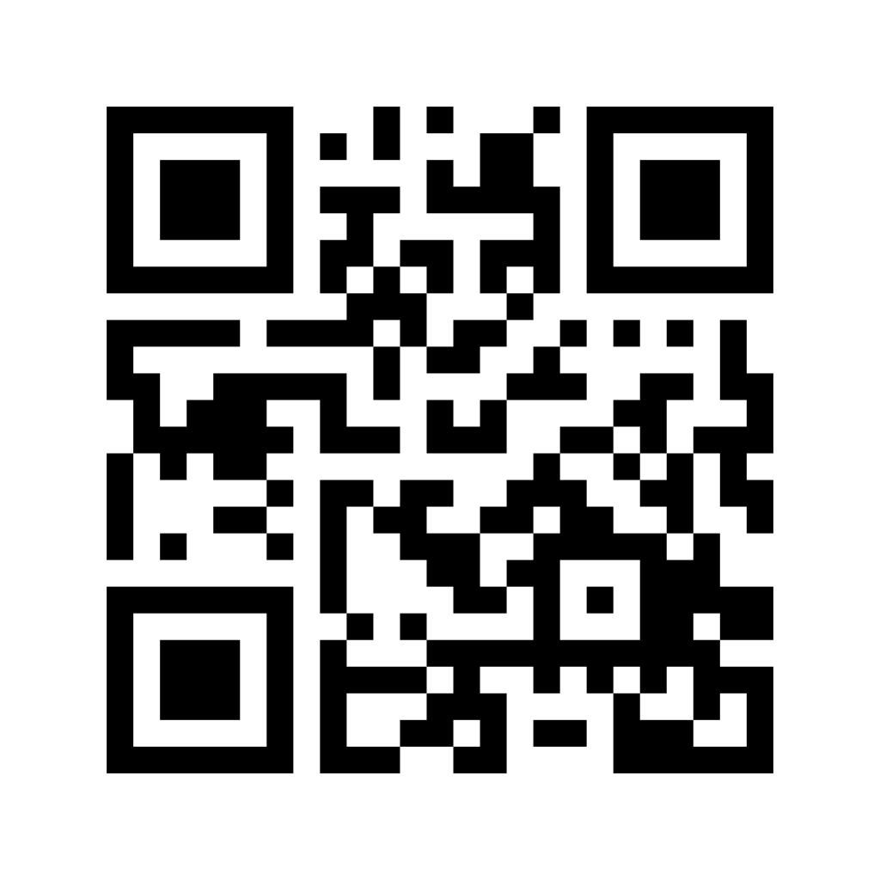
No. NF/2201060117/SBY

Disch. Invoice Date : DD/MM/YY
BL No. : 1721152112VIII (TFU45/BAU-SBY/21) - TELUK FLAMINGO
POD : SURABAYA
DO No. : 1721152112VIII
Payer Name : BUTON MANDIRI PERDANA, PT
Due Date : DD/MM/YY

QTY DAYS REMARKS CHARGES RESTITUTION SUBTOTAL
(IDR) (IDR) (IDR)
_____________________________________________________________________________________________________________________________________

1 - EOR/00001111/01/2022 (SPNU2689943) 175.000 0 175.000

