 | PT. Salam Pacific Indonesia Lines | No. Dokumen | : | FM-SPIL-ISD-02-01
 | PT. Salam Pacific Indonesia Lines | Tanggal | : | 27 Juni 2023
 | PT. Salam Pacific Indonesia Lines | Revisi | : | 01
 | PT. Salam Pacific Indonesia Lines | Halaman | : | 1 dari 2
FORM CUSTOMER RELATION MANAGEMENT (CRM)
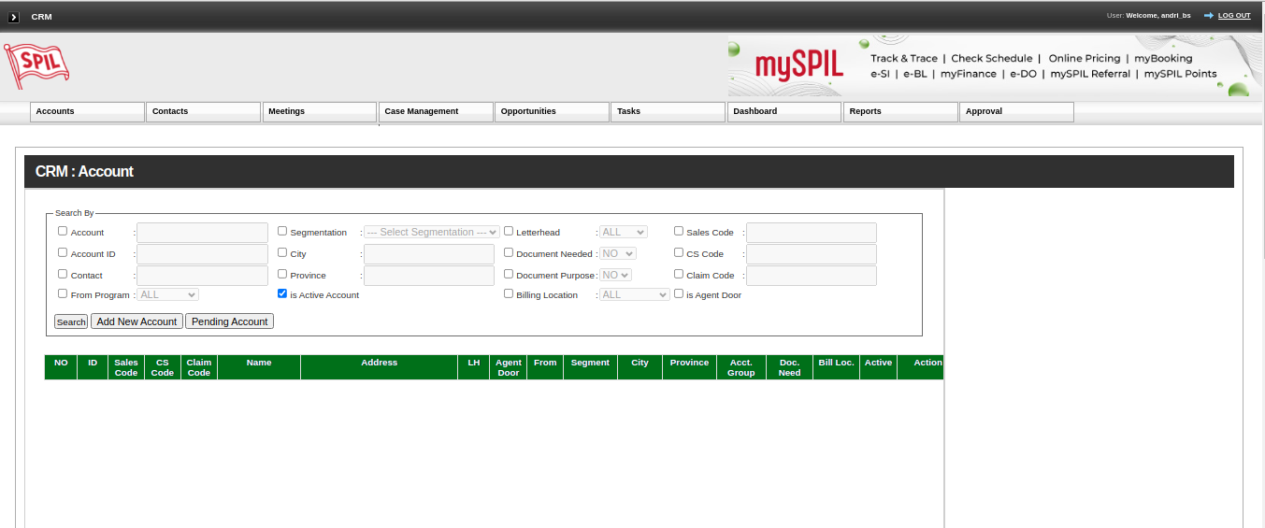

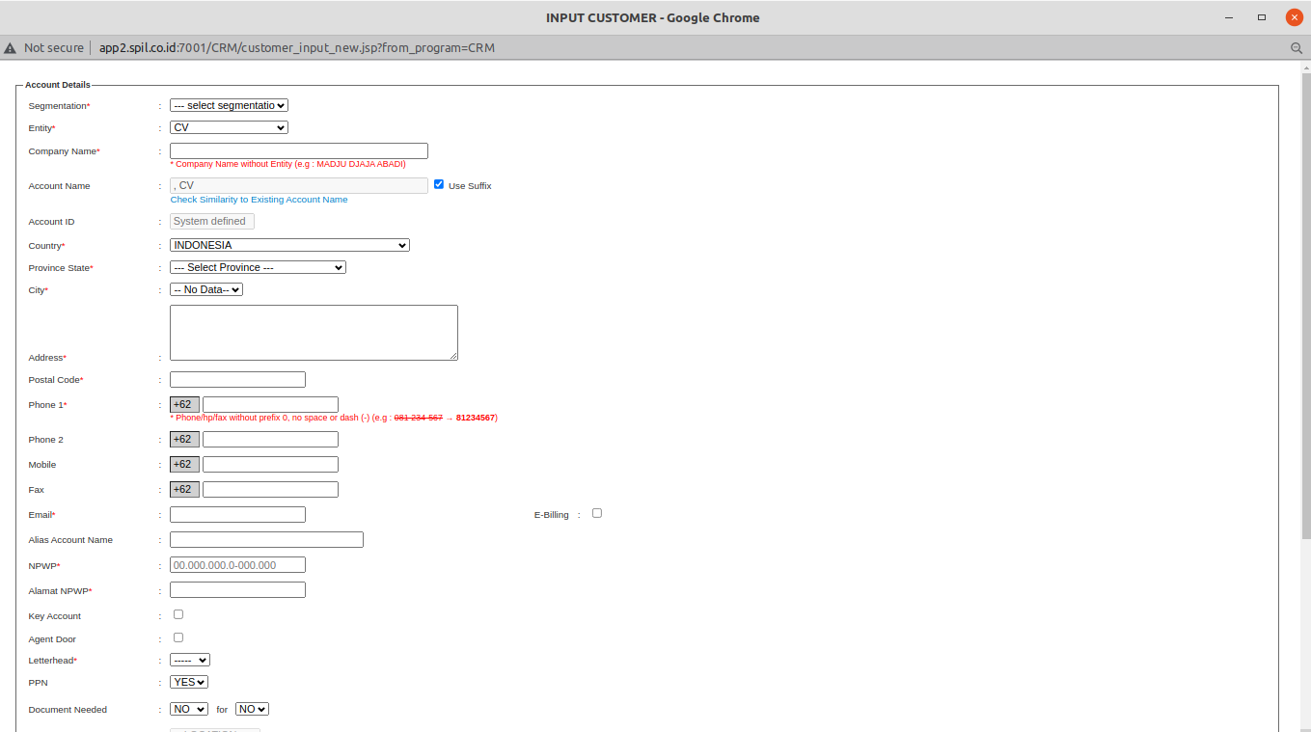

 | PT. Salam Pacific Indonesia Lines | No. Dokumen | : | FM-SPIL-ISD-02-01
 | PT. Salam Pacific Indonesia Lines | Tanggal | : | 27 Juni 2023
 | PT. Salam Pacific Indonesia Lines | Revisi | : | 00
 | PT. Salam Pacific Indonesia Lines | Halaman | : | 2 dari 2
FORM ANTRIAN TTT
