 | PT. SALAM PACIFIC INDONESIA LINES | No. Dokumen | : | FM-SPIL-PBM-01-06
 | PT. SALAM PACIFIC INDONESIA LINES | Tanggal | : | 27 Juni 2023
 | PT. SALAM PACIFIC INDONESIA LINES | Revisi | : | 02
 | PT. SALAM PACIFIC INDONESIA LINES | Halaman | : | 1 dari 2

FORM MAINTENANCE SURVEY
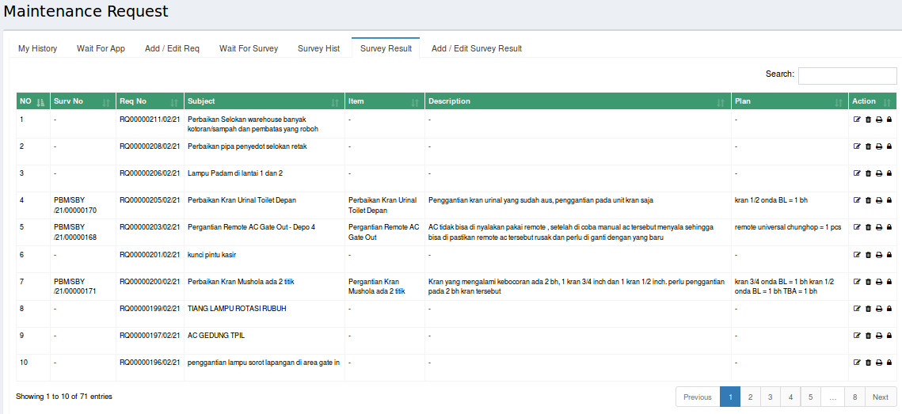

 | PT. SALAM PACIFIC INDONESIA LINES | No. Dokumen | : | FM-SPIL-PBM-01-06
 | PT. SALAM PACIFIC INDONESIA LINES | Tanggal | : | 27 Juni 2023
 | PT. SALAM PACIFIC INDONESIA LINES | Revisi | : | 02
 | PT. SALAM PACIFIC INDONESIA LINES | Halaman | : | 2 dari 2

BERITA ACARA
