 | PT. Salam Pacific Indonesia Lines | No. Dokumen | : | FM-SPIL-TA-01-04
 | PT. Salam Pacific Indonesia Lines | Tanggal | : | 27 Juni 2023
 | PT. Salam Pacific Indonesia Lines | Revisi | : | 01
 | PT. Salam Pacific Indonesia Lines | Halaman | : | 1 dari 4

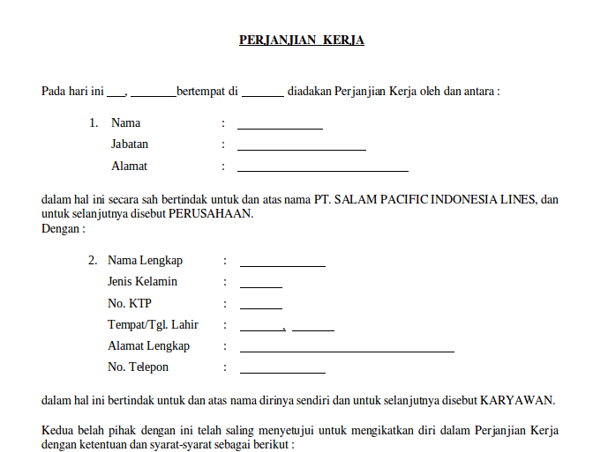
FORM PKWTT
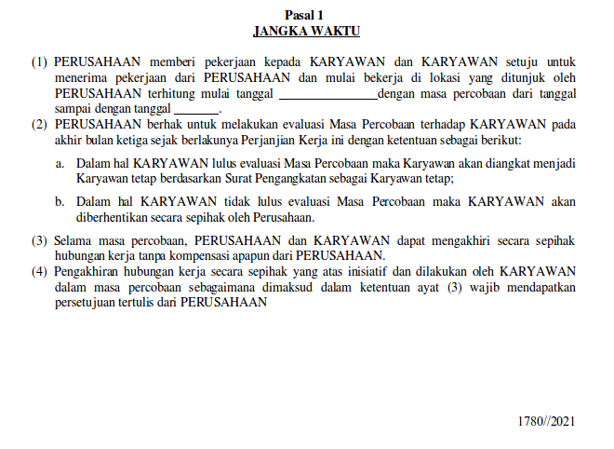
 | PT. Salam Pacific Indonesia Lines | No. Dokumen | : | FM-SPIL-TA-01-04
 | PT. Salam Pacific Indonesia Lines | Tanggal | : | 27 Juni 2023
 | PT. Salam Pacific Indonesia Lines | Revisi | : | 01
 | PT. Salam Pacific Indonesia Lines | Halaman | : | 2 dari 4
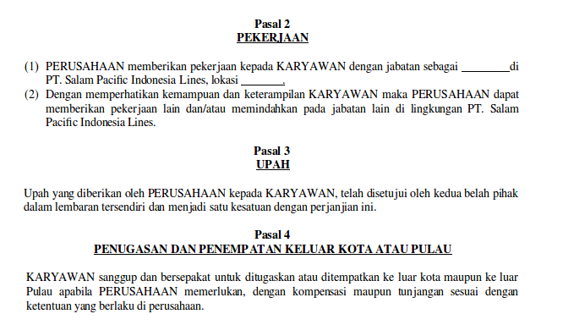
FORM PKWTT
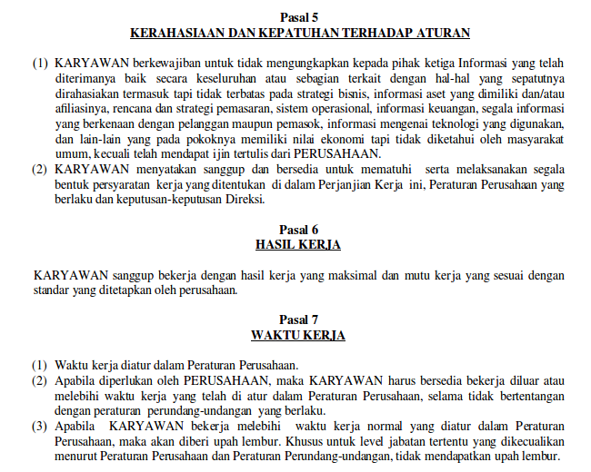
 | PT. Salam Pacific Indonesia Lines | No. Dokumen | : | FM-SPIL-TA-01-04
 | PT. Salam Pacific Indonesia Lines | Tanggal | : | 27 Juni 2023
 | PT. Salam Pacific Indonesia Lines | Revisi | : | 01
 | PT. Salam Pacific Indonesia Lines | Halaman | : | 3 dari 4
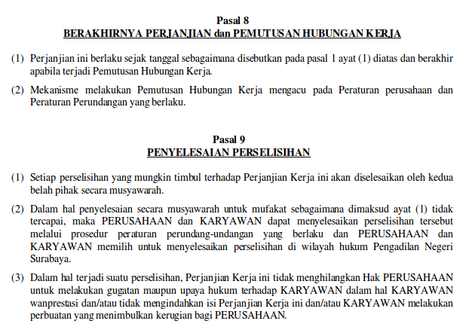
FORM PKWTT

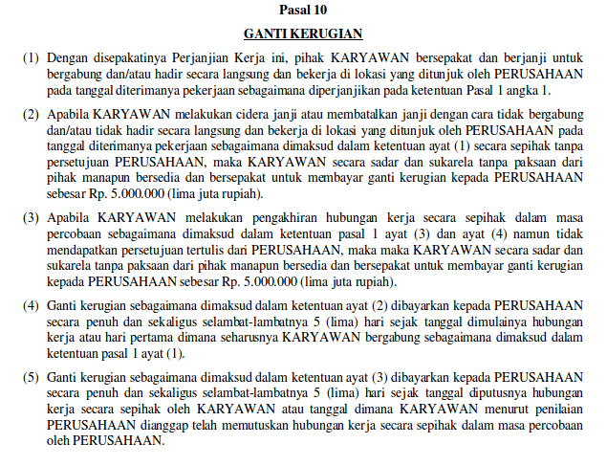

 | PT. Salam Pacific Indonesia Lines | No. Dokumen | : | FM-SPIL-TA-01-04
 | PT. Salam Pacific Indonesia Lines | Tanggal | : | 27 Juni 2023
 | PT. Salam Pacific Indonesia Lines | Revisi | : | 01
 | PT. Salam Pacific Indonesia Lines | Halaman | : | 4 dari 4

FORM PKWTT

