Numerical Electromagnetic Analysis of a PCB-Stator Coreless Axial-Flux Permanent-Magnet Motor
EEE4022S Final-Year Project AK-07 — Part C: Ansys Maxwell Modelling of the Rev0 and Rev1-S Motors
Olwethu Khanzi — Supervisor: Prof A. Khan — Department of Electrical Engineering, University of Cape Town
19 October 2026

Abstract
This report describes the numerical analysis (Part C) of a coreless axial-flux permanent-magnet (AFPM) motor whose stator is a stack of five six-layer printed circuit boards (PCBs). Two builds were analysed. Rev0 has one stator and one rotor of 16 N35 magnets on a steel backplate. Rev1-S stacks two such stators and two rotors (S1–R1–S2–R2).
The PCB copper was rebuilt in Ansys Maxwell 3D from the manufacturing files, and five models were developed, each checked against the next:
- a detailed single-board magnetostatic model;
- a board-by-board sum;
- a field-only “field map” of the trace paths;
- a full-motor detailed solve on the UCT high-performance computing (HPC) cluster;
- a rotating field-only transient;
- a calibrated equivalent-coil model.
Rev0. The full-motor solve gives a torque constant K = 18.53 mN·m/A, defined by T = 1.5·K·Î, which is 27.8 mN·m per ampere of peak phase current. The board-by-board sum agrees within 0.03 % and the field map reads 5 % high. At 1000 rpm the line back-EMF is 2.38 V rms with 0.7 % THD. Torque ripple is 1.26 % under sinusoidal drive, and cogging is below solver noise.
Rev1-S. K = 39.50 mN·m/A (59.2 mN·m/A peak with the stators in series) and the line back-EMF is 5.07 V rms at 1000 rpm.
Predicted operating points. Copper loss dominates, and track eddy loss is only 20–44 mW at 1000 rpm. The measured winding resistance is 1.87–1.90 Ω per stator phase. Combined with a candidate thermal test point of 0.84 A peak per stator, the predicted electromagnetic torque at the 1000 rpm target test speed is 23 mN·m (Rev0) and 50 mN·m (Rev1-S series). Continuous ratings will be set by bench testing.
The main remaining uncertainty is the difference between the modelled and as-built geometry (backplate, air gaps and stack spacing). We recommend re-modelling the motor once the hardware has been measured.

1 Introduction

1.1 Background
Axial-flux permanent-magnet machines achieve high torque density in a short axial length. Removing the stator iron (a coreless or ironless stator) eliminates cogging torque and core loss, at the cost of a larger effective air gap and a weaker field [4], [5]. Printed-circuit-board windings take this idea further. The winding is etched into copper layers, so it is thin, repeatable and cheap to manufacture, and many boards can be stacked to raise the torque constant [3], [6], [7].
The price is a winding with low copper fill. It also sits directly in the alternating magnet field, so eddy and circulating currents in the tracks must be checked [1], [2].

1.2 Related work
Coreless AFPM machines with conventional wound coils have been studied for more than two decades. Lombard and Kamper analysed an ironless-stator AFPM machine and showed how its performance follows from the large magnetic gap [5]. Wang et al. combined finite-element analysis with analytical design equations to optimise a coreless-stator AFPM generator [4]. Parviainen et al. reviewed how AFPM machines can be modelled with reduced (quasi-three-dimensional) methods instead of full 3-D FEM, trading accuracy for speed [8]. These three works frame the main modelling choice in this project: how far a reduced model can be trusted before a full 3-D solve is needed.
PCB windings bring their own questions. Neethu et al. designed and tested a high-speed coreless AFPM motor with a PCB winding, at conference and journal level [6], [7]. Han et al. optimised wave-winding PCB stators and verified them experimentally [3]. Chulaee et al. showed that eddy currents in the tracks and circulating currents between parallel paths can be a significant loss in PCB stators [1]. In later work they designed the track layout to minimise both [2].
The present work follows these studies in using 3-D FEM of the real copper. It adds three things that the cited works do not report for a stacked multi-board PCB stator:
- a board-by-board validation of the stack against a complete full-motor solve;
- a calibrated equivalent-coil model;
- a rotating field-only model.

1.3 Project and scope of Part C
Project AK-07 designs, analyses and prototypes a small PCB motor. The PCB stator geometry was taken from an open-source design and manufactured. Part C is the numerical electromagnetic analysis: predicting the torque constant, back-EMF, torque quality, field levels, losses and safe operating limits of the machine before it is tested. The objectives were:
- To build a faithful 3-D finite-element (FEM) model of the actual PCB copper, not an idealised winding.
- To find the torque constant and back-EMF of Rev0 and Rev1-S, with an estimate of their accuracy.
- To determine back-EMF harmonics, torque ripple, cogging, flux density in the air gap and steel, and losses.
- To turn these into predicted operating points and a test plan for first power-up.
A third build, Rev1-D (double-sided middle rotor), was modelled early on but was dropped on 16 October when the hardware plan changed. It is mentioned only where it informed the method.
This report follows the work in the order it was done. Table 1 gives the timeline.
Table 1. Timeline of the Part C work (2026).
Date | Work | Outcome
4–5 Oct | PCB copper rebuilt in Maxwell; single-board gates (resistance, inductance, FR-4 as air) | Detailed board model validated
5–6 Oct | Rotor plus one board: smoke test and full electrical-period sweep | k(θ), periodicity and antisymmetry confirmed
6–7 Oct | Five-board stator build with solder-bridge junctions; air-gap and backplate study; three-phase superposition check | Geometry fixed: 1.0 mm gap, 2.0 mm backplate
7 Oct | Three full-motor attempts on the 16 GB lab PCs | All failed (memory): reduced methods adopted
8 Oct | Icepak thermal models (Rev0, Rev1-S, Rev1-D) and MATLAB system model | Thermal limits and drive behaviour
9–12 Oct | Board-by-board FEM with 20 mm padding; field maps; harmonics; losses | Complete board-by-board result set
11–14 Oct | Single-file HPC runner; Rev0 full-motor solve (2 angles, 110 GB each) | K = 18.534 mN·m/A; board-by-board method confirmed
14–16 Oct | Rotating field-only and equivalent-coil models built; Rev1-D dropped | Provisional test specification
17–19 Oct | HPC rotating runs (Rev0, Rev1-S) and equivalent-coil calibration; resistance and stack thickness measured | Final results and predicted operating points
The rest of the report is organised as follows. Section 2 describes the machine. Section 3 covers the modelling methods and how each was validated. Section 4 presents the results, Section 5 the predicted operating points, and Section 6 the accuracy and limitations. Section 7 concludes.

2 The machine
Each stator is a stack of five identical 12-sided, six-layer PCBs (1 oz copper, 0.5 mm tracks), each about 93 mm across flats. The winding is a three-phase wave winding with the phases on layer pairs (A on L1+L6, B on L2+L5, C on L3+L4). Each board carries 205 vias per phase. The five boards of a stator are connected in series per phase, and the three phase strings are connected in star.
Each rotor has 16 N35 magnets (20 × 6 × 2 mm, axially magnetised, alternating) at a 28 mm mean radius on a 2 mm mild-steel (1010) backplate. With 8 pole pairs, 1000 rpm corresponds to 133.3 Hz electrical. Table 2 summarises the modelled geometry, and Fig. 1 shows it to scale.
Table 2. Modelled geometry (as of 19 October 2026).
Item | Rev0 | Rev1-S
Arrangement | S1–R1 | S1–R1–S2–R2
Boards per stator / layers | 5 / 6 | 5 / 6
Board pitch in stack | 1.020 mm (boards touch mask to mask) | 1.020 mm
Air gap, board 1 to magnet face | 1.0 mm | 1.0 mm (S2 to R2 magnets; S2 to R1 steel assumed 1.0 mm)
Magnets | 16 × N35, 20 × 6 × 2 mm, r = 28 mm | 2 × 16
Backplate | 1010 steel, 2.0 mm, 86 mm OD / 19 mm bore | Same, × 2
Phase connection | 5 boards in series, star | Stators in series (or parallel) per phase, star
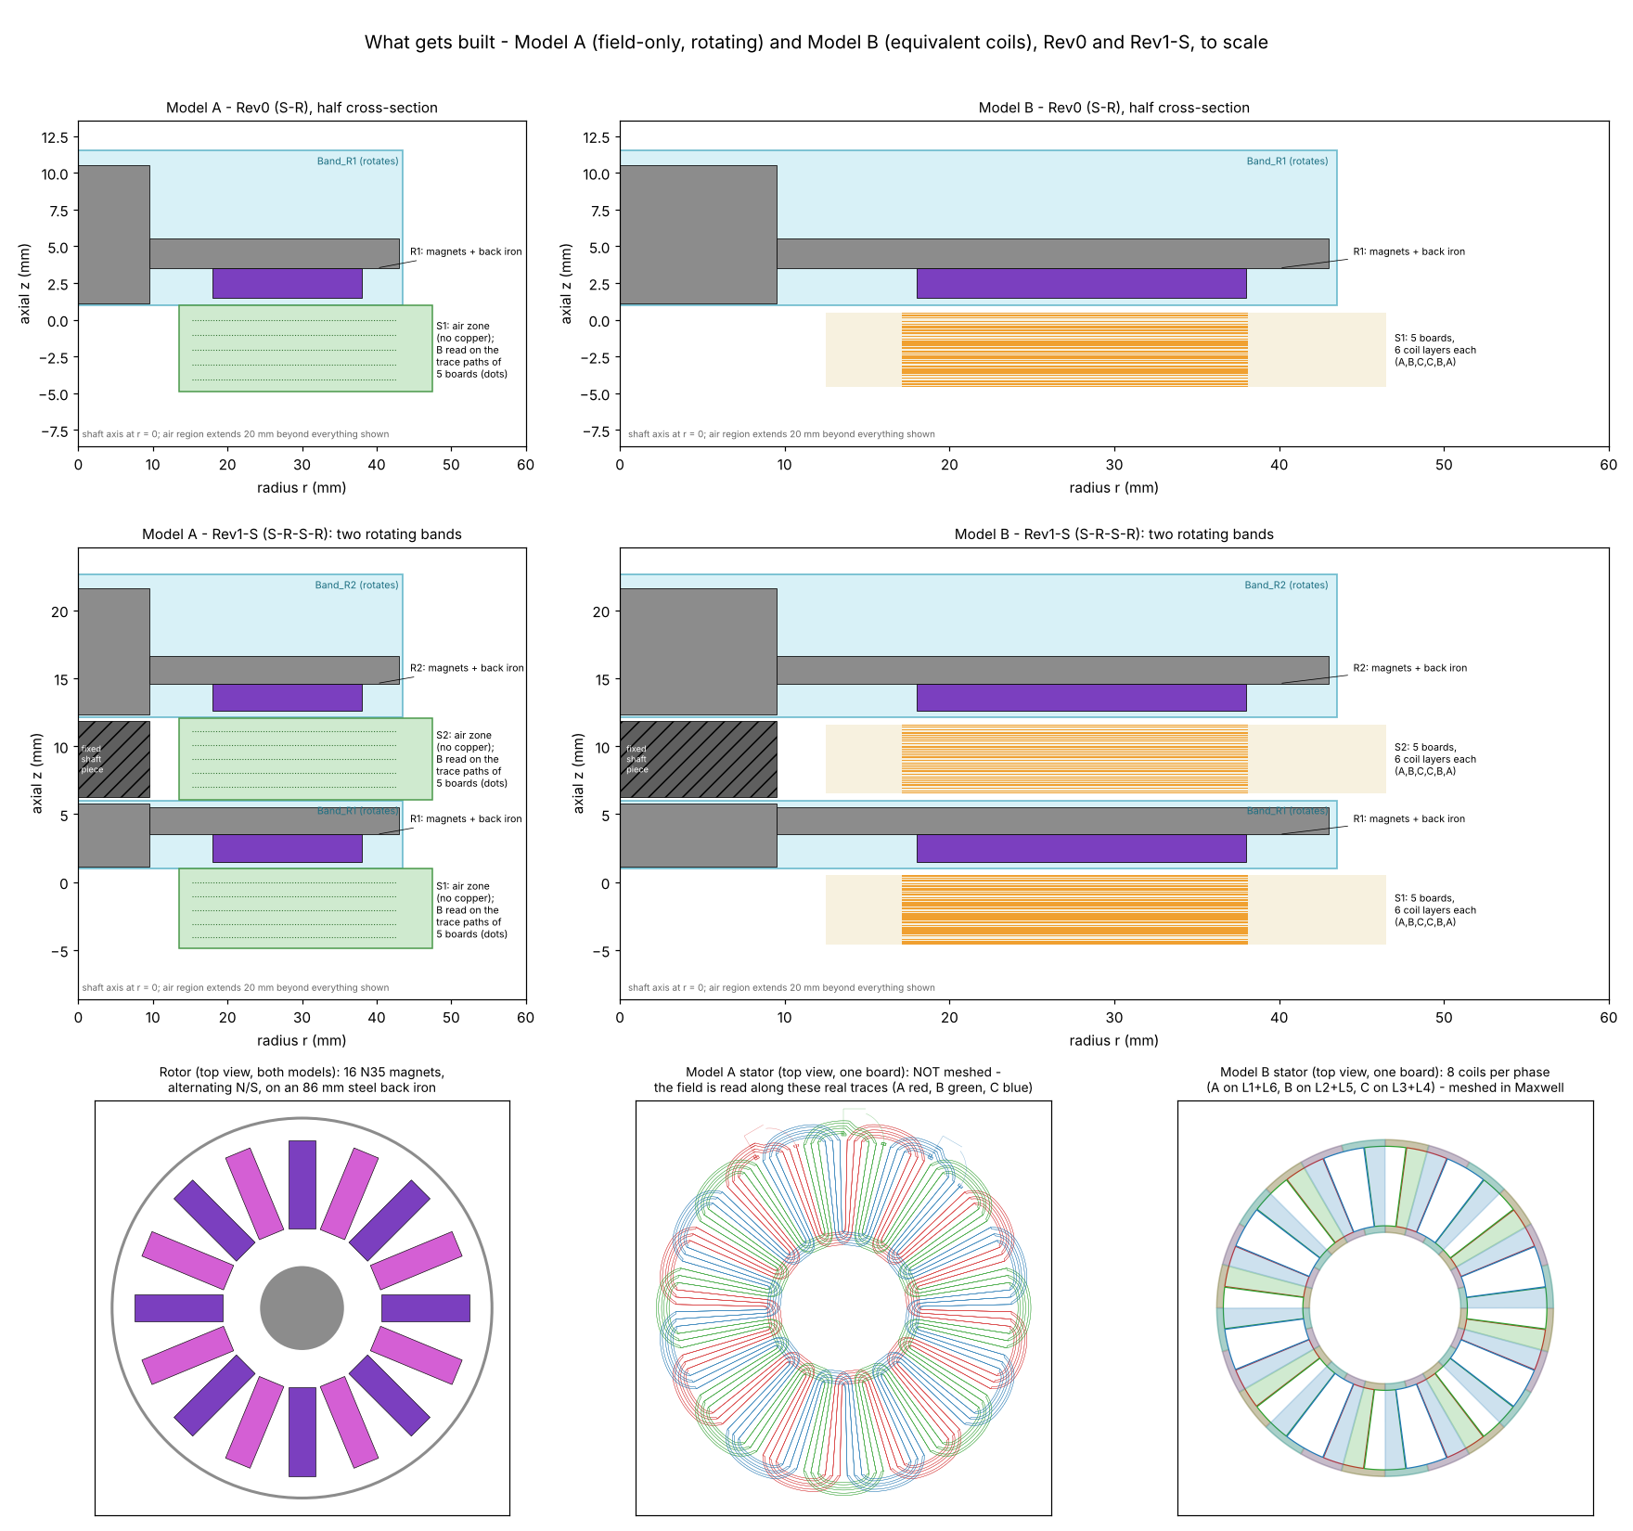
Fig. 1. Rotating field-only model (A) and equivalent-coil model (B) of Rev0 and Rev1-S, half cross-sections to scale, with the rotor, the real trace paths of one board, and the equivalent sector coils (top views).
The 1.0 mm air gap and 2.0 mm backplate were chosen from the design-of-experiments study in Section 3.3. The hardware differs in two known respects: the built backplate is 80 mm OD with a 25 mm bore, and the as-assembled air gaps and stack spacing have not yet been measured. Their effect is estimated in Section 6.

3 Modelling method and its validation

3.1 Definitions and solver
All models were built by Python scripts in Ansys Electronics Desktop 2025 R2 (Maxwell 3D). The PCB copper was rebuilt from the Gerber/ODB++ source package, layer by layer, including every via and the inter-board solder bridges.
Because the stator is coreless, the copper torque is linear in current. Each phase X therefore has a torque function k_{X}(θ) (N·m/A, equal to dλ_{X}/dθ in Wb/rad), and the machine torque and back-EMF are
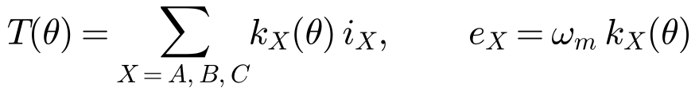
The torque constant K is the amplitude of the fundamental of k_{X}. With balanced sinusoidal currents of peak Î in phase with the back-EMF, the mean torque is T = 1.5·K·Î, and the phase back-EMF peak is K·ω_{m}. Torque was taken from the Lorentz force on the copper and checked against the rotor virtual-work torque. The two agreed within 0.05–0.5 % wherever both were available.

3.2 Single-board gates (4–6 October)
The detailed model was first validated one board at a time on 16 GB laboratory PCs. Table 3 lists these checks.
Table 3. Validation gates on one detailed board.
Gate | Check | Result
DC conduction, each phase | Resistance from the ohmic-loss integral | A/B/C = 0.2778 / 0.2774 / 0.2779 Ω (0.19 % spread; +2.9 % against the design value)
Stationary T-Ω transient | Flux linkage against induced voltage | L ≈ 2.07 µH by both routes (within 1 %)
Three phases together | No cross-phase current; energy | R within 0.5 % of the single-phase values
FR-4 and solder mask set to air | Change in R and magnetic energy | ≤ 0.22 %
Rotor + board, ±1 A | Copper against rotor torque | Within 0.05 %; ±I antisymmetry 0.002 %
0–45° sweep (one electrical period) | Periodicity and half-wave antisymmetry | 0.02 % and 0.05 %
Three-phase superposition | Phases B and C against A | K within 0.31 %, phase within 0.4°, mean torque within 0.11 %
Treating the non-magnetic, non-conducting FR-4 as air removed most of the mesh with no measurable effect. This follows the practice of modelling only the copper of PCB coils [3].
Two further findings shaped everything that followed:
- Transient solves were impractical on the lab PCs. A detailed T-Ω step took about 25 minutes per phase, and the PC froze twice when the solver reached the inductance-matrix stage. Torque and back-EMF were therefore obtained from magnetostatic solves at a set of rotor positions.
- Region padding mattered. Increasing the air-region padding from 5 mm to 20 mm raised board 1’s K by 3.1 % (6.09 to 6.28 mN·m/A). All later results use 20 mm.

3.3 Geometry study and decision (7 October)
The air gap and backplate thickness were varied on the single-board model (Table 4). The per-board torque constant decays exponentially with distance from the magnet face, with k = 0.303 /mm (fit residual ≤ 0.17 %). This is close to the fundamental spatial decay π/τ = 0.286 /mm expected for the pole pitch τ, consistent with the spatial-harmonic field models used for AFPM machines [8].
Table 4. Single-board design-of-experiments results (20 mm padding unless noted).
Variable | Value | K per board (mN·m/A) | Comment
Distance from magnet face | 0.5 mm | 7.11 | +17 % against 1.0 mm (5 mm padding basis)
 | 1.0 mm | 6.09 → 6.28 | 5 mm → 20 mm padding
 | 5.0 mm | 1.82 | Board-5 position
Backplate thickness | 2.0 → 5.0 mm | +0.1 % | 2 mm is already on the plateau
A 1.0 mm gap and a 2.0 mm backplate were fixed on 7 October. A smaller gap raises K, but 1.0 mm leaves clearance for board bow, run-out and bearing play. A thicker plate adds about 130 g for no gain.

3.4 Board-by-board method and the field map (7–12 October)
Three attempts to mesh the complete five-board Rev0 motor on the 16 GB lab PCs failed during meshing or the first adaptive pass. Two reduced methods were therefore used.
Board-by-board FEM. Each board was solved alone with its real copper at its actual axial position in the motor environment. The per-board phasors were then summed: K = |Σ K_{k} exp(jψ_{k})|. Because the stator is non-magnetic, this superposition is exact apart from the slight non-linearity of the steel. A 2 A run changed k by only 0.002 %, which confirms the linearity. The board phase angles agreed to 0.17°.
Field map. Only the magnets and steel are meshed. B is sampled on 180 775 points along the centre-lines of every track of every board, and the Lorentz force on a 1 A line current is integrated. This is fast and models the whole motor, but it treats each 0.5 mm × 35 µm track as a filament.
Fig. 2 compares the two methods. They agree at the board nearest the magnets (+1.4 %). The field map reads progressively higher further away, up to +10 % at board 5.
Several causes were ruled out:
- Boundary: both methods used 20 mm padding.
- Mesh: refinement changed either model by ≤ 0.1 %.
- Shaft stub geometry: changing it altered the result by ≤ 0.02 %.
The difference is therefore attributed to the method itself (centre-line filament against volume force). For the whole machine the field map is a consistent +5 % upper bound.
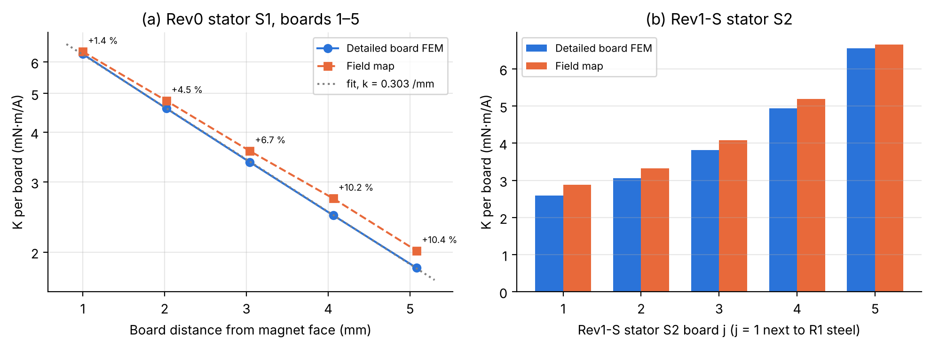
Fig. 2. Torque constant per board. (a) Rev0 stator: detailed FEM against field map, with the exponential decay fit. (b) Rev1-S stator S2, which sits between R2’s magnets (board 5) and R1’s bare steel (board 1).

3.5 Full-motor and rotating models on the UCT HPC (11–19 October)
To settle the 5 % gap between the two methods, the complete detailed motor was solved on the UCT HPC cluster under SLURM.
Full-motor detailed static solve (Rev0). All 5 boards and the rotor were solved with three-phase synchronous currents at two rotor angles. Each angle took about 17.5 h on 40 cores and about 110 GB of memory. The Rev1-S solve ran for 47 h, but it was stopped by the 50 GB scratch-disk quota before it completed an angle. Rev1-S therefore has no full-motor detailed result.
Two lighter models were then built (Fig. 1):
- Model A, rotating field-only transient. The magnets and steel turn at 1000 rpm in a rotating band through one electrical period in 24 steps. B is exported on all track points at every step, giving k_{X}(θ), back-EMF harmonics, the loaded torque waveform, cogging, steel flux density and eddy-loss inputs in a single run. Rev1-S needed two independent rotating bands and 32 cores, because of its 122 GB peak memory. This is a rotating version of the field-map method, so it was checked against the static field map at every angle.
- Model B, equivalent-coil model. Each phase on each board is replaced by 8 stranded sector coils. This model meshes in minutes rather than hours. Coils based on geometric turns over-predict K by 24 %, so the model was calibrated per board against the detailed FEM (Rev0: turns factor 0.809, board spread 7.1 %). It was then applied unchanged to Rev1-S as an independent check.
This kind of reduced or quasi-3-D model is standard for AFPM machines [8]. The calibration step is needed here because the PCB end-turns and the parallel tracks are far from the idealised coil sides.

3.6 Computational problems and their resolution
Table 5 lists the problems that affected the results and how each was resolved. All scripts were first exercised against a mock AEDT harness, so most remaining failures were resource limits rather than logic errors.
Table 5. Main computational issues.
Issue | Cause | Resolution
Lab-PC freezes and full-motor failures | Meshing 45 detailed solids on 16 GB | Board-by-board method; full motor moved to the HPC
Equivalent-coil mesh failure | Slivers between adjacent phases’ coil slabs (0.26° overlap) | Coil sides trimmed by 0.8°; 0.08 mm slabs
Rotating field maps all NaN | Point file in mm read as metres | Export probe accepts only finite results; post-processing re-run
Jobs killed at 45 GB | Shared 50 GB scratch quota | Clean-up; 24 steps per period instead of 48; one large job at a time
Out of memory, Rev1-S rotating | About 7.6 GB per core | 32 cores (122 GB peak)
Rev1-S equivalent-coil project corrupted (7 of 8 angles solved) | Disk quota during a save | 8th angle filled from half-wave antisymmetry T(θ+22.5°) = −T(θ), which matched to 0.08 mN·m on the solved pairs; calibration done offline

4 Results

4.1 Torque constant
Fig. 3 and Table 6 compare all methods. For Rev0, the full-motor detailed solve (copper Lorentz torque 18.534 mN·m/A; rotor virtual work 18.470) and the board-by-board sum (18.540) agree within 0.4 %. This validates the board-by-board method. The rotating model reproduces the static field map within 1.49 % over every angle and phase.
For Rev1-S, the board-by-board sum gives 39.50 mN·m/A: S1 18.54 plus S2 20.96. The equivalent-coil model with Rev0’s calibration gives 39.30 (−0.5 %), and the rotating model agrees with its static field map within 1.59 %.
Stator S2 contributes 13 % more than S1, even though it faces only one set of magnets. Its far side sits 1 mm from R1’s steel backplate, which raises the field through S2 (S2’s face toward R1’s steel sees 0.108 T).
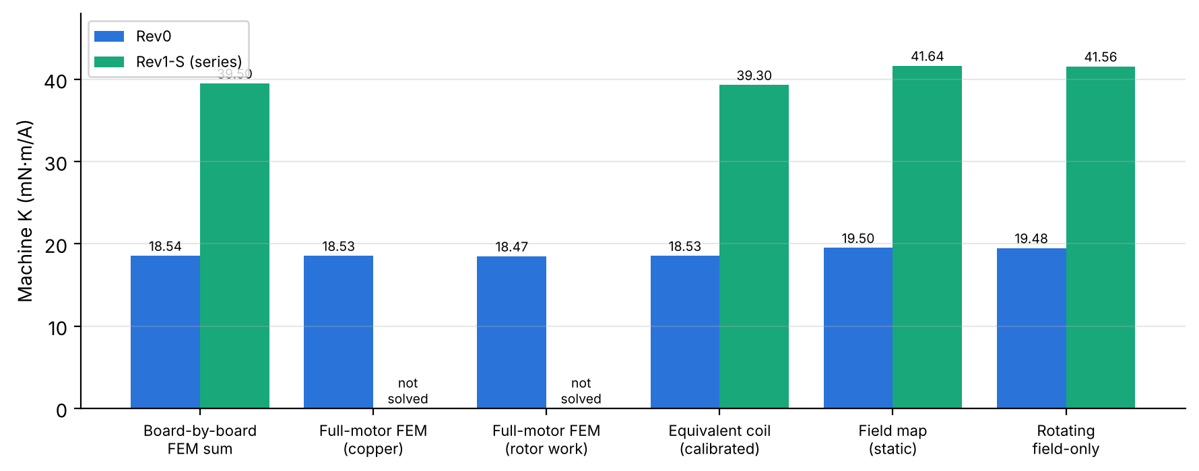
Fig. 3. Machine torque constant by method. The board-by-board sum and the full-motor FEM agree for Rev0; the field-only methods read about 5 % high, consistent with Fig. 2.
Table 6. Headline electromagnetic results (modelled geometry; K from the full-motor FEM for Rev0 and the board-by-board FEM for Rev1-S).
Quantity | Rev0 | Rev1-S (series)
K (mN·m/A) | 18.53 | 39.50
Torque per A peak / per A rms | 27.8 / 39.3 mN·m | 59.2 / 83.8 mN·m
Back-EMF at 1000 rpm, phase / line | 1.372 / 2.377 V rms | 2.925 / 5.066 V rms
Back-EMF THD, phase / line | 5.5 % / 0.7 % | 5.2 % / 0.6 %
Torque ripple, sinusoidal 1 A peak | 1.26 % pk-pk | 1.16 % pk-pk
Cogging (no-load rotor torque) | 0.61 mN·m pk-pk, not periodic (noise) | 0.78 mN·m pk-pk
Max |Bz| 0.25 mm from stator face | 0.448 T | 0.438 T (S1), 0.439 T (S2)
Backplate peak |B|, mid-thickness | 0.907 T | 0.835 T (R1), 0.931 T (R2)
Track eddy loss, 1000 rpm | 20.4 mW | 44.2 mW

4.2 Back-EMF and harmonics
Figs. 4 and 5 show the back-EMF from the rotating model. The phase waveform has a 5.5 % third harmonic (H5 0.67 %, H7 0.05 %). The magnet field on board 1 itself has B3/B1 = 0.20, so the wave winding’s distribution filters most of it.
The third harmonic is zero-sequence, so it cancels in the line voltage, which is almost sinusoidal (0.7 % THD). Only the board nearest each magnet face carries measurable 5th and 7th content, because higher spatial harmonics decay faster with distance. The same decay is what keeps the coreless winding’s EMF close to sinusoidal.
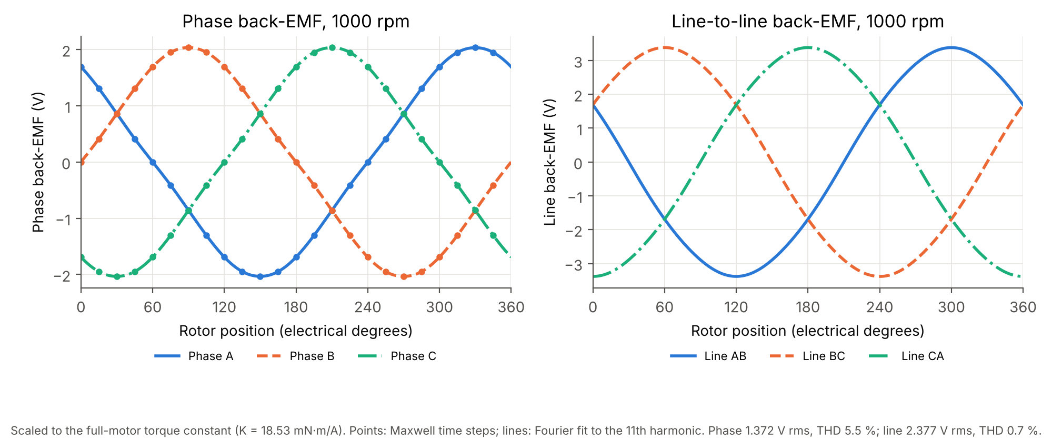
Fig. 4. Rev0 phase and line back-EMF at 1000 rpm from the rotating model (24 steps, Fourier fit to the 11th harmonic), scaled to the full-motor K.
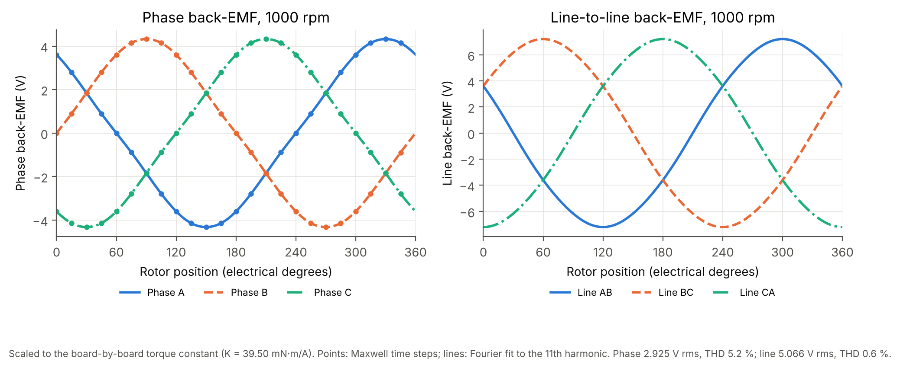
Fig. 5. Rev1-S back-EMF at 1000 rpm with the stators in series, scaled to the board-by-board K. Both stators are in phase (simulated phase difference 0.0°).

4.3 Torque ripple and cogging
With ideal sinusoidal currents the reconstructed torque has a sixth-harmonic ripple of 1.26 % pk-pk for Rev0 (Fig. 6). As a check, 2·(H5 − H7) of the back-EMF predicts 1.23 %.
The no-load rotor torque wanders within about 0.6 mN·m, with no periodicity linked to the magnet pitch. It is therefore solver noise, and the true cogging of the coreless stator is below the resolution of the model, as expected because there is no stator iron [4], [5]. The six-step (trapezoidal) drive studied in the MATLAB model gives 14.8 % ripple, so sinusoidal (FOC or SVPWM) drive is recommended.
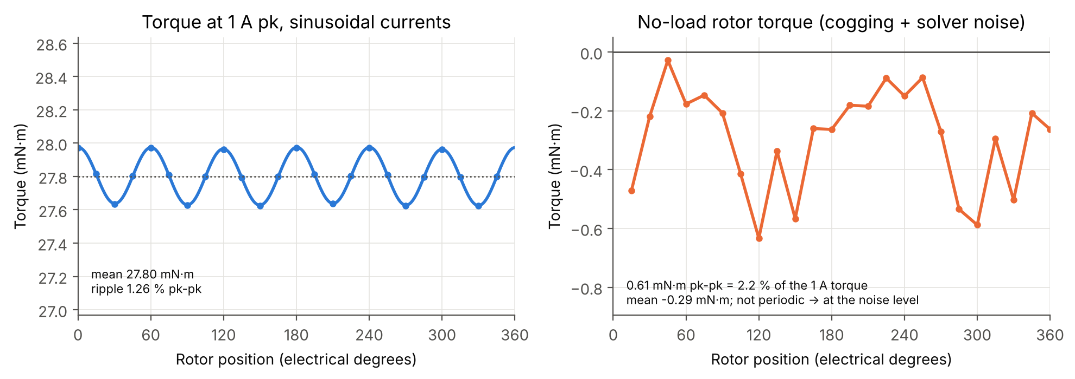
Fig. 6. Rev0 torque at 1 A peak with sinusoidal currents (left) and no-load rotor torque (right).
Rev1-S behaves the same way (Fig. 6b): 59.25 mN·m mean at 1 A peak with 1.16 % ripple. The no-load torque, summed over both rotors, stays within 0.78 mN·m pk-pk and is again not periodic.
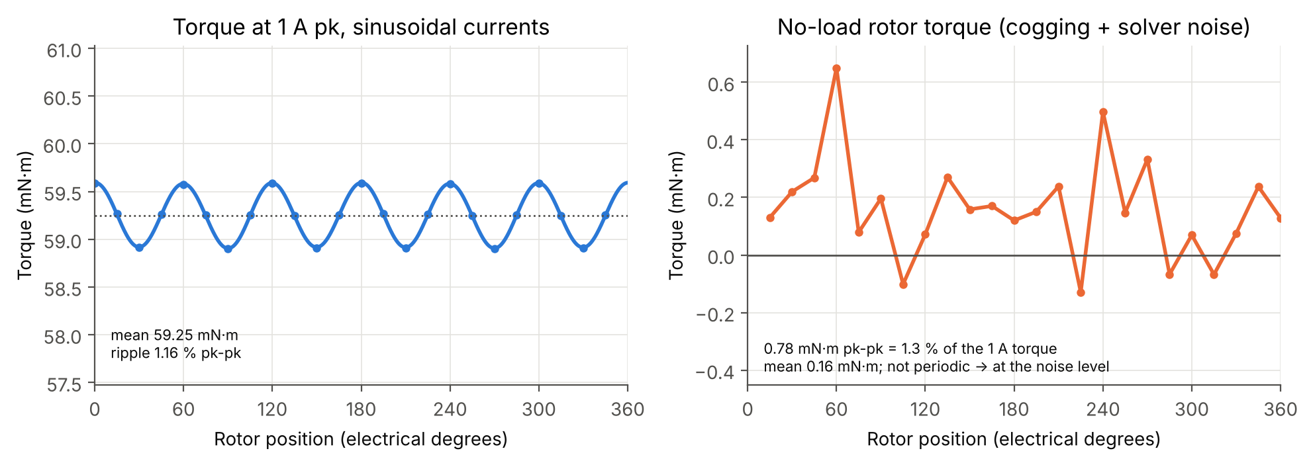
Fig. 6b. Rev1-S torque at 1 A peak with the stators in series (left) and no-load torque summed over both rotors (right).

4.4 Flux density
Figs. 7 and 8 show B_{z} just off the stator face and |B| in the backplates. The air-gap field over the magnets reaches about 0.45 T in both builds.
The backplate peaks at 0.91 T at mid-thickness (0.93 T in Rev1-S’s R2), and no point exceeds 1.6 T. The static single-board model showed local surface peaks of about 1.4 T at the magnet edges. The 2 mm plate is therefore well used but not saturated, which agrees with the backplate study in Table 4.
The field decays through each stator at 0.30 /mm, so 26 % is lost per board pitch. This is why the board nearest the magnets supplies 34 % of Rev0’s torque and the furthest only 10 % (Fig. 2).
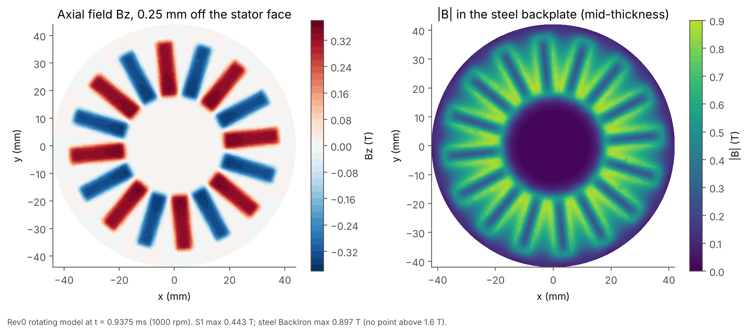
Fig. 7. Rev0 field: Bz 0.25 mm off the stator face and |B| at backplate mid-thickness, from the rotating model at 1000 rpm.
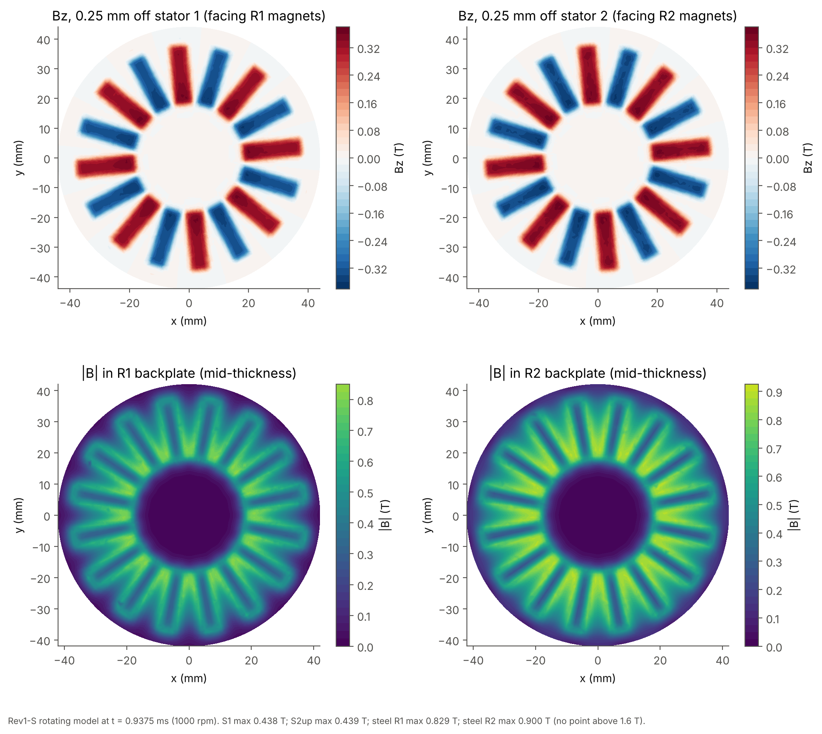
Fig. 8. Rev1-S field: both stator faces and both backplates. R2, whose magnets face only S2, carries slightly more flux than R1.

4.5 Current density and losses
The DC current distribution was taken from the nodal solution of each board (Fig. 9). The median current density is 9.2–9.4 A/mm² per ampere in every layer, with local maxima of 57 A/mm² per ampere at track necks near vias. At the rated 0.84 A peak (0.59 A rms), the bulk density is about 5.5 A/mm² rms, which is moderate for a PCB track with no forced cooling.
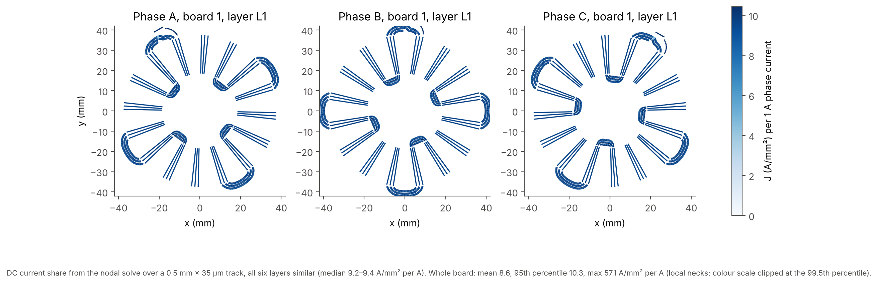
Fig. 9. Current density per 1 A on layer L1 of board 1 for each phase, from the solved track currents.
Copper loss. Copper loss is P_{Cu} = 3·I_{rms}²·R_{φ}. The model gives 0.2777 Ω per board phase, or 1.39 Ω per stator. The assembled stators measured 1.87–1.90 Ω on every phase of both S1 and S2. The difference of about 0.5 Ω is in the inter-board joints, the leads and contact resistance, which the model does not include. All ratings use the measured value, 1.89 Ω, corrected to winding temperature with α = 0.00393 /K.
Eddy loss. The skin depth at 133 Hz is 5.7 mm, 164 times the copper thickness, so R_{ac} ≈ R_{dc}. The eddy loss in the tracks was computed with the thin-strip formula, using the field harmonics on every track from the rotating model:
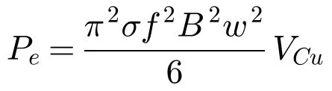
where σ is the copper conductivity, B the peak normal field of harmonic n at frequency f = n·f₁, w the track width (0.5 mm) and V_{Cu} the track volume. Summed over n = 1, 3 and 5, the result is 20.4 mW for Rev0 and 44.2 mW for Rev1-S at 1000 rpm. This scales with speed squared, so it is 0.3–0.7 W at 4000 rpm, and it is about 1 % of the copper loss at the rated point.
Circulating currents between parallel paths, which can dominate in some PCB stators [1], [2], are not captured by this field-only estimate. The measured phase resistances agree to within 1.6 %, which suggests that no large loop asymmetry exists, but a no-load spin-down test is the proper check.

4.6 Thermal behaviour (Icepak)
A steady-state Icepak model of the assumed housing was solved with the rotor still: an acrylic tube in the bench hood, 30 °C air and 1 m/s fan flow. The losses were iterated with R(T). Table 7 lists the main cases.
Table 7. Icepak steady state, rotor still, fans on (loss from the modelled resistance).
Case | Loss | Hottest board | Magnets | Stack-to-air R_{th}
Rev0, 1 A peak | 2.32 W | 50.3 °C | 42.7 °C | 8.6 K/W
Rev0, 2 A peak | 11.6 W | 124.9 °C | 89.2 °C | 8.0 K/W
Rev1-S, 1 A peak | 4.84 W | 65.7 °C (S1) | 52.5 °C (R1) | —
Rev1-S, 2 A peak | 28.9 W | 220 °C (S1) | 150 °C (R1) | —
In Rev1-S, S1 runs 2–15 K hotter than S2, and the middle rotor R1 is the hottest rotor, so its magnets set the limit (N35: 80 °C). These runs used the modelled resistance. The measured resistance is 36 % higher, so the real copper loss at a given current is higher still.
The operating points in Section 5 therefore assume a pessimistic 15 K/W and a 60 °C board limit, which gives a candidate test point of 0.84 A peak per stator. Neither value is measured, so this does not establish that the real winding stays below 60 °C; the continuous rating must come from a heat run. With the Icepak value (8.75 K/W) the limit would be 1.09 A peak at 60 °C, or 1.51 A peak at 100 °C.

4.7 Efficiency and drive requirements
Fig. 10 shows the electromagnetic efficiency, counting copper and track-eddy loss only, at 60 °C with the measured resistance. Because the machine is copper-loss-limited, the efficiency is highest at light load and high speed. At 1000 rpm and the rated current, Rev0 reaches about 51 % and Rev1-S about 53 %. Doubling the stator count roughly doubles the torque per ampere but also doubles the resistance, so the motor constant rises by only about 1.5× (K_{m} = 0.0193 against 0.0290 N·m/√W in the model): √2 from the second stator, plus the benefit of S2’s adjacent steel.
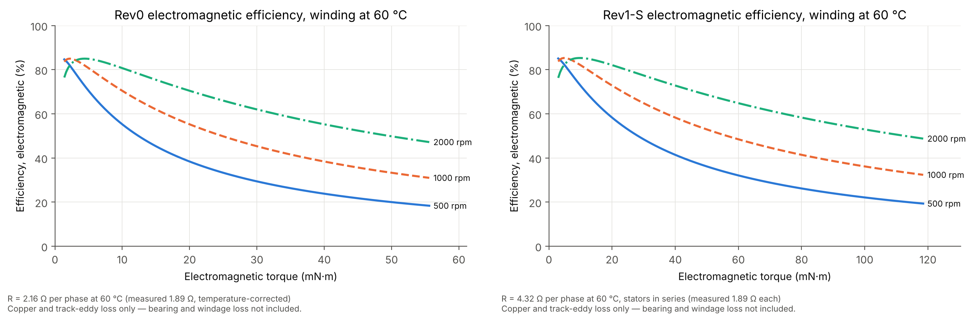
Fig. 10. Electromagnetic efficiency at 60 °C with the measured resistance: Rev0 (left, R = 2.16 Ω) and Rev1-S in series (right, R = 4.32 Ω). Bearing and windage losses are not included.
Inductance. The single-board inductance from Maxwell is about 2 µH (Table 3). The two-board junction test gave a mutual inductance of about 1.0 µH between adjacent boards. A current-weighted Neumann sum over the solved track currents gives the same ratio between boards, but its absolute self-term is about 4 times higher. This is attributed to its filament approximation for closely spaced tracks.
Scaling the Neumann stack sum to the Maxwell single-board value gives about 25 µH per stator. This replaces the 110 µH figure quoted in the 16 October provisional specification. The winding reactance at 133 Hz is therefore negligible (below 0.03 Ω). However, the inductance is far too small to filter PWM ripple, which is about V_{dc}/(6·L·f_{sw}): roughly 1.6 A pk-pk on 12 V at 50 kHz for Rev0. This estimate is uncertain by about ±50 %. It has to be checked against the inverter that is actually available:
- Measure the phase inductance with an LCR meter.
- Measure the phase-current ripple at low current.
- If the ripple exceeds about 20 % of the test current, raise the switching frequency or add 0.5–1 mH series inductance per phase. This would cut the ripple to below 0.1 A.

4.8 System-level (MATLAB) model
The Maxwell results were passed to a MATLAB/Simulink system model of the motor and a 12 V inverter with a 2 A peak current limit and a 20 mN·m load. The model uses the per-phase back-EMF harmonics and was run once with the detailed K and once with the field-map K, which brackets the ±5 % method band. Table 8 summarises the results.
Table 8. MATLAB model at 12 V, model resistance (detailed K / field-map K).
Quantity | Rev0 | Rev1-S (series)
No-load speed | 3568 / 3393 rpm | 1675 / 1589 rpm
Speed at 20 mN·m | 3054 / 2928 rpm | 1448 / 1385 rpm
Copper-limited efficiency at 20 mN·m, 1000 rpm | 66.0 / 68.3 % | 81.5 / 83.1 %
Acceleration 0 → 1000 rpm | 0.21 s | 0.20 s
Torque ripple, sinusoidal / six-step drive | 0.9 % / 14.8 % | similar
These runs used the modelled resistance (1.39 Ω per stator), so they overstate speed and efficiency compared with the measured 1.89 Ω. Section 5 supersedes them for the operating points. They remain useful for comparing designs and drive strategies: on a 12 V bus, Rev1-S in series runs out of voltage at about half Rev0’s speed, which is why the parallel connection or a 24 V bus is offered in Table 9.

5 Predicted operating points
Table 9 gives the predicted operating points for planning the bench tests, in star connection at the 1000 rpm target test speed. They are derived from:
- the simulated K and back-EMF;
- the measured resistance;
- the predicted track-eddy drag (0.19 mN·m for Rev0, 0.42 mN·m for Rev1-S);
- an assumed 2–5 mN·m of mechanical loss;
- the candidate thermal test point of Section 4.6.
They are not continuous ratings. Those will come from testing.
The required voltage is E + I·R with the current on the q-axis. The winding reactance is negligible.
Table 9. Predicted operating points, star connection, 1000 rpm (133.3 Hz), at most 0.84 A peak in any stator.
Quantity | Rev0 (12 V) | Rev1-S series (24 V) | Rev1-S parallel (12 V)
Line current | 0.84 A pk (0.59 A rms) | 0.84 A pk | 1.54 A pk (S1 0.84, S2 0.70)
Electromagnetic torque | 23.4 mN·m | 49.8 mN·m | 45.5 mN·m
Estimated shaft torque (eddy drag and assumed 2–5 mN·m removed) | 18.2–21.2 mN·m | 44.3–47.3 mN·m | 40.0–43.0 mN·m
Shaft power | 1.9–2.2 W | 4.6–5.0 W | 4.2–4.5 W
Line back-EMF | 2.38 V rms | 5.07 V rms | 2.53 V rms
DC bus needed (SVPWM, m = 0.95) | 6.4–7.4 V | 13.2–15.3 V | 6.4–7.3 V
Copper loss (25–60 °C) | 2.0–2.4 W | 3.9–4.7 W | 3.3–4.0 W
EM efficiency | about 51 % | about 53 % | about 54 %
Connection. The simulations impose balanced currents (i_{A} + i_{B} + i_{C} = 0), so they correspond directly to star connection, which is how the motors will be tested. Both ends of every winding are brought out, so delta connection remains possible. In delta, however, the 5.5 % third-harmonic EMF would drive a circulating current of about 40 mA rms at 1000 rpm. Delta is therefore not covered here.
Rev1-S parallel connection. S1 and S2 have different torque constants (18.54 and 20.96 mN·m/A), so their back-EMFs are in phase but differ by about 13 %. In parallel, this difference drives a circulating current of about 0.06–0.07 A peak at 1000 rpm, about 25 mW of extra loss. Under load it unbalances the current sharing: at 1.68 A peak terminal current, S1 would carry 0.91 A peak and S2 0.77 A peak.
The parallel column is therefore limited to 1.54 A peak, which keeps S1 at 0.84 A peak. Terminal current alone cannot show either stator’s current, so each stator’s current must be measured if parallel is used. Series connection on 24 V avoids the issue.
Speed. The voltage-limited speeds that the inverter could reach at this current (for example, about 2300 rpm for Rev0 on 12 V) are not ratings. The rotor assembly has not been qualified above the 1000 rpm target test speed.

6 Accuracy, limitations and the as-built motor
Table 10 summarises the main sources of error. The numerical uncertainty is small. The Rev0 full-motor torque calculations and the board-by-board sum agree within 0.4 %, and the static and rotating models agree within 1.6 %. The 5 % filament-method bias is understood and is not used for any headline number.
The dominant uncertainty is the mismatch between the model and the hardware. The predicted operating points should be read with this in mind.
Table 10. Uncertainty budget for K and back-EMF.
Source | Effect | Status
FEM method (detailed against full motor) | ±0.4 % | Closed for Rev0
Rev1-S without a full-motor solve | ±1 % (board-by-board and equivalent-coil agree within 0.5 %) | Accepted
Field-only methods | +5 % bias | Not used for headline values
Air gap | about −7 % per extra 0.25 mm | Gap not yet measured
Stack spacing | Up to −9 % had the stack reached 6 mm | Measured 5.1 mm maximum, matching the modelled 5.10 mm
Backplate 80/25 mm built against 86/19 mm modelled | Small (the plate is not saturated; the magnets lie at r 18–38 mm) | To be re-modelled
S2-to-R1 clearance (Rev1-S) | Assumed 1 mm; affects S2 by several % | Not yet measured
Resistance (joints, temperature) | ±3 % at a known temperature | Measured
Thermal resistance | 8.6–15 K/W | Housing not modelled as built
Other limitations are as follows:
- The rotating model is field-only, so the loaded torque waveform is reconstructed with ideal sinusoidal currents, and armature reaction in the steel is neglected. This is justified because the armature field of the coreless winding is a few millitesla.
- Bearing, windage and inverter losses are excluded from efficiency.
- Circulating-current loss between parallel tracks is not modelled [1].
- Model resistance excludes the joints.
The PCB layout itself could also be refined using published guidance on reducing eddy and circulating losses in PCB windings [1], [2], and on alternative coil patterns [3], [6], [7].
As-built recommendation. The backplate outer diameter and bore had to change for the hardware, and the air gaps depend on assembly. The measured motor will therefore deviate from these predictions by an amount that cannot be fixed in advance. The most accurate route is:
- Assemble the hardware.
- Measure the air gaps, S2-to-R1 clearance, backplate and magnet positions. The stack thickness has already been measured (5.1 mm).
- Rebuild the model to match.
- Re-run the board-by-board FEM and the calibrated equivalent-coil model. The scripts are parameterised, so this needs a few days of lab-PC and HPC time rather than new development.
The open-circuit line back-EMF measured at a known speed is the single best check. If it is more than a few percent below 2.38 V rms (Rev0) or 5.07 V rms (Rev1-S series) at 1000 rpm, the air gap is larger than modelled; the stack spacing is already confirmed.

6.1 Recommended first tests
The tests below check the predictions in order of increasing risk:
- Measure each stator’s phase resistance at a recorded room temperature, and the assembled air gaps. Measure the phase inductance with an LCR meter at 1–10 kHz, to check the value of about 25 µH.
- Spin each motor externally at a known speed and record the open-circuit line back-EMF. The expected values at 1000 rpm are 2.38 V rms (Rev0), 5.07 V rms (Rev1-S series) and 2.53 V rms (Rev1-S parallel). For Rev1-S, also record S1 and S2 separately (about 2.38 and 2.69 V rms line). This confirms that they are in phase and quantifies their difference before any parallel connection. Record the waveform: the line voltage should show less than 1 % THD and the phase-to-star-point voltage about 5 % third harmonic.
- Power Rev0 at 0.2–0.3 A peak and 300–500 rpm, and measure the phase-current ripple. Then step up towards 0.84 A peak at 1000 rpm while logging thermocouples on boards 1 and 5. Continue as a heat run until temperatures settle; this measures the thermal resistance and sets the continuous rating. The mean winding temperature follows from the resistance rise: ΔT = (R/R₀ − 1)/0.00393.
- Measure the no-load drag torque. A powered no-load input-power measurement cannot isolate it, because it also contains inverter, copper and eddy losses. Instead use one of these:
  - the no-load q-axis current, with T_{drag} = 1.5·K·I_{q} and K taken from step 2;
  - a spin-down test, with T_{drag} = −J·dω/dt;
  - an external drive through a torque sensor.
- Subtract the predicted eddy drag to obtain the mechanical part. Then measure torque against current to obtain K directly.
- Repeat for Rev1-S in series. Use parallel only with each stator’s current measured.
A measured K within about 5 % of 18.5 mN·m/A (Rev0), after correcting for the measured air gap, would validate the model chain. A larger difference would point first to the geometry and then to the method.

7 Conclusions
Part C is complete for the modelled geometry.
- A validated model chain. A detailed 3-D Maxwell model of the real PCB copper was validated step by step: resistance, inductance, torque from two independent force calculations, three-phase superposition and periodicity. It was then scaled to the full motor through a board-by-board method that a 110 GB full-motor HPC solve confirmed to within 0.4 %.
- Rev0 performance. Rev0 produces 27.8 mN·m per A peak with a nearly sinusoidal line back-EMF of 2.38 V rms at 1000 rpm, 1.3 % torque ripple and negligible cogging. Rev1-S doubles this to 59.2 mN·m per A peak (series) by adding a second stator that benefits from the adjacent steel.
- Losses and limits. The machines are copper-loss-limited: track eddy loss is about 1 % of copper loss at the rated point, and the steel is unsaturated. The continuous current is set by temperature. With the measured resistance and conservative cooling assumptions, the candidate thermal test point is 0.84 A peak per stator. This predicts 23 mN·m (Rev0) and 50 mN·m (Rev1-S series) at the 1000 rpm target test speed. The continuous ratings will be established by testing.
- Drive checks. The winding inductance is estimated at only about 25 µH per stator, so PWM current ripple may be large. Measure the inductance and the ripple with the available inverter, and add series inductance or raise the switching frequency if needed.
- Parallel connection. In Rev1-S, S2’s back-EMF is 13 % higher than S1’s. Series connection is preferred; parallel needs per-stator current measurement and a reduced terminal current.
- Remaining uncertainty. The main uncertainty is the as-built geometry. The motor should be measured after assembly, re-modelled with the same scripts, and compared with the measured back-EMF.
All scripts, results and figures are archived in the project repository (branches rev0 and rev1s).

Acknowledgements
The full-motor, rotating and equivalent-coil computations were performed using facilities provided by the University of Cape Town’s ICTS High Performance Computing team (hpc.uct.ac.za). The PCB stator geometry is derived from the open-source magnetless_motor project (GPL-3.0). The modelling scripts and this report were prepared with the assistance of an AI tool (Claude, Anthropic); this is to be declared as required by UCT policy.

References
[1] Y. Chulaee, D. Lewis, A. Mohammadi, G. Heins, D. Patterson, and D. M. Ionel, “Circulating and eddy current losses in coreless axial flux PM machine stators with PCB windings,” IEEE Trans. Ind. Appl., vol. 59, no. 4, pp. 4010–4020, Jul. 2023, doi: 10.1109/TIA.2023.3267026.
[2] Y. Chulaee, G. Heins, B. Robinson, A. Mohammadi, M. Thiele, D. Patterson, and D. M. Ionel, “Design and optimization of high-efficiency coreless PCB stator axial flux PM machines with minimal eddy and circulating current losses,” IEEE Trans. Ind. Appl., vol. 60, no. 6, pp. 8722–8735, Nov. 2024, doi: 10.1109/TIA.2024.3447620.
[3] P. Han, D. Lawhorn, Y. Chulaee, D. Lewis, G. Heins, and D. M. Ionel, “Design optimization and experimental study of coreless axial-flux PM machines with wave winding PCB stators,” in Proc. IEEE Energy Convers. Congr. Expo. (ECCE), 2021, pp. 4347–4352, doi: 10.1109/ECCE47101.2021.9595963.
[4] R.-J. Wang, M. J. Kamper, K. Van der Westhuizen, and J. F. Gieras, “Optimal design of a coreless stator axial flux permanent-magnet generator,” IEEE Trans. Magn., vol. 41, no. 1, pp. 55–64, Jan. 2005, doi: 10.1109/TMAG.2004.840183.
[5] N. F. Lombard and M. J. Kamper, “Analysis and performance of an ironless stator axial flux PM machine,” IEEE Trans. Energy Convers., vol. 14, no. 4, pp. 1051–1056, Dec. 1999, doi: 10.1109/60.815027.
[6] S. Neethu, S. P. Nikam, A. K. Wankhede, S. Pal, and B. G. Fernandes, “High speed coreless axial flux permanent magnet motor with printed circuit board winding,” in Proc. IEEE Ind. Appl. Soc. Annu. Meeting, 2017, pp. 1–6, doi: 10.1109/IAS.2017.8101733.
[7] S. Neethu, S. P. Nikam, S. Singh, S. Pal, A. K. Wankhede, and B. G. Fernandes, “High-speed coreless axial-flux permanent-magnet motor with printed circuit board winding,” IEEE Trans. Ind. Appl., vol. 55, no. 2, pp. 1954–1962, Mar. 2019, doi: 10.1109/TIA.2018.2872155.
[8] A. Parviainen, M. Niemelä, and J. Pyrhönen, “Modeling of axial flux permanent-magnet machines,” IEEE Trans. Ind. Appl., vol. 40, no. 5, pp. 1333–1340, Sep. 2004, doi: 10.1109/TIA.2004.834086.

