Report-ready material for insertion into Chapters 3-5. Section, table, figure and equation numbers are local (3.x, 4.x, 5.x) and should be renumbered on insertion. Every value refers to the ORIGINAL simulated geometry (86 mm OD, 19 mm bore, 2 mm backplates, 1.0 mm air gaps). The constructed Rev0 prototype is a different geometry and is reported separately. Experimental testing is postponed; no value here is measured except the winding resistance.

Chapter 3 material: Methodology of the operating characterisation

3.x Scope and evidence labels
The operating characterisation establishes simulation-based operating specifications for the two machines in their original simulated form: Rev0 (one stator, one rotor, five series PCBs per phase) and Rev1-S (two stators and two rotors, ten series PCBs per phase). Both are 16-pole, star-connected and driven by a three-phase inverter. The programme re-uses every completed and validated calculation, adds only the electromagnetic checks still missing from the test matrix, and then derives current, speed and DC-bus voltage characteristics with a steady-state circuit model.
Each result carries one of the labels in Table 3.1. The labels keep three kinds of evidence apart: finite-element solutions, independent analytical predictions, and circuit-model extrapolations built on them. The electromagnetic power T_em·ω computed here is the power converted across the air gap. It is not a measured shaft output, because bearing, windage and inverter losses are neither modelled nor measured.
Table 3.1. Evidence labels used in Chapters 4 and 5.
Label | Meaning
FEM | Ansys Maxwell 3D solution (magnetostatic or transient) of the modelled geometry
FEM (calibrated) | Equivalent-coil Maxwell model whose turns were calibrated on the detailed FEM
ANALYTICAL | Independent model with no Maxwell input: charged-sheet magnets, image planes, 2D sheet currents in the real copper
THERMAL-FEM | Ansys Icepak steady solution (hypothetical housing; see Section 3.x.4)
THERMAL-LUMPED | Lumped thermal network
CIRCUIT | dq steady-state model fed by the quantities above
MEASURED | Bench measurement on the built stators (winding resistance only)
ASSUMED | Engineering assumption stated in the text

3.x.1 Provenance and re-use of completed results
Before any new calculation, the archived Maxwell, Icepak and HPC results were inventoried against the test matrix (Table 3.2). The inventory records the solver, run or SLURM job identifier, settings and key values for each source. Of the sixteen matrix rows, seven are complete from archived results (V1, V2, V3 and C1 for Rev0; V1, V3 and C1 for Rev1-S). Six are new post-processing completed here (E1, T1 and F1 for both machines). Three need targeted HPC runs, which were prepared: the Rev1-S ±I check (V2) and independent 500 and 2000 rpm rotating solves (S1, both machines).
Table 3.2. Principal sources re-used (UCT HPC SLURM job numbers where applicable).
Source | Machine | Label | Job / run | Key result
Full detailed static motor | Rev0 | FEM | 1470376 | K = 18.534 mN·m/A
Full detailed static motor | Rev1-S | FEM | 1486831 | Not completed (disk quota); not rerun
Detailed single boards, S1 and S2 environment | Both | FEM | lab PCs (P20 runs) | Rev0 18.54; Rev1-S 18.54 + 20.96 = 39.50 mN·m/A
Rotating field-only transient, 1000 rpm | Rev0 | FEM | 1500352 | E = 2.377 V rms line; THD 5.5 % phase; eddy 20.4 mW
Rotating field-only transient, 1000 rpm | Rev1-S | FEM | ID not recorded | E = 5.066 V rms line; S1/S2 in phase
Equivalent-coil current sweep 0-3 A | Rev0 / Rev1-S | FEM (calibrated) | 1504750 / 1504792 | K linear within 0.01 %; L−M 34-51 / 74-113 µH
Targeted ±I diagnostic, boards 1 and 5 | Rev0 | FEM | 1517777 / 1517602 | Copper vs rotor torque −0.07 / +0.43 %
Sheet-current analytical model | Both | ANALYTICAL | offline | K 18.539 / 39.55 mN·m/A
Icepak steady, fans on/off | Both | THERMAL-FEM | RUN1 (lab PC) | R_th per stator 8.2-8.9 / 13.2-16.1 K/W
Winding resistance | Both | MEASURED | bench, 20 Oct | 1.87-1.90 Ω per stator phase

The series connection and terminals of both machines were checked from the archived rotating solution. Every board of both stators has a phase-A back-EMF angle of −30.0 ± 0.2° electrical, the Rev1-S stators S1 and S2 differ by 0.02°, and phases A, B and C lie at −30°, +90° and −150° (120.0° steps, torque-constant spread ≤ 0.04 %). The series connection is therefore additive, and the simulated balanced currents (i_A + i_B + i_C = 0) correspond to the star connection.

3.x.2 Remaining electromagnetic checks
Only checks that close an open matrix row were prepared, with acceptance criteria fixed before the runs. (i) The ±I diagnostic is repeated in the Rev1-S stator-2 environment (R2 magnets on one side, R1's bare steel backplate on the other) at the board-1 and board-5 positions. (ii) The rotating field-only model is solved at 500 and 2000 rpm, using 24 steps per period with half-wave symmetry, to test the speed scaling of back-EMF, harmonics and track eddy loss independently. (iii) Optionally, the calibrated current sweep is extended to 0.25 and 0.75 A. Until these runs return, the 250-4000 rpm characteristics use exact speed scaling of the 1000 rpm solution and are labelled accordingly.

3.x.3 Steady-state circuit model
With field-oriented control and the current on the q-axis (i_d = 0), the phase quantities at mechanical speed ω_m and electrical speed ω_e = p·ω_m (p = 8 pole pairs) are
T_em = 1.5 · K · Î, e_ph,pk = K · ω_m (3.1)
V_q = R(T) · Î + K · ω_m, V_d = −ω_e · L · Î, |V| = √(V_q² + V_d²) ≤ m · V_dc / √3 (3.2)
Here K is the FEM torque coefficient (Table 4.1), R(T) = R_20[1 + 0.00393(T − 20)] is the measured phase resistance evaluated at the winding hotspot temperature, L is the simulated synchronous inductance, and m = 0.95 is the usable SVPWM modulation depth. V_dc is the DC-bus voltage, not the motor line voltage. Because the characteristic current ψ/L is about 45 A against an operating range below 3 A, field weakening is ineffective and i_d = 0 is the only useful strategy. The voltage limit uses the upper inductance value; the lower value is a sensitivity case. Powers and efficiency are defined as
P_em = T_em · ω_m, P_out,EM = P_em − P_eddy, P_in = P_em + 1.5 · Î² · R(T), η_EM = P_out,EM / P_in (3.3)
P_eddy is the track eddy loss from the rotating FEM at 1000 rpm, scaled with speed squared. η_EM excludes mechanical and inverter losses and is therefore an upper bound on the real efficiency. PWM current ripple is not included; its effect is estimated separately in Chapter 5.

3.x.4 Thermal model revision
The Icepak models represent each machine in a hypothetical acrylic housing inside a bench hood. Their boundary conditions are a 30 °C inlet, fans at 1 m/s or off, the rotor stationary and radiation neglected. The housing is not the as-built open frame. The archived solves applied the trace-model resistance (1.389 Ω per stator phase at 20 °C), which is 27 % below the measured 1.89 Ω. Rather than repeat the solves, the stator-to-air thermal resistance was extracted from them,
R_th = (T_hotspot − T_inlet) / P_stator (3.4)
and re-applied with the measured resistance. R_th falls slightly as the temperature rise increases (Rev0 8.93 to 8.20 K/W; Rev1-S 16.1 to 13.2 K/W per stator), so it is interpolated between the solved points in log(ΔT); the interpolation reproduces every solved point exactly. The winding current I satisfying T = 60 °C then follows from
T_amb + R_th(ΔT) · [1.5 · Î² · R(60 °C) / n_st + P_eddy,st] = 60 °C (3.5)
In Rev1-S the two series stators carry the same current, and their measured resistances agree within 1.6 %, so the copper heat is equal. S1, which sits between the stators, runs 2.9 K hotter than S2 in Icepak, so R_th is defined on the S1 hotspot with half the total heat. The limit is evaluated at 25 and 30 °C ambient under four stated cooling scenarios (Table 3.3). Lab-PC scripts that re-solve the limit points with the measured heat are provided as a confirmation step.
Table 3.3. Cooling scenarios (R_th per stator at the 60 °C limit, 25 °C ambient).
Scenario | Description | Label | Rev0 (K/W) | Rev1-S (K/W)
A | Icepak, hood fans on, rotor still, hypothetical housing | THERMAL-FEM | 8.56 | 14.76
B | As A with fans off (×1.11, lumped ratio; Icepak at 2 A gives ×1.05-1.07) | THERMAL-FEM + inferred | 9.51 | 16.39
C | Lumped network, rotor turning at 1000 rpm (optimistic; 1000 rpm only) | THERMAL-LUMPED | 5.07 | 8.74
D | Cautious planning basis for the unknown as-built cooling (×1.71 on A) | ASSUMED | 15.0 | 25.3

Chapter 4 material: Operating characterisation results

4.x.1 Motor constants
Table 4.1. Comparative constants, original 1 mm-gap geometry.
Quantity | Rev0 | Rev1-S (series) | Label
Torque coefficient K (T = 1.5·K·Î), mN·m/A | 18.534 | 39.50 | FEM
K, analytical sheet-current model | 18.539 | 39.55 | ANALYTICAL
K, equivalent-coil current sweep | 18.52 | 39.43 | FEM (calibrated)
Torque per ampere peak, mN·m/A | 27.80 | 59.25 | FEM
Line back-EMF, V rms per 1000 rpm | 2.377 | 5.066 | FEM
Back-EMF THD, phase / line, % | 5.5 / 0.7 | 5.2 / 0.6 | FEM
Phase resistance at 20 °C, Ω | 1.89 | 3.78 | MEASURED
Synchronous inductance L − M, µH | 33.5-51.2 | 74.4-112.6 | FEM (not measured)
Motor constant K_m at 25 °C, mN·m/√W | 16.35 | 24.64 | FEM + MEASURED
Track eddy loss at 1000 rpm, mW | 20.4 | 44.2 | FEM
No-load voltage-limited speed, 12 / 24 V bus, rpm | 3391 / 6782 | 1591 / 3182 | CIRCUIT

The independent analytical model reproduces the FEM torque coefficient to within 0.03 % (Rev0) and 0.13 % (Rev1-S). Rev1-S has 2.13 times the torque per ampere of Rev0 but twice the resistance, so its motor constant K_m is 1.51 times higher.

4.x.2 Torque against current
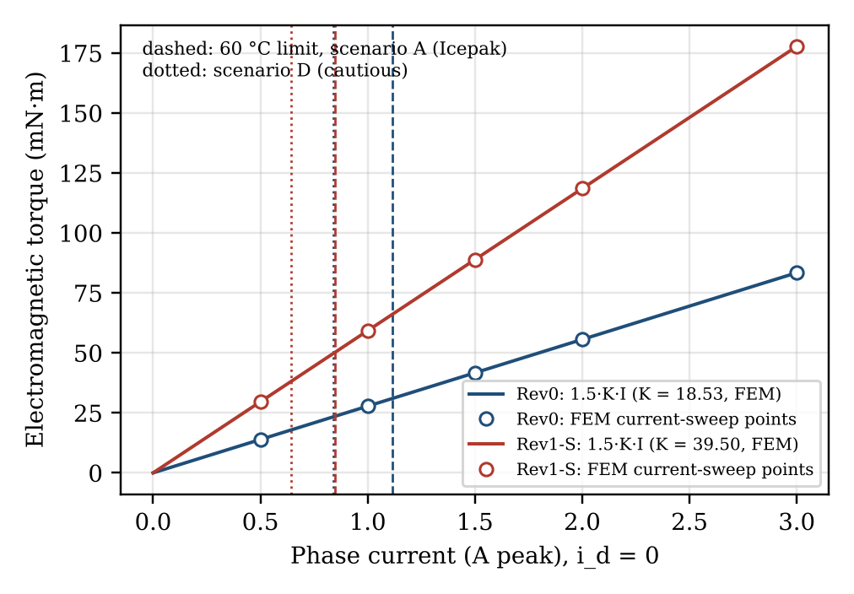
Fig. 4.1. Electromagnetic torque against phase current at i_d = 0. Lines: 1.5·K·Î with the FEM K; points: FEM equivalent-coil current sweep normalised to K at 1 A; vertical lines: 60 °C thermal limit for scenarios A (dashed) and D (dotted), 25 °C, 1000 rpm.
Torque is linear in current to within 0.01 % up to 3 A peak on both machines. The armature field at 1 A is 25 mT peak (1.3-1.4 mT inside the magnets), and the steel peak flux density is unchanged from 0 to 3 A. Within this range the current limit is therefore thermal, not magnetic.

4.x.3 Back-EMF and speed
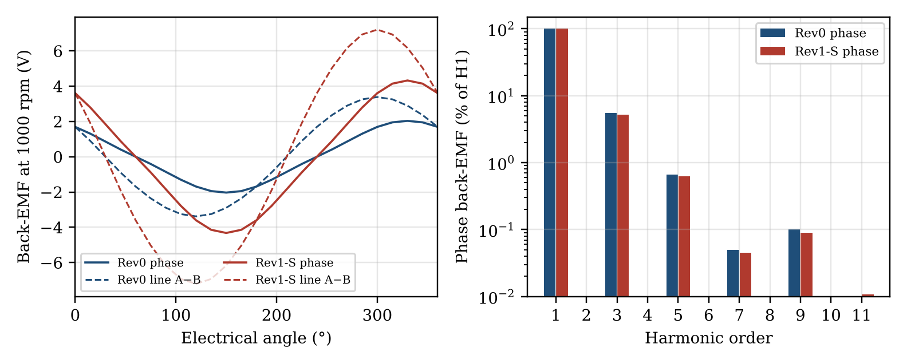
Fig. 4.2. Back-EMF at 1000 rpm from the rotating FEM (scaled to the detailed-copper K): phase and line waveforms, and phase harmonic content.
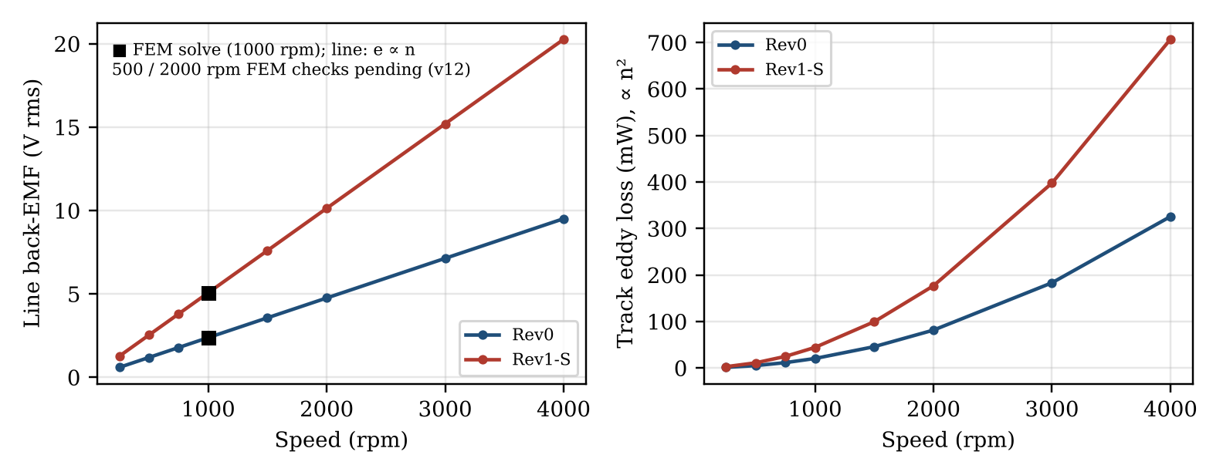
Fig. 4.3. Line back-EMF and track eddy loss against speed. The 1000 rpm point is a FEM solve; the other speeds are exact scaling (e ∝ n, P_eddy ∝ n²) pending the 500 and 2000 rpm FEM checks.
The third harmonic (5.2-5.5 % of the phase EMF) cancels in the star-connected line voltage, leaving a line THD of 0.6-0.7 %. The track eddy loss rises from 20.4 mW (Rev0) and 44.2 mW (Rev1-S) at 1000 rpm to 326 and 707 mW at 4000 rpm, which is 8 % (Rev0) and 15 % (Rev1-S) of the copper loss at the scenario-A thermal current; the eddy drag is 0.78 and 1.69 mN·m.

4.x.4 Thermal limits
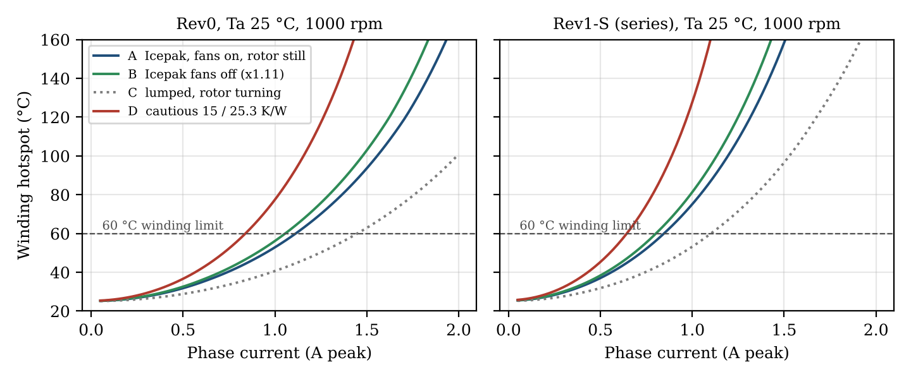
Fig. 4.4. Predicted winding hotspot against current at 1000 rpm and 25 °C ambient, with the measured resistance, for cooling scenarios A-D.
Table 4.2. Thermally limited phase current (A peak) for a 60 °C winding, measured resistance.
Machine | Scenario | 25 °C, 0 rpm | 25 °C, 1000 rpm | 30 °C, 1000 rpm | 25 °C, 4000 rpm
Rev0 | A | 1.116 | 1.113 | 1.027 | 1.071
Rev0 | B | 1.059 | 1.056 | 0.974 | 1.011
Rev0 | C | - | 1.448 | 1.341 | -
Rev0 | D | 0.843 | 0.840 | 0.777 | 0.782
Rev1-S | A | 0.850 | 0.846 | 0.780 | 0.779
Rev1-S | B | 0.807 | 0.802 | 0.740 | 0.731
Rev1-S | C | - | 1.102 | 1.020 | -
Rev1-S | D | 0.649 | 0.644 | 0.595 | 0.553

At the same 1 A that the archived Icepak solves applied with the trace-model resistance, the measured resistance raises the heat from 2.32 to 3.26 W (Rev0) and from 2.42 to 3.51 W per stator (Rev1-S). The predicted hotspot then rises from 50.3 to 58.2 °C and from 65.7 to 80.6 °C at 30 °C inlet air. The resistance uncertainty (R_20 = 1.80-1.94 Ω) moves the limit by ±2.5 %, and a 30 °C ambient lowers it by 7-8 %. Stacking two stators raises R_th per stator by a factor of 1.72, so the thermally limited current of Rev1-S is 24 % lower than that of Rev0.

4.x.5 DC-bus voltage
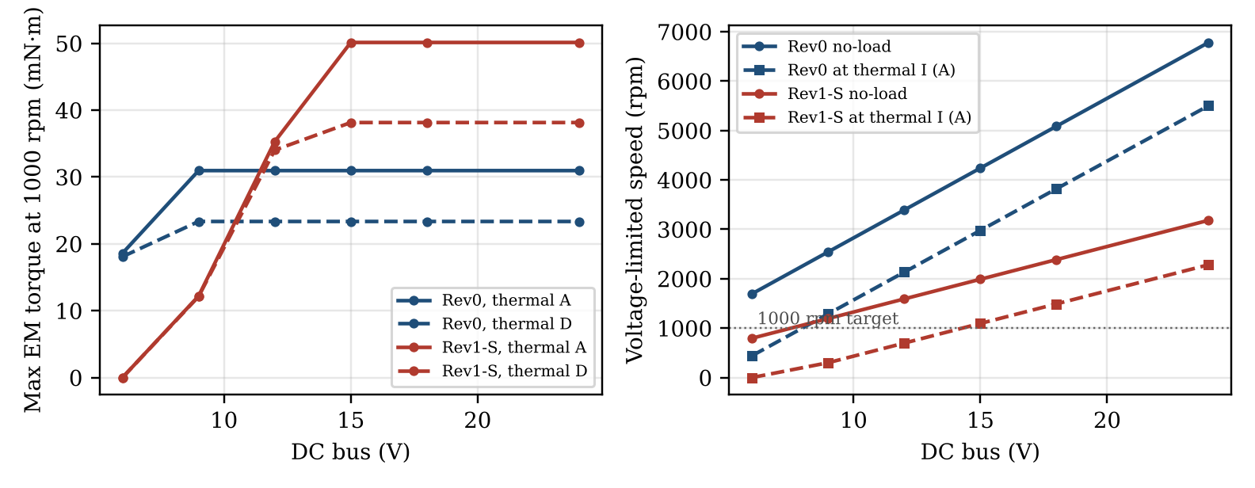
Fig. 4.5. DC-bus sweep, SVPWM m = 0.95, 25 °C: maximum EM torque at 1000 rpm (thermal scenarios A and D) and voltage-limited speeds at no load and at the scenario-A thermal current.
Table 4.3. DC-bus sweep (thermal scenario A, 25 °C, L upper value).
Machine | V_dc (V) | No-load speed (rpm) | Max Î at 1000 rpm (A) | Limit | T_em at 1000 rpm (mN·m) | Corner speed at thermal Î (rpm)
Rev0 | 6 | 1696 | 0.669 | voltage | 18.6 | 442
Rev0 | 9 | 2543 | 1.113 | thermal | 31.0 | 1288
Rev0 | 12 | 3391 | 1.113 | thermal | 31.0 | 2133
Rev0 | 15 | 4239 | 1.113 | thermal | 31.0 | 2977
Rev0 | 18 | 5087 | 1.113 | thermal | 31.0 | 3820
Rev0 | 24 | 6782 | 1.113 | thermal | 31.0 | 5503
Rev1-S | 6 | 796 | 0.000 | E > bus | 0.0 | 0
Rev1-S | 9 | 1193 | 0.206 | voltage | 12.2 | 300
Rev1-S | 12 | 1591 | 0.595 | voltage | 35.3 | 697
Rev1-S | 15 | 1989 | 0.846 | thermal | 50.1 | 1094
Rev1-S | 18 | 2387 | 0.846 | thermal | 50.1 | 1491
Rev1-S | 24 | 3182 | 0.846 | thermal | 50.1 | 2283

Rev0 reaches its thermal current at 1000 rpm from about 8 V upwards. Rev1-S needs at least 12.7 V (scenario D) to 14.3 V (scenario A). On a 12 V bus it is voltage-limited to 0.60 A and 35.3 mN·m at 1000 rpm, and it cannot reach 1000 rpm at all on 6 V. Using the lower inductance changes these currents by less than 0.01 %, because ω_e·L is only 0.04-0.09 Ω at 1000 rpm against 2-4 Ω of resistance.

4.x.6 Operating envelopes
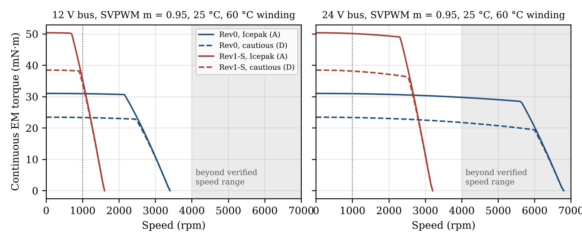
Fig. 4.6. Continuous electromagnetic torque-speed envelopes at 12 and 24 V bus (25 °C, 60 °C winding; solid: scenario A, dashed: scenario D). Speeds above 4000 rpm lie outside the verified scaling range; no speed above 1000 rpm is mechanically qualified.
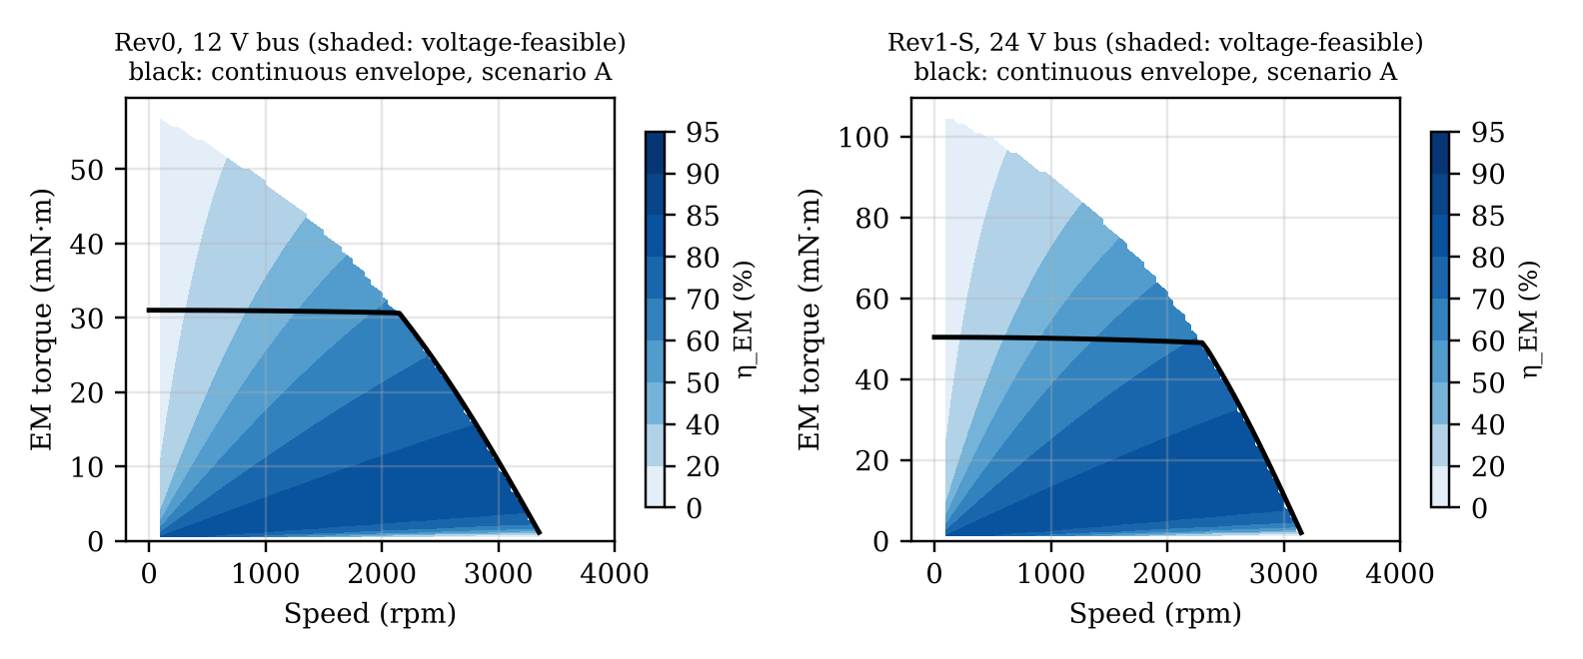
Fig. 4.7. Electromagnetic efficiency η_EM (excluding mechanical and inverter losses) over the voltage-feasible region at the nominal bus, with the scenario-A continuous envelope.

4.x.7 Proposed conditional operating specifications
Table 4.4. Proposed simulation-based operating specifications at 1000 rpm, 25 °C ambient, 60 °C winding, star, i_d = 0 (D = cautious thermal basis / A = Icepak basis).
Item | Rev0 | Rev1-S (series) | Label
DC bus | 12 V | 24 V | ASSUMED
Continuous phase current, D / A | 0.84 / 1.11 A pk | 0.64 / 0.85 A pk | thermally inferred
Continuous EM torque, D / A | 23.3 / 31.0 mN·m | 38.1 / 50.1 mN·m | FEM K × current
EM output P_out,EM, D / A | 2.42 / 3.22 W | 3.95 / 5.20 W | CIRCUIT
Electrical input to the winding, D / A | 4.76 / 7.31 W | 6.71 / 9.94 W | CIRCUIT
EM efficiency η_EM, D / A | 51 / 44 % | 59 / 52 % | CIRCUIT
Terminal line voltage, D / A | 4.63 / 5.36 V rms | 8.52 / 9.60 V rms | CIRCUIT
Minimum DC bus, D / A | 6.9 / 8.0 V | 12.7 / 14.3 V | CIRCUIT
Voltage-limited speed at that current (not a rating) | 2439 / 2133 rpm | 2493 / 2283 rpm | CIRCUIT
Short-time current from cold (τ = 9.2 min) | 1.5 A ≤ 7.7 min; 2.0 A ≤ 3.6 min | 1.0 A ≤ 11.8 min; 1.5 A ≤ 3.7 min | indicative
Current range of the EM model | ≤ 3 A pk | ≤ 3 A pk | FEM

Shaft torque, shaft power, mechanical efficiency and a validated continuous rating are not available from these results; they require the measurements listed in Chapter 5.

Chapter 5 material: Discussion

5.x.1 What the verification establishes
Three numerically independent routes agree on the modelled machines. These are the detailed copper FEM, the analytical model with sheet currents in the real copper islands, and the calibrated equivalent-coil sweep. They agree to 0.03 % on K for Rev0 and 0.13 % for Rev1-S. The ±I differencing confirms the torque sign and removes a rotor-side numerical offset. The rotating and static solutions agree point by point within 1.6 % of K. The 5 % excess of the field-map method is fully explained by the centre-line current routing, not by the field or by Maxwell. This verification does not establish the real magnet remanence, the assembled gaps or any measured torque. It shows that the model is solved correctly, not that the model matches the hardware.

5.x.2 Comparison of Rev0 and Rev1-S
Doubling the stator-rotor stages more than doubles the torque per ampere (×2.13), because stator S2 also benefits from R1's steel backplate (S2 alone is 13 % stronger than S1). The thermal penalty of stacking, however, is large. S1 is enclosed between the two rotors, R_th per stator rises by about 1.7 times, and the continuous current falls from 1.11 to 0.85 A pk (scenario A). The continuous torque gain is therefore ×1.62 rather than ×2.13. Rev1-S also needs about twice the bus voltage at the same speed: 24 V is required for its thermal current at 1000 rpm, while 12 V suffices for Rev0. Rev1-S has the higher electromagnetic efficiency at the same speed (52 against 44 % at 1000 rpm, scenario A), because its back-EMF is a larger share of the terminal voltage.

5.x.3 Assumptions that prevent a defensible continuous rating
The specifications in Table 4.4 are conditional. Table 5.1 lists, in order of influence, the assumptions that currently prevent them from being stated as continuous ratings.
Table 5.1. Remaining technical assumptions.
# | Assumption | Effect | What closes it
1 | Thermal boundary conditions: hypothetical housing, fans, rotor still, radiation off; R_th not measured | Scenarios A-D span 25-33 % in current | Heat run on the built motor
2 | 60 °C winding limit (holder material unconfirmed) | 100 °C would raise the current by about 37 % | Confirm holder material
3 | Resistance measured 2-wire at an unrecorded temperature | ±2.5 % in current | 4-wire measurement with temperature
4 | Location of the 36 % excess resistance over the trace model | Local hotspots may exceed the model | Thermocouples or thermal imaging at junctions
5 | PWM ripple excluded; L simulated, not measured | +8-19 % (Rev0) and +12-27 % (Rev1-S) copper loss at 50 kHz | Measure L and the ripple; set f_sw or add inductance
6 | No mechanical or inverter loss model | No shaft quantities; η_EM is an upper bound | No-load drag and power measurements
7 | Library magnet properties; nominal gaps | K ∝ B_r; about 7 % per 0.25 mm of gap | Open-circuit back-EMF test
8 | Rev1-S has no full-motor FEM; ±I check pending | < 0.5 % | v12 diagnostic runs
9 | Speed scaling from one 1000 rpm solve; eddy formula | Eddy is 0.5-1 % of the loss at 1000 rpm, 8-15 % at 4000 rpm | v12 500/2000 rpm runs
10 | Thermal time constants from the lumped network only | Short-time limits are indicative | Heating curve from the heat run
11 | Ambient 25-30 °C; speeds above 1000 rpm not mechanically qualified | 7-8 % per 5 K ambient | Record ambient; mechanical check

The dominant item is the thermal environment. The difference between scenarios A and D, which is the difference between the modelled hood and an unknown open frame, outweighs every electromagnetic uncertainty by an order of magnitude. The ripple estimate shows that the drive switching frequency belongs to the motor specification: at 50 kHz without added inductance, the ripple can add a fifth or more to the copper loss, which would lower the continuous current by roughly a tenth.

5.x.4 Prototype and outstanding work
The specifications apply to the original simulated geometry only. The constructed Rev0 differs in backplate size and air gap and must be characterised in its own right. The outstanding simulation work is the v12 HPC set (Rev1-S ±I, 500 and 2000 rpm rotating solves) and, optionally, the Icepak re-solve at the limit points with the measured heat. Neither is expected to change the specifications by more than about 0.5 %. The outstanding experimental work, which is postponed, is the open-circuit back-EMF test, the inductance and ripple measurement, the no-load drag measurement and the heat run.

