Supplementary as-built material. It supports the experimental validation of Rev0 and does not change the main Rev0 versus Rev1-S comparison, which uses the nominal 1 mm geometry throughout. Numbering is local.

Chapter 3 material: As-built geometry modelling
The manufactured Rev0 differs from the simulated design in two respects that affect the magnetic field at the winding: the magnet-to-board gap is approximately 4.0 mm rather than 1.0 mm, and the rotor uses an 80 mm OD, 25 mm bore, 2 mm ferromagnetic steel backplate instead of the 86/19 mm plate with a 19 mm steel shaft. Three cases separate the two effects (Table 3.A). Every other quantity (magnets, magnet radius, boards, layers, connection) is unchanged.
The prototype photographs show how the manufactured machine is supported. The central shaft/support tube, the hub ring that locates the backplate on it, the bore ring on the magnet face and the end plates that carry the stator stack are 3D-printed PLA. PLA is non-magnetic and practically non-conducting, so it is represented as air (μr ≈ 1, σ ≈ 0). It is distinct from the metallic parts of the assembly: the backplate, which remains ferromagnetic steel and is modelled; the steel screws and nuts that fix the backplate to the PLA hub (a ring at r ≈ 12-14 mm, inside the magnet ring) and at the rim; and the threaded rods and nuts that clamp the stator stack outside the active winding region. These fasteners are small, lie outside the magnet track (r = 18-38 mm), and are not modelled; their effect is expected to be minor but has not been quantified. The dynamometer shaft and coupling are outside the model region.
The solved Case C geometry contains an 8 mm steel shaft at r ≤ 4 mm, separate from the backplate, with the hub region as air. The manufactured support at that position is PLA, i.e. the model holds slightly more steel than the prototype. Because the whole change from the nominal to the as-built rotor (plate size, bore and shaft together) alters K by only +0.09 % (Chapter 4), a PLA shaft in place of the 8 mm steel one cannot change the result measurably, and no separate PLA-shaft solution was run. Case C is therefore taken as the as-built model.
Table 3.A. Rev0 cases of the as-built study.
Case | Gap (mm) | Backplate OD / ID (mm) | Shaft | Purpose
A nominal | 1.0 | 86 / 19 | 19 mm steel, fills bore | Reference (reused, not re-solved)
B gap only | 4.0 | 86 / 19 | 19 mm steel, fills bore | Isolates the gap
C as built | 4.0 | 80 / 25 (steel) | 8 mm steel modelled (bounds the PLA support); PLA hub = air | Adds the manufactured rotor
C, gap band | 3.5 and 4.5 | 80 / 25 | as C | Gap uncertainty

Each case was solved with the field-only Maxwell model used for the nominal machine: magnets, steel and air are meshed (20 mm region padding, four adaptive passes), the copper is not, and the magnetic flux density is exported on the centre-lines of every track of the five boards at twelve rotor positions spanning half an electrical period (1.875° steps; the second half follows from half-wave antisymmetry). The same run gives the back-EMF waveform and harmonics, the track eddy loss and flux-density maps 0.25 mm from the board-1 face, at the mid-planes of boards 1, 3 and 5 and in the backplate. The method was first applied to the nominal geometry (Case A), where it reproduced the archived rotating solution: K 19.478 against 19.470 mN·m/A on the centre-line basis, phase back-EMF 1.4423 against 1.4418 V rms at 1000 rpm, third harmonic 5.5 %, ripple 1.30 against 1.26 %.
Centre-line integration over-predicts the torque of the real copper by a distance-dependent amount (1.4-10 % per board at the nominal positions) because the current spreads across the copper islands. Each board's field-map value was therefore multiplied by the ratio of the sheet-current to the centre-line torque computed for the same distance with the independent analytical model:
K = Σ_k K_FM,k · [K_sheet(d_k) / K_cl(d_k)], d_k = g + (k − 1)·1.0203 mm (3.A)
Applied to Case A this gives 18.514 mN·m/A, -0.11 % from the full-motor detailed FEM (18.534). The ratio is 0.91-0.92 at every board position of the 4 mm cases. The analytical model treats the backplate as an infinite steel plane and so cannot represent the 80/25 mm plate; that effect is taken from the field maps alone.
Before any of these solutions, and without reference to the bench measurement, the analytical model predicted K = 7.539 mN·m/A at a 4.0 mm gap (8.742 / 6.506 mN·m/A at 3.5 / 4.5 mm). The geometry of every case was checked in the build logs (gap, plate size, bore, shaft, no additional steel), all phase angles are within 0.3° of −30° and the phase steps are 120.0°, confirming polarity and rotor coordinates. Back-EMF at 50, 100 and 150 rpm is obtained as e = K·ω_m from the position-dependent solution (verified at 500, 1000 and 2000 rpm for the nominal machine); these are speed-scaled values, not separate transient solutions.

Chapter 4 material: Nominal, gap-only and as-built Rev0
Table 4.A. Rev0 electromagnetic coefficients (FEM field map, sheet-current corrected; Case A = full-motor FEM). Electrical frequency 6.67 / 13.33 / 20.0 / 133.3 Hz at 50 / 100 / 150 / 1000 rpm.
Case | K (mN·m/A) | vs A (%) | T per A pk (mN·m) | ψ_pm (mWb) | E_LL 50/100/150 rpm (mV rms) | E_LL 1000 rpm (V rms) | THD phase / line (%)
A nominal | 18.534 | - | 27.80 | 2.317 | 118.9 / 237.7 / 356.6 | 2.377 | 5.6 / 0.68
B gap only | 7.547 | -59.3 | 11.32 | 0.943 | 48.4 / 96.8 / 145.2 | 0.968 | 1.1 / 0.08
C as built | 7.554 | -59.2 | 11.33 | 0.944 | 48.4 / 96.9 / 145.3 | 0.969 | 1.0 / 0.11
C, 3.5 mm | 8.754 | -52.8 | 13.13 | 1.094 | 56.1 / 112.3 / 168.4 | 1.123 | 1.4 / 0.09
C, 4.5 mm | 6.518 | -64.8 | 9.78 | 0.815 | 41.8 / 83.6 / 125.4 | 0.836 | 0.9 / 0.11

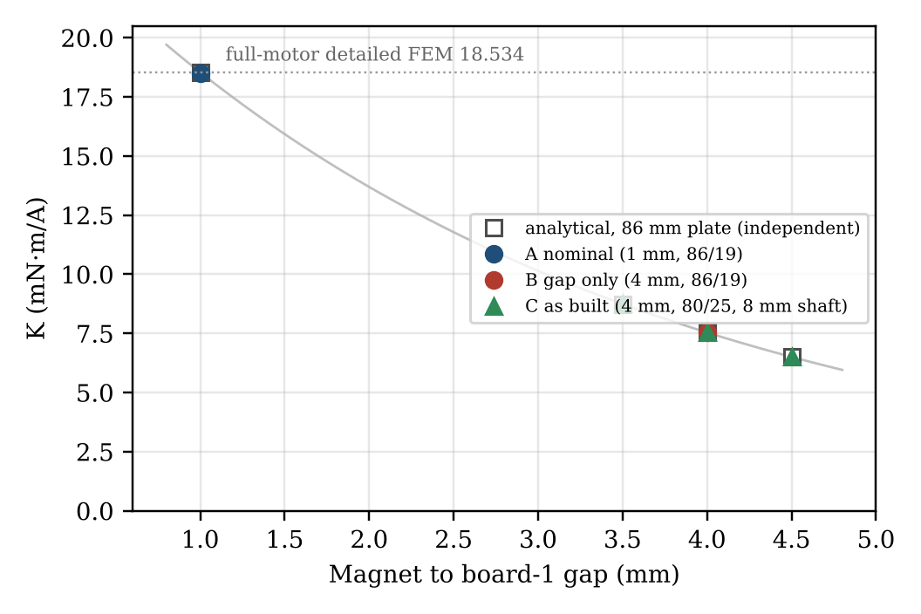
Fig. 4.A. Torque coefficient against gap: field maps (corrected) and the independent analytical prediction made before the field maps were solved.
Increasing the gap from 1.0 to 4.0 mm lowers K by 59.2 % (Case B). Changing the rotor to the manufactured 80/25 mm steel backplate (with the PLA support represented as air and an 8 mm steel shaft) changes K by a further +0.10 %, which is within the numerical scatter of the method: the magnets occupy r = 18-38 mm, inside both plates, and the plate carries at most 0.92-0.95 T, so neither its outer diameter nor its bore affects the field at the winding. The as-built prediction is therefore governed by the gap alone. Over the 3.5-4.5 mm band K varies from 8.754 to 6.518 mN·m/A (+16 / −14 %), about 30 % per millimetre.
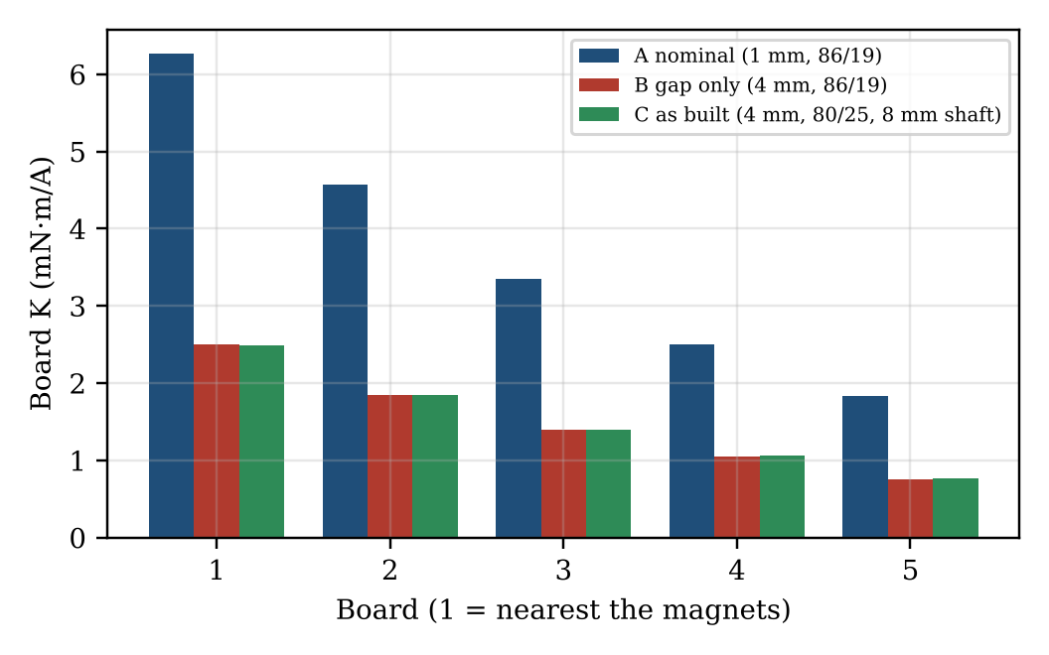
Fig. 4.B. Board-by-board contribution to K. At 4 mm the field decays more slowly relative to its value at board 1, so the boards share the torque more evenly.
The larger gap also filters the field: higher spatial harmonics decay faster with distance, so the phase back-EMF THD falls from 5.6 % (Case A) to 1.0 % (Case C) and the line THD from 0.68 % to 0.11 %. The peak axial flux density 0.25 mm from the board-1 face falls from 0.38 T to 0.16 T, and at the board-5 mid-plane from 0.084 T to 0.040 T (Fig. 4.C). The track eddy loss at 1000 rpm falls from about 21 mW to 3.4 mW.
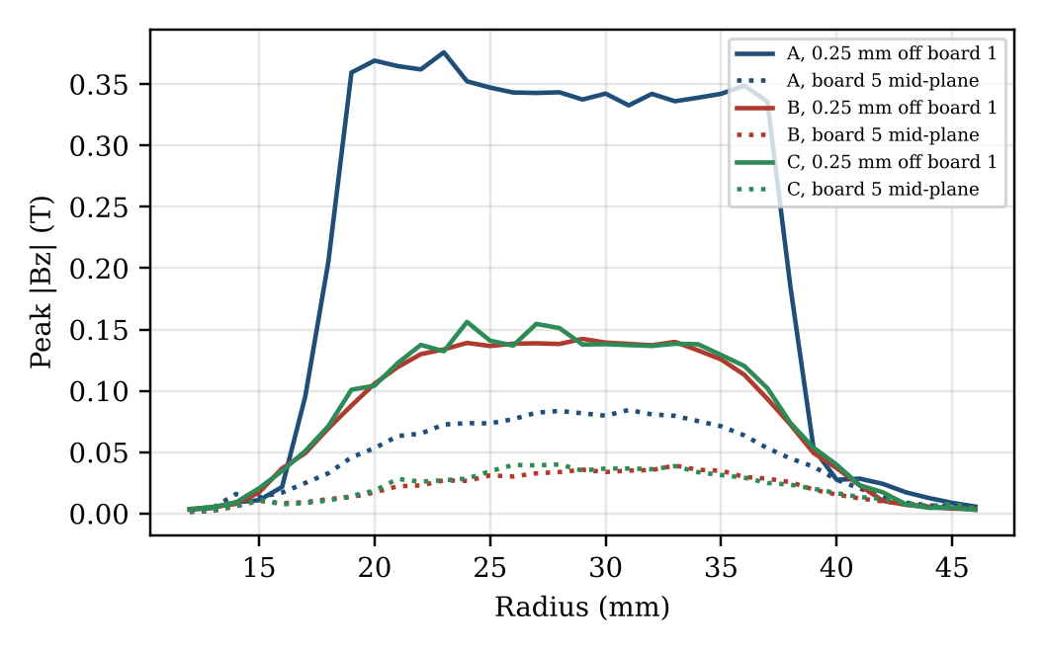
Fig. 4.C. Peak axial flux density against radius, 0.25 mm from the board-1 face and at the board-5 mid-plane (rotor at 0°).
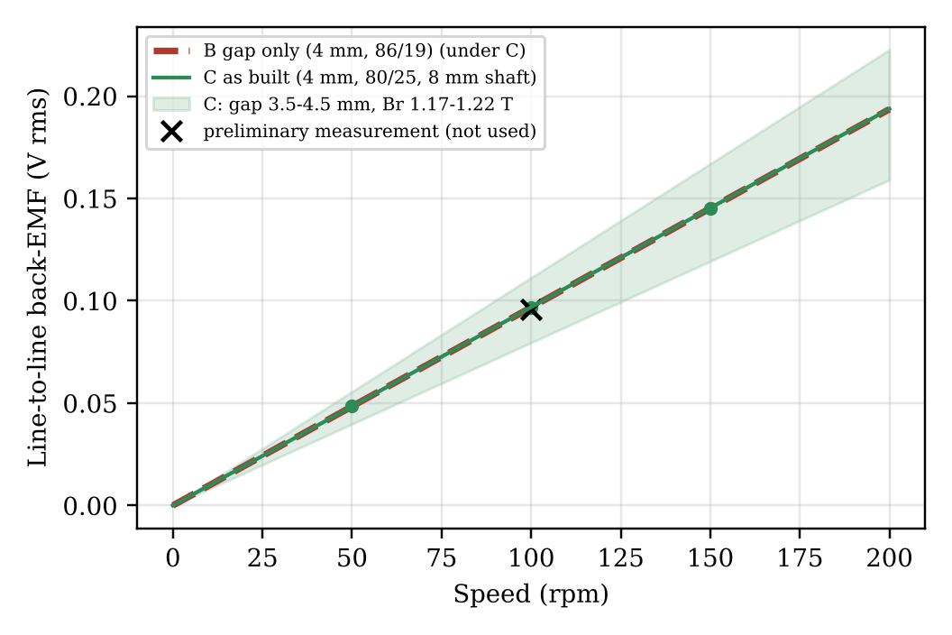
Fig. 4.D. Predicted open-circuit line back-EMF of the as-built Rev0 (Case B lies under Case C), with the band for a 3.5-4.5 mm gap and N35 remanence 1.17-1.22 T, and the preliminary bench value at 100 rpm, which was not used in the model.
Table 4.B. Model checks.
Check | Result | Criterion
Case A: corrected field map vs full-motor detailed FEM | -0.11 % | ±0.5 %
Case A: method vs archived rotating solution (K, E, H3, ripple) | +0.04 %, +0.03 %, 5.5 %, 1.30 % | 0.5 % / 0.3 pt / 0.2 pt
Case A: static-field eddy loss vs rotating solution | 21.6 vs 20.35 mW (+6.2 %) | 5 % (not met; loss only)
Case B: field map vs analytical, centre-line basis | 8.270 vs 8.260 (+0.12 %) | -
Case B: corrected vs analytical sheet-current | 7.547 vs 7.539 (+0.11 %) | -
Polarity / phase | ψ −29.80 to −30.29°, steps 120.0° | ±1°
Case C detailed boards 1 / 5: copper vs rotor virtual work | +0.01 % / +1.28 % | ±3 %
Case C detailed boards 1 / 5: copper vs analytical sheet-current | +0.25 % / +0.48 % | -
Case C boards 1 / 5: corrected field map vs detailed copper | -1.43 % / -0.48 % | ±1 % (board 1 not met)

The detailed-copper boards of Case C (jobs 1526907/1526908; one real-copper board at the board-1 and board-5 positions, ±1 A) close the verification. In both, the copper Lorentz torque and the rotor virtual-work torque agree (+0.01 % and +1.28 %), and the copper result agrees with the independent analytical sheet-current value (+0.25 % and +0.48 %), confirming the sheet-current correction at 4.0 and 8.1 mm. The corrected field map agrees with the detailed copper at board 5 (-0.48 %) but is 1.43 % low at board 1, outside the 1 % criterion. The cause is the field map's flux density, not the correction: on the centre-line basis board 1 of the field map is 1.2 % below both the detailed model's own magnet field (2.710 against 2.743 mN·m/A) and the analytical value. Per board the field map scatters by −1.2 to +3.4 % about the analytical centre-line values (mesh resolution of the five-board region at a 4 mm gap), but these deviations cancel in the sum (+0.12 % and +0.21 % for the whole stack in Cases B and C). Substituting the two detailed boards for their field-map values would raise K for Case C from 7.554 to 7.594 mN·m/A (+0.53 %, +0.5 mV at 100 rpm). The as-built K is therefore taken as 7.554 mN·m/A with a method uncertainty of about ±0.5 %, which is small against the gap and remanence band of Fig. 4.D.

Chapter 5 material: Air-gap sensitivity and the as-built prototype
For this coreless winding the gap is the only geometric quantity of consequence. The field above a single-sided magnet array decays approximately as exp(−πz/τ) with the pole pitch τ, giving about 0.30 /mm here, so every additional millimetre of gap costs roughly a quarter of the torque coefficient. The manufactured backplate size and the shaft have no measurable effect. A gap of 4 mm instead of 1 mm therefore reduces the torque per ampere and the back-EMF of the prototype to 41 % of the design value; for the same torque the prototype needs 2.45 times the current and dissipates six times the copper loss, so the simulated thermal limits of the nominal machine do not apply to it.
At 100 rpm the as-built model predicts 96.9 mV rms line-to-line (band 79.5-111.4 mV for a 3.5-4.5 mm gap and N35 remanence 1.17-1.22 T). The preliminary measurement of about 96 mV lies within 1 % of the central value. Because remanence and gap act on the same quantity, the measurement alone cannot separate them: with the library remanence of 1.23 T it corresponds to an effective gap of 4.03 mm, and with 1.17 T to 3.86 mm. The agreement is therefore consistent with the model and the measured geometry, but it is not yet an independent validation: the measurement is preliminary, and the gap must be measured directly before the comparison can be used to infer either quantity.
The support arrangement bears directly on that gap. In the prototype the rotor is carried on a PLA tube and hub and the stator stack on PLA end plates clamped by threaded rods, without a bearing that locates the rotor axially or radially in the machine itself. The gap is therefore set by assembly rather than by a machined datum, and it can differ around the rotor (tilt and face run-out) and change during a test: PLA is compliant, creeps under sustained load and softens well below the temperatures a loaded winding can reach (its glass transition is around 55-60 °C), while the threaded-rod stack can shift if a nut loosens. Because K falls by about 30 % per millimetre of gap, a few tenths of a millimetre of movement is enough to change the back-EMF and torque per ampere by several per cent. This does not affect the electromagnetic model, in which the PLA parts are non-magnetic as in the real machine, but it limits how precisely a bench result can be compared with it and is the main reason the gap must be measured at the time of each test.

Chapter 7 material: Mechanical improvements and simulation-matched testing
Recommendations for the mechanical design:
• Set the magnet-to-board gap mechanically, not by assembly: a machined spacer or shim stack between the stator holder and a shaft shoulder, with a target of 1.0-1.5 mm. Recovering 2.5-3 mm of gap roughly doubles the torque per ampere and the back-EMF at no cost in copper.
• Control axial play and run-out: bearing preload or a locating collar so that the rotor cannot move towards the stator; measure face run-out of the backplate, because the minimum gap, not the mean, limits how close the rotor can be set.
• Replace the PLA support with a rigid, accurately aligned, bearing-supported assembly for future controlled testing: a metal shaft running in a pair of preloaded bearings housed in a stiff frame that also locates the stator, so that the shaft axis is square to the boards and concentric with the winding and the gap is fixed by machined faces rather than by the printed parts. A steel shaft does not degrade the machine: Case C includes an 8 mm steel shaft and the as-built rotor changes K by less than 0.1 %.
• Retain the rotor positively on the shaft: a keyed or clamped hub (or set screws on a flat) for torque, and a shoulder with a locking collar or circlip for axial position, so that the rotor cannot slip under dynamometer torque or be drawn towards the stator by the magnet attraction.
• Keep the 80/25 mm steel backplate: the simulations show its size and bore do not reduce performance.
Recommended test sequence matched to the simulations:
• Measure the gap with feeler gauges at four or more positions around the rotor, and the face run-out, before testing.
• Open-circuit back-EMF at 50, 100 and 150 rpm with the drive disconnected: line-to-line rms and waveform, speed confirmed from the electrical frequency (6.67, 13.33, 20.0 Hz). Expected for a 4.0 mm gap: 48, 97 and 145 mV rms, nearly sinusoidal (line THD about 0.1 %).
• Compute K_exp = √2·E_LL / (√3·ω_m) and compare with K(g) at the measured gap; the remaining difference is a measure of the magnet remanence.
• Torque against current at low current with the dynamometer: expected 11.3 mN·m per A peak at 4 mm. Limit the current to the thermal capability of the prototype, which is lower in torque terms than the nominal design by the factor 0.41.
• Repeat after reducing the gap to confirm the predicted exponential dependence.

