This is a mini project using Azue virtual machine, and Azure storage blob container. The task is to download page 50 of the API web page at <https://www.themuse.com/developers/api/v2>

[**https://www.themuse.com/api/public/jobs?page=50**](https://www.themuse.com/api/public/jobs?page=50)

, then obtain the following data:  publication date, job name, job type, job location, company name

which can be found on the “Response body”

Below are the steps in detail

**1/ Create Ubuntu virtual environment on the VM** including installing all of the required tools/libraries, such as azcopy, etc

python3 -m venv venv

source venv/bin/activate

pip install requests

pip install pandas

pip install toml

sudo apt update

sudo apt install snapd

sudo snap install azcli #this will install azcopy as well

azcopy –version # verify if azcopy was installed successfully

**2/ Create a virtual machine on Azure**

setting connection to VM from VS code

**3/ Create a storage account on Azure, and blob container**

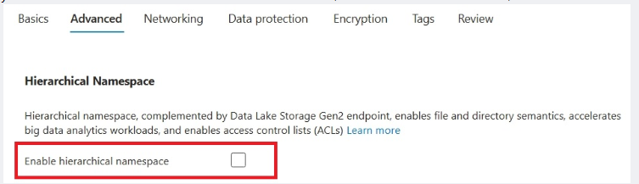

After creating storage account, we then create blob container, and create shared access token on the container to generate url for accessing using subprocess in the python script

**4/ write python script** to download data from the above API webpage, transform, and then upload it to the blob container. Please see below python script (note: config.toml is not disclosed due to confidentiality)

*#down load data from the API*

def read_data(url: str) -> list[dict]:

    try:

        response = requests.get(url)

        if response.status_code == 200:

*#only get the results*

            data = response.json()['results']

            if isinstance(data,list):

                return data

            else:

                print('the data received is not a list of dictionary')

        else:

            print('failed to load data from the API. Status code is {response.status_code}')

    except Exception as e:

        print(' an error occured {e}')

*#extract downloaded data*

def extract_data(data: list[dict]) -> list[list[str], list[str], list[str], list[str], list[str]]:

    companies = [item['company']['name'] for item in data]

    locations = [item['locations'][0]['name'] for item in data]

    jobs = [item['name'] for item in data]

    job_type = [item['type'] for item in data]

    publication_date = [item['publication_date'] for item in data]

    return companies, locations, jobs, job_type, publication_date

if __name__ == '__main__':

    import requests

    import pandas as pd

    import subprocess

    from typing import List

    import toml

    config_data = toml.load('config.toml')

    url = config_data['config']['url']

    shared_key = config_data['config']['shared_key']

    data = read_data(url)

    li = extract_data(data)

*# convert the data (list of list) by transposing first, then convert to data frame, and lastly export to filename*

    transposed_list = list(map(list,zip(*li)))

    df = pd.DataFrame(transposed_list, columns=['Company','Location','Job','Job_type','Publication_date'])

    df[['City','Country-State']]=df['Location'].str.split(',',expand=True)

    df = df.drop(['Location'],axis=1)

    df.to_csv('demo.csv',index=False)

*#upload file to blob container on azure storage account*

*#recursive to allow copy multiple files just in case*

    subprocess.run(['azcopy','copy','demo.csv', shared_key,'--recursive=true','--overwrite=true'])

**5/ Verify if the upload was done successfully**

