CSS

Margin:

/* Apply to all four sides */

margin: 1em;

margin: -3px;

/* vertical | horizontal */

margin: 5% auto;

/* top | horizontal | bottom */

margin: 1em auto 2em;

/* top | right | bottom | left */

margin: 2px 1em 0 auto;

/* Global values */

margin: inherit;

margin: initial;

margin: unset;

The margin property may be specified using one, two, three, or four values. Each value is a [<length>](https://developer.mozilla.org/en-US/docs/Web/CSS/margin#<length>), a [<percentage>](https://developer.mozilla.org/en-US/docs/Web/CSS/margin#<percentage>), or the keyword [auto](https://developer.mozilla.org/en-US/docs/Web/CSS/margin#auto). Negative values draw the element closer to its neighbors than it would be by default.

* When **one** value is specified, it applies the same margin to **all four sides**.
* When **two** values are specified, the first margin applies to the **top and bottom**, the second to the **left and right**.
* When **three** values are specified, the first margin applies to the **top**, the second to the **left and right**, the third to the **bottom**.
* When **four** values are specified, the margins apply to the **top**, **right**, **bottom**, and **left**in that order (clockwise).

Values

[**<length>**](https://developer.mozilla.org/en-US/docs/Web/CSS/length)

The size of the margin as a fixed value.

[**<percentage>**](https://developer.mozilla.org/en-US/docs/Web/CSS/percentage)

The size of the margin as a percentage, relative to the *width* of the containing block.

**auto**

The browser selects a suitable margin to use. For example, in certain cases this value can be used to center an element.

CSS Fonts

The CSS color property defines the text color to be used.

The CSS font-family property defines the font to be used.

The CSS font-size property defines the text size to be used.

h1 {  
    color: blue;  
    font-family: verdana;  
    font-size: 300%;

## CSS Border

The CSS border property defines a border around an HTML element:

### **Example**

p {  
    border: 1px solid powderblue;  
}

## CSS Padding

The CSS padding property defines a padding (space) between the text and the border:

### **Example**

p {  
    border: 1px solid powderblue;  
    padding: 30px;  
}

## The id Attribute

To define a specific style for one special element, add an id attribute to the element:

<p id="p01">I am different</p>

then define a style for the element with the specific id:

### **Example**

#p01 {  
    color: blue;  
}

## Image Maps

The <map> tag defines an image-map. An image-map is an image with clickable areas.

In the image below, click on the computer, the phone, or the cup of coffee:



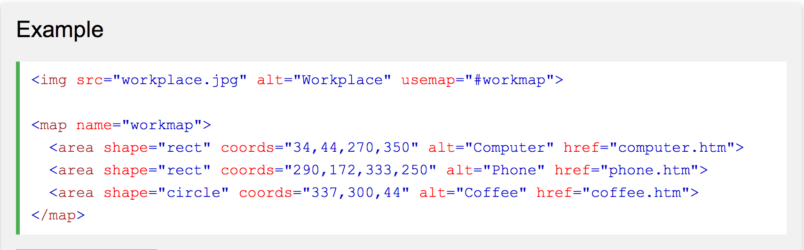

## Background Image

To add a background image on an HTML element, use the CSS property background-image:

### Example

To add a background image on a web page, specify the background-image property on the BODY element:

<body style="background-image:url('clouds.jpg')">  
  
</body>

To add a background image on a paragraph, specify the background-image property on the P element:

<body>  
  
<p style="background-image:url('clouds.jpg')">  
...  
</p>  
  
</body>

## The <picture> Element

Show one picture if the browser window (viewport) is a minimum of 650 pixels, and another image if not, but larger than 465 pixels.

<picture>  
  <source media="(min-width: 650px)" srcset="img_pink_flowers.jpg">  
  <source media="(min-width: 465px)" srcset="img_white_flower.jpg">  
  <img src="img_orange_flowers.jpg" alt="Flowers" style="width:auto;">  
</picture>