Documentation
Section 1 — Project Overview
"Built an end-to-end Banking Business Intelligence system simulating real banking operations in Nepal. The project covers data generation, ETL transformation using Power Query, star-schema data modeling, DAX measure development, and interactive dashboard creation in Power BI."
Section 2 — Data Model Diagram

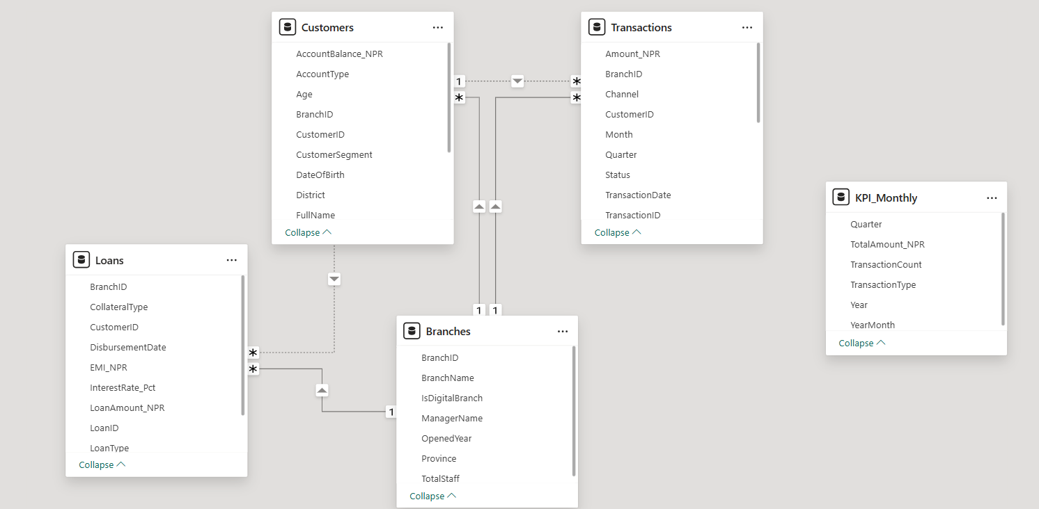

DAX Measures
-- Total Transaction Amount
Total Amount = SUM(Transactions[Amount_NPR])

-- Transaction Count
Total Transactions = COUNT(Transactions[TransactionID])

-- Average Transaction Value
Avg Transaction = AVERAGE(Transactions[Amount_NPR])

-- Total Deposits Only
Total Deposits =
CALCULATE(SUM(Transactions[Amount_NPR]),
Transactions[TransactionType] = "Deposit")

-- Total Withdrawals Only
Total Withdrawals =
CALCULATE(SUM(Transactions[Amount_NPR]),
Transactions[TransactionType] = "Withdrawal")

-- Completed Transaction Rate (%)
Completion Rate =
DIVIDE(
CALCULATE(COUNT(Transactions[TransactionID]),
Transactions[Status] = "Completed"),
COUNT(Transactions[TransactionID])
) * 100

-- Total Loan Amount Disbursed
Total Loans = SUM(Loans[LoanAmount_NPR])

-- Active Loan Count
Active Loans =
CALCULATE(COUNT(Loans[LoanID]),
Loans[Status] = "Active")

-- Loan Default Rate (%)
Default Rate =
DIVIDE(
CALCULATE(COUNT(Loans[LoanID]),
Loans[Status] = "Defaulted"),
COUNT(Loans[LoanID])
) * 100

-- Total Customers
Total Customers = DISTINCTCOUNT(Transactions[CustomerID])

-- MoM Growth (Month-over-Month)
MoM Growth =
VAR CurrentMonth = [Total Amount]
VAR PrevMonth = CALCULATE([Total Amount],
DATEADD(Transactions[TransactionDate], -1, MONTH))
RETURN DIVIDE(CurrentMonth - PrevMonth, PrevMonth) * 100
Section 4 — Business Insights Found
- "Kathmandu Main Branch accounts for 28% of total deposit volume"
- "Home Loans have the lowest default rate at 4.2%"
- "Mobile Banking channel has grown 45% from 2022 to 2024"

