[https://www.nattynutrition.com/pages/clientlogin/](https://www.nattynutrition.com/pages/clientlogin/" \t "_blank)

I have checked the reference site, I have few question Below:

**Question1: Plan will be created when our current Total is equal to 100 (= 100). We want to make the same functionality**

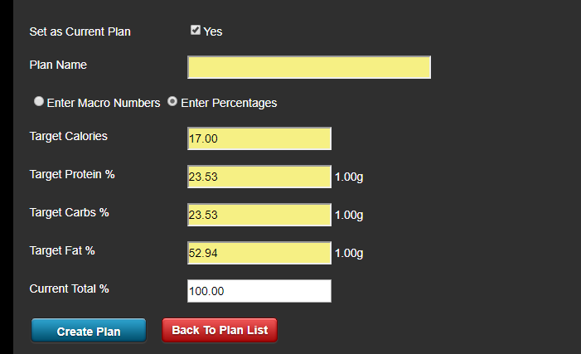

**Question2: There is two actions performing one for Add and edit Food items and second is create Alternate meal:**

**`Add and edit food` is for add new food items or update last added items and `** **Alternate meal `**

**For adding Alternate meal but its not working properly. So my question is that how it will be work**

**IF I already added items in my meal and I click on Alternate meal and add new one, so my last for added items will be replace with new items or just update last updated item in the meal.**

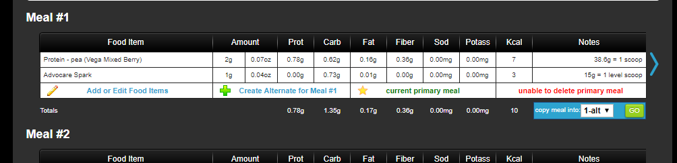

**Question3: You want the search functionality as well and layout will be shown same:**

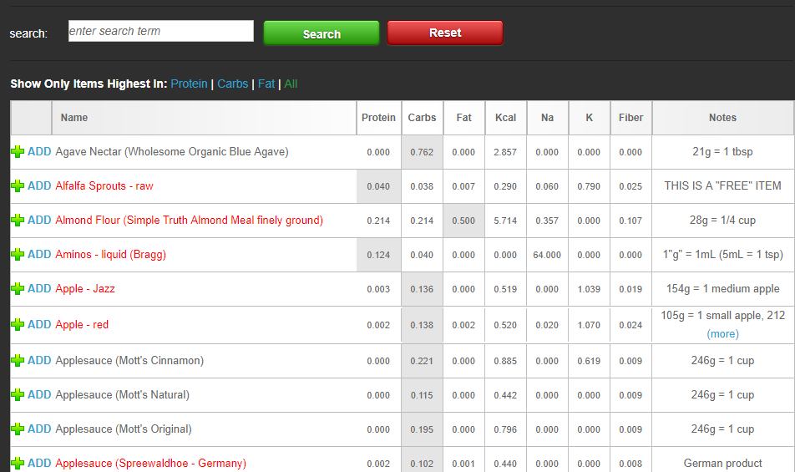

**Question4: Do you have the formula of this calculation or I have to find in this site?**

**Question5 : As you told in document only paid yours will access this:**

**For payment, we have to add our own payment method for this. Please tell me which payment gateway you want to use for this . (Like :- Paypal, authorize.net)**