**Simple Fintech Calculator**

**Short Description:** Simple Fintechisa WordPress plugin. There are two columns :

1. Månedlig ydelse e/skat
2. LTV / Bidragssats

**Plugin Actions**

Active, Deactivate Plugin code written in fintech.php.

1. **Active Plugin:** When we active that plugin new table will be created in database Name ` fintech_calc `

Also One new page will be created in pages section Name ` Fintech Calculator`

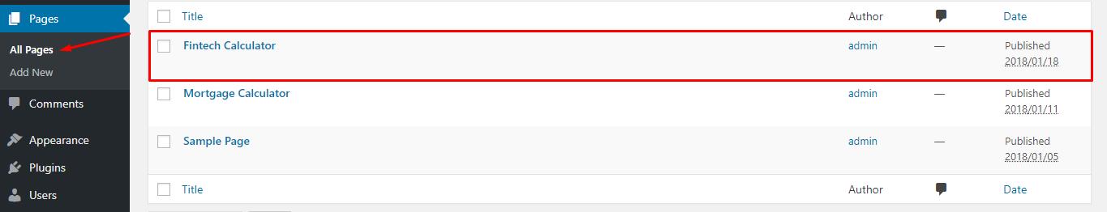

And One new section added in admin section sidebar, All values are shown here which are using in calculate the fintech calculation. And its coming from database, when we activate the plugin these all values are inserted in database and shown here.

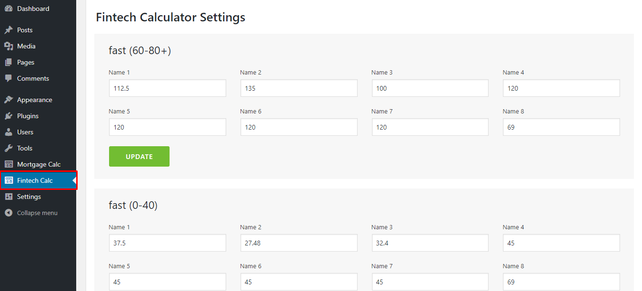

1. **Deactivate Plugin:** After Deactivate this plug all changes and page will be deleted from your site

**Calculation Functionality:**

When we change anything in two columns (`Månedlig ydelse e/skat `, ` LTV / Bidragssats`) calculation() function is calling who is located in calculation.js (js/ calculation.js) or this function checking that both columns are not empty and hit calculate.php by ajax and all calculation and logic implemented in calculate.php and its return response in json format.

**Excel Parameter is used in calculation**

fast (60-80+) (v)

fast (0-40) (t)

fast (40-60) (u)

Kortrente (0-40) (w)

Kortrente (60-80+) (y)

Ekspedition (f)

lånoptagelse (g)

garanti provision fast (j)

Deponering af udbetaling (n)

kurtage (h)

kursfradrag (i)

garanti provision var (k)

Oblkurs fast (al)

Kupon fast (ao)

kupon kortrente (ap)

Oblkurs kortrente (am)

Kortrente (40-60) (x)