Resume Analysis using Natural Language Processing

Rashmi Asthagi*  Dept. of Computer Engineering, BRACT’s Vishwakarma Institute of Technology, Pune, India, Rashmi.ashtagi@vit.edu | SUJAL KHARDEKAR  Dept. of Computer Engineering, BRACT’s Vishwakarma Institute of Technology, Pune, India, sujal.khardekar21@vit.edu | SIDDESH KHAPLE  Dept. of Computer Engineering, BRACT’s Vishwakarma Institute of Technology, Pune, India, siddesh.khaple21@vit.edu

SHRUTI KHATAL
Dept. of Computer Engineering, BRACT’s Vishwakarma Institute of Technology, Pune, India, shruti.khatal21@vit.edu

ABSTRACT—In today’s era where getting a job in engineering field has become competitive and a difficult task, both the job seekers and companies are in a need of resume analyser and summarizer software which will help the candidates or job seekers to analyse their resume with the help of pie charts, graphs or even check for any typos or spelling mistakes in the resume to make the resume ats free and also help the companies to compare the resume and job description using Natural language processing which will make the shortlisting task less tedious, less time consuming and reliable. The proposed work presents a solution which will generate a resume matching score based on the input resume and job description provided. The system will also check for spelling error in the resume, provide a score table which consists of different skill set along with the respective scores which highlights proficiency of the candidate, provide graphs and pie charts which help in data interpretation and visualization. Companies can compare the different resumes based on the scores in different skill set via scatter plots, bar graph etc. Summary of the resume is also generated which will help to get an overview of the resume.

To help candidates improve the skills required in the job description and, in the meantime, assist employers in selecting the best candidates in accordance with their standards and preferences, the paper includes measures to help employees and candidates analyse resumes in a manner like that of a real-world application tracking system (ATS). NLP (Natural Language Processing) techniques were employed in the article for skill-based categorization, pattern matching, and text summarization.

KEYWORDS —ATS, NLP, Text Summarization, Text Classification, Phrase Matcher, Python, Similarity, Dissimilarity, Spell Checker.

INTRODUCTION

Before a resume is examined by a human representative, 90% of the top industries' HR departments utilize Application Tracking Systems (ATS) to automatically screen qualified applicants from a vast pool of submissions. This reduces labor costs and increases productivity. Because of this, it is now necessary for applicants to have a working knowledge of ATS in order to be considered for any position in the competitive job market.

This paper presents a method that assists job seekers in enhancing their skill set, while simultaneously helping employers find qualified applicants for open positions. In order to anticipate the accuracy of the outcomes, a comparable study was presented using visualizations and similarity/dissimilarity measurements.

It has been demonstrated that in the event of a pandemic or recession, when there is a significant decline in the employment market, an ideal system is required. In these situations, it is more important than ever to prepare a resume that corresponds with the job description for each position and to be given consideration during the application and interview stages.

RELATED WORK

Due to its popularity and efficacy, NLP has been used in several articles for text summarizing and classification to date. A few relevant research papers that have a common interest will be introduced and further examined in order to gain a better understanding of our work and how it varies from the methods that are currently in use.
- RESUMATCHER

Resumatcher: A customized approach for matching resumes with jobs (Shiqiang Guo, 2015) developed a finite state transducer based on a data extraction library to extract models from resumes and job descriptions, which were primarily unstructured, in order to facilitate the job search process for job seekers. In order to compare and contrast the CV and job models, the article presented a new statistically based ontology similarity metric. It also measured the similarities among technical terminology.

In contrast to conventional job search websites, the goal was to return jobs based on appropriateness. To validate the models, the author calculated Normalized Discounted Cumulative Gain (NDCG), which is a ratio of Discounted Cumulative Gain (DCG) and Ideal Discounted Cumulative Gain (IDCG). In addition, the author compared three pre-existing models—Okapi BM25, TF-IDF, and Kullback-Leibler divergence—while utilizing Indeed.com's real-time results.

- RESUME RANKING

A ranking algorithm has been utilized in Resume Ranking utilizing NLP and Machine Learning (Zubeda, Shaheen, Godavari, and Naseem, 2016) to score resumes of any format mapping with the restrictions provided by an organization. Additionally, despite the existence of resumes, the paper has employed NLP and ML approaches to read applicants' diverse social media accounts, such as Github, LinkedIn, etc. in order to obtain correct information about candidate.
- LIMITATIONS
The papers that are currently available offer a great deal of flexibility in reaching a consensus and assisting companies and candidates in making the best choice. Although our paper employs some of the same common techniques as the above, the main distinction is that we use the existing NLP techniques, matching and summarizing data using CountVectorizer and verifying the models using precisely defined Cosine similarity and Jaccard dissimilarity measures.
In addition, the candidate is made aware of the keywords that are lacking from their resume yet are crucial to the job description; this could lead to their application being rejected.

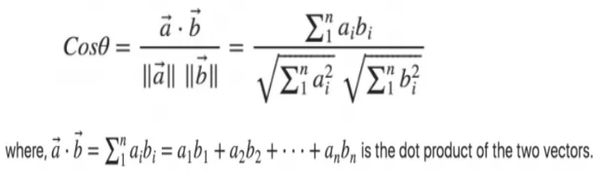
The two papers have various input methods, and our system has input Word and PDF files—two of the most popular formats used by candidates for resumes. In the parts to come, we'll talk about how to extract the provided files and evaluate the models.

METHOD

Created a model that analyzes a set of users' resumes and uses pie charts and bar charts to highlight technologies and talents. This helps companies select candidates with the highest level of expertise they need by providing them with thorough visual aids. Employers and candidates can use the model to compare resumes and job descriptions for Data Science and Analytics positions.

Spoken language: Python
Methods include spell checking, text summarization, skill-based classification, and pattern matching.
The Count Vectorizer algorithm
The following libraries are used: CountVectorizer, nltk, textract, genism, docx2txt, pandas, re, and spaCy.
Cosine and Jaccard similarity are the evaluation metrics.

The study made use of libraries such as genism for similarity retrieval for summarization, pyPDF2 and docx2txt to extract information from resumes in the Word and PDF formats, and Phrase Matcher from spaCy to match terms from the resume with keyword dictionaries.

EXPERIMENTS

The study includes six experiments: Missing Keywords, Similarity Scores, Text Summarization, Count Vectorizer, Spell Checker, and Skill Wise Classification and Comparison. The next sections will go into more detail about these trials.

- COUNT VECTORIZER AND COSINE SIMILARITY

The process begins by converting resumes, initially in an unstructured format, into a structured textual format. Feature extraction is then applied to this structured data.
Feature extraction is accomplished through the utilization of the count vectorizer concept. Count vectorizer employs predictive modeling techniques specifically tailored for text data. It achieves this by parsing through the data or removing words, a process known as tokenization. CountVectorizer utilizes this approach to transform the text data into a vector of token counts. This transformation aids in the preprocessing of text data, rendering it both flexible and amenable to further analysis.
Here is an example illustrating how CountVectorizer operates:
Text = The quick brown fox jumps over the lazy dog

Data = [‘The’, ’quick’, ’brown’, ’fox’, ’jumps’, ’over’, ’the’, ’lazy’ ,’dog’]

Count Vector =
The quick brown fox jumps over the lazy dog
2 1 1 1 1 1 1 1 1

Using the underlying notion of CountVectorizer, it was applied on the converted input of resumes. After this stage, cosine similarity is applied which is a similarity of two documents regardless of their size. In this paper, it measures the cosine angle between the two count vectors achieved in the previous stage. The formula for it is as follows:

(1)

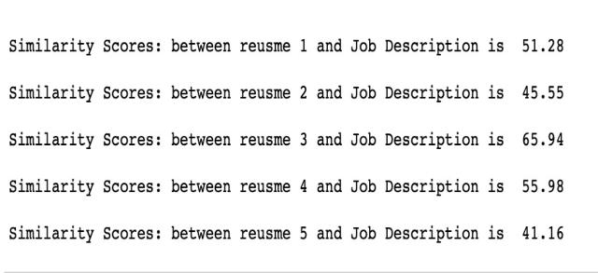
Computing the above formula in python on a sample of 5 resumes and job description for entry level Data Analyst available on Indeed.com the following results were achieved:

Figure 1: Cosine similarity scores among five different data analyst candidates and entry-level data analyst job description.
The figure indicates that candidate 3 achieves the highest similarity score, reaching 65.94% in comparison to the job description. Consequently, this candidate stands a greater chance of being selected for the job. Conversely, candidate 5 exhibits

notably lower similarity score, at 41.16% with respect to the job description, indicating a decreased likelihood of being shortlisted for the position compared to the other candidates.
These findings offer valuable insights for candidates during the job application process. It alerts them to potential deficiencies in crucial skills outlined in the job description, providing an opportunity for improvement to enhance their candidacy for the job role. Similarly, candidates can prioritize skill development to better align with job requirements and increase their chances of being considered for the position.
- SPELL CHECKER

To mitigate a common mistake often made by candidates—using incorrect words in their resumes—the paper implemented a spell checker. This tool, integrated with a built-in function in Python, aims to assist candidates in avoiding such errors. Even if mistakes occur, they can be rectified promptly.
The output of the spell checker for a resume typically identifies misspelled words and provides suggestions for corrections. This proactive approach ensures that resumes are free from spelling errors, which could otherwise lead to the ATS disregarding incorrectly spelled words and only considering similarity scores with the correct keywords.
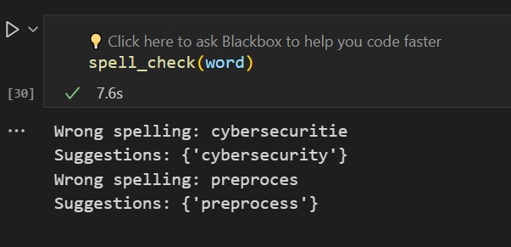
Figure 2: Spell check for the words – connectivity, dashboard, deployment, automating, test-case and spark.

The function employed in the program successfully identifies incorrect words used in a resume and suggests corrections. For instance, "connectrivity" is corrected to "connectivity," "autometing" to "automating," "deploment" to "deployment," and so forth.
If the resume contains all correct words, the program provides a signal indicating no spelling mistakes were detected. This signal serves as an indicator that the resume is prepared for further analysis, including similarity assessment and classification, which will be elaborated upon in the subsequent section.

- TEXT SUMMARIZATION

Text summarization is a significant area within Natural Language Processing (NLP), aimed at condensing large documents into concise, meaningful summaries. This process serves to reduce reading time, enhance computational efficiency for modelling, and improve accuracy. Text summarization finds application across various domains, including articles, journals, research papers, and even resumes.
The rationale behind implementing text summarization in this paper lies in the fact that resumes can often span multiple pages or contain a plethora of information. Reading through the entire document may not be feasible or efficient. Therefore, Automated Tracking Systems (ATS) often utilize shortened versions of resumes to analyse similarities between resumes and job descriptions.

The system makes use of LSA (Latent Semantic Analysis) for summarization of the resume. This technique aims at understanding the relation of the text amongst itself hence understanding the context and semantic meaning of the text or resume. It is a extractive summarization technique which implies that it identifies important and the most relevant texts from the source which is resume and doesn’t add newly framed sentences or words.

Bright of this, the paper has summarized approximately 10 sample resumes, while the job description remains unsummarized. This decision stems from the specificity of job descriptions, wherein missing key keywords could lead to inaccuracies in similarity assessments. Conversely, resumes may contain non-essential information for pattern matching and similarity score computation.

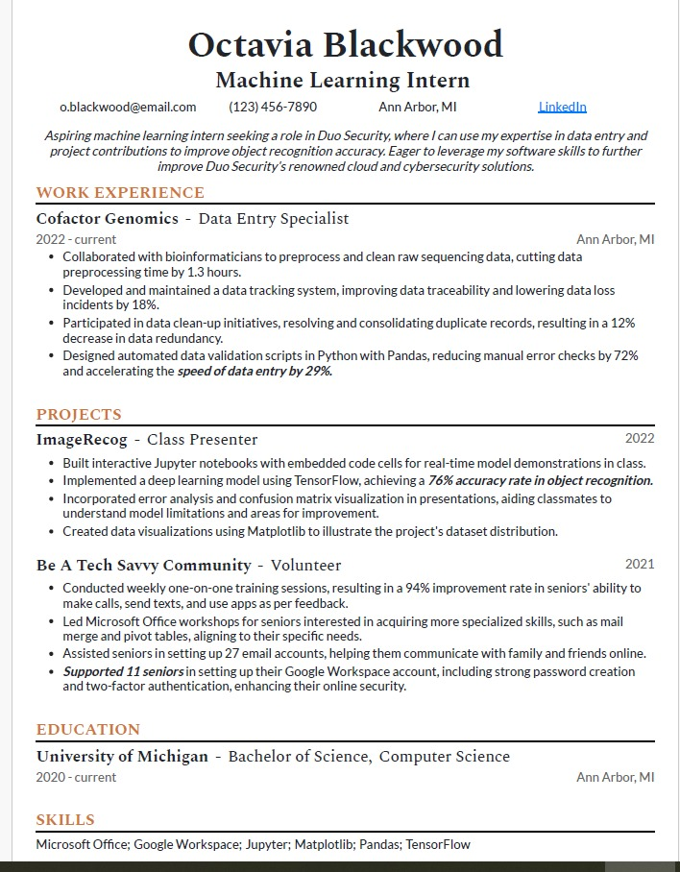
Figure 3: Original resume taken from the user.

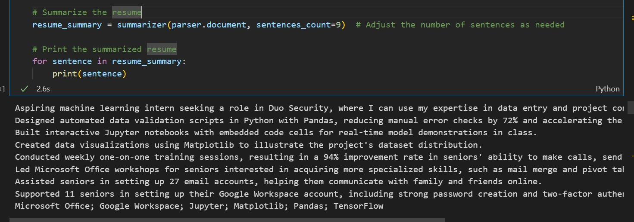
Figure 4: Summarization of resume.

Depending on the number of sentences provided, the number of lines in the summary is determined. Depending on the company's or candidate's requirements, they can decide the length of the resume summary

- SIMILARITY SCORES USING SUMMARIZED TEXT
The paper has employed two measures to evaluate similarity and dissimilarity. The cosine similarity, detailed earlier with the formula (1), quantifies the similarity between two datasets.
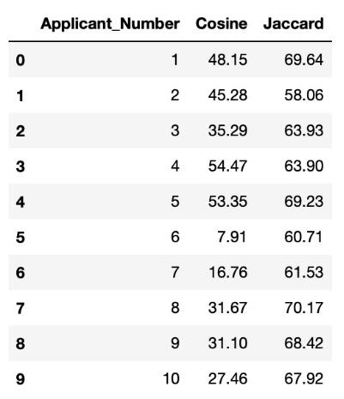
In contrast, the Jaccard distance serves as a complement to the Jaccard index, gauging the dissimilarity between two datasets and providing a percentage value accordingly. The formulas used to compute the Jaccard index and distance are as follows:

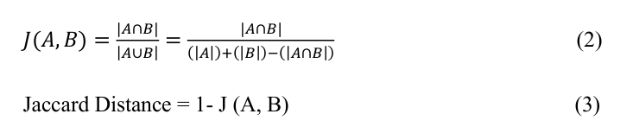
Considering the formulae above, python calculated the Cosine and Jaccard similarity measures for a sample of 10 summarized resumes and following were the results.

- MISSING KEYWORDS

Once candidates understand the likelihood of their resume being accepted or rejected for the next stage of the application process, it becomes advantageous to identify areas for skill improvement or potential omissions.
Similarly, employers can utilize this information to assess why they should or should not select a candidate based on the presence or absence of specific skills in their resume, thereby informing decisions regarding the next interview stage.
Below is a sample output derived from a summarized resume aligned with an entry-level data analyst job description sourced from Indeed.com.

Figure 5: Cosine and Jaccard similarity scores for 10 candidates.
Candidate 6 exhibits the lowest cosine similarity measure among the 10 candidates, standing at 7.91%, indicating a higher likelihood of rejection by an employer. Conversely, candidate 4 boasts the highest cosine similarity measure, reaching 54.47%, suggesting a strong alignment with the job requirements and a higher probability of being accepted for the interview stage.
Similarly, the inverse relationship applies to the Jaccard distance, which measures dissimilarity. Candidate 7 demonstrates the highest dissimilarity measure at 70.17%, indicating a significant misalignment between the candidate's resume and the job requirements, thus lowering the likelihood of consideration. Conversely, candidate 2 presents the lowest dissimilarity measure at 58.06% among all candidates, indicating a closer alignment with the job requirements and a higher chance of being considered for the role.
Both the cosine and Jaccard similarity measures offer valuable insights to employers and candidates alike. They highlight areas where candidates may be lacking in skills, providing an opportunity for improvement.
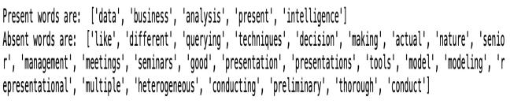

Figure 6: Present and absent words from a resume vs job description with a ratio of 0.7 of total keywords.

The above figure demonstrates the detection of labels for present and absent words within the resume by utilizing a ratio of 0.7 out of the total keywords present. This same ratio is applied to both the summarized resume and the original job description.
For instance, in the context of an entry-level data analyst role, it is anticipated that the keyword 'data' would likely be present in the resume, aligning with the corresponding keyword from the job description and thus falling under the present label. Conversely, if a required keyword from the job description, such as 'techniques', does not match with any keywords present in the summarized resume, it is categorized under the absent label. This approach is consistently applied to all keywords to determine their presence or absence.
In summary, this methodology provides both candidates and employers with an understanding of the percentage of skills present or absent. However, by employing the missing keywords method, candidates can identify areas where they should focus or enhance their knowledge, as these keywords are essential prerequisites for being considered suitable for an entry-level data analyst position.
- SKILL-WISE CLASSIFICATION

Text classification is a pivotal process in organizing textual data into distinct groups or categories. Leveraging techniques from Natural Language Processing (NLP), it assigns predefined tags or scores to each group, facilitating in-depth analysis. This method has demonstrated efficacy in handling unstructured data by creating meaningful groups or categories. Widely applied in tasks such as Sentiment Analysis, Language Detection, and Topic Detection, it finds relevance in this paper's context of structuring unstructured resumes. Here, the process involves creating dictionaries from a detailed job description outlining the requisite skills for an entry-level data analyst or data scientist. Subsequently, scores are assigned to each skill based on its relevance to the job requirements.
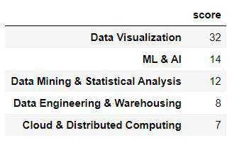
The following figure illustrates the implementation of five dictionaries on a sample of six resumes, wherein scores are assigned to each skill based on its relevance to the job role.

Figure 7: Skill-wise dictionaries for a data analyst along with scores for each dictionary.

As an entry-level data analyst, the job description sourced from indeed.com emphasizes the paramount importance of data visualization skills, reflected by the highest assigned score of 32. This prioritization aligns with the position's requirements, as proficiency in data cleaning, pre-processing, and basic exploratory data analysis is foundational. Conversely, Cloud and Distributed Computing receive the lowest score of 7, indicating that while crucial, mastery in other areas of data analysis precedes implementation of cloud and distributed systems. Each score is justified according to its relevance to the role.

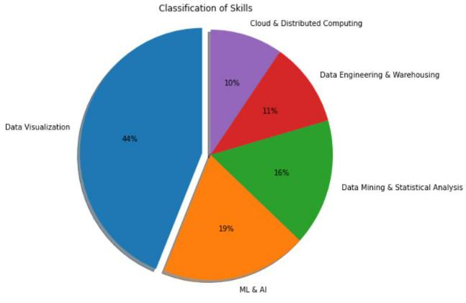

Figure 8: Pie Chart of a resume based on skill-wise dictionary
Upon assigning scores, resumes can be evaluated based on the created dictionaries. The subsequent pie chart illustrates the skill distribution within an individual's resume. In this case, the sample resume exhibits a dominant proficiency in data visualization, comprising 44% of the skill set, while Cloud Computing and Data Engineering skills are comparatively lower at 10% and 11%, respectively. Given the emphasis on high visualization skills in the job description, this candidate stands a chance of advancing to further interview rounds.
- SKILL-WISE COMPARISON

Text classification has proven invaluable in categorizing skills based on their significance in a sample resume. This methodology can be extended to analyse a larger pool of resumes, particularly given the competitive nature of today's job market. Evaluating resumes skill-wise enables employers to compare candidates more efficiently.
The study examined six resumes to classify skills using dictionaries. Figure 9 illustrates the keywords and their frequency across the six resumes for various skill dictionaries. For instance, candidate 1 has a count of 22 for the keyword "data" in the data visualization and data engineering dictionaries. Conversely, candidate 6 has a count of 1 for the keyword "design" in the data engineering dictionary.
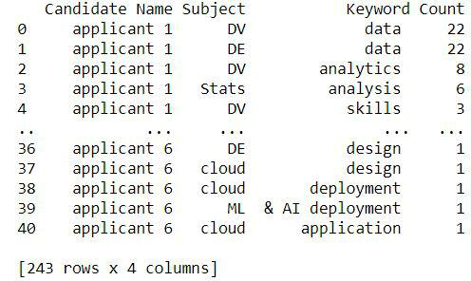

Figure 9: Keywords and counts for 6 resumes based on text classification.

With 243 rows of data, direct comparison becomes cumbersome. Therefore, Figure 10 presents a bar chart visualization of the six candidates' resumes, categorizing skills based on the five dictionaries created in Figure 7.

Observing the chart, candidate 1 emerges with the highest data visualization score (24), followed closely by candidate 4 with a score of 22. Employers seeking candidates proficient in data visualization are likely to favor candidate 1. Conversely, candidate 3 exhibits the lowest score (1) in cloud computing, while candidate 1 boasts the highest (7). This pattern applies across all skills, guiding employers in selecting candidates based on their skill proficiency.

Figure 10 represents different candidate’s skills in the form of a bar graph. It further highlights and compares two different candidates. This feature allows the hiring managers or company to compare different candidates based on the skill set defined. It makes the shortlisting process of candidates comparatively less complex

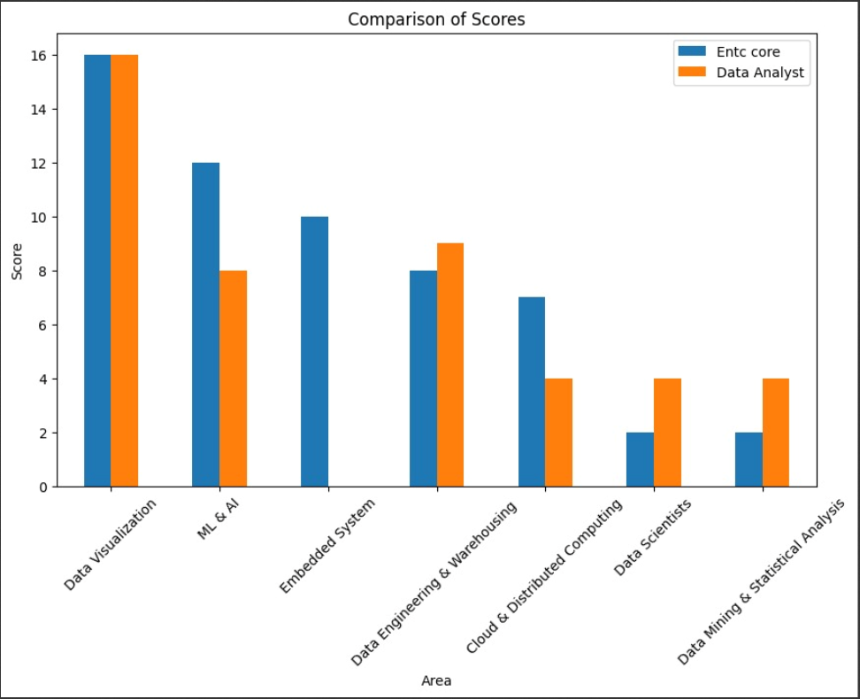
Figure 10: Bar chart for skill-wise comparison

CONCLUSION

Pattern matching, text summarization, text classification, skill-wise comparison, missing keyword checking, and spell checking are some of the techniques used in this research. The results are validated using the Cosine similarity score and the Jaccard dissimilarity score.
The purpose of the article was to improve the candidates' ability to predict with greater accuracy whether they would be hired or rejected in the future. This will be useful for recent graduates, in times of recession, hiring freezes, and unpredictability in pandemics. In the end, this results in a reduction in the number of employees and physical labour required by HR departments and organizations, making everyone's work simpler and more accurate than resume selection by hand.

The research concludes by suggesting useful resume analysis techniques that help applicants assess how well they match the job description, their chances of being hired or rejected, and the areas in which they may develop their talents in order to land a position. Furthermore, it is advantageous for an employer to select the best applicant who will strengthen their particular firm over time and fulfil their requirements.

LIMITATION

The only limitation in the proposed work is dictionary of words which are defined. Lot of other technical words can be added to it in order to make sure that the system correctly understands the technical words and correct their spelling if found incorrect.

FUTURE SCOPE

Increased attention should be paid to missing value keywords by indicating the precise percentage of missing data as well as resume and job description similarities.
Although the study concentrated on the topic of data analytics, it can be applied to any other industry job. Software engineering, product management, business development, sales, and other areas could be extensions.
In addition to phrase matchers, active action verbs are more likely to appear in resumes, so resumes can also be checked for them.

ACKNOWLEDGEMENT

We extend our sincere thanks to Dr. Rashmi Asthagi for her invaluable support and guidance throughout the development of this system. Her expertise, encouragement, and feedback have been instrumental in shaping our work. Dr. Asthagi's dedication to our success, along with her patience and commitment to excellence, have been a constant source of inspiration. We are deeply grateful for her belief in our abilities and her unwavering support at every stage of this project. Without her mentorship, this achievement would not have been possible.

REFRENCES

[1] Shiqiang Guo, 2015, Resumatcher: A Personlized Resume Matching System. https://oaktrust.library.tamu.edu/bitstream/handle/1969.1/154963/GUO-THESIS-2015.pdf?sequence=1

- Juneja Zubeda, Momin Shaheen, Gunduka Godavari, Sayed Naseem, 2016,

Resume Ranking using NLP and Machine Learning. https://core.ac.uk/download/pdf/55305289.pdf

- CountVectorizer in Python. Educative: Interactive Course for Software Developers, 2020. https://www.educative.io/edpresso/countvectorizer-in-python.

- Cosine Similarity – Understanding the math and how it work? (with python). ML+, 2020. https://www.machinelearningplus.com/nlp/cosine-similarity/.

- Baban Deep Singh, 2020, Summarizing and Matching. In Medium. https://towardsdatascience.com/resume-summarizing-and-matching-165840cf9f75

- Venkat Raman, 2020. How I used NLP (Spacy) to screen Data Science Resumes. In Medium. https://towardsdatascience.com/do-the-keywords-in-your-resume-aptly-represent-what-type-of-data-scientist-you-are-591314105ba0d.

