Contents
1. Introduction 1
2. Spark Session and Data Loading 1
3. Feature Engineering 1
4. Label Mapping 2
5. Assembling Features 2
6. Logistic Regression Model 2
7. Pipeline and Model Training 4
8. Predictions and Confidence Scores 4
9. Evaluation Metrics 4
10. Confusion Matrix and ROC Curve 5
11. Notes About Selection and Use of Logistic Regression Model 6
Appendix A – ML Model Backround 10
Appendix B – pySpark Notebook Code 12

1. Introduction
This document explains the logic and machine learning techniques used in the PySpark MLlib notebook designed to detect synthetic or test customers. The program uses logistic regression and evaluates model performance using metrics such as accuracy, precision, recall, F1 score, and AUC. It also visualizes the confusion matrix and ROC curve.

2. Spark Session and Data Loading
The notebook begins by initializing a Spark session and loading a labeled training dataset containing customer information. This dataset includes fields such as first_name, last_name, email, phone, date_of_birth, address, zip_code, company_name, and label (0 = real customer, 1 = test/synthetic customer).

3. Feature Engineering
Synthetic patterns are defined for various fields. Flags are created for each field based on the presence of known synthetic indicators. These flags are then summed to create a 'synthetic_score' feature.

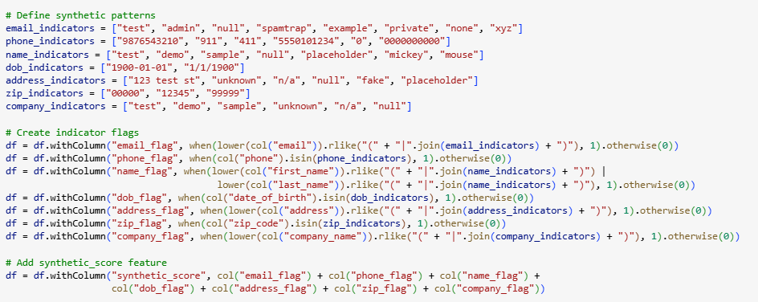

Feature engineering is the process of using domain knowledge to extract features from raw data. Learn more: https://en.wikipedia.org/wiki/Feature_engineering

4. Label Mapping
The label column is mapped such that real customers are labeled as 0 and synthetic customers as 1.

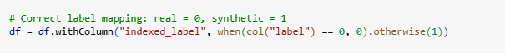

5. Assembling Features
The VectorAssembler combines all indicator flags and the synthetic_score into a single feature vector for model training.
VectorAssembler documentation: https://spark.apache.org/docs/latest/api/python/reference/api/pyspark.ml.feature.VectorAssembler.html

6. Logistic Regression Model
A logistic regression model is trained using the assembled features. The threshold is adjusted to 0.3 to improve sensitivity to synthetic customers.
Logistic regression is a statistical model used for binary classification. Learn more: https://en.wikipedia.org/wiki/Logistic_regression

The threshold in logistic regression determines the cutoff point for converting predicted probabilities into class labels (e.g., real vs. synthetic customer).

Possible Range
- The threshold can range from 0.0 to 1.0:
  - 0.0 → Every prediction will be classified as real (class 0), regardless of probability.
  - 1.0 → Every prediction will be classified as synthetic (class 1), regardless of probability.
  - Default is usually 0.5, meaning:
    - If probability ≥ 0.5 → predict real.
    - If probability < 0.5 → predict synthetic.

Usage
- Lowering the threshold (e.g., to 0.3):
  - Makes the model more sensitive to detecting synthetic customers.
  - More customers will be flagged as synthetic because the requirement for being classified as synthetic is easier to meet.
  - This increases recall for synthetic customers but may reduce precision (more false positives).
- Increasing the threshold (e.g., to 0.7):
  - Makes the model stricter about labeling synthetic customers.
  - Fewer customers will be flagged as synthetic, improving precision but reducing recall.

Why Adjust It?
- Threshold tuning is a business decision:
  - If missing a synthetic customer is costly → lower threshold to catch more.
  - If false alarms are costly → raise threshold to be more certain.

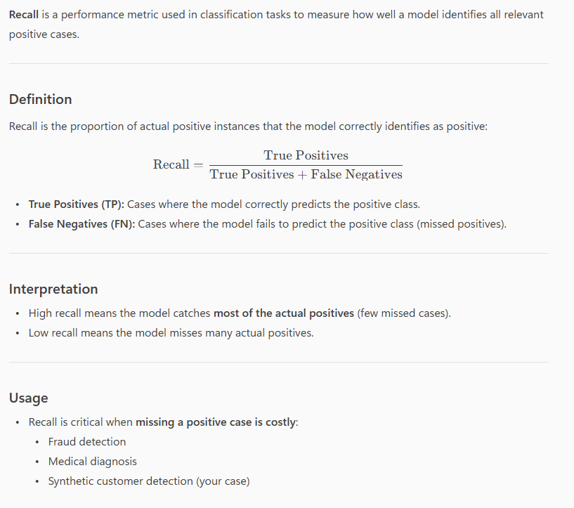

7. Pipeline and Model Training
A pipeline is built with the assembler and logistic regression stages. The dataset is split into training and test sets, and the model is trained on the training set.
Pipeline documentation: https://spark.apache.org/docs/latest/api/python/reference/api/pyspark.ml.Pipeline.html

8. Predictions and Confidence Scores
The model is applied to the full dataset. Predictions are made, and confidence scores for the real customer class are extracted.

9. Evaluation Metrics
The model is evaluated using accuracy, precision, recall, F1 score, and AUC.
Definitions:
- Accuracy: Proportion of correct predictions. https://en.wikipedia.org/wiki/Accuracy_and_precision

- Precision: Proportion of true positives among predicted positives. https://en.wikipedia.org/wiki/Precision_and_recall

- Recall: Proportion of true positives among actual positives. https://en.wikipedia.org/wiki/Precision_and_recall

- F1 Score: Harmonic mean of precision and recall. https://en.wikipedia.org/wiki/F1_score

- AUC: Area under the ROC curve. https://en.wikipedia.org/wiki/Receiver_operating_characteristic

10. Confusion Matrix and ROC Curve
The confusion matrix and ROC curve are visualized using matplotlib and sklearn.
- Confusion Matrix: https://en.wikipedia.org/wiki/Confusion_matrix
- ROC Curve: https://en.wikipedia.org/wiki/Receiver_operating_characteristic

11. Notes About Selection and Use of Logistic Regression Model

Although the indicator flags and synthetic_score already provide strong signals about whether a customer is synthetic or real, use of a logistic regression model on top of that adds the following value:

1. Formalizing Decision Boundaries
Even if synthetic_score = 8 is a strong indicator, not all cases are that clear-cut. The logistic regression model learns how much weight each flag contributes to the likelihood of being synthetic. For example:
- Maybe email_flag is more predictive than zip_flag.
- Maybe dob_flag alone is weak, but in combination with company_flag, it's strong.
This allows the model to generalize better across edge cases.

2. Probabilistic Output
The model gives a confidence score (probability) for each prediction. This is useful for:
- Threshold tuning (e.g., using 0.3 instead of 0.5 to catch more synthetics).
- Ranking customers by risk.
- Feeding downstream systems that need a probability, not just a binary label.

3. Handling Ambiguity
Some customers might have:
- synthetic_score = 3 (not obviously synthetic).
- Flags that conflict (e.g., real name but fake email).
The model helps resolve these ambiguous cases by learning from labeled data.

4. Evaluation and Monitoring
Using a model allows you to:
- Measure accuracy, precision, recall, F1, and AUC.
- Track performance over time.
- Detect drift if synthetic patterns change.

5. Extendability
You can easily:
- Add new features (e.g., behavioral signals).
- Retrain with new data.
- Swap in more complex models (e.g., random forest) if needed.

Summary
Even though the flags and score are strong heuristics, the logistic regression model:
- Learns optimal weights
- Handles edge cases
- Provides confidence scores
- Supports evaluation and monitoring
- Enables future extensibility

Notebook Output:
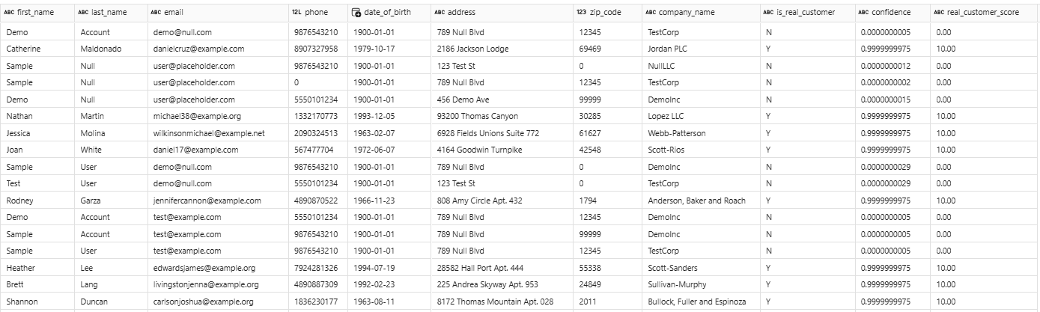
The confidence column is showing the probability that the customer is real (class 0).
- When is_real_customer = Y, the probability is very high (close to 1.0), meaning the model is almost certain the customer is real.
- When is_real_customer = N, the probability is extremely small (close to 0.0), meaning the model is almost certain the customer is synthetic.
The real_customer_score column is showing a normalized or scaled representation of the model’s confidence, designed to make interpretation easier for downstream systems or business users.
Here’s what it is showing:
- It converts the raw probability (from the confidence column) into a score range, often from 0.00 to 10.00.
- A higher score means the model is more confident the customer is real.
- A lower score means the model is more confident the customer is synthetic.
For example:
- If confidence ≈ 0.9999 (almost certain real), then real_customer_score = 10.00.
- If confidence ≈ 0.0001 (almost certain synthetic), then real_customer_score = 0.00.
- Intermediate probabilities (e.g., 0.5) would map to around real_customer_score = 5.00.

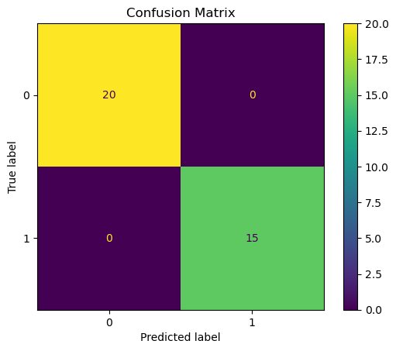
The confusion matrix is a 2×2 matrix for a binary classification problem.
Structure of the Matrix
- Rows represent the True Labels (actual classes).
- Columns represent the Predicted Labels (model predictions).
Values in the Matrix
- Top-left (20): True Negative (TN)
The model correctly predicted class 0 when the actual class was 0.
There are 20 such cases.
- Top-right (0): False Positive (FP)
The model predicted 1 when the actual class was 0.
There are 0 such cases.
- Bottom-left (0): False Negative (FN)
The model predicted 0 when the actual class was 1.
There are 0 such cases.
- Bottom-right (15): True Positive (TP)
The model correctly predicted class 1 when the actual class was 1.
There are 15 such cases.

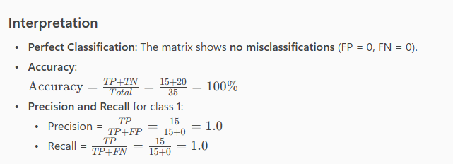
Summary: This confusion matrix indicates that the model achieved perfect performance on this dataset—every prediction was correct.
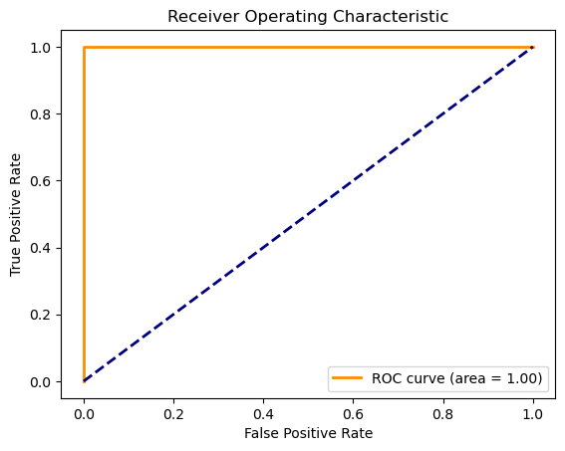
The Receiver Operating Characteristic (ROC) curve is a graphical representation used to evaluate the performance of a binary classification model.
Here’s what it provides:
Key Elements in the Image
- X-axis: False Positive Rate (FPR) – proportion of negative cases incorrectly classified as positive.
- Y-axis: True Positive Rate (TPR) – proportion of positive cases correctly classified (also called sensitivity or recall).
- Orange Curve: The ROC curve for the model.
- Diagonal Blue Line: Represents a random classifier (baseline performance).
- Area Under Curve (AUC): Displayed as 1.00 in the legend.
Interpretation
- The ROC curve is almost a perfect right angle hugging the top-left corner.
- AUC = 1.00 indicates perfect classification performance:
  - The model achieves 100% sensitivity and specificity.
  - No false positives or false negatives.
- The diagonal line is the reference for random guessing (AUC = 0.5). The orange curve being far above this line shows the model is much better than random.
What It Tells You
- The classifier is ideal for the given dataset.
- It perfectly separates the two classes without error.
- This could happen if:
  - The dataset is very simple or separable.
  - There might be overfitting if this is on training data.

Appendix A – ML Model Backround
An ML model is the output of a machine learning algorithm that has been trained on data. It encapsulates what the system has learned from the data and is used to make predictions or decisions without being explicitly programmed to perform the task. ML models can be categorized by learning approach and type.

- Supervised Learning and Unsupervised Learning are the two primary approaches
- Supervised Learning involves the use of labeled datasets that are designed to train or “supervise” algorithms into classifying data or predicting outcomes accurately.
  - Using labeled inputs and outputs, the model can measure its accuracy and learn over time.
  - Supervised learning can be separated into two types of problems when data mining: classification and regression.
    - Classification problems use an algorithm to accurately assign test data into specific categories.
    - Regression is uses an algorithm to understand the relationship between dependent and independent variables.
- Unsupervised Learning uses algorithms to analyze and cluster unlabeled datasets to discover hidden patterns in data without the need for human intervention (hence, they are “unsupervised”).
  - Clustering is a data mining technique for grouping unlabeled data based on their similarities or differences.

- The main difference between supervised and unsupervised learning is one uses labeled data to help predict outcomes, while the other does not.

- Another way to think about these model types is in terms of the question they try to answer:
  - How much? for Regression, Which of two? For Binary Classification, Which of many for Multi-class Classification, and What is it most like? For Clustering.

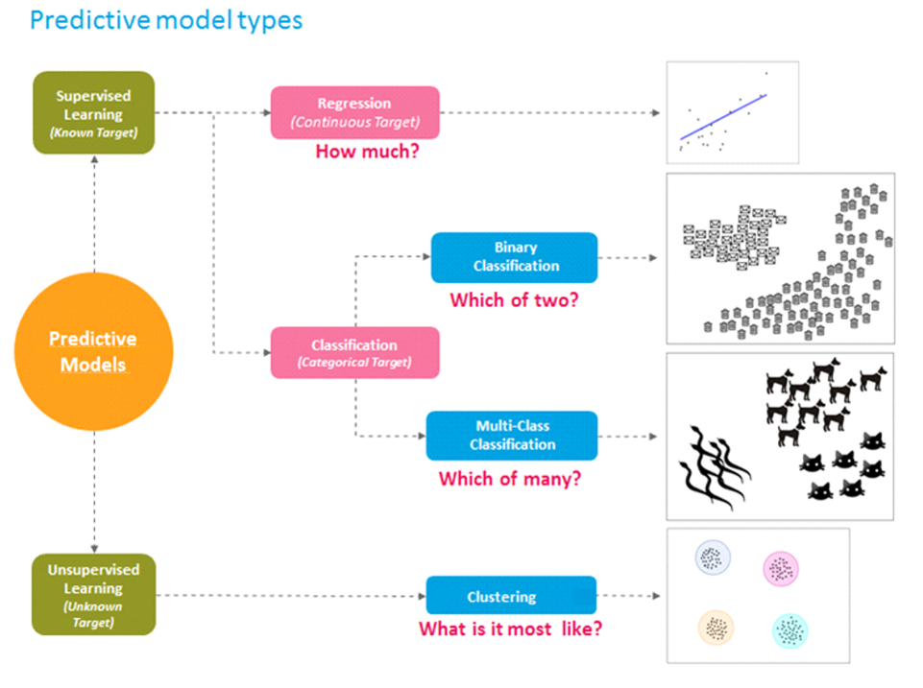

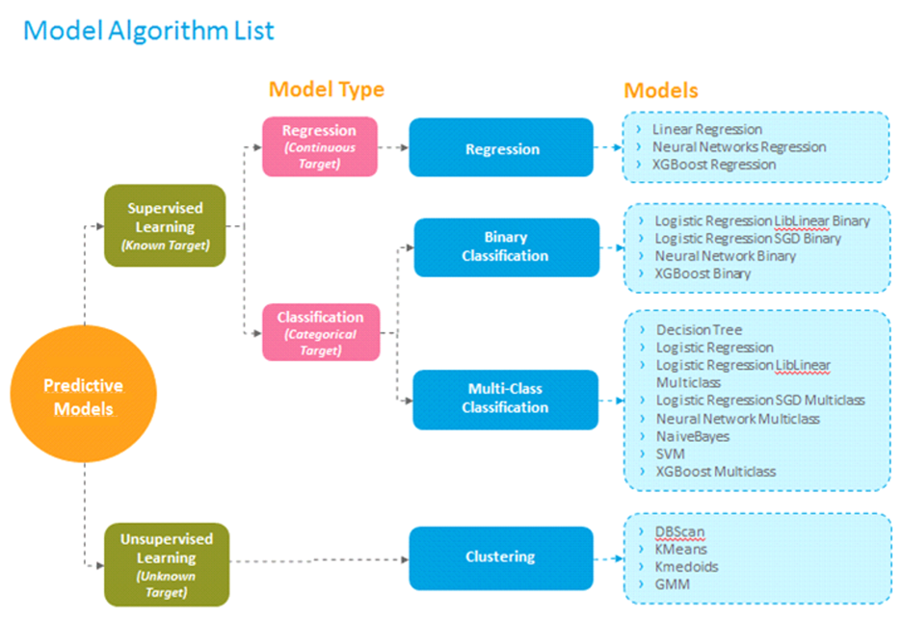

Appendix B – pySpark Notebook Code

#---------------------------------------------------------------------
# Name: run_stage_load.ipynb
#---------------------------------------------------------------------
# Purpose: Stages registered files from the landing zone to
# delta stage tables in the bronze layer using expected
# schema and source attributes from the meta data.
#---------------------------------------------------------------------
# ver. | date | author | change
#---------------------------------------------------------------------
# v1 | 10/28/25 | K. Hardis | Initial Version.
#---------------------------------------------------------------------

# Standard library
import sys
import fnmatch
import os
import re

# PySpark SQL functions
from pyspark.sql.functions import col, current_timestamp, lit

# PySpark types
from datetime import datetime

sys.path.append("./builtin")

# External Modules
import shared_context as sc
import mlUtil as ml

import importlib

# Force reload in case modules were cached
importlib.reload(sc)

# Log external module versions
from log_module_versions import log_module_versions
log_module_versions(["shared_context","mlUtil"])

print('||-------------run_stage_load.ipynb--------------||')
print('||-----')

# Create spark shared context
ctx = sc.SparkContextWrapper(spark)

# Load all REGISTERED files
registered_files_df = ctx.spark.sql("""
SELECT * FROM lk_cdsa_bronze.meta_db.data_file
WHERE file_status = 'REGISTERED'
""")

staged_count = 0
for file_row in registered_files_df.collect():
try:
file_id = file_row.file_id
filename = file_row.filename
object_id = file_row.object_id
source_id = file_row.object_id
batch_id = file_row.batch_id
landing_directory = file_row.file_path

full_path = f"abfss://CDSA@onelake.dfs.fabric.microsoft.com/lk_cdsa_landing_zone.Lakehouse{landing_directory}/{filename}"
print(f"\n|| Processing file_id: {file_id}")
print(f"|| Filename: {filename}")
print(f"|| Full path: {full_path}")

# Load source attributes
source_attr_df = ctx.spark.sql(f"""
SELECT *, sf.source_id as source_feed_id, t.target_id as target_object_id
FROM lk_cdsa_bronze.meta_db.source s
JOIN lk_cdsa_bronze.meta_db.data_object do ON s.source_id = do.object_id
LEFT JOIN lk_cdsa_bronze.meta_db.source_feed sf ON s.source_id = sf.source_id
LEFT JOIN lk_cdsa_bronze.meta_db.target t ON sf.target_object_name = t.target_name
WHERE s.source_id = '{source_id}'
""")

if source_attr_df.count() == 0:
print(f"|| Skipping file_id {file_id}: No source attributes found.")
continue

source_row = source_attr_df.first()
column_delimiter = source_row.column_delimiter or ","
stage_name = source_row.stage_name

# Generate stage table name
stage_table_name_df = ctx.spark.sql(f"""
SELECT UPPER(LOWER(c.stage_name) || '_' || RIGHT('0000000' || CAST(a.file_id AS STRING), 7)) AS table_name
FROM lk_cdsa_bronze.meta_db.data_file a
JOIN lk_cdsa_bronze.meta_db.source c ON a.object_id = c.source_id
WHERE a.file_id = {file_id}
""")
stage_table_name = stage_table_name_df.first()["table_name"]
print(f"|| Stage table name: {stage_table_name}")

# Get source feed columns
feed_columns_df = ctx.spark.sql(f"""
SELECT column_name, data_type, max_length, scale
FROM lk_cdsa_bronze.meta_db.source_feed_column
WHERE source_id = '{source_id}'
ORDER BY ordinal_position, column_id
""")
feed_columns = feed_columns_df.collect()

# Load file
df = ctx.spark.read \
.option("header", True) \
.option("delimiter", column_delimiter) \
.csv(full_path)

print(f"|| Records read from file: {df.count()}")

# Normalize column names
df = df.toDF(*[col_name.lower() for col_name in df.columns])

# Check for schema mismatch
expected_columns = [row.column_name.lower() for row in feed_columns]
df_columns = [col.lower() for col in df.columns]

if set(expected_columns) != set(df_columns):
print(f"|| Schema mismatch for file_id {file_id}.")
print(f"|| Expected columns: {expected_columns}")
print(f"|| Found columns: {df_columns}")
continue

# Cast columns to expected types
for row in feed_columns:
col_name = row.column_name.lower()
expected_type = row.data_type.lower()

if expected_type == "decimal":
df = df.withColumn(col_name, col(col_name).cast(f"decimal({int(row.max_length)},{int(row.scale)})"))
elif expected_type in ["char", "varchar", "string"]:
df = df.withColumn(col_name, col(col_name).cast("string"))
elif expected_type in ["bigint", "long"]:
df = df.withColumn(col_name, col(col_name).cast("long"))
elif expected_type in ["int", "integer"]:
df = df.withColumn(col_name, col(col_name).cast("int"))
elif expected_type == "double":
df = df.withColumn(col_name, col(col_name).cast("double"))
elif expected_type == "float":
df = df.withColumn(col_name, col(col_name).cast("float"))
elif expected_type == "boolean":
df = df.withColumn(col_name, col(col_name).cast("boolean"))
elif expected_type == "date":
df = df.withColumn(col_name, col(col_name).cast("date"))
elif expected_type == "timestamp":
df = df.withColumn(col_name, col(col_name).cast("timestamp"))
else:
df = df.withColumn(col_name, col(col_name).cast("string")) # fallback

# Reorder columns
df = df.select(*expected_columns)

# Create stage table
column_defs = []
for row in feed_columns:
col_name = row.column_name.lower()
data_type = row.data_type.lower()

if data_type in ["char", "varchar"]:
col_def = f"{col_name} string"
elif data_type == "decimal":
col_def = f"{col_name} decimal({int(row.max_length)},{int(row.scale)})"
else:
col_def = f"{col_name} {data_type}"

column_defs.append(col_def)

# Add real_customer_score as float
column_defs.append("real_customer_score float")

create_table_sql = f"""
CREATE TABLE IF NOT EXISTS lk_cdsa_bronze.bronze_db.{stage_table_name} (
{', '.join(column_defs)}
) USING DELTA
"""
ctx.spark.sql(create_table_sql)

mapping_rules = {
"first_name": ["first", "firstname", "first_name"],
"last_name": ["last", "lastname", "last_name"],
"email": ["email"],
"date_of_birth": ["dob", "date_of_birth"],
"address": ["street_address", "address"],
"zip_code": ["postal", "zip", "zip_code"],
"company_name": ["company", "company_name"],
"phone": ["phone", "phone_number"]
}

column_map = {}
for model_col, patterns in mapping_rules.items():
for col in df.columns:
if any(re.fullmatch(pattern, col, re.IGNORECASE) for pattern in patterns):
column_map[col] = model_col
break

print(f"|| Scoring staged customers in {stage_table_name}")
model_path = "abfss://CDSA@onelake.dfs.fabric.microsoft.com/lk_cdsa_landing_zone.Lakehouse/Files/ml_models/synthetic_customer_logistic_model"
scored_df = ml.score_customers(df, model_path, column_map)
print(f"|| real_customer_score appended to {stage_table_name}")

reverse_column_map = {v: k for k, v in column_map.items() if v}
for std_col, orig_col in reverse_column_map.items():
if std_col in scored_df.columns:
scored_df = scored_df.withColumnRenamed(std_col, orig_col)

# Get original column names
original_columns = df.columns

# Select only original columns + real_customer_score from scored_df
df = scored_df.select(*original_columns, "real_customer_score")

# Write to stage table
output_table = f"lk_cdsa_bronze.bronze_db.{stage_table_name}"
df.write.format("delta").mode("append").saveAsTable(output_table)

row_count = df.count()
print(f"|| Records staged to {stage_table_name}: {row_count}")

# Update metadata
ctx.spark.sql(f"""
UPDATE lk_cdsa_bronze.meta_db.data_file
SET row_count = {row_count}, file_status = 'COMPLETED'
WHERE file_id = {file_id}
""")

print(f"|| Staged file_id {file_id} successfully.")
staged_count += 1

except Exception as e:
print(f"|| Error processing file_id {file_row.file_id}: {str(e)}")

# Final output
if staged_count == 0:
print("|| No REGISTERED files were staged.")
print("||----------------SKIPPED----------------||")
else:
print(f"|| Stage load completed successfully for {staged_count} file(s).")
print("||----------------SUCCESS----------------||")

print('||-----')

# ------------------------------------------------------------------------------------------------------------------
# mlUtil.py
# ------------------------------------------------------------------------------------------------------------------

__version__ = "ml_1.0"

from pyspark.ml import PipelineModel
from pyspark.sql.functions import col, lower, lit, when, udf, format_number, round
from pyspark.sql.types import DoubleType

successCode = 0
errorCode = 1
InvalidArgsCode = 2
failedStr = 'FAILED'
completedStr = 'COMPLETED'

def score_customers(df, model_path, column_map=None):
"""
Scores customer records using a trained logistic regression model and adds real_customer_score (0.00–10.00).

Parameters:
----------
df : DataFrame
Input PySpark DataFrame containing staged customer data.
model_path : str
Path to the trained PipelineModel in Fabric (ABFSS path).
column_map : dict (optional)
Mapping of source columns to model feature names. Example:
{
"firstname": "first_name",
"lastname": "last_name",
"email": "email",
"dob": "date_of_birth",
"street_address": "address",
"postal": "zip_code",
"company": "company_name",
"phone": "phone"
}

Returns:
-------
DataFrame
Original DataFrame with an additional column: real_customer_score.
"""

try:
# Default column mapping if none provided
if column_map is None:
column_map = {
"firstname": "first_name",
"lastname": "last_name",
"email": "email",
"dob": "date_of_birth",
"street_address": "address",
"postal": "zip_code",
"company": "company_name",
"phone": "phone"
}

# Rename or create missing columns
for src_col, target_col in column_map.items():
if src_col in df.columns:
df = df.withColumnRenamed(src_col, target_col)
elif target_col not in df.columns:
df = df.withColumn(target_col, lit("")) # placeholder if missing

# Indicator patterns
email_indicators = ["test", "admin", "null", "spamtrap", "example", "private", "none", "xyz"]
phone_indicators = ["9876543210", "911", "411", "5550101234", "0", "0000000000"]
name_indicators = ["test", "demo", "sample", "null", "placeholder", "mickey", "mouse"]
dob_indicators = ["1900-01-01", "1/1/1900"]
address_indicators = ["123 test st", "unknown", "n/a", "null", "fake", "placeholder"]
zip_indicators = ["00000", "12345", "99999"]
company_indicators = ["test", "demo", "sample", "unknown", "n/a", "null"]

# Create indicator flags
df = df.withColumn("email_flag", when(lower(col("email")).rlike("(" + "|".join(email_indicators) + ")"), 1).otherwise(0))
df = df.withColumn("phone_flag", when(col("phone").isin(phone_indicators), 1).otherwise(0))
df = df.withColumn("name_flag", when(lower(col("first_name")).rlike("(" + "|".join(name_indicators) + ")") |
lower(col("last_name")).rlike("(" + "|".join(name_indicators) + ")"), 1).otherwise(0))
df = df.withColumn("dob_flag", when(col("date_of_birth").isin(dob_indicators), 1).otherwise(0))
df = df.withColumn("address_flag", when(lower(col("address")).rlike("(" + "|".join(address_indicators) + ")"), 1).otherwise(0))
df = df.withColumn("zip_flag", when(col("zip_code").isin(zip_indicators), 1).otherwise(0))
df = df.withColumn("company_flag", when(lower(col("company_name")).rlike("(" + "|".join(company_indicators) + ")"), 1).otherwise(0))

# Add synthetic_score
df = df.withColumn("synthetic_score",
col("email_flag") + col("phone_flag") + col("name_flag") +
col("dob_flag") + col("address_flag") + col("zip_flag") + col("company_flag"))

# Load trained model
model = PipelineModel.load(model_path)

# Apply model
predictions = model.transform(df)

# Extract confidence for real class (index 0)
extract_confidence = udf(lambda v: float(v[0]), DoubleType())
predictions = predictions.withColumn("confidence", extract_confidence(col("probability")))

# Convert confidence to score between 0.00 and 10.00
predictions = predictions.withColumn("real_customer_score", round((col("confidence") * 10.0), 1).cast("float"))

return predictions

except Exception as e:
errorStr = 'ERROR (score_customers)' + str(e)
print(errorStr)
raise

