CEHv13 — MODULE 06
SYSTEM HACKING
Practical Lab Report
Gaining Access, Privilege Escalation, Buffer Overflow Analysis,
Endpoint Monitoring and Network Reconnaissance
Prepared by: Dhruva
Course: Certified Ethical Hacker (CEH) v13
Module: 06 — System Hacking
Date: July 27, 2026
Environment: iLabs / Isolated CEH Practice Range
Classification: Internal Training Use Only

1. Executive Summary
This report documents the practical exercises completed under Module 06 (System Hacking) of the CEH v13 curriculum, performed within an isolated training range. The objective of the module was to gain hands-on experience with the core phases of the system hacking lifecycle: gaining access, escalating privileges, maintaining access, and clearing tracks — using industry-standard offensive tooling against dedicated lab targets. All activity described below was carried out strictly within the authorized lab environment against systems provisioned for this purpose; no production systems or third-party assets were involved.
The exercises covered remote shell delivery using a PowerShell-based reverse-shell generator, privilege escalation and session handling with the Metasploit Framework, buffer-overflow crash analysis using Immunity Debugger, an assessment of a commercial endpoint-monitoring product, Windows event-log enumeration, network/RDP reconnaissance, and the use of an AI-assisted command-line shell to accelerate exploitation workflow. The assessment concluded with a knowledge-check exam, in which a score of 80% (8 out of 10) was achieved.

2. Lab Environment
The following systems and addressing scheme were used throughout the exercises:
Attacker Machine | Parrot Security OS — 10.10.1.13
Target 1 | Windows 11 — 10.10.1.11 (hostname: WINDOWS11)
Target 2 | Windows Server 2019 — 10.10.1.19 (hostname: SERVER2019)
Target 3 | Windows Server 2022 — 10.10.1.22 (hostname: SERVER2022, domain: CEH.com)
Target 4 | Windows machine "MARK" — 10.10.1.40 (domain: CEH.com)
Primary Tools | HoaxShell, Metasploit Framework, Immunity Debugger, Nmap, Crowbar/Hydra, ShellGPT, Refog

3. Remote Access via Reverse Shell Generator (HoaxShell)
The Online Reverse Shell Generator was used to build a PowerShell-based HoaxShell payload targeting the attacker listener at 10.10.1.13 on port 4444. HoaxShell is an unconventional shell payload framework that uses HTTP request/response cycles instead of a raw TCP socket, which allows it to bypass many traditional AV/EDR signatures that look for classic reverse-shell network patterns.
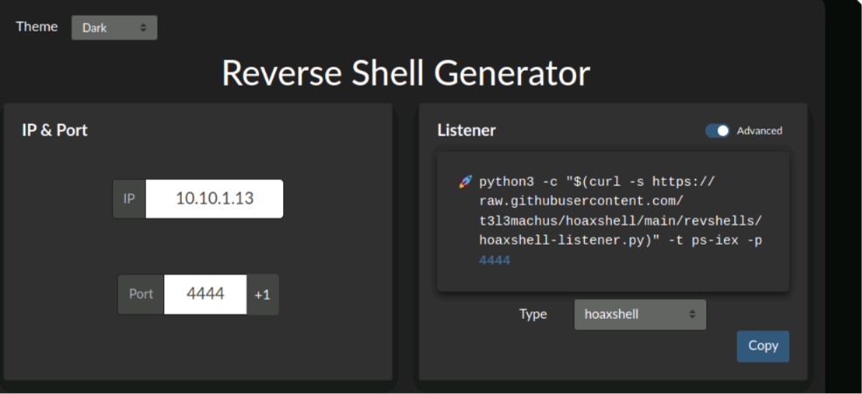
Figure 1 — Reverse Shell Generator configured for IP 10.10.1.13, port 4444, payload type: HoaxShell.
The generator produced a PowerShell one-liner that repeatedly polls the listener over HTTP, executes any returned command via IEX (Invoke-Expression), and POSTs the result back with an Authorization header used as a session token.
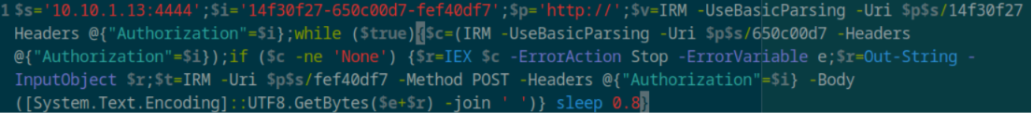
Figure 2 — Generated PowerShell IEX polling loop (session token, command retrieval, and result POST-back).
After executing the payload on the Windows 11 target, the HoaxShell listener on Parrot Security confirmed session establishment and returned an interactive-style command prompt. A whoami check confirmed code execution context as Jason on the WINDOWS11 host.
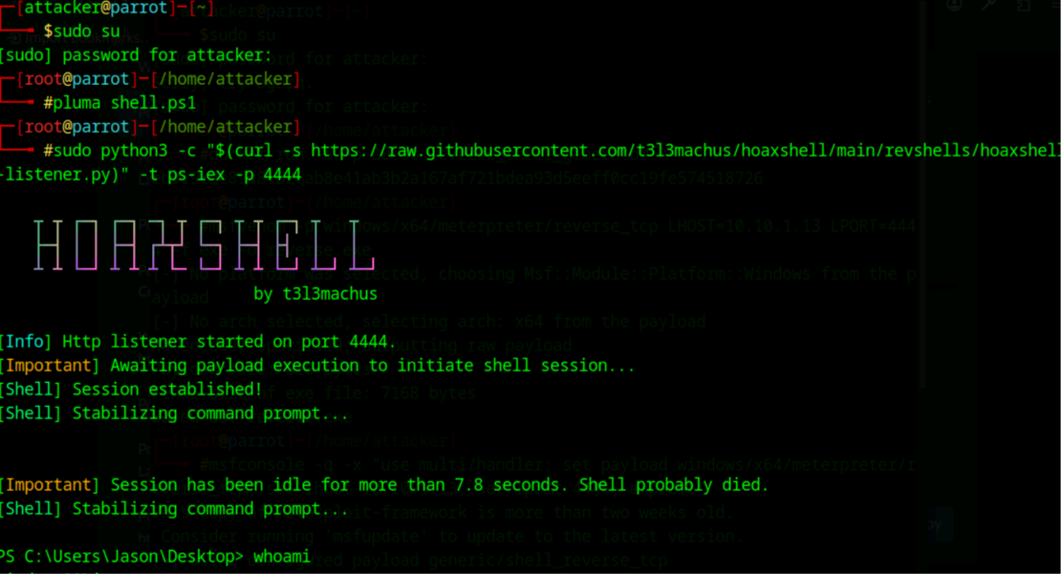
Figure 3 — HoaxShell listener: session established and command prompt stabilized on Windows 11 (whoami confirms user context).

Key takeaway
- Payload type selected under the HoaxShell tab: PowerShell IEX.
- HoaxShell's HTTP polling model demonstrates how command-and-control channels can blend into normal web traffic.

4. Privilege Escalation & Remote Access via Metasploit (Meterpreter)
The Metasploit Framework's multi/handler module was configured with a windows/x64/meterpreter/reverse_tcp payload (LHOST 10.10.1.13, LPORT 4444) to catch a staged Meterpreter session from the Windows 11 target.
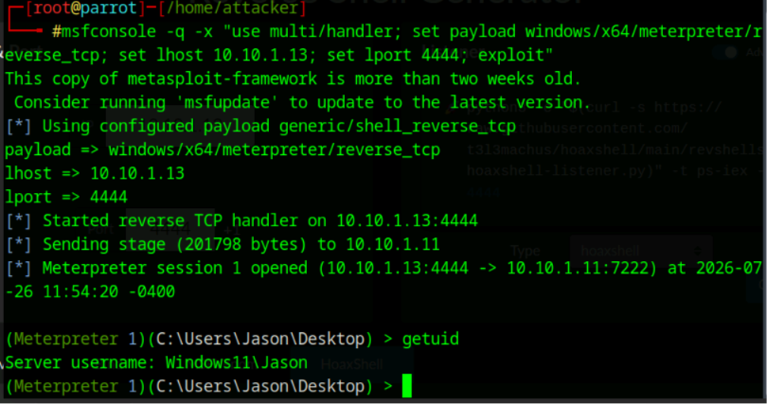
Figure 4 — msfconsole multi/handler catching a Meterpreter session; getuid confirms Windows11\\Jason.
Once the session opened, a getuid check confirmed the session was running in the context of the Jason account on the Windows11 host, validating that the delivered stage executed successfully and that the handler correctly matched the payload architecture and transport.

5. Buffer Overflow Analysis — Vulnserver
Using the Parrot Security machine (10.10.1.13) as the attacking host and Windows 11 (10.10.1.11) as the target, the intentionally vulnerable vulnserver.exe application (located under D:\CEH-Tools\CEHv13 Module 06 System Hacking\Buffer Overflow Tools\vulnserver) was attached to Immunity Debugger for crash analysis.
A Python fuzzing/overwrite script (overwrite.py) was used to determine whether the EIP (Instruction Pointer) register could be reliably overwritten with attacker-controlled data — the essential precondition for building a working buffer-overflow exploit.
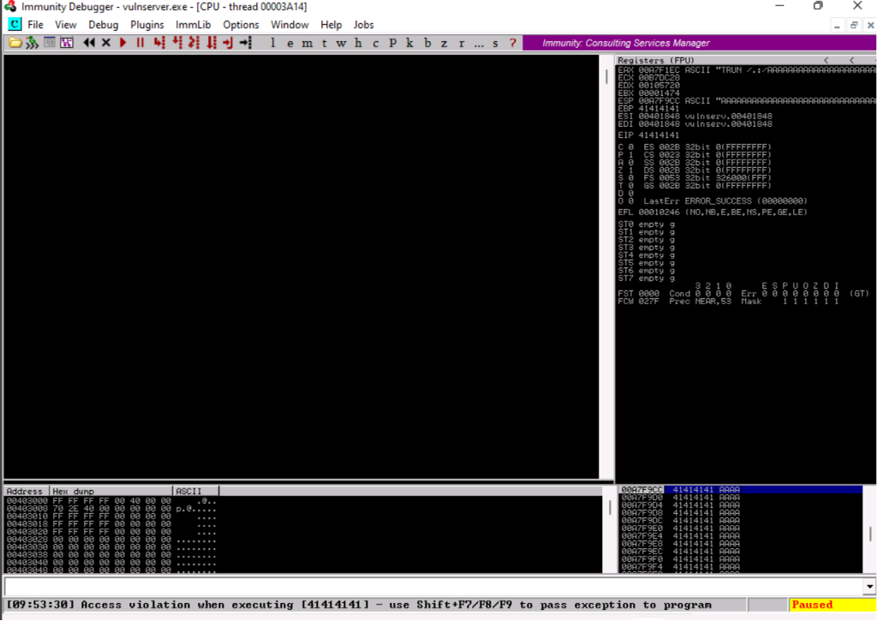
Figure 5 — Immunity Debugger: EIP fully overwritten with the pattern 0x41414141 ("AAAA"), confirming full control of the instruction pointer.
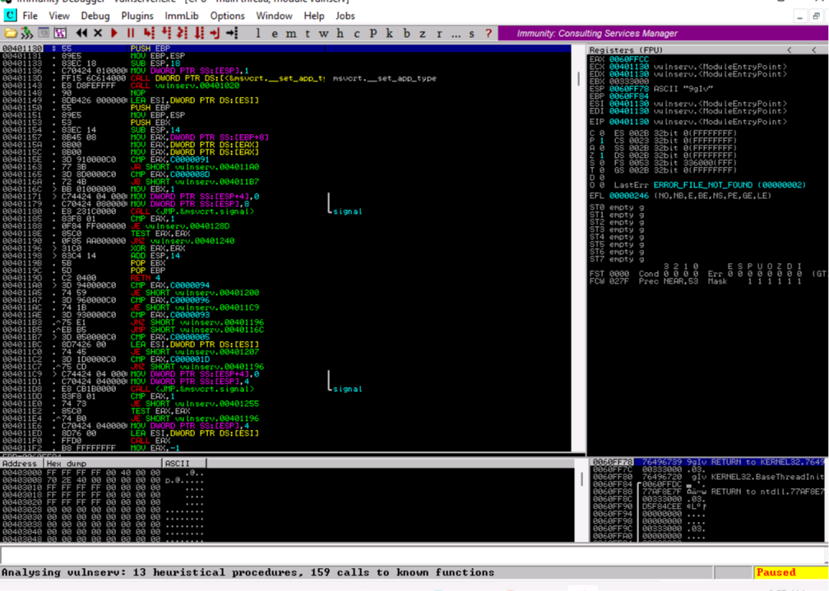
Figure 6 — Static disassembly of vulnserv.exe in Immunity Debugger, used to map function entry points and calling conventions ahead of exploit development.

Key takeaway
- Script used to verify EIP control: overwrite.py.
- A clean 0x41414141 overwrite of EIP confirms the offset is correct and that the crash is exploitable, forming the foundation for later JMP ESP / return-address redirection stages.

6. Endpoint Monitoring Software Assessment (Refog)
As part of understanding commercial monitoring/spyware tooling and its use in maintaining access and post-exploitation surveillance, the Refog "Personal Monitor for Windows" product page was reviewed on the Windows Server 2022 machine. The download page listed the current build (v9.6.0.5100) along with an archive password required to extract the installer package.
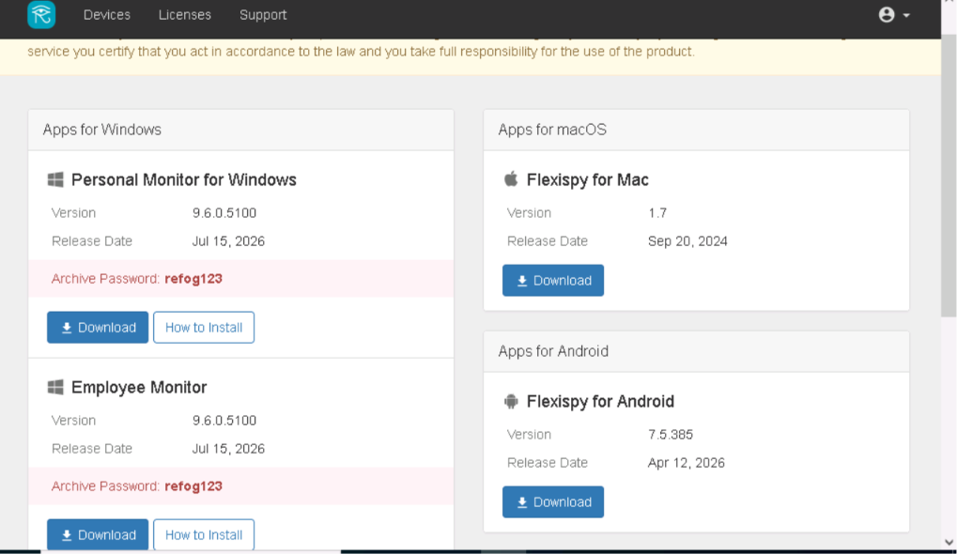
Figure 7 — Refog download portal listing Personal Monitor / Employee Monitor builds with the archive extraction password.
The archive password displayed for the downloadable package was refog123. Separately, the Refog web dashboard was reviewed to illustrate the type of telemetry such software captures once deployed on an endpoint — in this case, periodic desktop screenshots and browser/search activity for the monitored account "MARK".
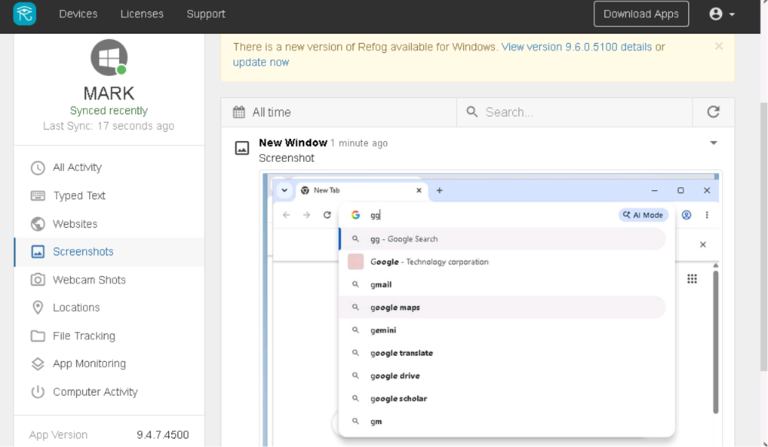
Figure 8 — Refog dashboard showing synced activity for user MARK, including a captured browser screenshot.

7. Windows Event Log Enumeration
On the compromised Windows host, the built-in wevtutil utility was used from an elevated command prompt to enumerate the full list of available Windows Event Log channels. This step supports both defensive log-review work and the "covering tracks" phase of the system-hacking lifecycle, since it identifies which channels (Security, System, Application, and numerous component-specific Analytic/Operational/Debug logs) would need to be reviewed or cleared to remove evidence of an intrusion.
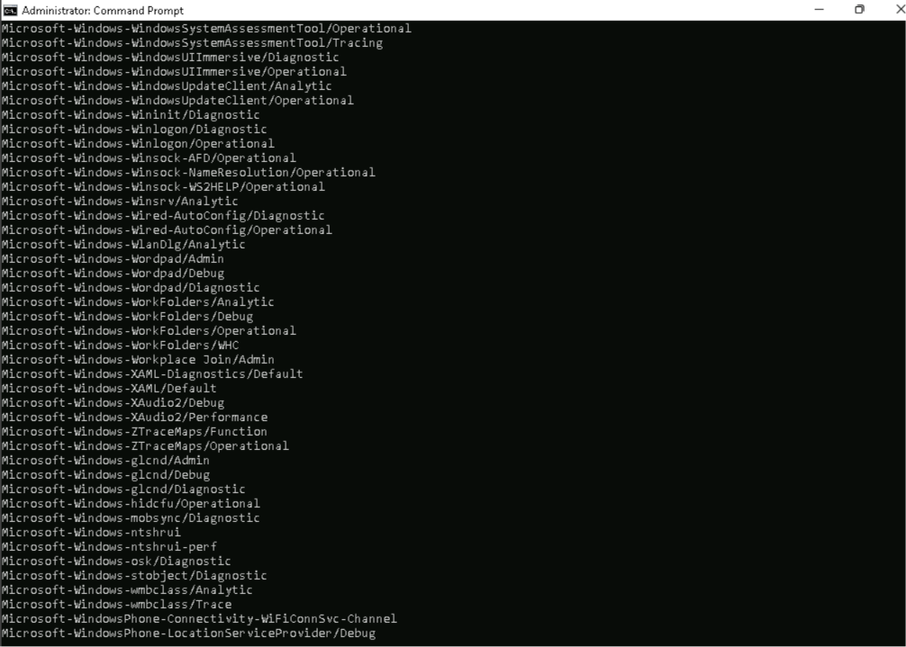
Figure 9 — Enumeration of Windows Event Log channels via wevtutil from an elevated command prompt.

8. Network Reconnaissance & RDP Credential Auditing
Nmap was used with NTLM/RDP enumeration scripts to fingerprint the CEH.com domain infrastructure. The scan against 10.10.1.22 (SERVER2022) returned NetBIOS and DNS domain information, the server's DNS hostname, product build (10.0.20348), and a self-signed TLS certificate bound to the RDP service — useful for confirming host identity and domain membership prior to further attack.
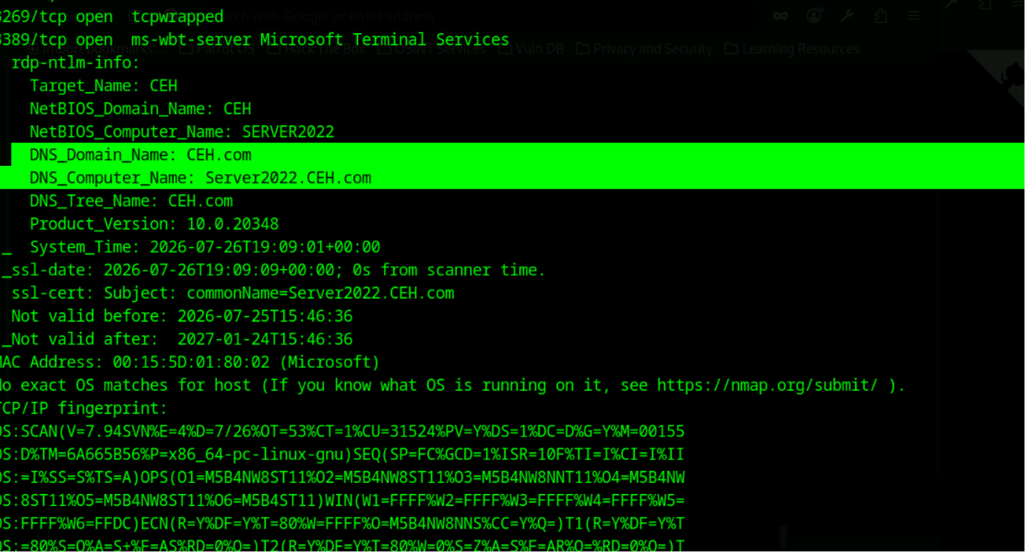
Figure 10 — Nmap rdp-ntlm-info script output identifying domain CEH.com and host SERVER2022.
A credential-spraying pass against RDP (port 3389) was then run across all discovered Windows hosts (WINDOWS11, SERVER2019, SERVER2022, and MARK) using a common candidate password. Most attempts returned STATUS_LOGON_FAILURE, illustrating both the tool's brute-force workflow and the importance of account lockout policies and strong password requirements in a hardened environment.
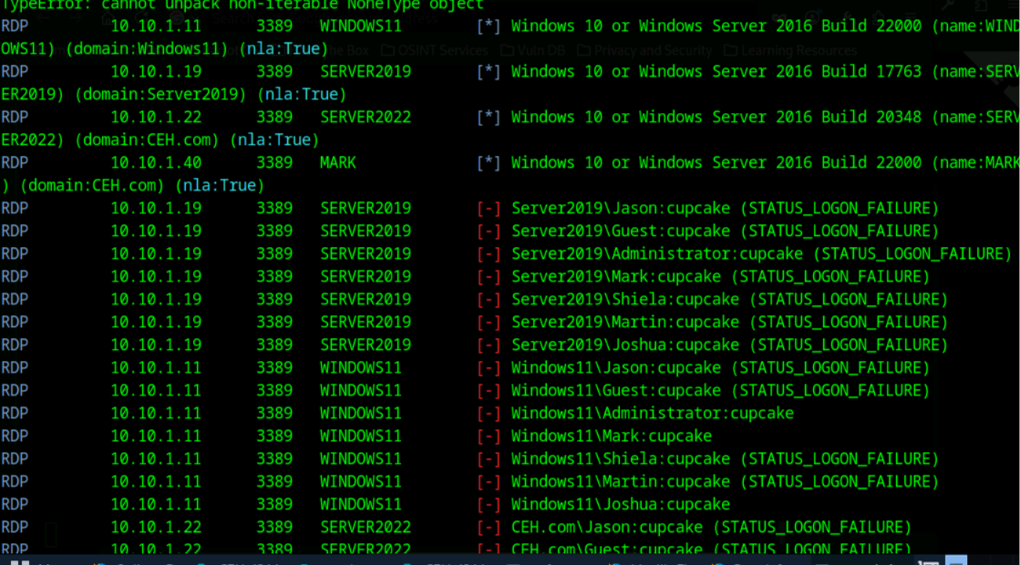
Figure 11 — RDP host discovery via Nmap followed by an automated credential-spraying pass across enumerated hosts.

9. AI-Assisted Exploitation Workflow (ShellGPT)
To evaluate how AI-assisted command-line tools can accelerate routine offensive-security tasks, ShellGPT (sgpt --shell) was used to translate a natural-language instruction — "start the Metasploit console, configure a listener for a Windows reverse TCP payload, then run the exploit as a background job" — directly into the correct msfconsole command sequence.
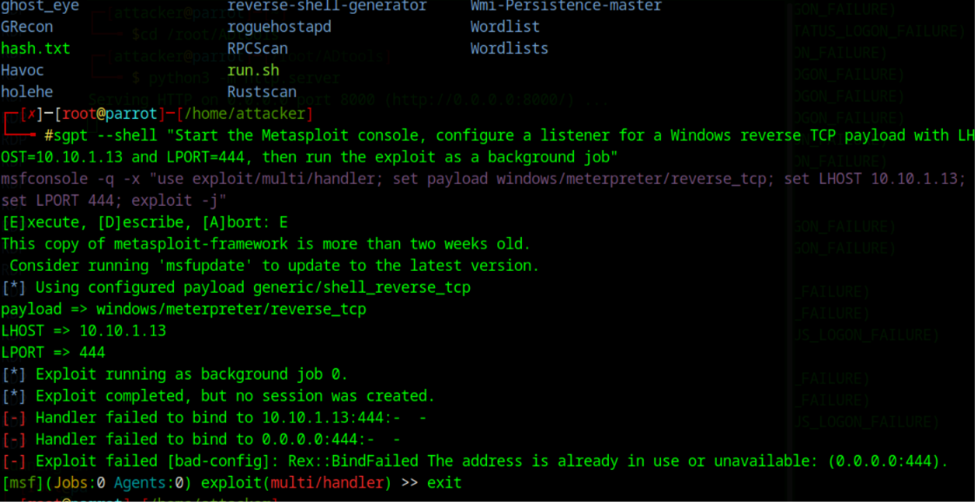
Figure 12 — ShellGPT generating and executing an msfconsole multi/handler background-job command from a natural-language prompt.
The generated command was syntactically correct; the resulting bind failure ("Address already in use") was caused by the listener port already being bound by a handler from an earlier exercise, not by an error in the AI-generated syntax. This highlights both the productivity benefit and the operational judgment still required when using AI-assisted tooling — generated commands still need to be validated against the current environment state.

10. Assessment Results
The module concluded with a scored knowledge-check exam covering the tasks performed above. A summary of the graded responses and overall performance is provided below.
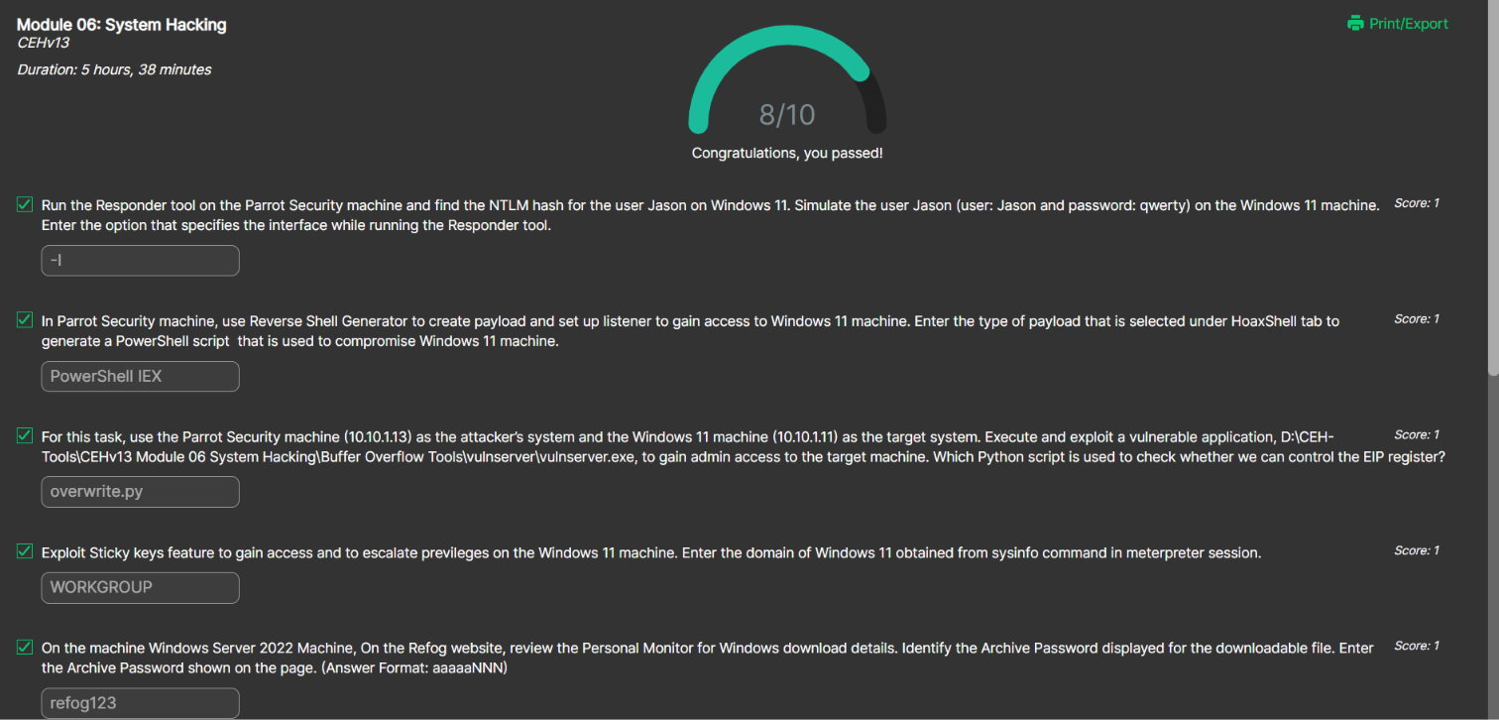
Figure 13 — Module 06 graded question summary (8/10 correct).
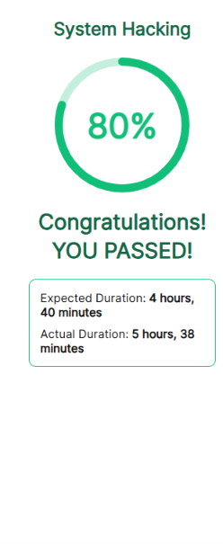
Figure 14 — Final module result: 80% score, completed in 5 hours 38 minutes.
Module | 06 — System Hacking (CEHv13)
Score | 8 / 10 (80%)
Result | PASS
Expected Duration | 4 hours 40 minutes
Actual Duration | 5 hours 38 minutes

11. Conclusion
This module provided end-to-end, hands-on exposure to the system-hacking lifecycle: initial access via a lightweight HTTP-based shell, staged access via Metasploit's Meterpreter, low-level exploit-development groundwork through buffer-overflow crash analysis, evaluation of commercial monitoring software as a maintaining-access analogue, event-log enumeration relevant to anti-forensics awareness, network/credential reconnaissance over RDP, and the integration of AI-assisted tooling into an offensive workflow. All activities were confined to the isolated CEH practice range and its designated target machines, consistent with authorized training use.

— End of Report —

