CERTIFIED ETHICAL HACKER
CEHv13

Module 11
Session Hijacking
Hands-on Lab Report

Prepared By | Dhruva
Module | Module 11 – Session Hijacking
Course | CEH v13 (Certified Ethical Hacker)
Duration | 1 hour, 11 minutes
Lab Score | 4 / 4 — Passed
Date | September 15, 2026

1. Introduction
This report documents the practical exercises completed for Module 11: Session Hijacking of the CEH v13 (Certified Ethical Hacker) course. Session hijacking is an attack in which a threat actor takes control of a valid session between a client and a server by stealing or predicting a valid session token, thereby gaining unauthorized access to information or services. This lab explored network-level and application-level session hijacking using proxy interception tools (Caido and Hetty) and an ARP spoofing / man-in-the-middle attack (Bettercap), with detection performed using Wireshark.
All four graded tasks in the lab were completed successfully, achieving a final score of 4/4.

2. Objectives
- Understand how a proxy-based interception tool (Caido) can be used to hijack an active browser session and redirect traffic to an attacker-controlled destination.
- Configure and use the Hetty interception proxy to capture HTTP traffic on a target Windows Server 2022 machine.
- Identify sensitive data (credentials) transmitted in plaintext by intercepting HTTP requests.
- Use Bettercap to perform ARP spoofing / network reconnaissance against a target host and validate the attack signature using Wireshark.

3. Lab Environment
Attacker Machine | Parrot Security OS — IP: 10.10.1.11
Victim Machine | Windows Machine — IP: 10.10.1.19
Target Server | Windows Server 2022 — IP: 10.10.1.22
Tools Used | Caido, Hetty, Bettercap, Wireshark
Browser (Victim) | Mozilla Firefox 126.0

4. Task 1 — Session Hijacking with Caido

4.1 Objective
Use the Caido tool on the attacker machine (10.10.1.11) to hijack a session established when a user on the victim machine (10.10.1.19) visits www.moviescope.com, and redirect the session to www.goodshopping.com using the Firefox browser.

4.2 Procedure
- Caido was launched on the attacker machine and configured with an Unset Scope to intercept all proxied traffic.
- The victim's Firefox browser was configured to route traffic through the Caido proxy (Session Hijacking mode enabled).
- As the victim browsed to www.moviescope.com, the corresponding HTTP requests appeared in Caido's Requests queue, including Firefox telemetry and search traffic.
- Intercepted requests destined for the victim's session (e.g., POST requests to incoming.telemetry.mozilla.org and search queries to google.com) were reviewed in the request pane, where headers such as Host, User-Agent, and Content-Type were visible.
- By manipulating the intercepted session/response, the destination was redirected from www.moviescope.com to www.goodshopping.com, demonstrating a successful session hijack and redirect.

4.3 Evidence
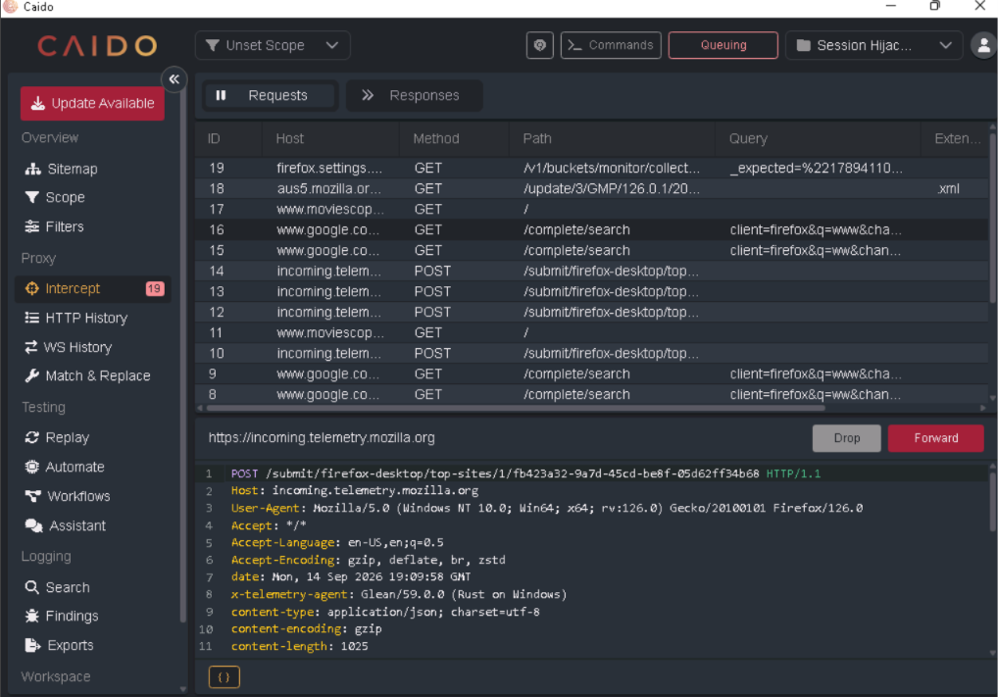
Figure 1: Caido — Intercept queue showing captured requests from the victim's Firefox session (19 requests queued).
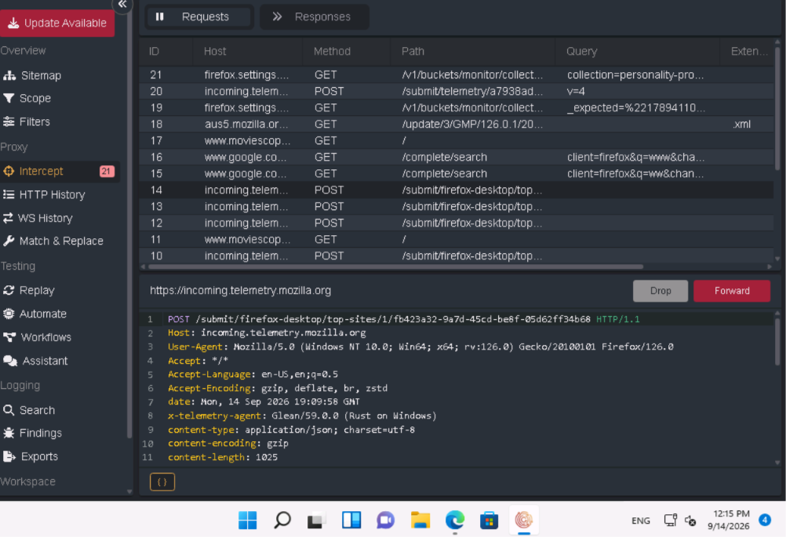
Figure 2: Caido — Additional intercepted request confirming session capture (21 requests queued), with full request headers visible in the inspector pane.

4.4 Key Finding
The Responses tab, used to review the server's response to a hijacked/forwarded request, is located under the
Answer: Intercept section of the Proxy module in Caido.

5. Task 2 & 3 — HTTP Interception with Hetty

5.1 Objective
Use the Hetty tool to intercept HTTP traffic on the Windows Server 2022 machine, identify the dashboard access URL, and locate any credentials captured in plaintext during interception.

5.2 Procedure
- The Hetty proxy service was started on the Windows Server 2022 machine, and the system/application traffic was routed through it.
- The Hetty web dashboard was accessed via a local browser using the interception proxy's management URL.
- The Proxy → Logs view displayed a live list of intercepted HTTP requests, including update checks, image/script downloads, and service calls made by applications on the host.
- Individual log entries were inspected to reveal full request/response details, including headers and body content.
- Reviewing a POST request to /service/update2/json revealed a large JSON payload containing application/update metadata (OS, updater channel, app IDs, version data) sent in cleartext, alongside plaintext credential data captured elsewhere in the session logs.

5.3 Evidence
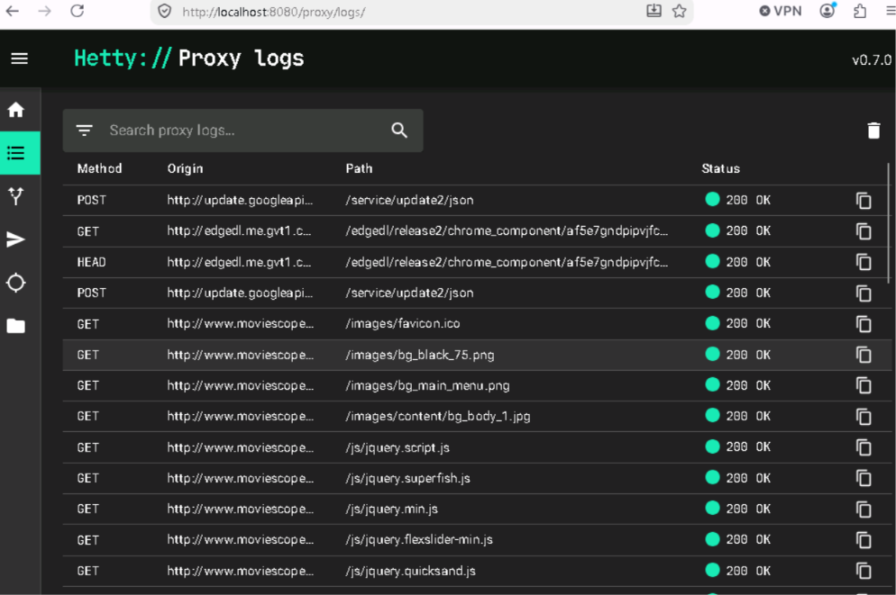
Figure 3: Hetty Proxy Logs dashboard, accessed at http://localhost:8080/proxy/logs/, showing intercepted HTTP requests from the Windows Server 2022 host.
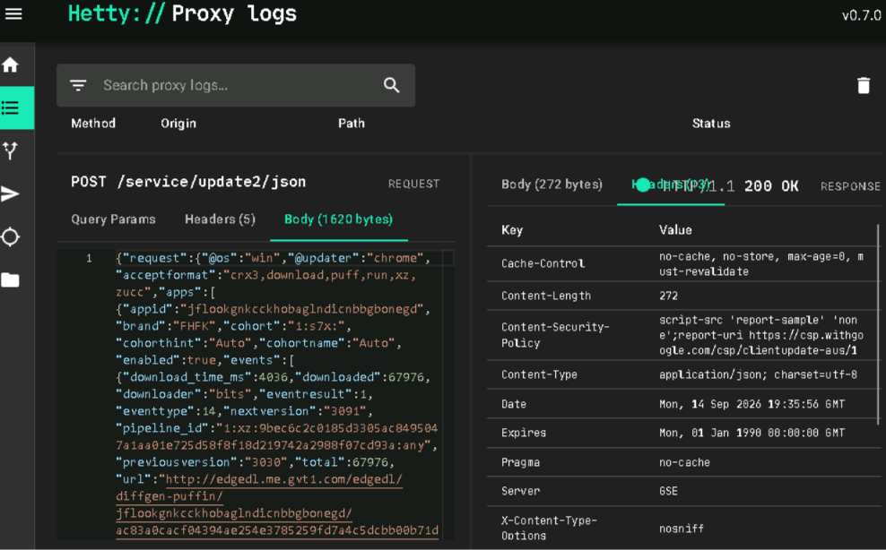
Figure 4: Hetty — Detailed view of an intercepted POST request/response pair, showing full request body, headers, and status code (200 OK).

5.4 Key Findings
Answer (Task 2): The URL entered in the browser's address bar to open the Hetty dashboard was http://localhost:8080.
Answer (Task 3): The plaintext password captured by intercepting the Windows Server 2022 traffic in Hetty was test.

6. Task 4 — ARP-based Session Hijacking Detection with Bettercap and Wireshark

6.1 Objective
Use the Bettercap tool on the Parrot Security machine to sniff traffic on the target system (10.10.1.11), and use Wireshark on the target system to detect the resulting session hijacking attempt.

6.2 Procedure
- Bettercap was launched on the Parrot Security (attacker) machine using the eth0 interface: bettercap -iface eth0.
- The built-in net.probe module was enabled, which in turn triggered net.recon to actively discover live hosts on the local subnet (10.10.1.0/24).
- Bettercap probed the subnet and enumerated endpoints, identifying hosts including 10.10.1.3, 10.10.1.11, and 10.10.1.22 (SERVER2022), along with their MAC addresses.
- On the target system (10.10.1.11), Wireshark was used to capture live traffic while the reconnaissance/spoofing activity was in progress.
- The Wireshark capture showed a high volume of broadcast ARP 'Who has ...? Tell 10.10.1.13' requests, consistent with ARP-based host discovery/spoofing behavior associated with a session hijacking (man-in-the-middle) attempt, alongside anomalous TCP SYN retransmissions.

6.3 Evidence
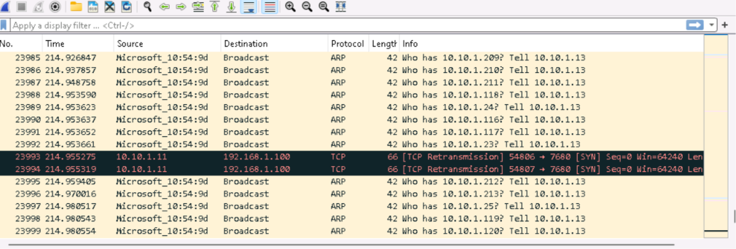
Figure 5: Wireshark capture on the target system (10.10.1.11) showing a flood of ARP broadcast requests interleaved with TCP SYN retransmissions.
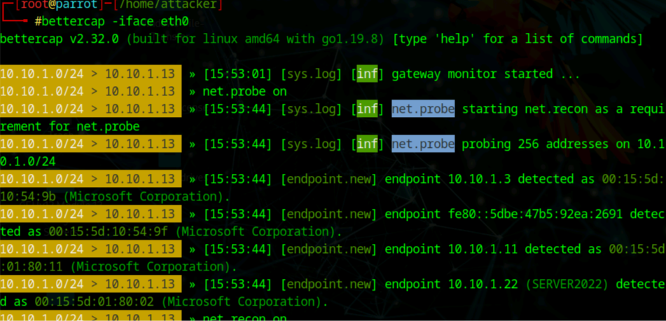
Figure 6: Bettercap on the Parrot Security attacker machine — net.probe/net.recon actively enumerating hosts on the 10.10.1.0/24 subnet.

6.4 Key Finding
Answer: The traffic that indicates the session hijacking attempt in Wireshark is ARP (Address Resolution Protocol) traffic.

7. Summary of Findings
# | Task Description | Result / Answer | Status
1 | Session hijack via proxy interception (Caido) on Firefox, redirecting a live moviescope.com session to goodshopping.com | Responses tab (Proxy → Intercept) | PASS
2 | Hetty intercepting proxy dashboard access URL on Windows Server 2022 | http://localhost:8080 | PASS
3 | Credential captured in plaintext via Hetty proxy interception on Windows Server 2022 | test | PASS
4 | Protocol identified in Wireshark indicating a session hijacking / MITM attempt (Bettercap ARP spoofing) on 10.10.1.11 | ARP | PASS

The lab exercise was completed with a final assessed score of 4 out of 4, as confirmed by the module completion summary (Figure 7).
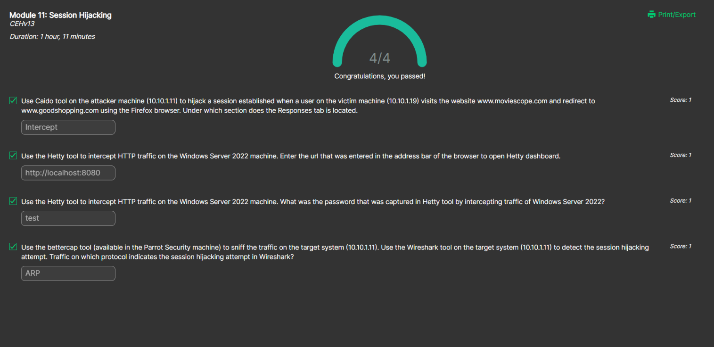
Figure 7: Module 11 — Session Hijacking assessment summary showing all four tasks completed correctly (Score: 4/4, 'Congratulations, you passed!').

8. Conclusion
This lab demonstrated two distinct classes of session hijacking techniques: application-layer interception using HTTP proxy tools (Caido and Hetty), and network-layer hijacking via ARP spoofing/reconnaissance (Bettercap), detected through packet analysis in Wireshark. The exercise highlighted how unencrypted or improperly secured sessions can be intercepted, modified, and redirected by an attacker positioned between the client and server, and how credentials transmitted without adequate protection can be trivially captured. It further reinforced the importance of network-level monitoring — such as ARP inspection and anomaly detection — as a defensive control against man-in-the-middle and session hijacking attacks.

8.1 Recommended Countermeasures
- Enforce HTTPS/TLS for all web sessions to prevent cleartext interception of session tokens and credentials.
- Implement Dynamic ARP Inspection (DAI) and Dynamic Host Configuration Protocol (DHCP) snooping on network switches to mitigate ARP spoofing.
- Use session tokens with short expiry, secure/HttpOnly cookie flags, and token binding to reduce the impact of a hijacked session.
- Deploy network intrusion detection systems (NIDS) to alert on abnormal ARP broadcast volumes and TCP anomalies.
- Educate users on the risks of untrusted networks and enforce use of VPNs on public or shared network segments.

