NETWORK TRAFFIC SNIFFING
Packet Capture & RDP Traffic Analysis — Lab Report

Prepared By | Dhruva
Report Type | Network Security / Packet Sniffing Lab
Tools Used | Wireshark, Windows Services (MMC), RDP (Port 3389)
Module | Sniffing
Result | Passed — 60% Score
Date | August 9, 2026

1. Objective
The objective of this exercise was to demonstrate practical packet sniffing and network traffic analysis using Wireshark. The lab focused on capturing and inspecting live traffic between two hosts on a local network, with particular attention to Remote Desktop Protocol (RDP) sessions carried over TCP port 3389, and on enabling the Windows Remote Packet Capture Protocol service to support remote packet capture.

2. Scope & Environment
Capture Tool | Wireshark
Capture Interface | eth0
Primary Hosts | 10.10.1.13 and 10.10.1.3
Protocol of Interest | RDP (Fast-Path PDU) over TCP port 3389
Supporting Service | Remote Packet Capture Protocol v.0 (experimental)
Operating System | Windows (Services / MMC console)

3. Methodology
The following steps were carried out to complete the sniffing exercise:
- Enabled the "Remote Packet Capture Protocol v.0 (experimental)" service on the target Windows machine via the Services (Local) management console, allowing traffic on that machine to be captured remotely.
- Launched Wireshark and started a live capture on the network interface (eth0) connecting the two hosts.
- Observed general broadcast/ARP traffic to confirm host discovery, including an ARP request/reply resolving 10.10.1.11 to its MAC address.
- Filtered and followed the TCP conversation between 10.10.1.13 and 10.10.1.3 on port 3389 to isolate the RDP session.
- Analyzed the resulting Fast-Path PDU frames exchanged during the RDP session, noting sequence numbers, acknowledgements, and window sizes.
- Completed the accompanying "Sniffing" assessment module to validate understanding of the capture and analysis process.

4. Findings

4.1 Remote Packet Capture Protocol Service
The "Remote Packet Capture Protocol v.0 (experimental)" service was located in the Windows Services console and confirmed to be running with a Manual startup type under the Local System account. This service allows traffic on the host to be captured from a remote Wireshark instance, which is a prerequisite for the remote-capture portion of the exercise.
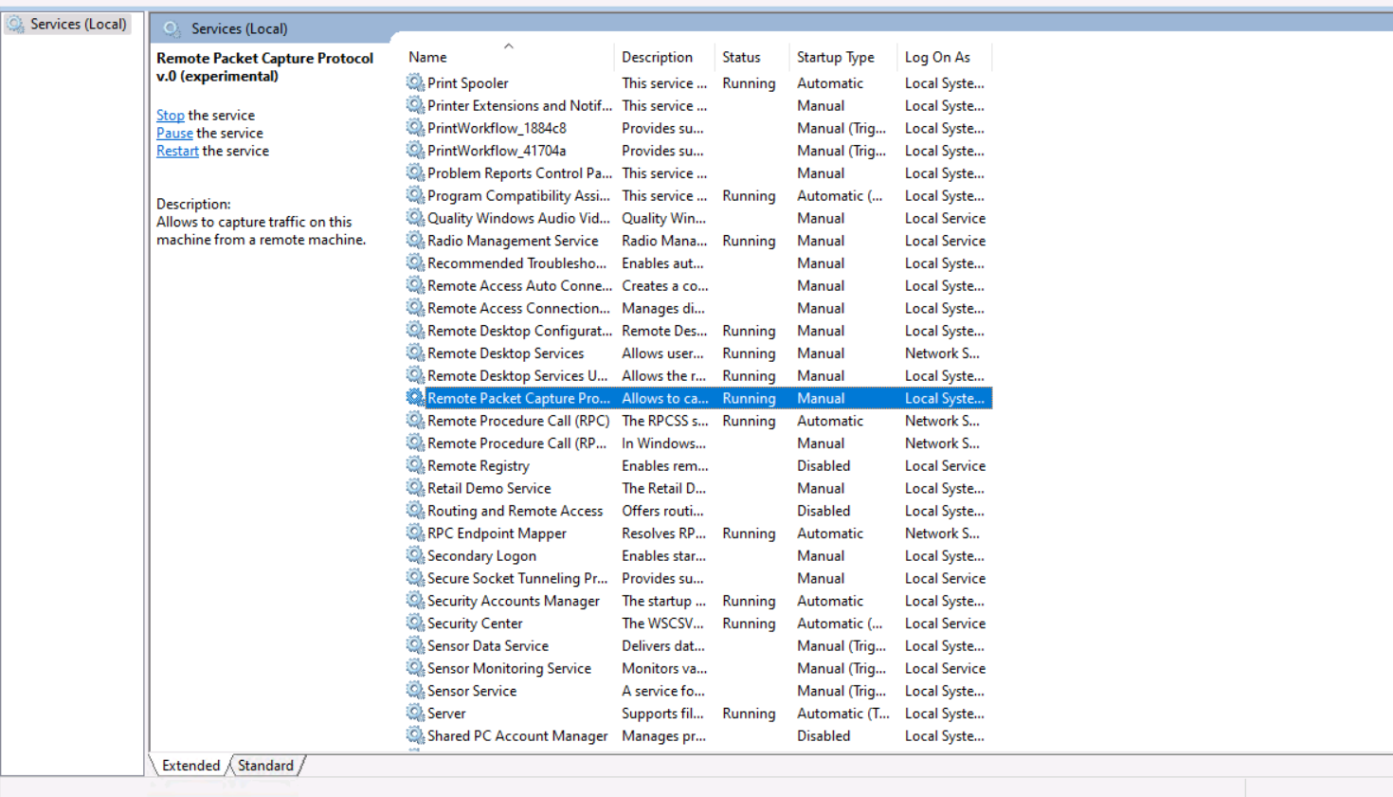
Figure 1: Remote Packet Capture Protocol service shown as Running in Windows Services (Local).

4.2 General Traffic Capture
An initial capture showed a mix of background IPv4 traffic alongside the TCP conversation of interest. An ARP exchange was also observed, in which 10.10.1.13 requested the MAC address for 10.10.1.11, which was resolved as belonging to Microsoft_01:80:11. Multiple PSH/ACK segments were exchanged between 10.10.1.13 and 10.10.1.3 on port 3389, consistent with an active RDP session transferring data.
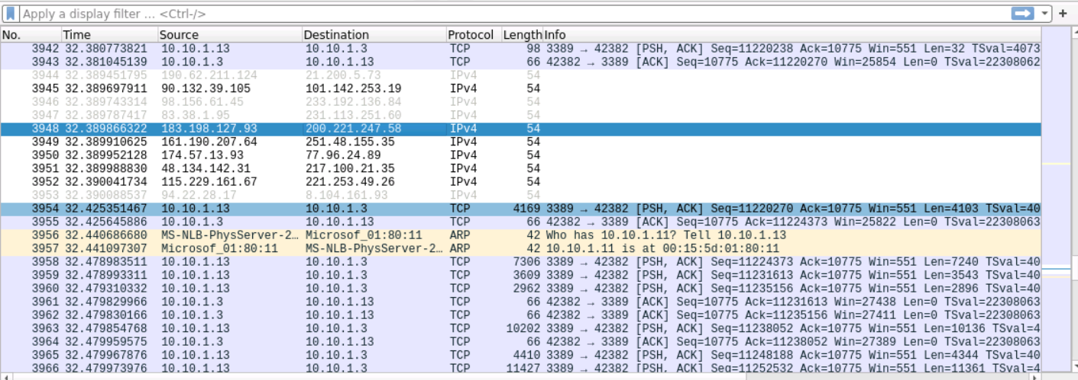
Figure 2: Wireshark capture showing TCP/ARP traffic and the RDP conversation on port 3389.

4.3 RDP Fast-Path PDU Analysis
A focused filter on the RDP conversation revealed a continuous stream of Fast-Path PDU frames (NewPointer, ColorPointer, CachedPointer, PointerPosition, LargePointer, Palette, Synchronize, and Surface types), interspersed with TCP ACK segments. Several of these PDUs were flagged by Wireshark as "Malformed Packet," and one TCP segment was identified as a retransmission (frame 7349), indicating some packet loss or dissection limitations during the capture. The Ethernet frame details confirmed the source and destination MAC addresses for the two NLB-clustered physical servers involved in the exchange.
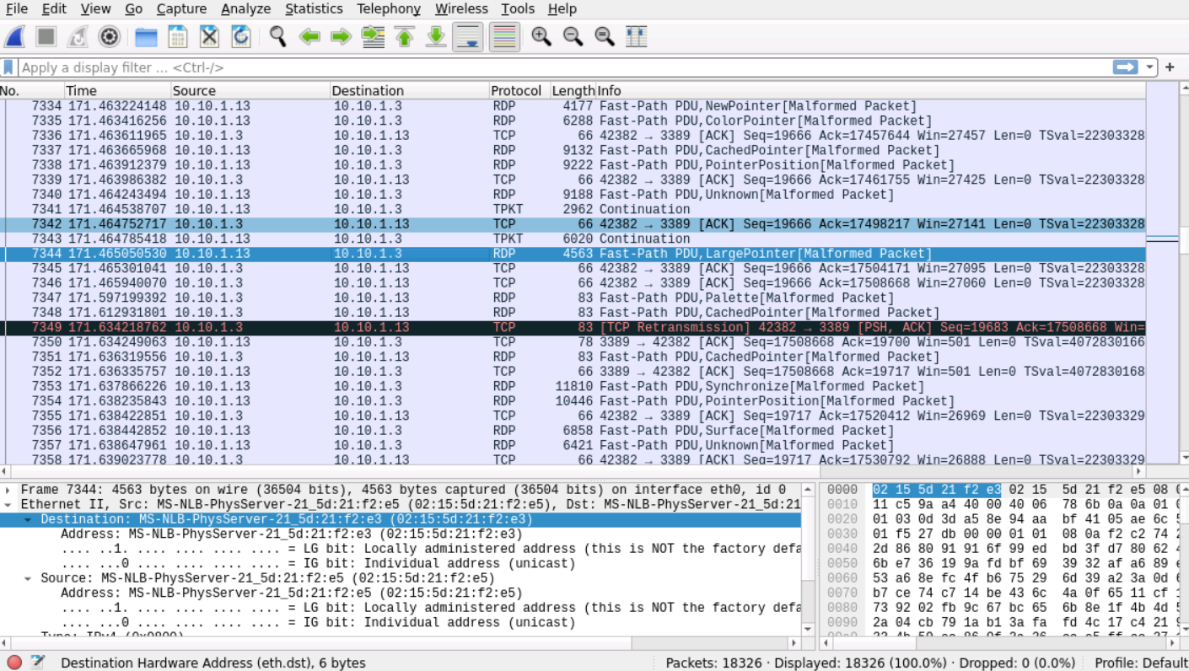
Figure 3: Detailed view of RDP Fast-Path PDU frames, including a TCP retransmission and Ethernet frame breakdown.

5. Assessment Result
Upon completion of the practical capture and analysis steps, the associated "Sniffing" module assessment was submitted and passed with a score of 60%. The task was completed in 2 hours and 1 minute against an expected duration of 1 hour and 20 minutes.
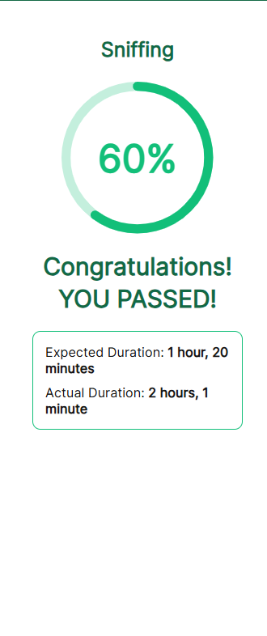
Figure 4: Module completion summary — Sniffing module passed at 60%.

6. Conclusion
This exercise provided hands-on experience with network sniffing fundamentals: enabling a remote capture service, capturing live traffic with Wireshark, and dissecting an RDP session at the packet level. The presence of malformed Fast-Path PDUs and a TCP retransmission highlighted the kind of anomalies that appear in real-world captures and underscored the importance of careful frame-by-frame analysis when investigating network traffic. The exercise was completed successfully, with the associated assessment module passed.

7. Recommendations
- Disable the Remote Packet Capture Protocol service when not actively in use, as it increases the remote attack surface if left running.
- Where possible, use encrypted RDP configurations (e.g., Network Level Authentication and TLS) to reduce the value of intercepted traffic to an eavesdropper.
- Investigate the cause of the malformed PDUs and the observed retransmission to rule out network instability or an MTU/fragmentation issue.
- Revisit the areas that led to the 60% score to reinforce weaker concepts before attempting more advanced sniffing or protocol-analysis modules.

