CEH v13 — LAB REPORT
Module 10: Denial-of-Service (DoS/DDoS) Attacks
DoS and DDoS Attack Tools — Hands-On Lab Exercise
Prepared by
Dhruva Khare
Certified Ethical Hacker (CEH) v13 Candidate
Report Title | DoS/DDoS Attack Tools — Lab Walkthrough
Curriculum | EC-Council CEH v13, Module 10 — Denial-of-Service
Lab Environment | Isolated iLabs cyber range (Windows 11, Windows Server 2022/2019, Parrot Security, Ubuntu)
Date Performed | September 2, 2026
Classification | For educational / certification training purposes only

1. Objective
The objective of this lab was to gain hands-on experience with common Denial-of-Service (DoS) and Distributed Denial-of-Service (DDoS) attack techniques and tools, as covered in Module 10 of the CEH v13 curriculum. The exercise was conducted entirely within an isolated, sandboxed training range (iLabs) with no connectivity to production or public networks, using RFC1918 private addressing (10.10.1.0/24).
Specifically, the lab aimed to:
- Perform target reconnaissance and a TCP port scan using the ISB (I'm So Bored) tool.
- Launch a volumetric flood attack using UltraDDoS and observe its effect on target CPU/network resources.
- Establish a Meterpreter reverse-TCP session using the Metasploit Framework's exploit/multi/handler module.
- Execute a scripted, multi-threaded DoS attack (eagle-dos.py) from multiple attacker shells against a target.
- Capture and analyze the resulting flood traffic in Wireshark to understand its network-layer signature.

2. Lab Environment
Attacker Machines | Parrot Security OS, Ubuntu (Wireshark analysis host)
Target Machines | Windows Server 2019 / Windows Server 2022 (10.10.1.19), Windows 11 client (10.10.1.22)
Target IP : Port | 10.10.1.19 : 80 (HTTP service under test)
Attacker IP | 10.10.1.13 (Metasploit handler / listener)
Network Mode | Isolated virtual lab network — no external/internet exposure
Tool Suite Path | CEH-Tools \ CEHv13 Module 10 Denial-of-Service \ DoS and DDoS Attack Tools

3. Tools Used
Tool / Utility | Category | Purpose in this Lab
ISB (I'm So Bored) v1.1.0 | DoS Attack Tool | Target reconnaissance (WHOIS/NS/Traceroute/Ping) and TCP port scanning against the target host
Resource Monitor (Windows) | System Monitoring | Observing CPU utilization on the target while flood traffic was received
UltraDDoS | DDoS Attack Tool | Generating high-volume packet floods against the target IP/port to simulate a DDoS condition
Metasploit Framework (msfconsole) | Exploitation Framework | Configuring exploit/multi/handler with a Meterpreter reverse TCP payload and catching a session
eagle-dos.py | Python DoS Script | Launching a scripted multi-threaded packet-flood attack from multiple attacker shells
Wireshark | Network Protocol Analyzer | Capturing and inspecting the fragmented UDP flood traffic generated during the attack

4. Procedure and Observations

4.1 Reconnaissance and TCP Port Scan with ISB
The ISB (I'm So Bored) v1.1.0 utility was launched and the target was configured as 10.10.1.19 on port 80 (URL set to 10.10.1.19:80). Using the Target Info panel, WHOIS, NS, Traceroute and Ping lookups can be issued against the target; a ping report confirmed the host was reachable with a 0 ms round-trip and a successful status. The TCP Port Scan module was then configured to scan the port range 1–35565 with a 32 ms timeout per port, and the scan was started via the Start Scan control. The application's built-in log panel timestamped each action (interface discovery, target configuration, and the ping report), and a live network monitor panel displayed real-time statistics for the host's Ethernet, Ethernet 2, and Loopback interfaces.
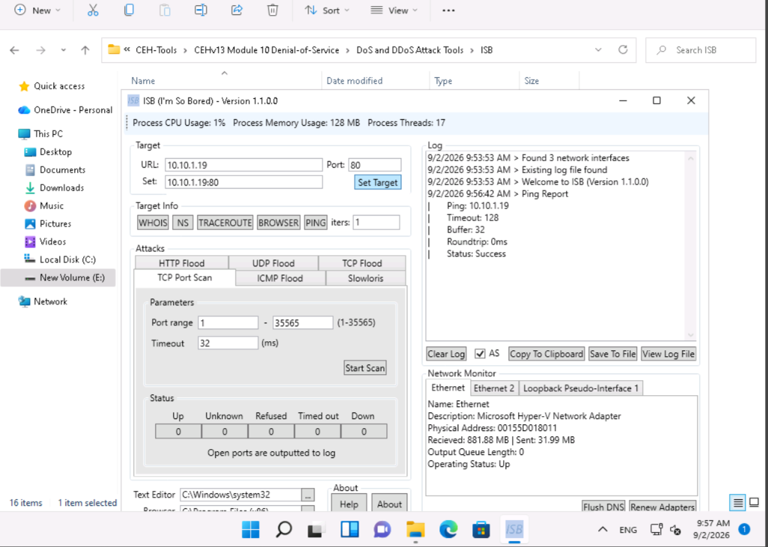
Figure 1: ISB (I'm So Bored) v1.1.0 — target configuration, ping report, and TCP Port Scan module (port range 1–35565) against 10.10.1.19:80.

4.2 Baseline Resource Monitoring
Windows Resource Monitor was used on the target system to establish a resource-utilization baseline before and during the attack phase. The CPU tab shows total CPU usage at 41% with per-core graphs (CPU 0–2 and beyond) and a live process table listing active images such as SearchUI.exe, ShellExperienceHost.exe, perfmon.exe, System Interrupts, and svchost.exe instances. This view was used to visually correlate rising CPU/network load with the subsequent flood attacks.
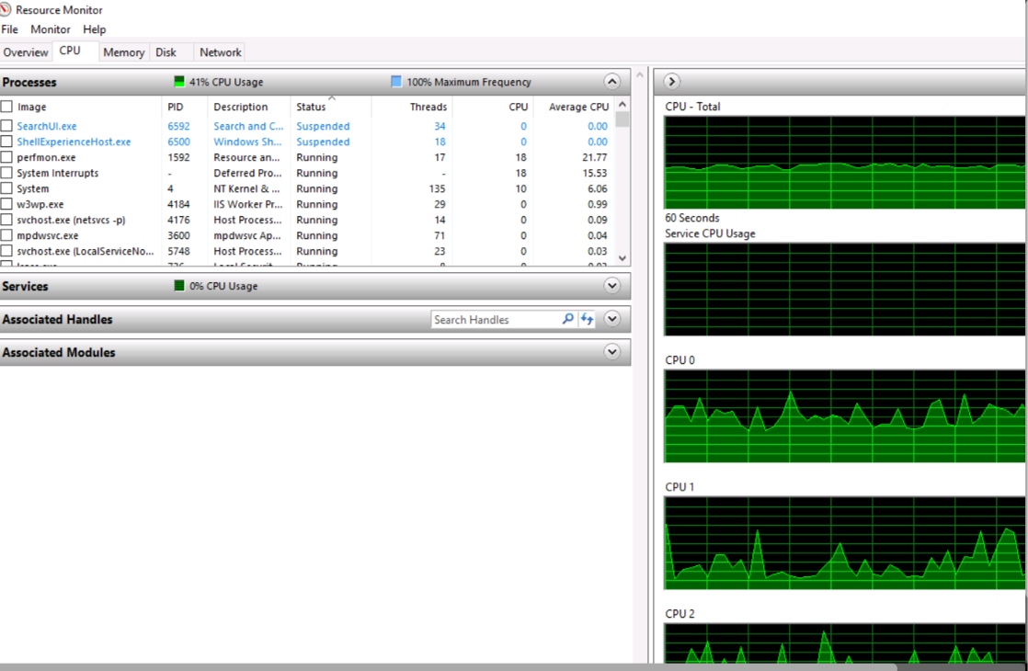
Figure 2: Windows Resource Monitor — CPU tab showing per-process and per-core utilization on the target host.

4.3 Volumetric Flood Attack with UltraDDoS
The UltraDDoS utility (ultraddos.exe) was executed from the CEH-Tools DoS/DDoS Attack Tools directory and pointed at 10.10.1.19:80. The tool's console output confirms a sustained packet flood, with the "Sent" packet counter climbing steadily across log lines — reaching values in excess of 28 million packets sent during the run. Several threads eventually raised WinError 10055 ("An operation on a socket could not be performed because the system lacked sufficient buffer space or because a queue was full"), which is expected behavior once the target's send buffers/socket queues are saturated by the flood, and it demonstrates the attack was successfully exhausting available network resources on the sending side.
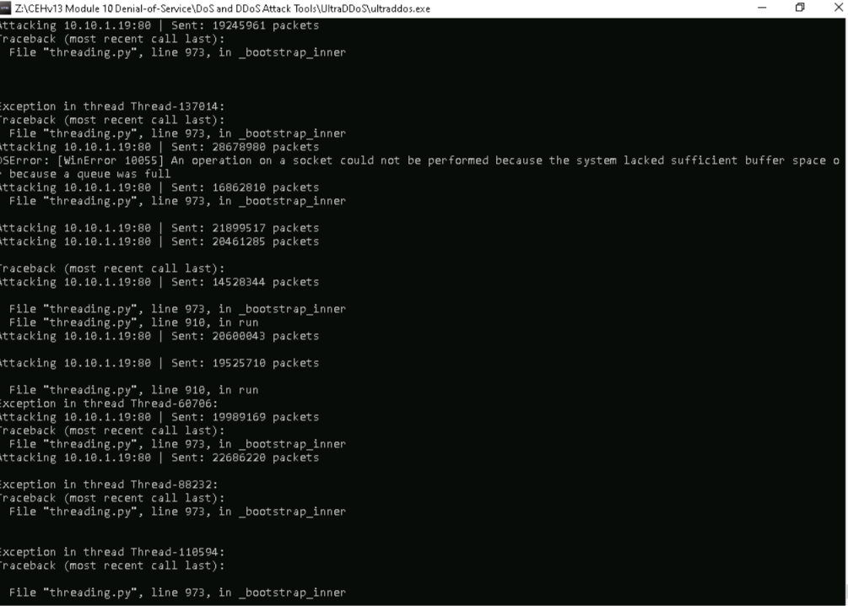
Figure 3: UltraDDoS console — sustained packet flood against 10.10.1.19:80, including a WinError 10055 buffer-exhaustion exception.

4.4 Establishing a Reverse Shell with Metasploit
In parallel, the Metasploit Framework (v6.4.8-dev) was launched via msfconsole to demonstrate how a DoS/DDoS toolkit can be delivered and controlled through a Meterpreter payload. The exploit/multi/handler module was configured with the generic/shell_reverse_tcp payload, subsequently auto-upgraded to windows/meterpreter/reverse_tcp, with LHOST set to 10.10.1.13 and LPORT set to 5555. After starting the handler, a 176,198-byte stage was sent to 10.10.1.22, and Meterpreter session 1 was successfully opened from 10.10.1.13:5555 to 10.10.1.22:50129 at 13:48:14 on September 2, 2026, confirming remote code execution on the target.
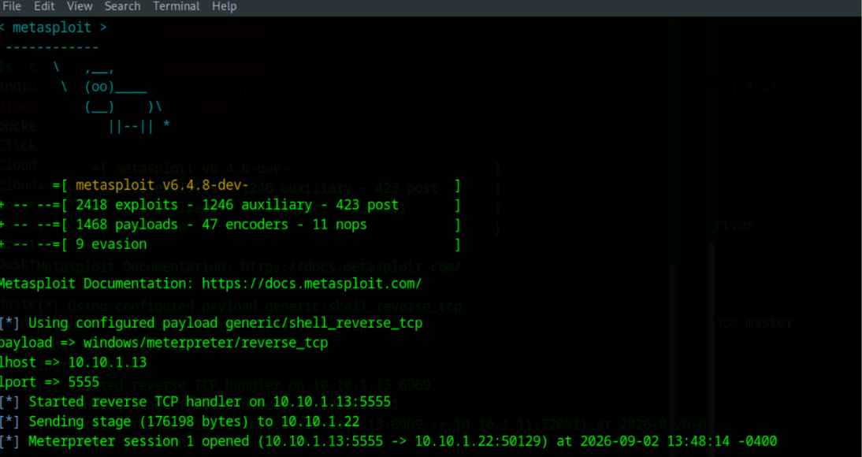
Figure 4: Metasploit Framework — exploit/multi/handler configured for a reverse Meterpreter payload; Meterpreter session 1 successfully opened.

4.5 Multi-Threaded Scripted DoS Attack (eagle-dos.py)
Following the lab's guided instructions, the eagle-dos.py Python script was executed from three separate attacker shell terminals on the Parrot Security machine, with each instance prompted for the target's IP address (10.10.1.9). Running the script concurrently from multiple terminals increased the volume of flood traffic directed at the target. The terminal output confirms tens of thousands of packets were sent to 10.10.1.9 across a wide range of destination ports (from roughly port 23,861 through port 58,818 across the parallel sessions), illustrating a distributed, multi-source packet-flood pattern consistent with a DDoS attack.
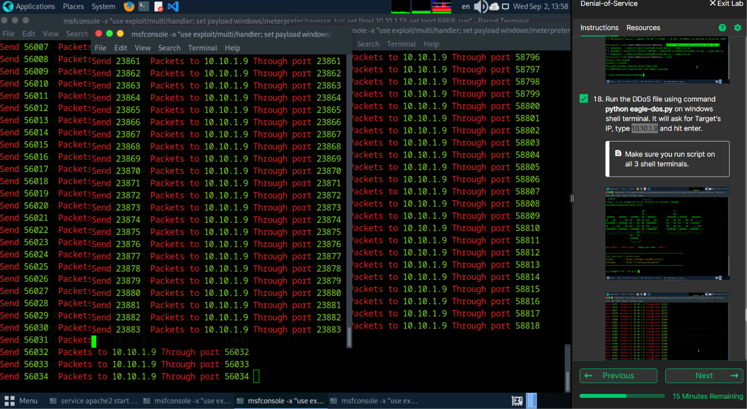
Figure 5: eagle-dos.py running concurrently across three Parrot Security shell terminals, flooding 10.10.1.9 with packets across a wide range of source/destination ports.

4.6 Traffic Capture and Analysis with Wireshark
To validate the attack at the packet level, Wireshark was run on an Ubuntu analysis host, capturing on interface eth0. The capture (335,575 packets shown, 100% displayed) shows a continuous stream of fragmented IPv4/UDP traffic from source 10.10.1.11 to destination 10.10.1.9, including reassembled DNP3-labeled UDP segments (port 51100 → 40492/40493) with a length of roughly 3500 bytes each, fragmented into 1514-byte frames on the wire. The packet detail pane confirms Ethernet II framing between the lab's NLB physical server interfaces and an IPv4 header addressed from 10.10.1.19 to 10.10.1.9, consistent with the flood traffic generated by the tools above.
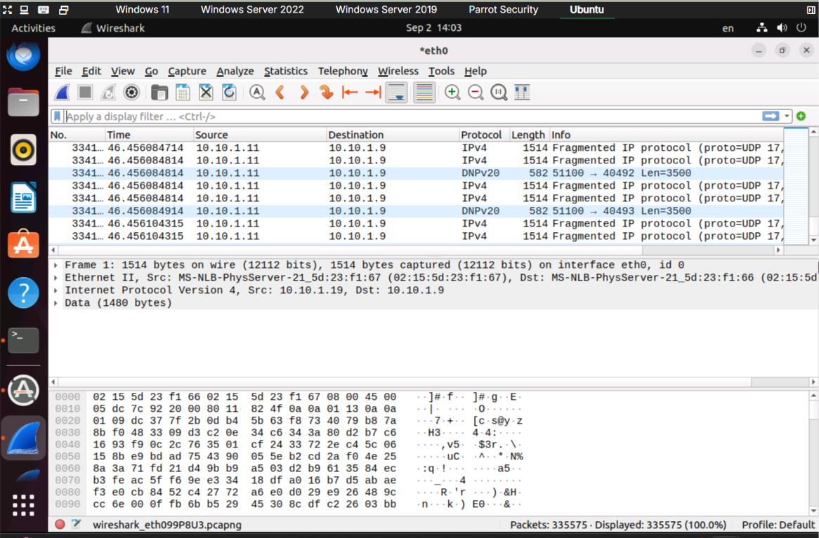
Figure 6: Wireshark capture on eth0 showing a sustained stream of fragmented UDP flood packets between lab hosts (335,575 packets captured).

5. Key Observations
- Simple GUI-based flooders (ISB, UltraDDoS) were able to generate tens of millions of packets against a single target port in a short time window, rapidly exhausting local socket send-buffer capacity (WinError 10055).
- Resource Monitor provided direct, real-time visibility into how flood traffic and process activity translate into rising CPU load on the victim host.
- Combining a remote-access payload (Meterpreter) with flood tooling illustrates how an attacker who has already gained code execution can also stage or amplify a DoS/DDoS attack from the compromised host.
- Running the same script (eagle-dos.py) from multiple concurrent attacker shells demonstrated, at small scale, how distributing attack sources across several machines increases aggregate packet volume — the core principle behind real-world DDoS/botnet attacks.
- Wireshark confirmed the attacks were visible on the wire as a high-volume, fragmented UDP stream between the same source/destination pair, which is a detectable signature that intrusion-detection and rate-limiting controls could flag.

6. Mitigation Recommendations
- Deploy rate-limiting and connection/packet-per-second thresholds at the network edge (firewall/IPS) for the affected service ports.
- Use SYN cookies, TCP/UDP flood protection, and ingress/egress filtering to reduce the impact of volumetric floods.
- Monitor for anomalous fragmented-UDP or single-destination packet bursts using an IDS/NIDS baseline, and alert on deviations.
- Employ upstream DDoS scrubbing services or CDN-based traffic distribution for internet-facing assets.
- Harden hosts against unauthorized payload execution (patching, endpoint protection, least privilege) to prevent an attacker from pivoting a foothold into a launch point for further attacks.

7. Conclusion
This lab provided practical, contained exposure to the mechanics of DoS/DDoS attacks as taught in CEH v13 Module 10 — from reconnaissance and port scanning, through single-source and scripted multi-source flooding, to payload delivery via Metasploit and packet-level verification with Wireshark. The exercise reinforced how straightforward it is to generate a denial-of-service condition with freely available tooling, and why layered defenses (rate-limiting, IDS/IPS, DDoS scrubbing, and host hardening) are essential for protecting production services. All activity was performed strictly within an isolated iLabs training environment for educational and certification purposes.
— End of Report —

