**# ExchangeRateAPI**

1. Needs an API client to make requests

2. Client can make requests on URL : localhost:8080/api/v1/exchangeRate

Following is a screenshot of successful response :

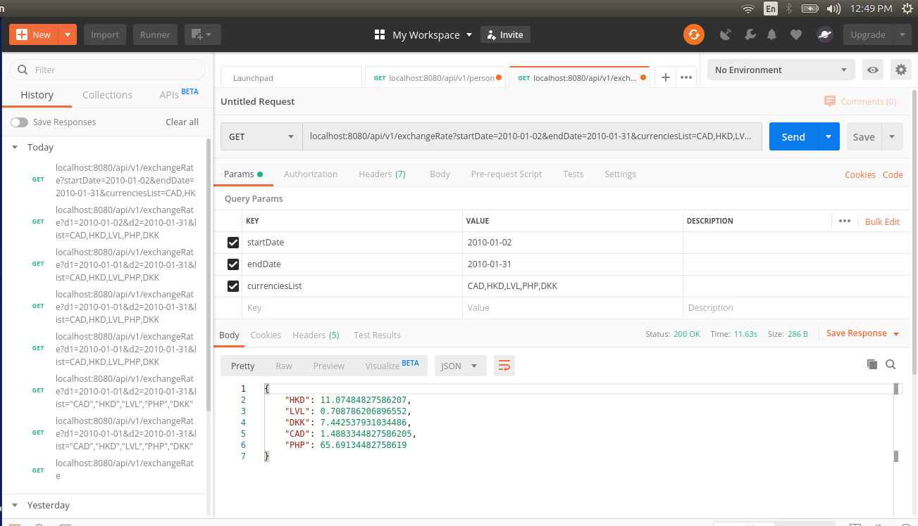

**testcase#1**:

Query:

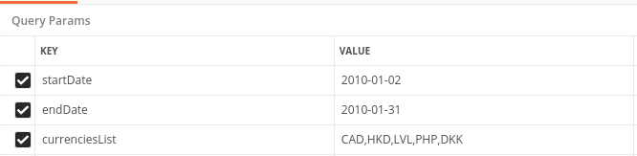

Response: Currencies code and their average exchange rates for given time span

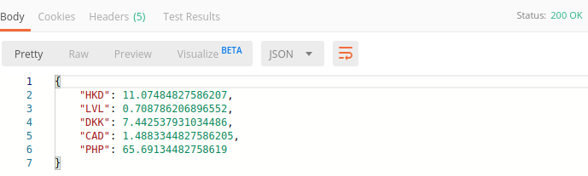

testcase#2:

Query:

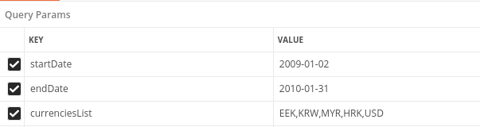

Response :

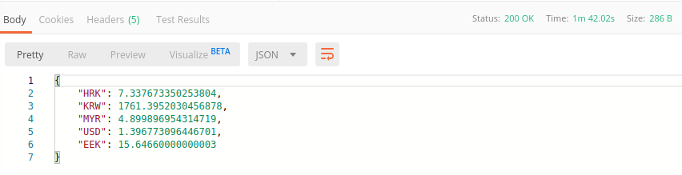

* Main Logic part of code is documented , please go through that to have a clear understanding of complete process.