ELECTRONICS HARDWARE REPORT

|  |  |
| --- | --- |
| Part | Rt12e_ELE_ACC |
| Department | Electronics |
| Owner | Bartosz Gwiazda |
| Owner’s e-mail | bartosz.gwiazda.pwrrt@gmail.com |
| Owner’s phone no. | 505613201 |
| Season | 2020/21 |
| Car | RT12e |

# Rules defining the part

# Schedule

|  |  |  |
| --- | --- | --- |
| Beginning | End | Task |
| 5.11 | 13.11 | Scheme creation |
| 13.11 | 25.11 | Layout creation |
| 11.12 | 18.12 | Fixes |
| 4.01 | 12.01 | Case model |
|  |  |  |
|  |  |  |
|  |  |  |
|  |  |  |

# Description and ASSUmPTIONS of the part

Accelerometer, part used to read vehicle position and transfer it to can to future use.

# Research

(previous team mainly)

* IAM-20680 datasheet
* STM32F042K6T datasheet

1. SIMULATIONS

(none)

# PROTOTYPES

(in progress)

*RT12e_ACC_00*

* DESIGN RULES

(type of paths, paths width, min. size of vias – in the table, layers, etc.)

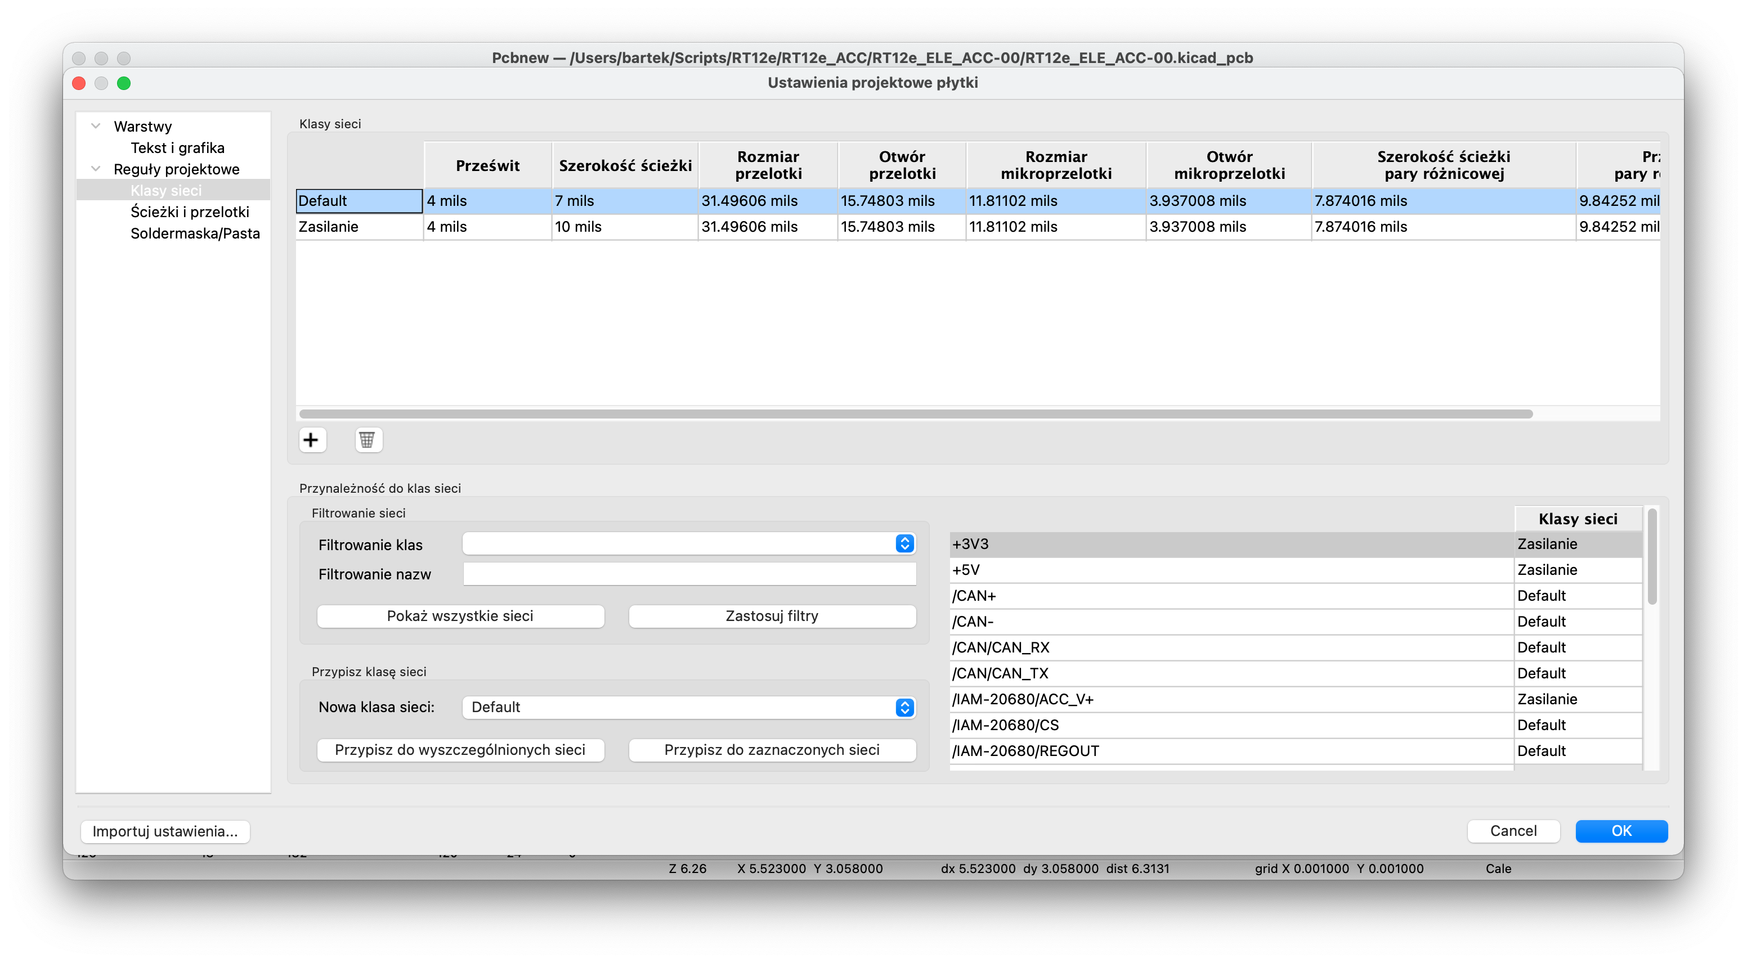

Figure . Paths classes

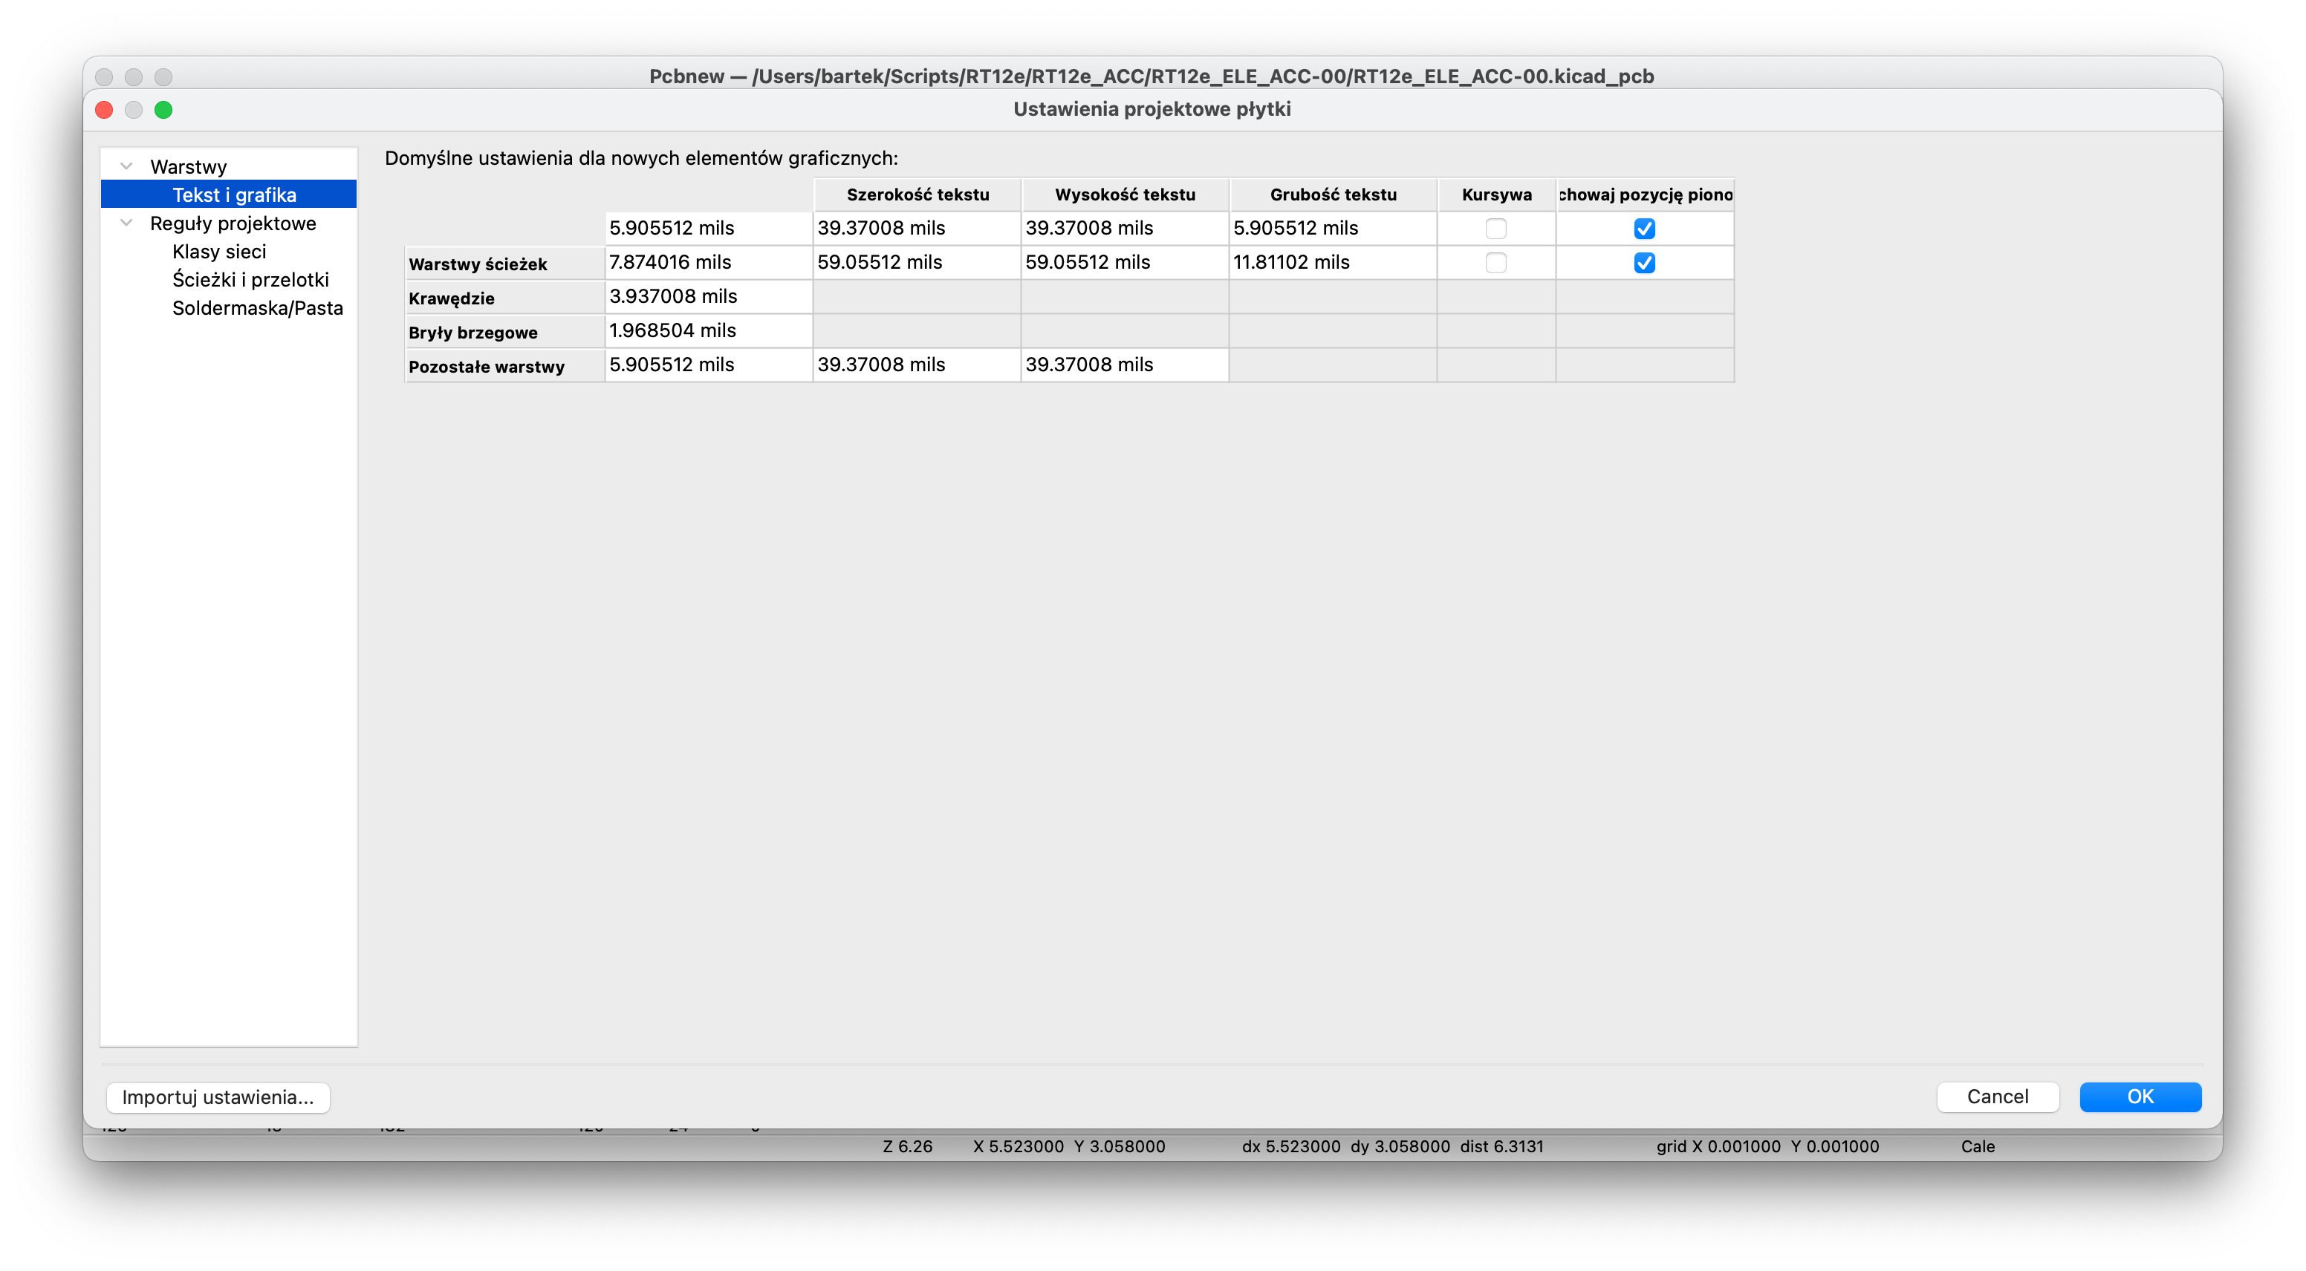

Figure . Text classes

* SCHEMA

(drawings, printed screens, photos – must have!. Includes each page of hierarchical sheet)

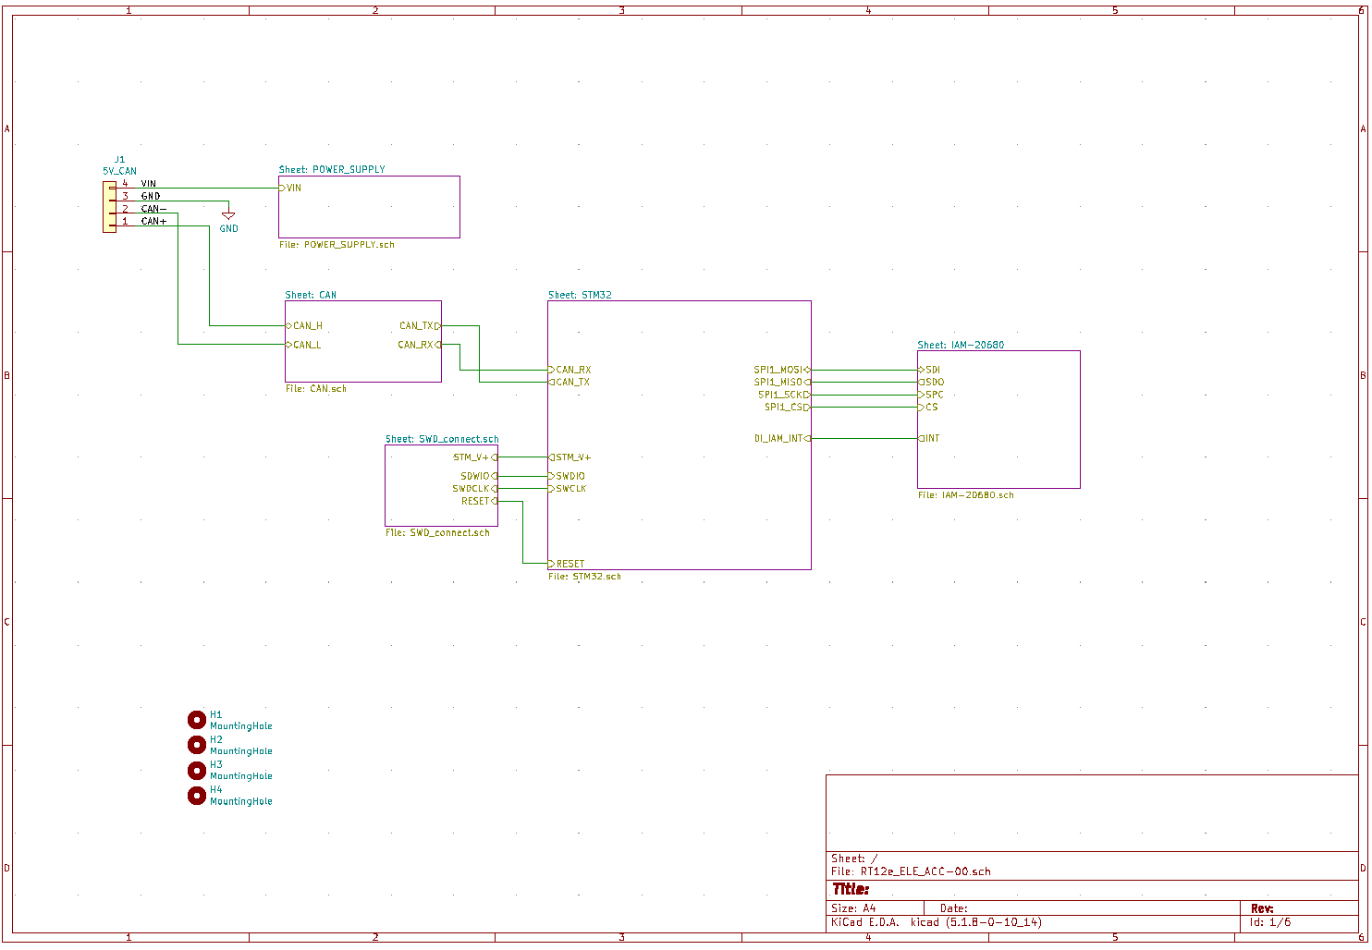

Figure . Main sheet of schema

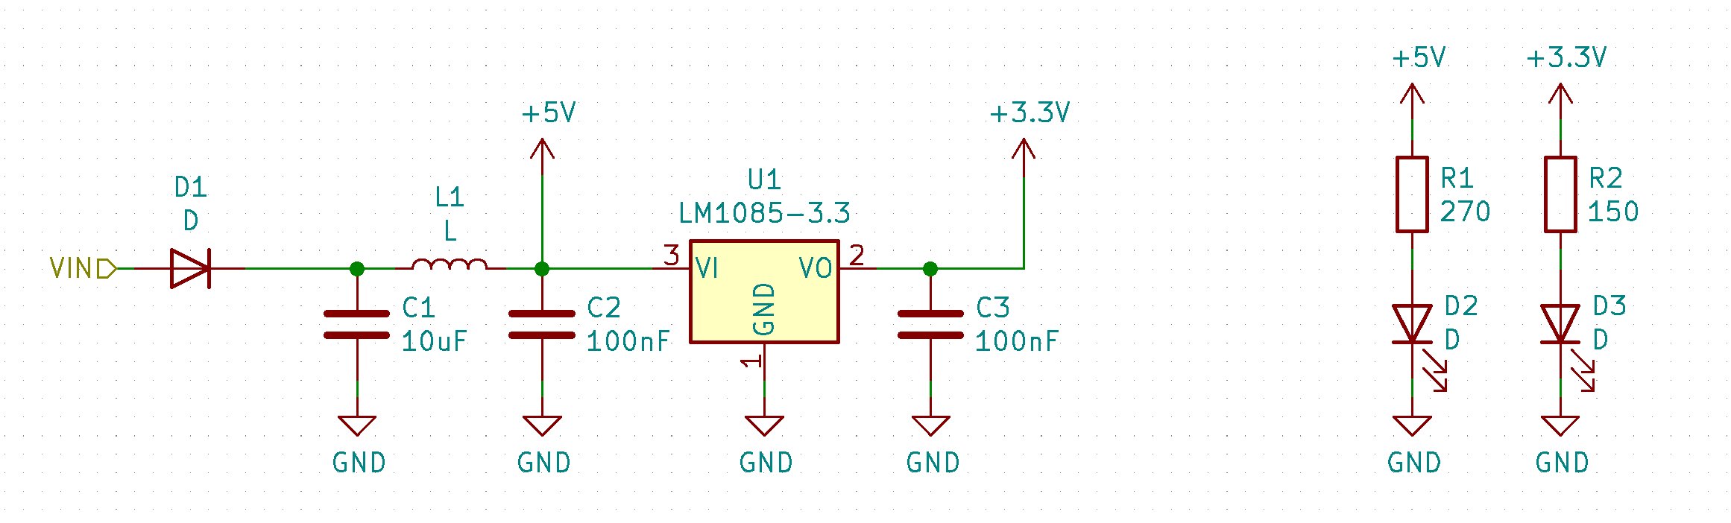

Figure . Power supply filer

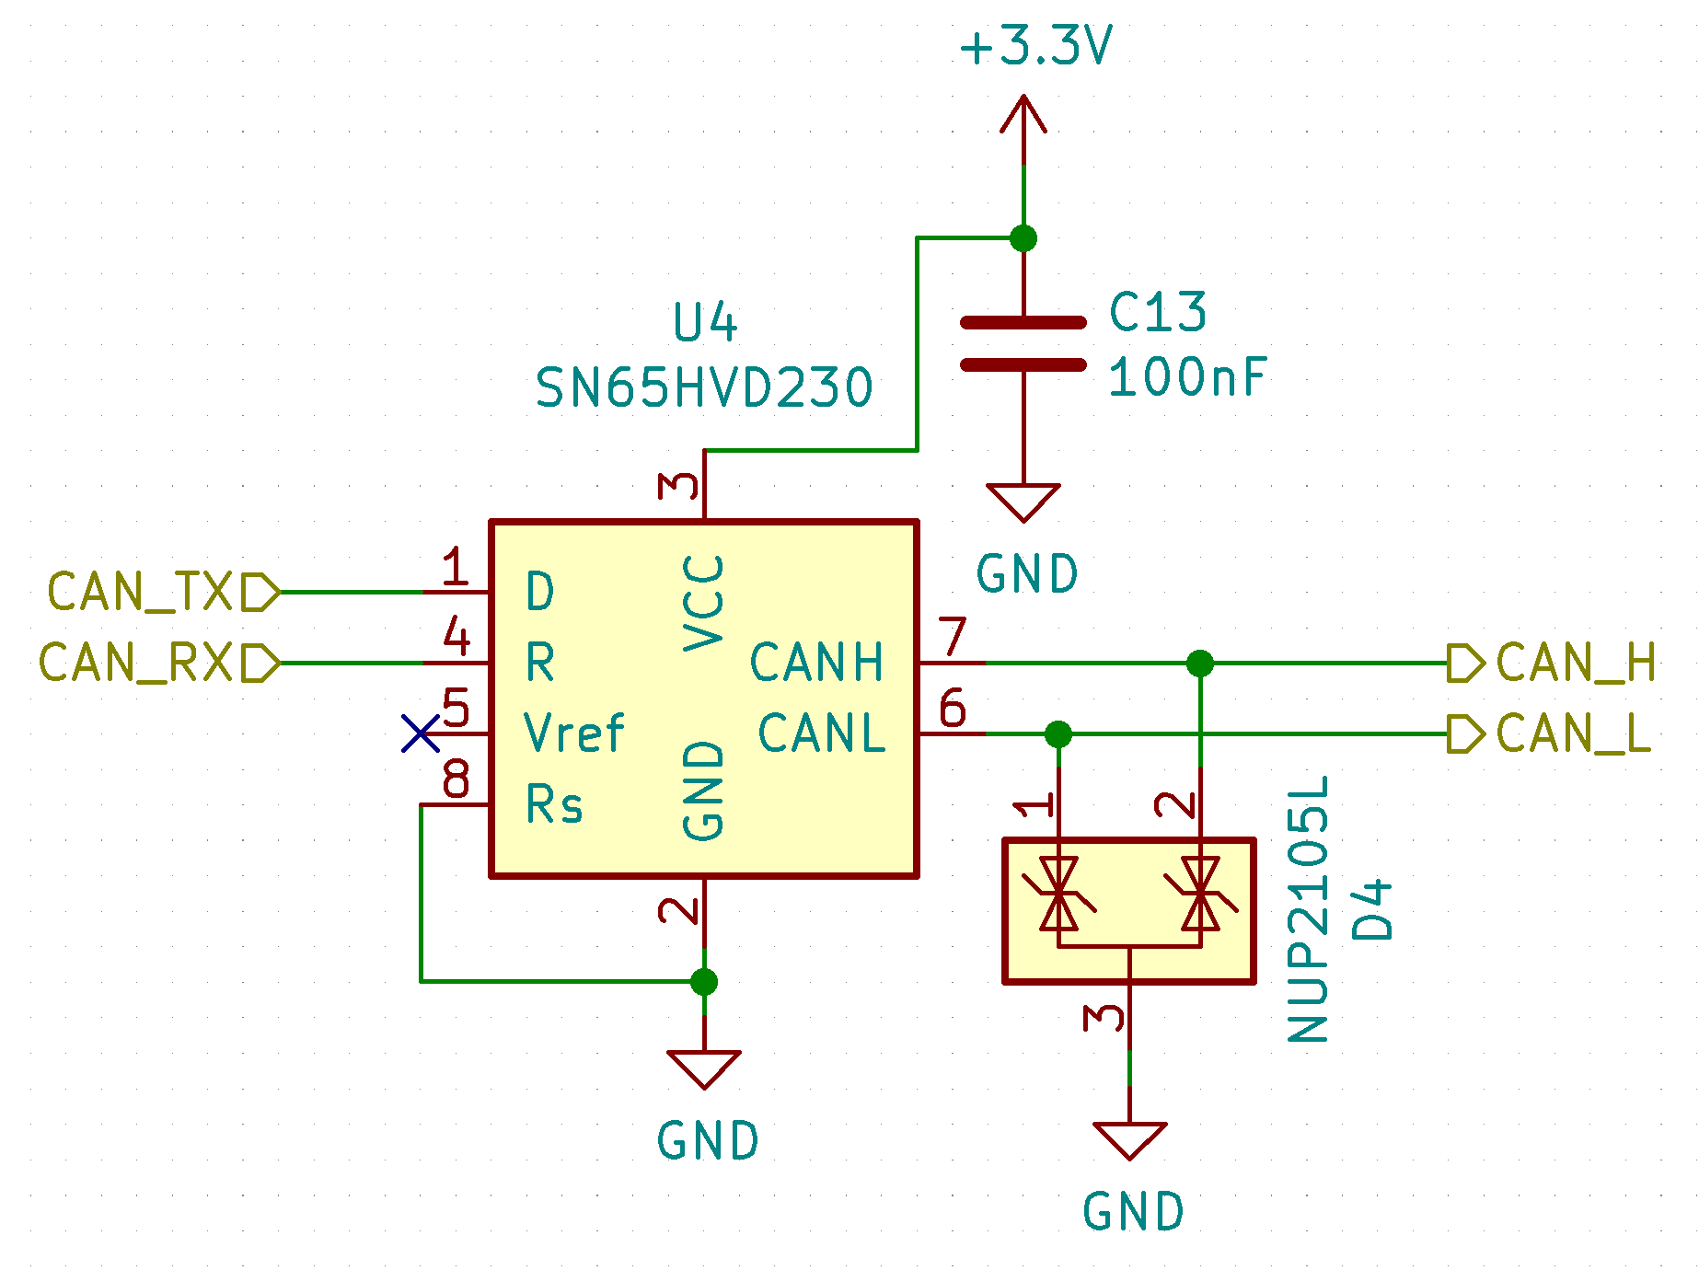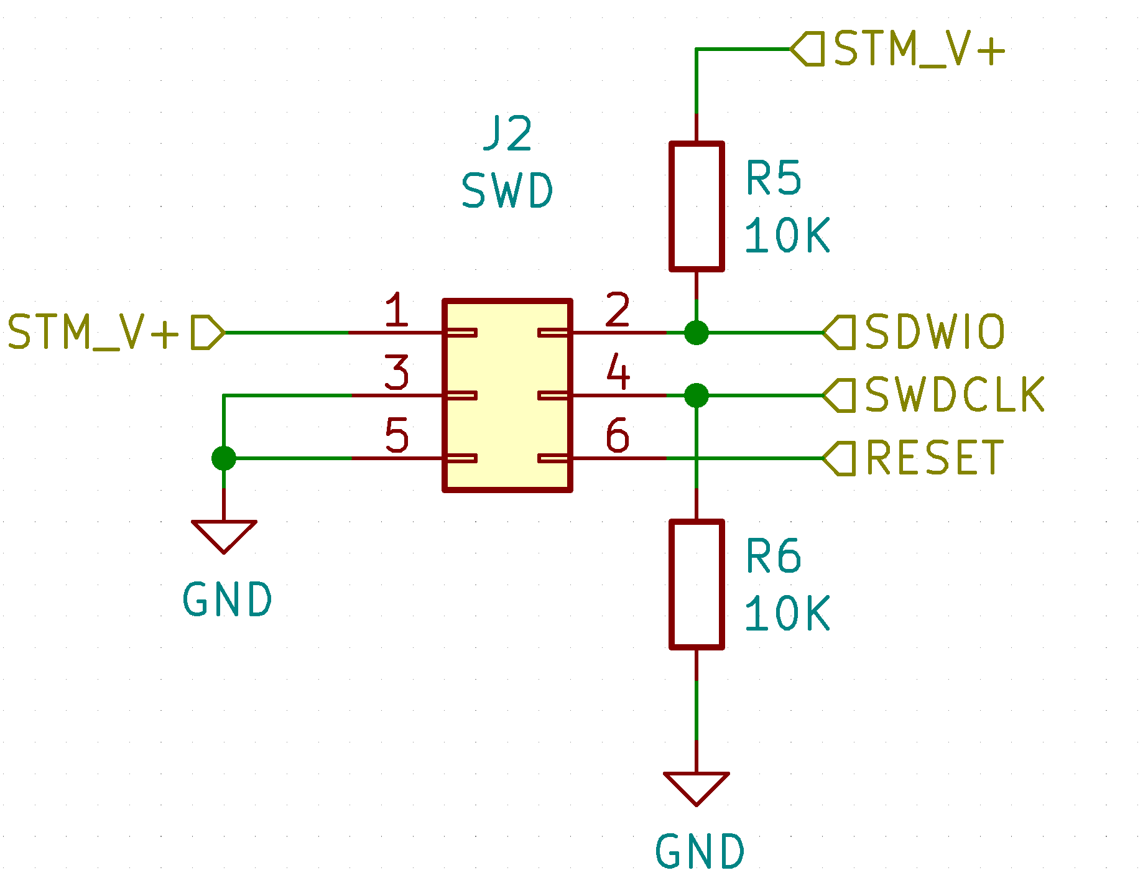

Figure 5. Can transceiver Figure 6. SDIO connector

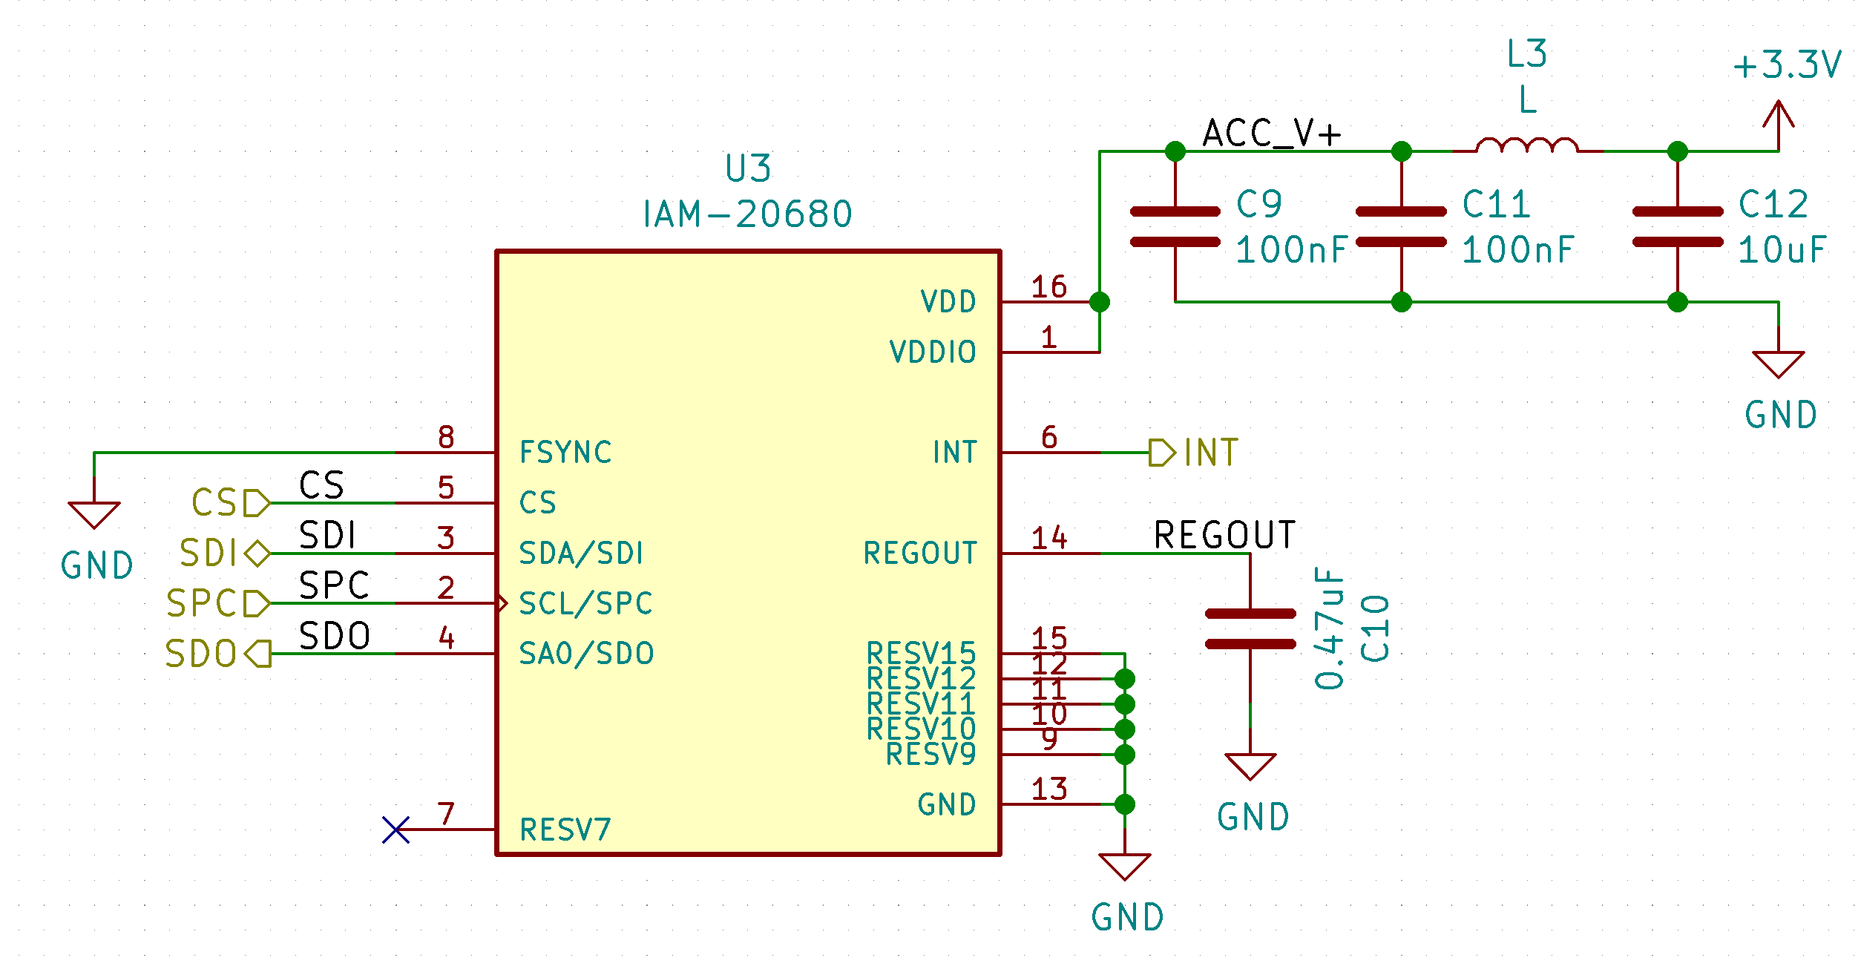

Figure 7. Accelerometer module

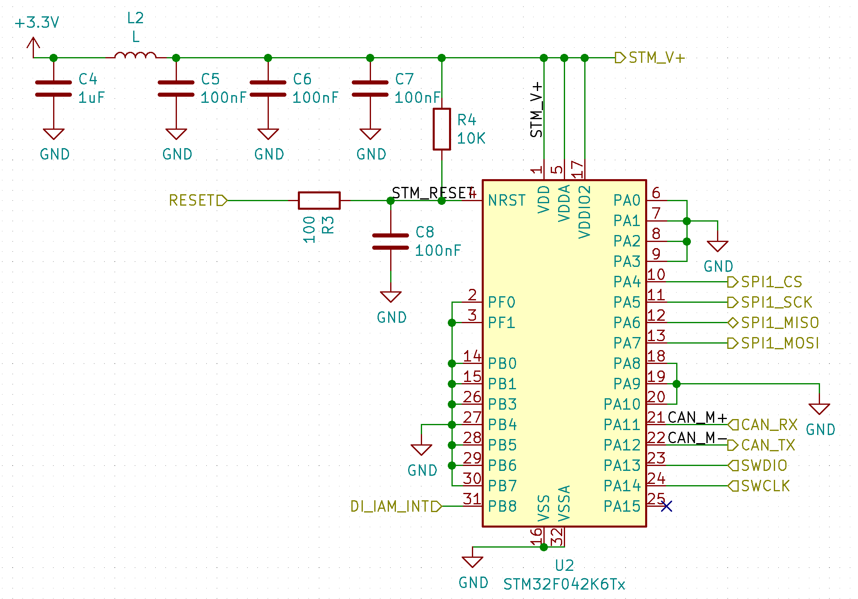

Figure 8. STM32 module

* LAYOUT PCB

(drawings, printed screens, photos – must have!. Includes each page of hierarchical sheet. If the PCB is large - many photos enlarged. )

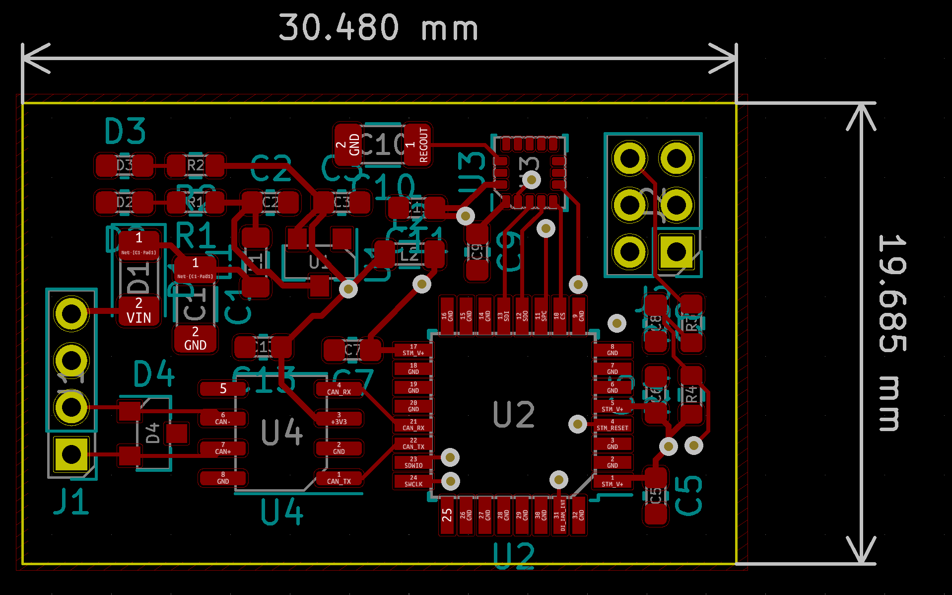

Figure 9. Top layer layout

Figure 10. Bottom layer layout

Figure 11. Top GND

Figure 12. Bottom GND

# FInal MODEL

* DESIGN RULES

(type of paths, paths width, min. size of vias – in the table, layers, etc.)

* SCHEMA

(drawings, printed screens, photos – must have!. Includes each page of hierarchical sheet)

* LAYOUT PCB

(drawings, printed screens, photos – must have!. If the PCB is large - many photos enlarged.)

1. Comparison of different versions

(what was changed – why?, why not?, made decisions between releases, which components was changed/removed? etc…)

1. 3D MODEL AND PLACEMENT ON THE CAR

(where and why the part is located, pictures, screens, drawings of assemblies, assumptions for location on the car )

There are two types of use this device in car. First, main in center of car, under steering rode to measure car vibrations and position. Second type is on all four wheels steering to measure vibrations and behavior of dumpers.

1. TESTS

(type of the test[current measurment, voltage measurment, switching time etc.], what is needed to do the tests, proces of the tests, PICTURES!)

1. IDEAS FOR THE NEXT SEASON