The Managing Director,
Garissa Water & Sewerage Company Ltd,
Garissa Town.

Nairobi, 6th January 2015.

Dear Sir,

RE: CLEARING OF ICT POLICY PAYMENT

We would like to bring to your attention that the above work was completed and delivered to the company in February 2013.

We invoiced 40% of the amount when we began the work.

We have since learnt that the contact person at the time when we were doing the consultancy work has since left the company.

Sir, kindly look into our issue with a view to clearing the balance that is long overdue.

Thanking you in advance.

Yours Faithfully,
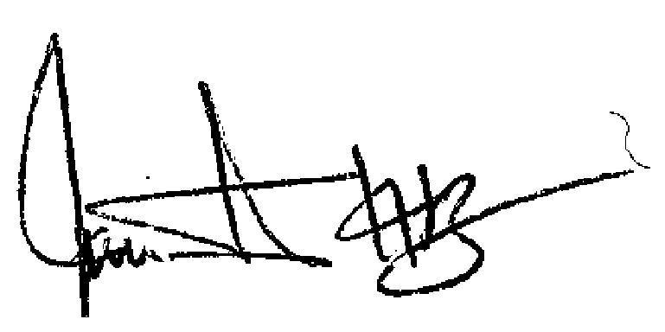

Rop Kiplagat.
Managing Director

