

**COUNTY GOVERNMENT OF VIHIGA**

**AUTOMATION OF REVENUE COLLECTION**

**END OF TRAINING REPORT**

**Submitted by;**

**Compulynx Limited**

**23rd February 2015**

**19th February 2015**

**TABLE OF CONTENTS**

1 Executive Summary 3

1.1 Resource Persons: 3

1.2 Training Facilitator: 3

1.3 Training Target group 3

2 Overview of the Project: 4

2.1 Objective of the Training: 4

2.2 Background 5

2.3 Rationale 5

2.4 Structure of training 5

2.5 Justification for structured training into four groups 6

3 TRAINING ANALYSIS 7

3.1 Training Program 7

3.2 An overview of Training Session 1- POS Collectors 3 days 7

3.3 2nd Session: Enforcement Team – 1 day 8

3.4 3rd Session: Accountants/Auditors/cashiers 8

4 Conclusion (Learning/Feedback) 10

4.1 Recommendation 10

4.2 Challenges 10

5 Annex: Photographs & Attendance sheet 11

6 Training Status Approvals 13

**AUTOMATION OF REVENUE COLLECTION**

**TRAINING OF USERS ON COREBIZ FRAME**

# Executive Summary

Date: 2nd to 21st February 2014

Venue: Joventure Hotel, Kisumu

Number of participants:

Group1 - 60

Group 2 - 58

Group 3 - 62

Group 4 - 69

## Resource Persons:

* Mr. Rop Kiplagat – Project Coordinator, Compulynx Limited
* Elijah Omondi – Developer Compulynx Limited
* Cliff Mitamita – Developer Compulynx Limited
* Micah Kangogo – Developer Compulynx Limited
* Oscar Ombima – ICT, County Government of Vihiga
* Billy Khwiesero–ICT County Government of Vihiga
* Robert Olang – Revenue supervisor, County Government of Vihiga
* Henry Mulati - Revenue supervisor, County Government of Vihiga
* Okubasu Gilbert- Revenue supervisor, County Government of Vihiga

## Training Facilitator:

* Compulynx Limited

## Training Target group

|  |  |  |
| --- | --- | --- |
| Target Group | Roles | Areas Trained |
| ICT Team | Systems Administration | System management |
| Revenue collectors | Collection of revenue | POS |
| Enforcement | Compliance | Android |
| Accountants | Cash book handling | Transaction reorts |
| Auditors | Auditing of receipts done | Transaction reports |
| Cashiers | Reconciliation of cash collected | Reports, BI |

# Overview of the Project:

County Government of Vihiga is implementing automation of its revenue collection. Revenue collection will be handled by POS (Point of sale ) devices and transactions seen on a real time on a web portal which will be hosted by the county government. The automation will also non cash payment that will include but not limited to MPESA in the first phase and later on cards will be adopted. Currently the system can handle all the revenue streams in the county but in the first phase the following services have been identified:

* Markets
* Entry Park
* Parking
* SBP (single Business Permit)

The project began last year in June and since then several milestones have been achieved namely:

* Project Inception
* System Requirement Study(SRS)
* Pilot test
* Training (which has been completed)

The remaining phase is implementation and launch of the project.

## Objective of the Training:

Training of the system had the following objectives:

* To build capacity in Vihiga County work force - ToT (Training of Trainers) who would transfer skills of the system from the developers to the users
* To identify those involved in the revenue collection process and their roles
* To support the county in the change management that is anticipated
* To identify any gaps/loop holes the new system might present
* To have support of the staff in implementing the system

## Background

County governments have been losing revenue in the past when they have been collecting their revenue using the manual system. Leakages have been occurring through collusion, faking of receipts, and duplication of receipt books and lack of quick management reports.

It is against this back drop that the county has automated its revenue collection with a view to maximizing on revenue collection without additional costs.

## Rationale

Automation process needs people to manage the process. Automation of the revenue collection will involve tools and infrastructure that were not existing before. POS devices will replace the manual process of issuing manual receipts, web portal will show transactions and accountants, cashiers and auditors will use it to perform their daily work. System administrators will manage the POS devices as well as manage users in the new system.

There was need to sensitize staff involved in the revenue collection on the expected automation process and manage change that will arise as a result of new and sometimes changed roles.

Once the system is implemented it is expected that the users in the county will depend less on the developers of the system for first line support. Skills transfer from the developers is therefore essential for the smooth adoption of the new automated revenue collection process.

## Structure of training

The training was organized into four groups of an average of sixty people per session. Three group roles were identified in each group ( revenue collectors, enforcement, cashiers/auditors/accountants).

In the first group to be trainer were the ToT that had been identified. The ToT group comprised of :

* Revenue Supervisors – to assist in the business process as they understand the work flow
* ICT Team – to manage the technical aspect of the collections (POS, web portal, API, android )

After the first group had been trained by Compulynx Limited, they were able to train the subsequent groups.

## Justification for structured training into four groups

It will be appreciated that the revenue collectors come from a diverse age group, skills and abilities. Training on the POS required less a low trainer to learner ratio in order for the training to be taken through in 3 days. A larger number would slow down the trainers in terms of giving personal attention to slow learners. Small number of trainees would ensure high success rate of training objectives due to the personalized attention.

There was need to have a small and manageable size that trainers would manage easily through hand holding process of each step of the training.

The three roles (POS, enforcement and accountants/auditors/cashiers) identified had distinct roles and duties hence they were grouped together.

The three identified for the POS was informed by the pilot training exercise which had allocated one day for the POS training but it was realized that it wasn’t enough.

# TRAINING ANALYSIS

|  |  |  |
| --- | --- | --- |
| Group | Date | Target |
| 1 | 2nd - 4th February 2015 | POS collectors |
| 5th February 2015 | Accountants |
| 2 | 6th - 7th & 9th February 2015 | POS Collectors |
| 10th February 2015 | Accountants |
| 3 | 11th - 13th February 2015 | POS collectors |
| 14th February 2015 | Accountants |
| 4 | 16th- 18th February 2015 | POS collectors |
| 19th February 2015 | Enforcement |
| 20th February 2015 | Accountants |

## Training Program

The trainings were divided in into four groups of 3 roles/group of trainees

* Session 1 - POS Collectors 3 days
* Session 2 - Accountants/Auditors/Cashiers
* Session 3 - Enforcement

## An overview of Training Session 1- POS Collectors 3 days

POS users are the primary revenue collectors in the county. Their duty is to ensure that every revenue that is to be collected and under their jurisdiction is collected without failure. They work in conjunction with the enforcement team to ensure that this is realized.

Objectives of training on POS were:

1. To understand the POS hardware components.
2. To enable learners do settings on the POS
3. To learn the navigation buttons
4. To understand the log in/log out process
5. To be able do transactions on the POS
6. To be able to make cash and MPESA payment trasactions
7. To void receipts using POS
8. To produce and verify Z reports

## 2nd Session: Enforcement Team – 1 day

Enforcement is charged with ensuring that compliance in revenue payment is adhered to by the rate payers. They are also in charge of security in the markets. They work hand in hand with the revenue collectors. They have powers to arrest on matters pertaining to revenue collection and misdemeanor acts in the market.

In the manual process enforcement was done through physical inspection of the receipts/business premises for compliance. With the electronic payment verification of the receipts and payment will be done via a mobile app. The enforcement team were therefore trained on the mobile android app.

Objectives of training on Android were:

1. To understand the android application functions.
2. To enable learners do settings on the POS
3. To learn the menus
4. To understand the log in/log out process
5. To be able do verification using
   1. Receipt number
   2. Vehicle registration
   3. Scanning of the receipt
6. To make comments after the scanning
7. To look at the reports
8. To Confirm from the portal that the verification has been done

## 3rd Session: Accountants/Auditors/cashiers

The team is involved in the management of the revenue collection. They are based in the sub county offices. Reconciliations of collections, auditing of the receipts and handling the of cash book are done by the team.

Cashiers – do the reconciliation from the market superintendents by checking the number of receipts issued against the banking slips using control sheets

Auditors- - ensure that the cashiers reconciliations tally

Accountants – pass the collections to the books of accounts.

With the real time transactions realized by automation, all transactions reflect on the dash board meaning there is no more filling of the control sheets.

Objectives of training for Accountants/auditors/cashiers were:

1. To understand the new business process and work flow.
2. To enable cashiers perform their reconciliations from the portal
3. To enable auditors perform their duties from the portal
4. To enable accountants perform their duties on the portal
5. To understand their right/roles on the portal (access rights & privileges)
6. To be able to log in/log out of the portal
7. To access the different transaction reports
8. To be able to print/export the reports

# Conclusion (Learning/Feedback)

The sessions on the POS was conducted well with all the expected attendees making appearances.

The enforcement team was not adequately trained as the mobile phones were not adequate. There were only four phones available and they were sharing. The training exercise needs to be repeated for this team.

The accountants session was completed with some adjustment s on the reports which some have been accomplished already.

## Recommendation

1. Once the county government procures the android phones, the enforcement will have to be retrained.
2. The county government should ensure that the POS devices are insured before roll out.
3. The systems administrator should be trained by Safaricom Ltd on MPESA administration before roll out
4. All SIM cards should be registered on pre-paid data bundles
5. Have an internal meeting on change management
6. Advise Compulynx Limited on the launch date.

## Challenges

1. Internet connectivity was a big challenge affecting the operations of the POS management on the portal.
2. Data bundles acquisition was a challenge the facilitators as they had to spend their money to buy data bundles for the trainees.
3. Thermal rolls and other consumables were a challenge
4. Internet challenges

# Annex: Photographs & Attendance sheet

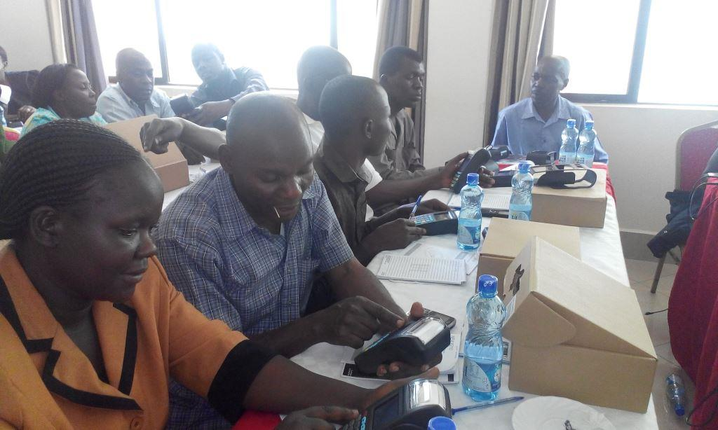

Photo 1: Accountants, Auditors & Cashiers Session

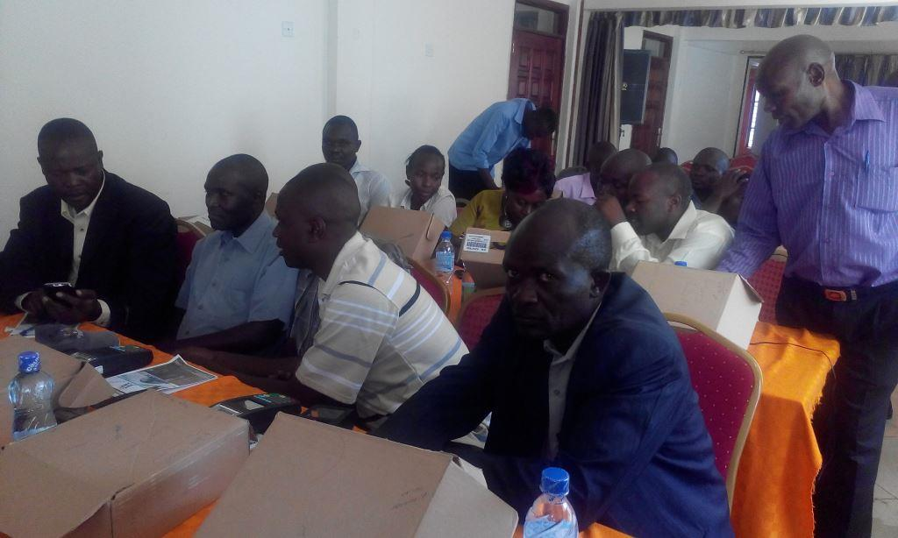

Photo 2: Enforcement Team learning the android app

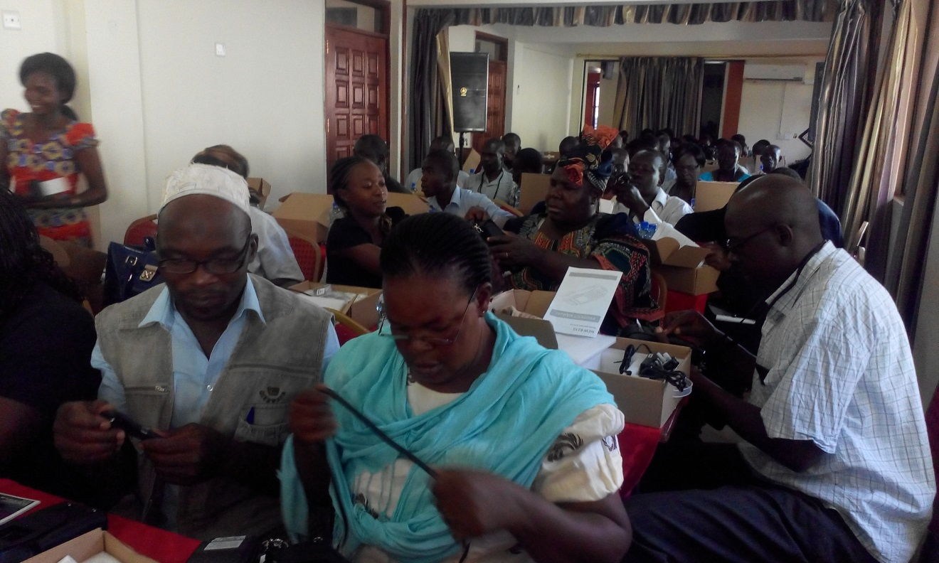

Photo 3: Revenue Collectors learning how to use POS

# Training Status Approvals

**Rop Kiplagat Branham,**

**Automation Revenue Projects Coordinator Compulynx Limited**

Signature________________________________________

**Ikoha Ernest,**

**Revenue In Charge Automation, County Government of Vihiga**

Signature________________________________________

**Morgan Musung,**

**Automation Revenue Project Manager, County Government of Vihiga**

Signature________________________________________