EE 236: Experiment 3 Photodiode Characteristics and Applications

Jatin Kumar, 22B3922 August 24, 2024

# Aim

* To study the forward and reverse bias I/V characteristics of a Photodiode.
* To measure the response of the Photodiode for different lights and different intensities. (4 LEDs are provided, along with their current vs intensity data)
* To use the Photodiode as an optical signal sensor in combination with an Infra-red LED.

# Parts of the Experiment

## Part 1

* + 1. **Circuit**

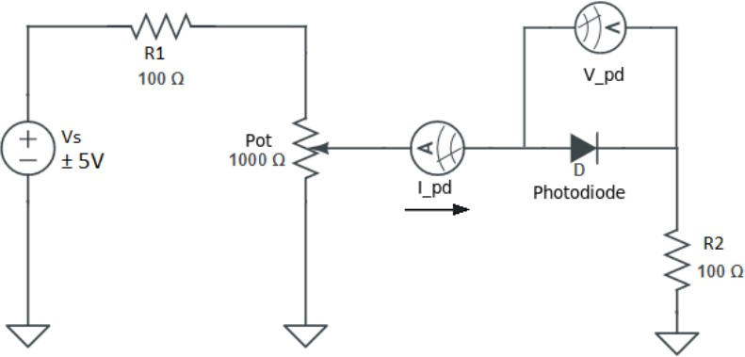

* + 1. **I-V data**

|  |  |  |
| --- | --- | --- |
| **V pd** | **I pd (mA)** | **ln(abs(I pd))** |
| 0 | 0 |  |
| 0.05 | 0 |  |
| 0.1 | 0 |  |
| 0.15 | 0 |  |
| 0.2 | 0 |  |
| 0.26 | 0 |  |
| 0.46 | 0.65 | -7.3385 |
| 0.543 | 1.98 | -6.2247 |
| 0.567 | 2.83 | -5.8675 |
| 0.572 | 3 | -5.8091 |
| 0.578 | 3.22 | -5.7384 |
| 0.588 | 3.58 | -5.6324 |
| 0.592 | 3.74 | -5.5887 |
| 0.603 | 4.16 | -5.4822 |
| 0.62 | 4.89 | -5.3206 |
| 0.63 | 5.44 | -5.2140 |
| 0.653 | 6.66 | -5.0116 |
| 0.672 | 7.89 | -4.8422 |
| 0.708 | 10.88 | -4.5208 |
| 0.759 | 16.77 | -4.0882 |
| 0.766 | 17.91 | -4.0224 |

* + - * **Ideality factor** : 3.7531
    1. **Plots**

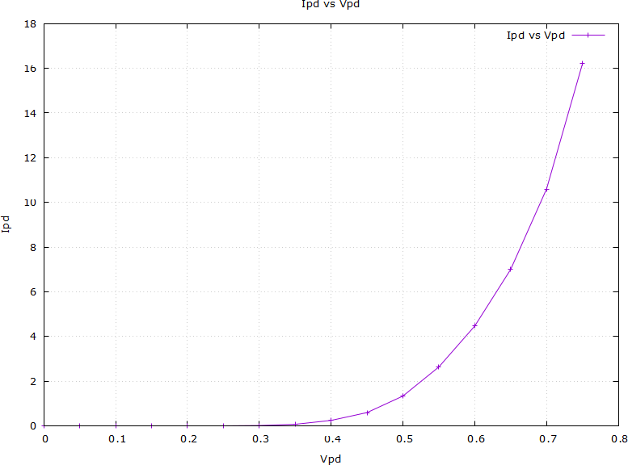

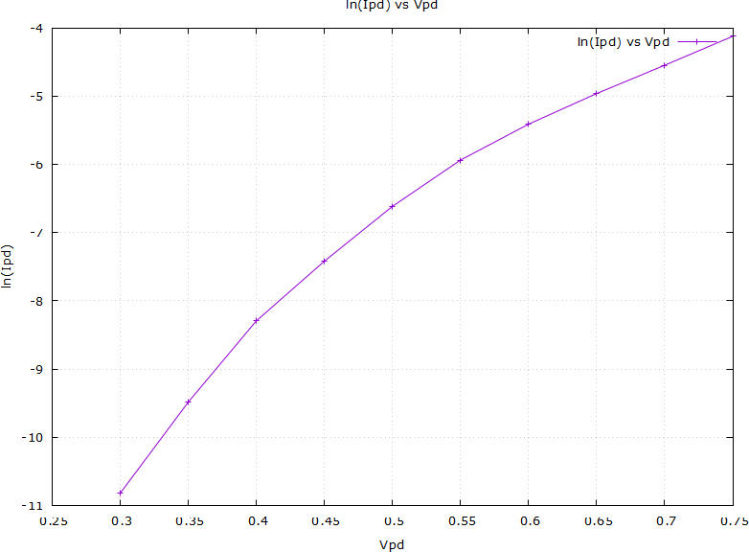

## Part 2

* + 1. **Circuit**

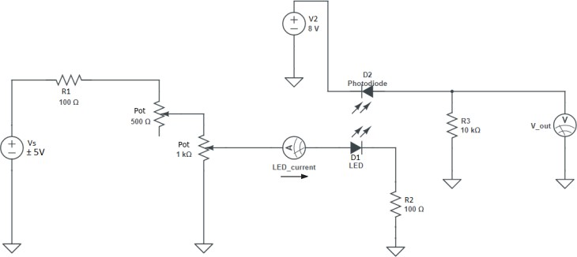

* + 1. **Data**

|  |  |  |  |  |
| --- | --- | --- | --- | --- |
|  | **Vout(V)** | | | |
| **Intensity(lux)** | **IR** | **Red** | **Green** | **Blue** |
| 1000 | 4.51E-03 | 2.00E-03 | 1.88E-04 | 3.01E-04 |
| 1500 | 5.17E-03 | 3.00E-03 | 2.94E-04 | 4.16E-04 |
| 2000 | 6.28E-03 | 4.00E-03 | 3.71E-04 | 5.72E-04 |

|  |  |  |  |  |
| --- | --- | --- | --- | --- |
|  | **IR** | **Red** | **Green** | **Blue** |
| **Lambda (m)** | 9.50E-07 | 7.50E-07 | 5.20E-07 | 4.50E-07 |

* + 1. **Plots**
    2. **Vout vs Wavelength**

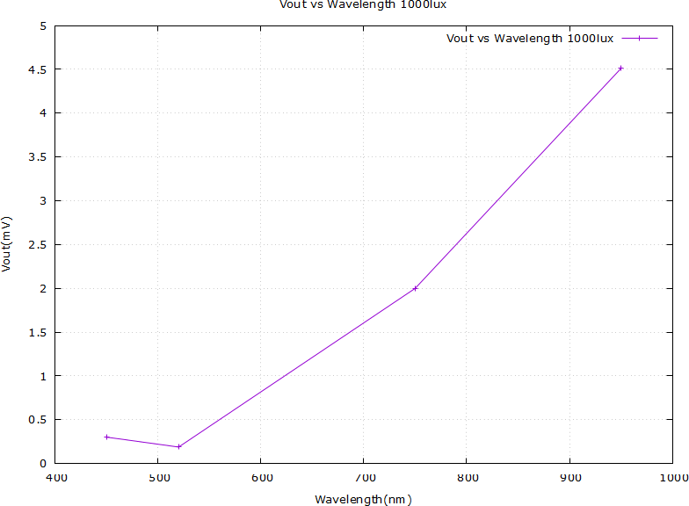

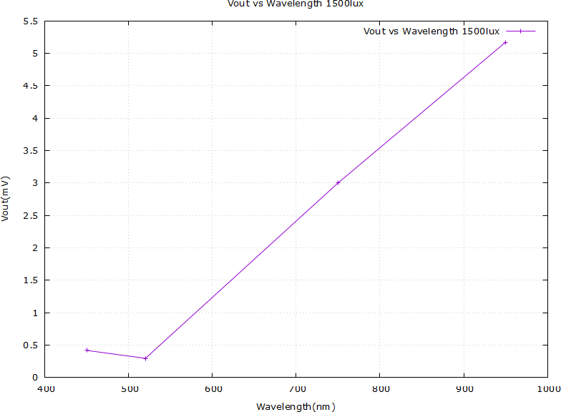

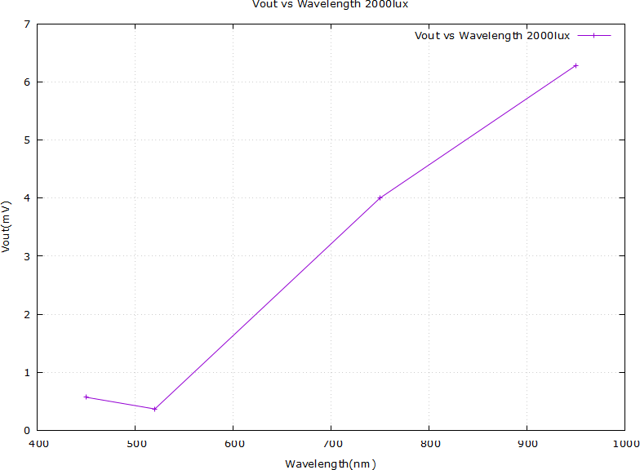

* + 1. **Vout vs Intensity**

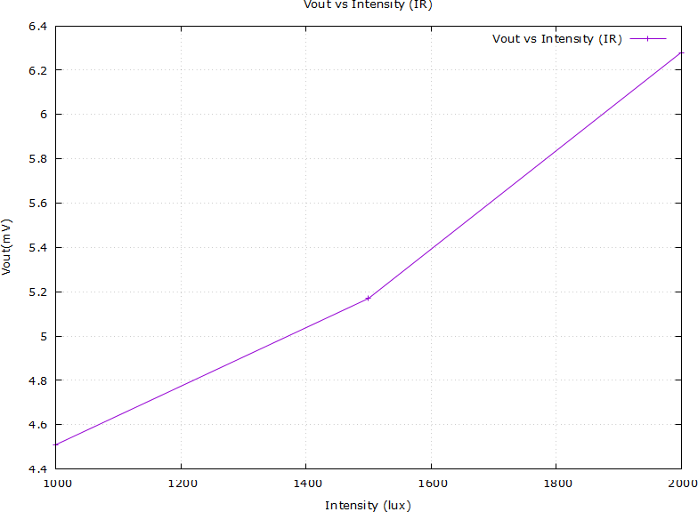

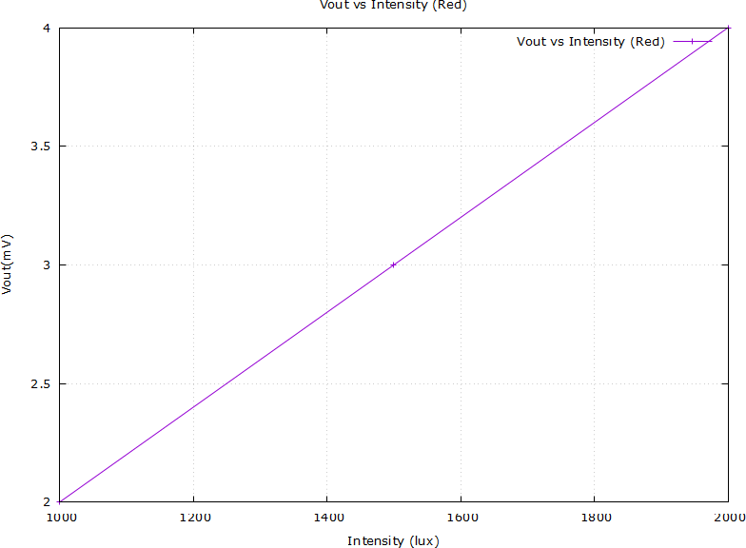

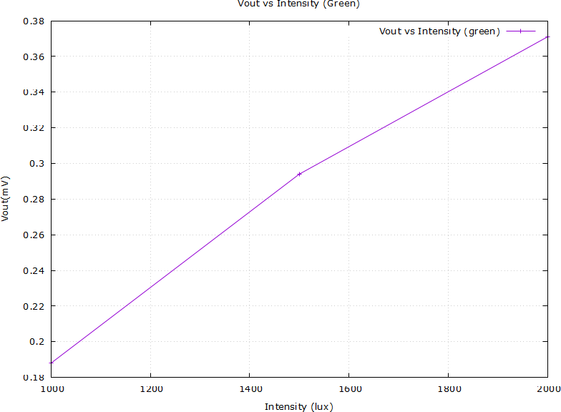

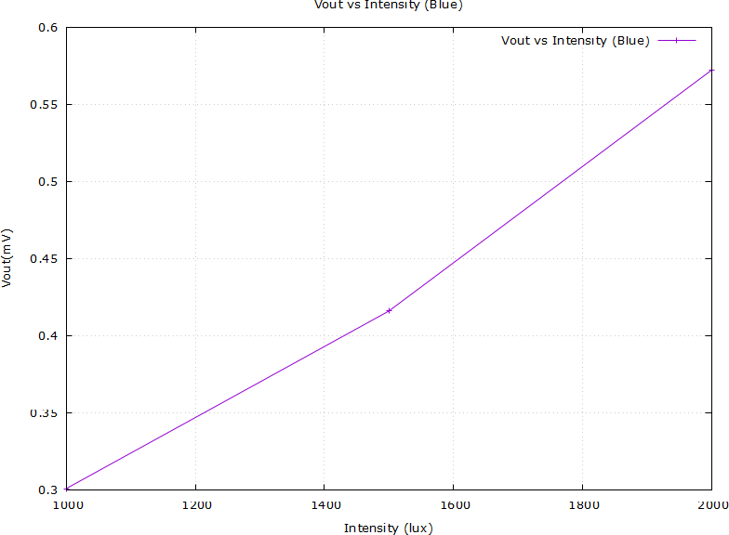

* + 1. **Efficiency**

|  |  |  |  |  |
| --- | --- | --- | --- | --- |
| **Intensity** | **IR/Intensity** | **Red/Intensity** | **Green/Intensity** | **Blue/Intensity** |
| 1000 | 1.91E-03 | 5.90E-03 | 2.18E-02 | 9.97E-03 |
| 1500 | 1.27E-03 | 4.35E-03 | 1.31E-02 | 5.93E-03 |
| 2000 | 9.85E-04 | 3.50E-03 | 9.70E-03 | 4.02E-03 |
| Lambda | 9.50E-07 | 7.50E-07 | 5.20E-07 | 4.50E-07 |

Most efficient: Green

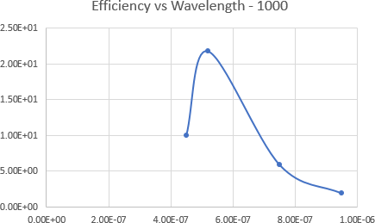

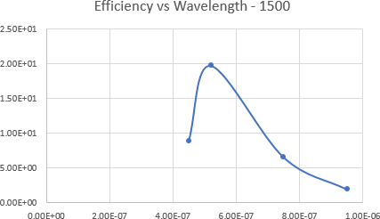

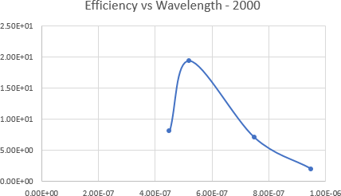

## Part 3

* + 1. **Circuit**

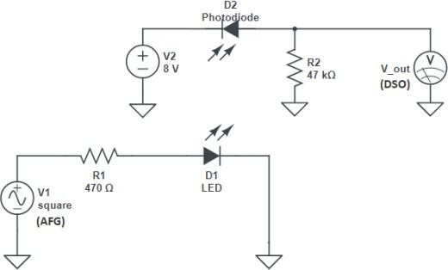

* + 1. **Data**

|  |  |  |
| --- | --- | --- |
| **Frequency (Hz)** | **Rise time (us)** | **Fall time (us)** |
| 1000 | 15.37 | 15.72 |
| 5000 | 11.37 | 11.62 |
| 10000 | 11.98 | 11.34 |
| 15000 | 12.31 | 12.15 |
| 20000 | 12.19 | 12.03 |

* + 1. **Observations and Reasoning**
       - **Distortion:** Distortion is observed to become too large at 20 kHz.
       - **Reason for Slow Photodiode Response:** A photodiode has a ”detection bandwidth” associated with it, which determines the speed at which its output can vary in response to a varying input signal. This bandwidth depends on two factors:
         1. Junction capacitance in the diode.
         2. Transit time of the photocurrent in the junction.

# Completion Status

The experiment was thoroughly conducted and successfully completed within the lab setting. All objec- tives were met, and the procedures were carried out as planned, yielding the expected results.