EE 236 : Lab 1 Post-lab report

Rahul Agarwal, 22B3961 August 2024

1. **Experiment 1 - Diode forward bias character- istics**

# Aim:

The aim of this experiment is to study the forward bias I-V characteristics of PN junction diodes, estimate the band gap of the semiconductor material used in the diodes, and calculate the ideality factor, reverse saturation current, and doping densities of various PN junction diodes

# Design:

This experiment was done in 2 parts, first in simulation and then practical in lab. The design of the circuit was simply a voltage source connected with a potentiometer, which was providing variable voltage to a diode and a resistance in series, as can be seen in the figure below. The potentiometer was tweaked to change the voltage across diode and current across the resistor in series was measured, which is equal to current through diode.

# Simulation result:

Following are the code snippets and graphs for the simulation of the experiment on ngspice:

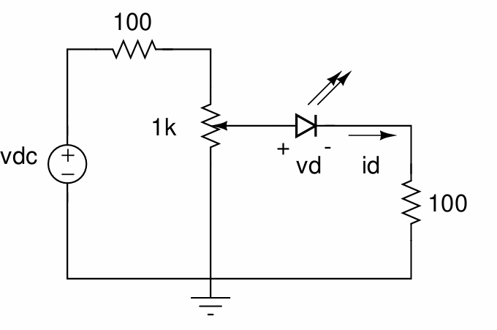

Figure 1: Caption

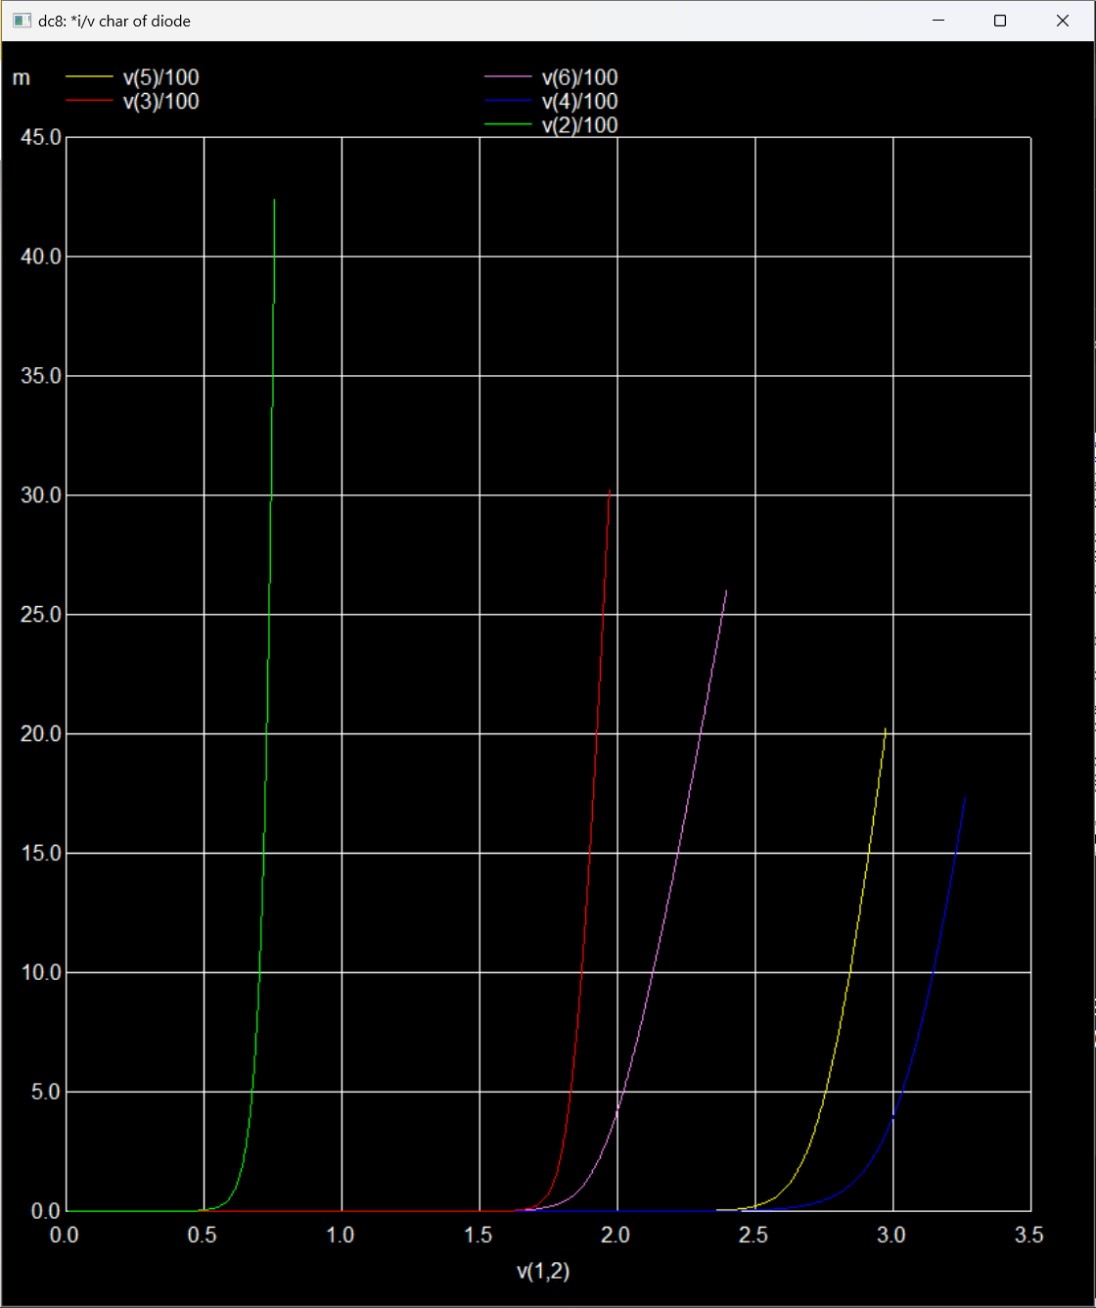

Figure 2: Id v/s Vd

1

* I/ v char of diode

. include " D :\5 th_semester \ EE236 \ Lab1 \ Prelab \ PN_ 1 N 4007 . txt"

. include " D :\5 th_semester \ EE236 \ Lab1 \ Prelab \ red_5 mm . txt"

. include " D :\5 th_semester \ EE236 \ Lab1 \ Prelab \ green_ 5 mm . txt"

. include " D :\5 th_semester \ EE236 \ Lab1 \ Prelab \ blue_5 mm . txt"

. include " D :\5 th_semester \ EE236 \ Lab1 \ Prelab \ white_ 5 mm . txt" vin 1 0

d1 1 2 1 N4007

r1 2 0 100

d2 1 3 RED

r2 3 0 100

d3 1 4 WHITE

r3 4 0 100

d4 1 5 BLUE

r4 5 0 100

d5 1 6 GREEN

r5 6 0 100

. dc vin 0.01 5 0.01

. control run

plot v(2) /100 vs v(1 ,2) v(3) /100 vs v(1 ,3) v(4) /100 vs v(1 ,4) v(5)

/100 vs v(1 ,5) v(6) /100 vs v(1 ,6)

plot ln( v(2) /100) vs v(1 ,2) ln( v(3) /100) vs v(1 ,3) ln( v(4) /100) vs

v(1 ,4) ln( v(5) /100) vs v(1 ,5) ln( v(6) /100) vs v(1 ,6)

. endc

2

3

4

5

6

7

8

9

10

11

12

13

14

15

16

17

18

19

20

21

22

23

24

25

26

27

28

29

30

31

32

Listing 1: Forward bias analysis of diodes

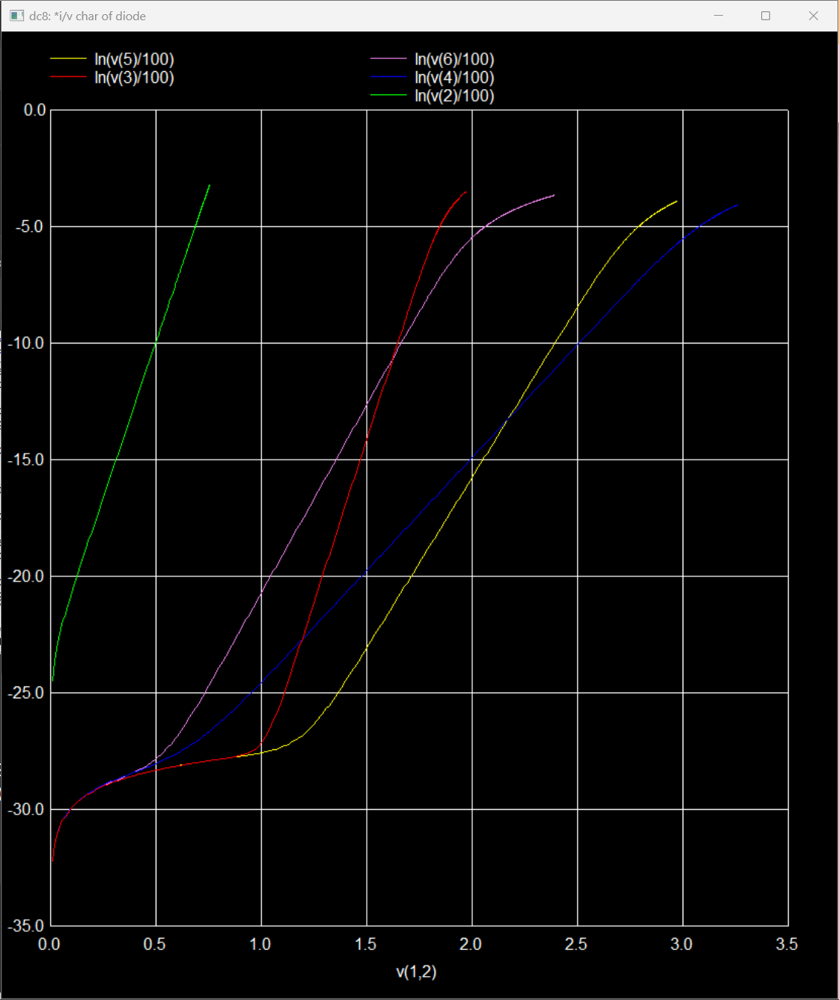

Figure 3: log of Id vs Vd

# Experiment Results:

We took readings at multiple voltages and measured the current through diodes. Following are the readings and graph of the data.

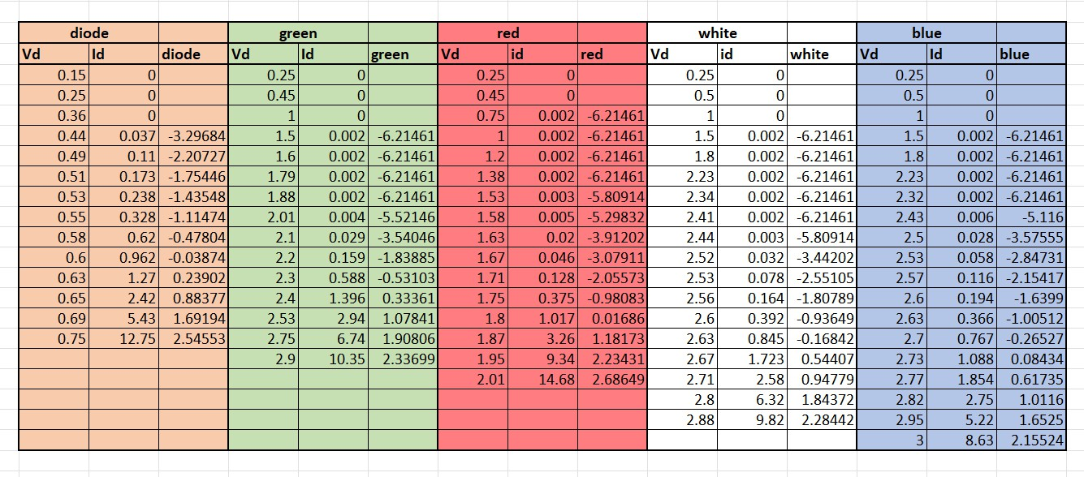

Figure 4: Readings

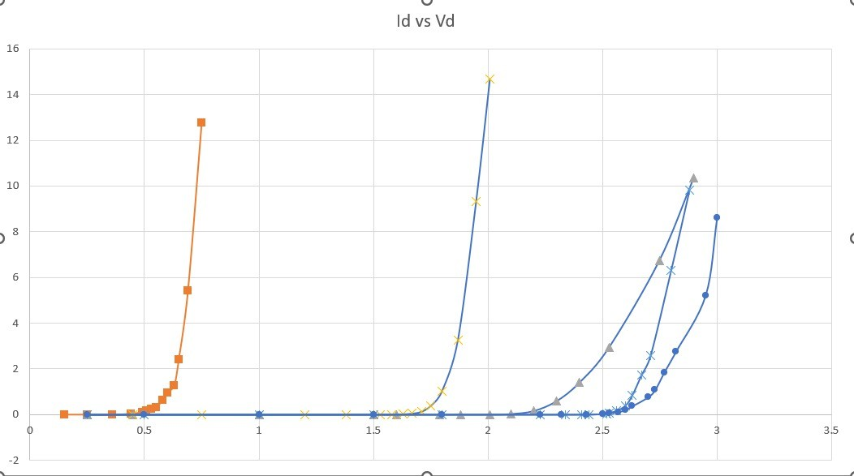

Figure 5: experimental data

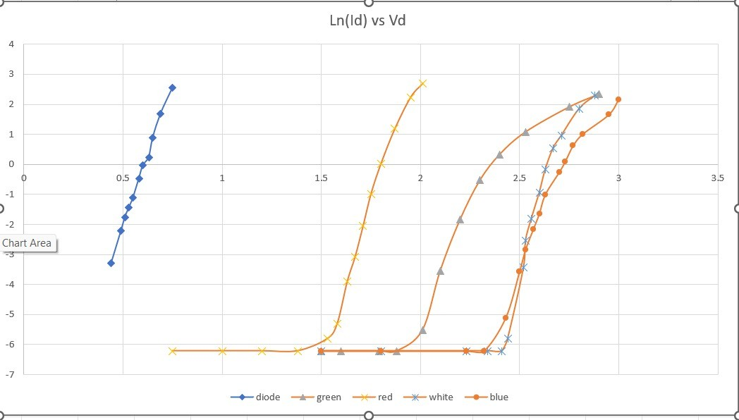

Figure 6: Experimental data

## Calculations:

The calculations were done from the collected data and following are the results:

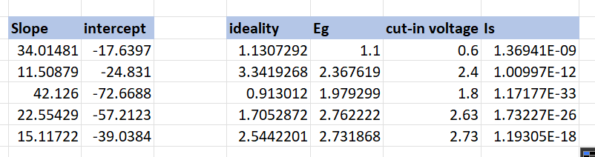

Figure 7: Calculation results

# Conclusion and Inference:

The cut-in voltage increases with increase in band gap energy. This is because larger bandgap requires more energy to the electron to overcome, and hence more forward bias voltage.

## Experiment Conclusion Status:

The experiment was completed and results were shown to the alloted TA.