EE236: Electronics Devices Lab Lab No. 2

Shetty Sathwik Prakash, 22b2209 August 16, 2024

1. **PIN DIODE v/s PN DIODE**

# Aim of the experiment

To find forward voltage, reverse saturation current and ideality factor of the given PIN diode (Infineon BAR 15-1) and compare with normal PN junction Diode (1N4007).

To find reverse recovery time of the given PIN diode at various frequencies and compare with the reverse recovery time of normal PN junction Diode. To observe how the PIN diode works as an RF switch at different DC bias voltages.

# Design

In prelab report we plotted I-V characteristics of RN142 PIN diode to mea- sure cut-in voltage and ideality factor. Then we tried measuring reverse recovery time for the same. Then next task was to understand how PIN diodes work as RF switches by implementing the given circuit in Figure 1 and compare the same with regular PN junction diodes. Write NGSPICE netlist and simulate the given RF switch circuit and plot output voltage, output current and diode current for different DC bias voltages (-5V, 0V, 1V, 3V, 5V).

Follwing is the code

LAB_2_1

. model dmodel D (+ IS =127.76 E -12

1

2

3

+ N =1.7346

+ RS =.1581

+ IKF =.14089

+ CJO =385.59 E -15

+ M =.11823

+ VJ =.78827

+ ISR =139.38 E -12

+ NR =3

+ BV =60

+ TT =275.00 E -9) r1 2 0 100

d1 1 2 dmodel

4

5

6

7

8

9

10

11

12

13

14

r1 2 0 100

d1 1 2 dmodel

vin 1 0 PULSE (-1 V +1 V 0.02 m 0.01 m 0.01 m 0.05 m 0.1 m)

. tran 0.02 ms 0.2 ms

. control run

plot V (1)-V (2)

|  |  |  |  |  |  |
| --- | --- | --- | --- | --- | --- |
| 15 vin | 1 0 dc 0 |  | | | |
| 16 * DC | Analysis on source vin , to vary | from | 0 | to | +5 V |
| 17 . dc | vin 0 10 0.01 |  |  |  |  |

|  |  |  |  |
| --- | --- | --- | --- |
| 18 | . control | |  |
| 19 | run | |
| 20 | plot ( v(2) /100) vs | | v(1 ,2) |
| 21 | . endc | |  |
| 22 | . end | |  |
|  |  | |  |
| 1 | LAB_2_2 | |  |
| 2 | . model dmodel D (+ | | IS =127.76 E -12 |
| 3 | + | N =1.7346 | |
| 4 | + | RS =.1581 | |
| 5 | + | IKF =.14089 | |
| 6 | + | CJO =385.59 E -15 | |
| 7 | + | M =.11823 | |
| 8 | + | VJ =.78827 | |
| 9 | + | ISR =139.38 E -12 | |
| 10 | + | NR =3 | |
| 11 | + | BV =60 | |
| 12 | + | TT =275.00 E -9) | |

13

14

15

16

17

18

19

20

. endc

. end

21

1

LAB_2_3

. model dmodel D (+ IS =127.76 E -12

+ N =1.7346

+ RS =.1581

+ IKF =.14089

+ CJO =385.59 E -15

+ M =.11823

+ VJ =.78827

+ ISR =139.38 E -12

+ NR =3

+ BV =60

+ TT =275.00 E -9)

vin 1 0 AC 6 sin (0 6 10 Meg 0 0)

c1 1 2 100 n

r1 2 0 500

d1 6 2 dmodel

r4 3 6 1

r2 3 4 500

vdc 4 0 dc -5 s

c2 3 5 100 n

r3 5 0 50

. control

tran 0.1 n 200 n

plot v(3 ,6) v(5) /50 v(5) v(1)

. endc

. end

2

3

4

5

6

7

8

9

10

11

12

13

14

15

16

17

18

19

20

21

22

23

24

25

26

# Simulation results of PreLab

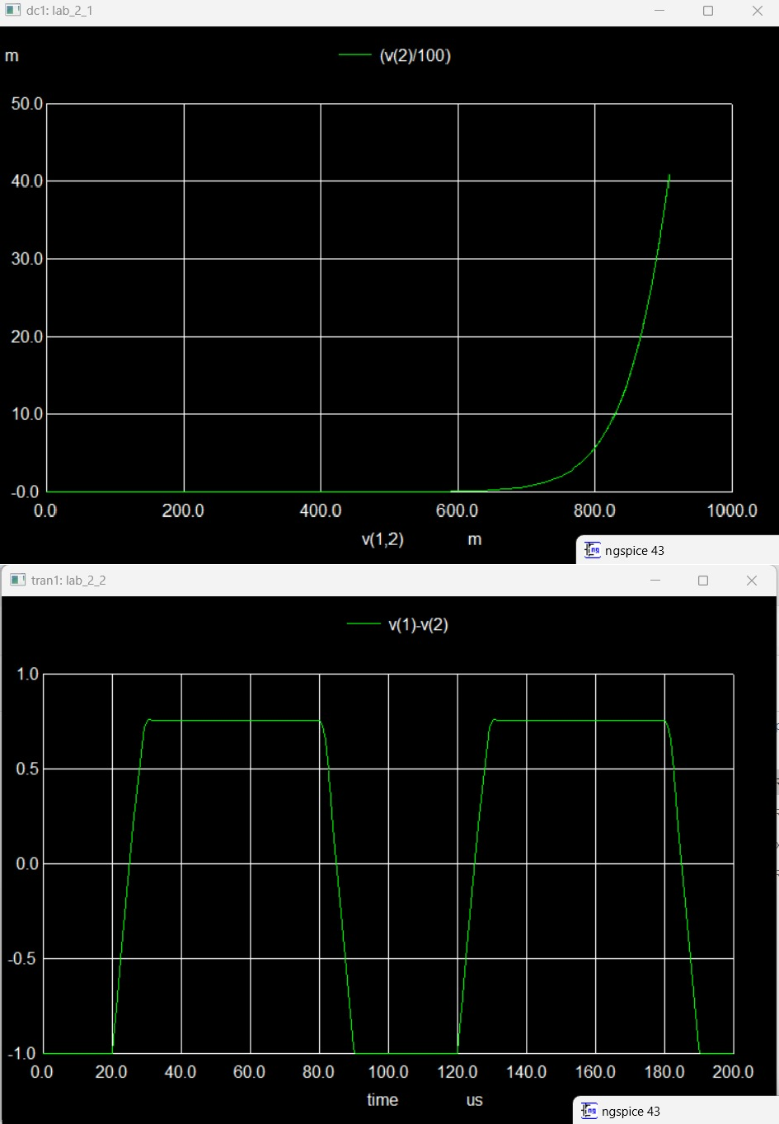

4

Figure 3 at bias 5volts

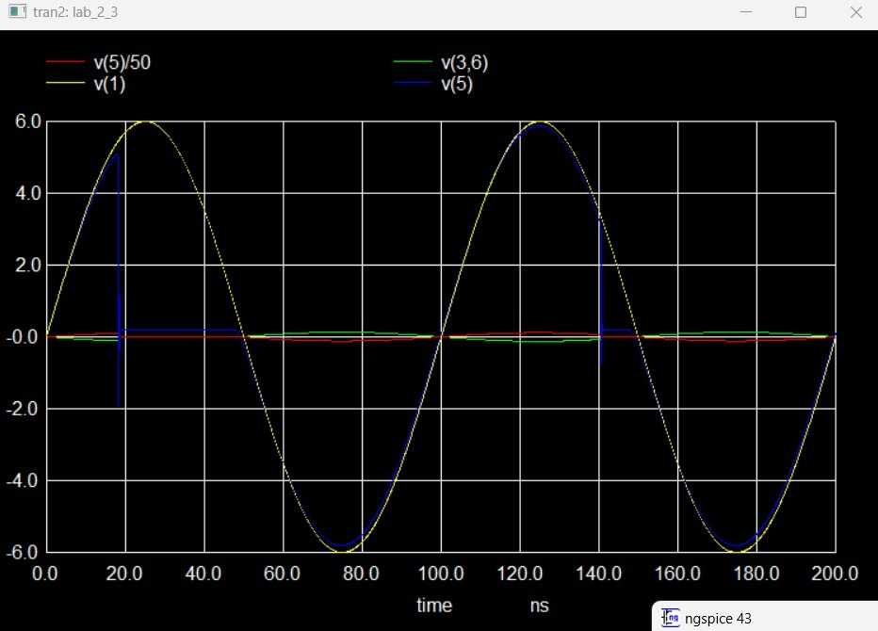

Values got:

Cut-in voltage = 800 mV Ideality Factor (N) = 2.74 Recovery time = 5 microseconds

# In-Lab

In the lab, we build the following circuit using pot and transistors then tried to check IV charateristics Data was collected manually.

**Slope:** Slope was found using Linest function of Excel.

**Ideality Factor:** As we know with the help of equation, slope=q/nkT where kT/q is 0.026 so we got the ideality factor.

Then we compared the reverse recovery time of both diodes using 4 different frequencies. There may be an error here as it was manually calculated.

Then we built an RF switch and saw its working at different bias voltage.

# Simulation results of Lab

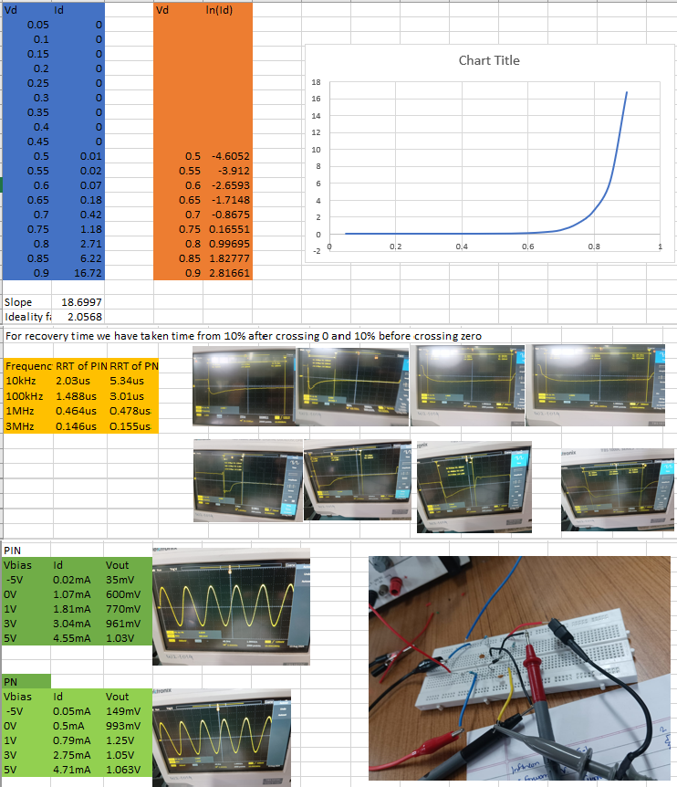

* 1. **Conclusion and Inference**

n this experiment, the forward voltage, reverse saturation current, and ideal- ity factor of the Infineon BAR 15-1 PIN diode were determined and compared with those of the standard 1N4007 PN junction diode. The results indicated that the PIN diode exhibits a lower forward voltage drop and higher reverse saturation current compared to the PN junction diode, making it more suit- able for high-frequency applications.

The reverse recovery time was also measured for both diodes at various fre- quencies. It was observed that the PIN diode demonstrated a significantly lower reverse recovery time than the PN junction diode, particularly at higher frequencies. This characteristic enhances the PIN diode’s performance in switching applications, especially in RF circuits.

Furthermore, the behavior of the PIN diode as an RF switch was studied at different DC bias voltages. The experimental results confirmed that the PIN diode can efficiently operate as an RF switch, with its performance highly dependent on the applied bias voltage.

Finally, the experiment revealed that at a frequency of 3 MHz, the PIN diode has a greater potential to pass a major portion of the input signal to the out- put compared to the PN junction diode. This makes the PIN diode a better choice for high-frequency switching and signal processing applications.

Overall, the Infineon BAR 15-1 PIN diode outperforms the 1N4007 PN junc- tion diode in high-frequency and RF switching applications, making it a preferable choice in these scenarios.

# Experiment completion status

Completed