EE 236: Experiment 3 Photodiode Characteristics and Applications

**Hardik Khariwal, 22B3954** August 24, 2024

# Aim

* To study the forward and reverse bias I/V characteristics of a Photodiode.
* To measure the response of the Photodiode for different lights and different intensities. (4 LEDs are provided, along with their current vs intensity data)
* To use the Photodiode as an optical signal sensor in combination with an Infra-red LED.

# Parts of the Experiment

## Part 1

* + 1. **Circuit**

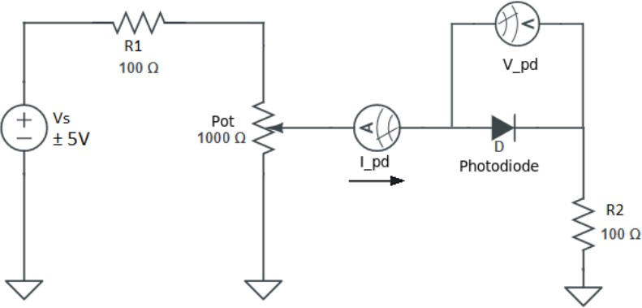

* + 1. **I-V data**

|  |  |  |  |  |
| --- | --- | --- | --- | --- |
| V | Ipd(mA) | log(Ipd) | Slope | Intercept |
| 0.22 | 0.00084 | -3.07572 | 8.915544 | -4.4535 |
| 0.27 | 0.017 | -1.76955 | Eeta |  |
| 0.39 | 0.196 | -0.70774 | 4.313987 |  |
| 0.46 | 0.742 | -0.1296 |  |  |
| 0.47 | 0.881 | -0.05502 |  |  |
| 0.5 | 1.317 | 0.119586 |  |  |
| 0.51 | 1.594 | 0.202488 |  |  |
| 0.52 | 1.718 | 0.235023 |  |  |
| 0.53 | 1.93 | 0.285557 |  |  |
| 0.54 | 2.3 | 0.361728 |  |  |
| 0.55 | 2.6 | 0.414973 |  |  |
| 0.56 | 2.8 | 0.447158 |  |  |
| 0.57 | 3.3 | 0.518514 |  |  |
| 0.59 | 4 | 0.60206 |  |  |
| 0.6 | 4.5 | 0.653213 |  |  |
| 0.64 | 6.2 | 0.792392 |  |  |
| 0.65 | 6.8 | 0.832509 |  |  |
| 0.66 | 7.6 | 0.880814 |  |  |
| 0.67 | 8.3 | 0.919078 |  |  |
| 0.68 | 9.3 | 0.968483 |  |  |
| 0.69 | 10.1 | 1.004321 |  |  |
| 0.7 | 11.1 | 1.045323 |  |  |
| 0.71 | 11.8 | 1.071882 |  |  |
| 0.72 | 13.4 | 1.127105 |  |  |
| 0.74 | 16.1 | 1.206826 |  |  |
| 0.76 | 19.8 | 1.296665 |  |  |

* + - * **Ideality factor** : 4.313
    1. **Plots**

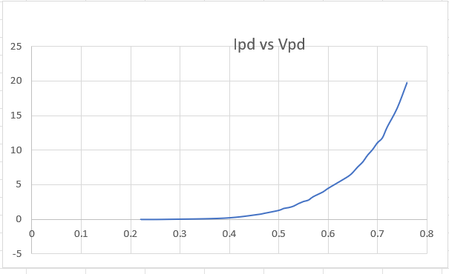

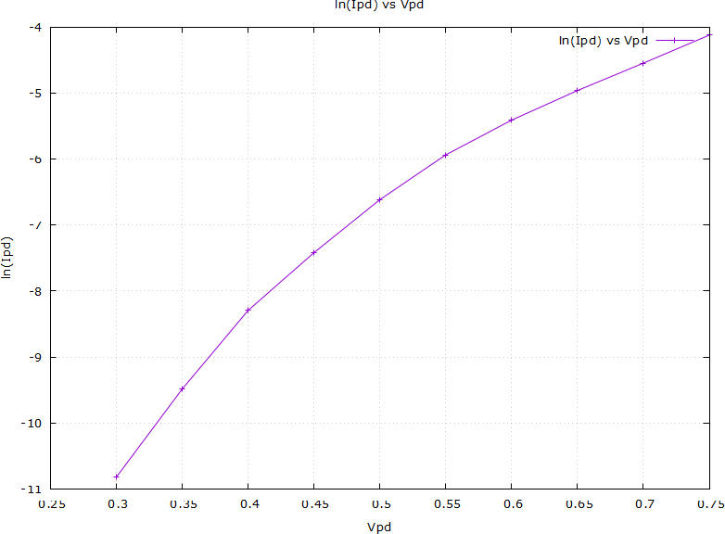

## Part 2

* + 1. **Circuit**

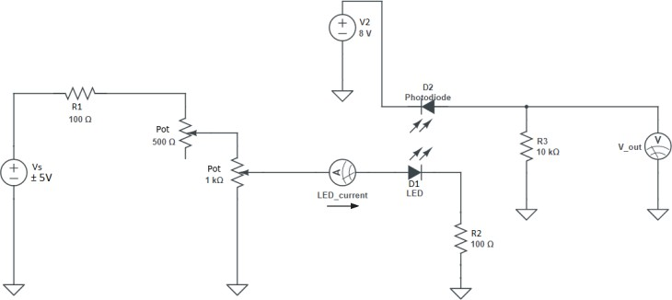

* + 1. **Data**

|  |  |  |  |
| --- | --- | --- | --- |
| green | | |  |
| I | Vo(green) | Intensity | Eeta |
| 0.188 | 0.3 | 1000 | 1.595745 |
| 0.294 | 0.4 | 1500 | 1.360544 |
| 0.371 | 0.4 | 2000 | 1.078167 |

|  |  |  |  |
| --- | --- | --- | --- |
| red | | |  |
| I | Vo(red) | Intensity | Eeta |
| 2 | 0.6 | 1000 | 0.3 |
| 3 | 0.8 | 1500 | 0.266667 |
| 4 | 1 | 2000 | 0.25 |

|  |  |  |  |
| --- | --- | --- | --- |
|  | blue |  |  |
| I | Vo(blue) | Intensity | Eeta |
| 0.301 | 0.5 | 1000 | 1.66113 |
| 0.416 | 0.5 | 1500 | 1.201923 |
| 0.572 | 0.6 | 2000 | 1.048951 |

|  |  |  |  |
| --- | --- | --- | --- |
|  | Infrared |  |  |
| I | Vo(IR) | Intensity | Eeta |
| 4.51 | 0.9 | 1000 | 0.199557 |
| 5.17 | 1 | 1500 | 0.193424 |
| 6.28 | 1.1 | 2000 | 0.175159 |

* + 1. **Plots**
    2. **Vout vs Wavelength**

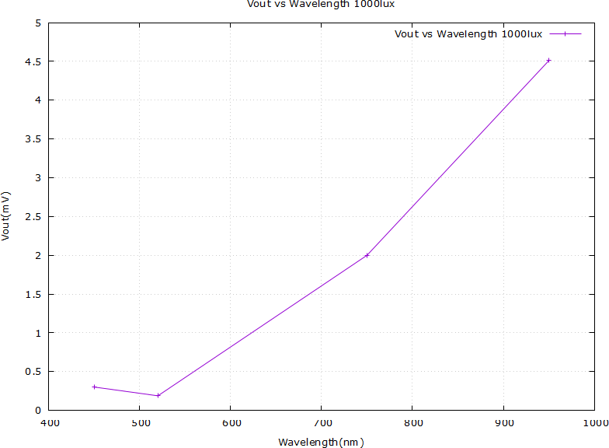

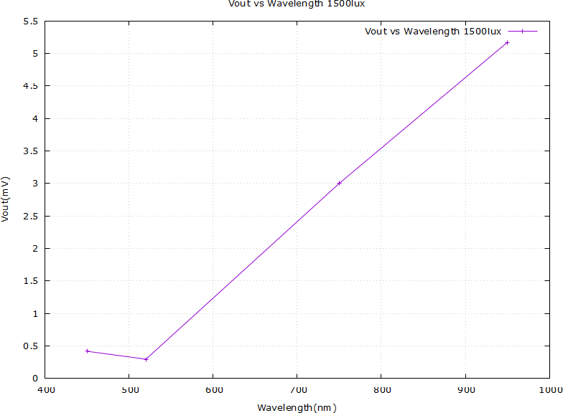

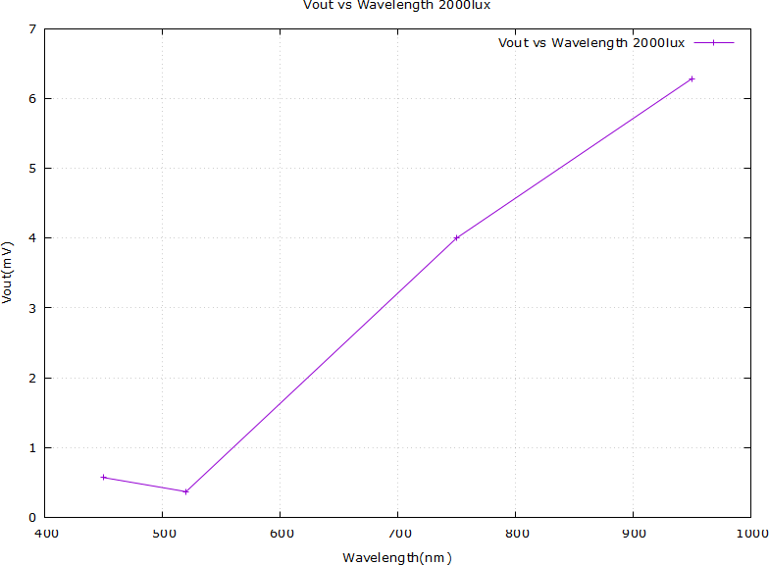

* + 1. **Vout vs Intensity**

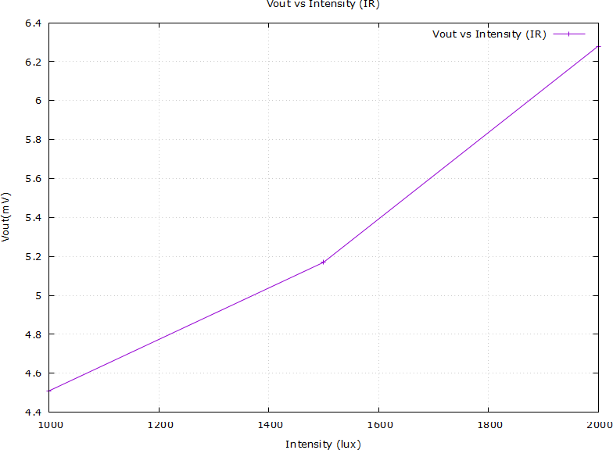

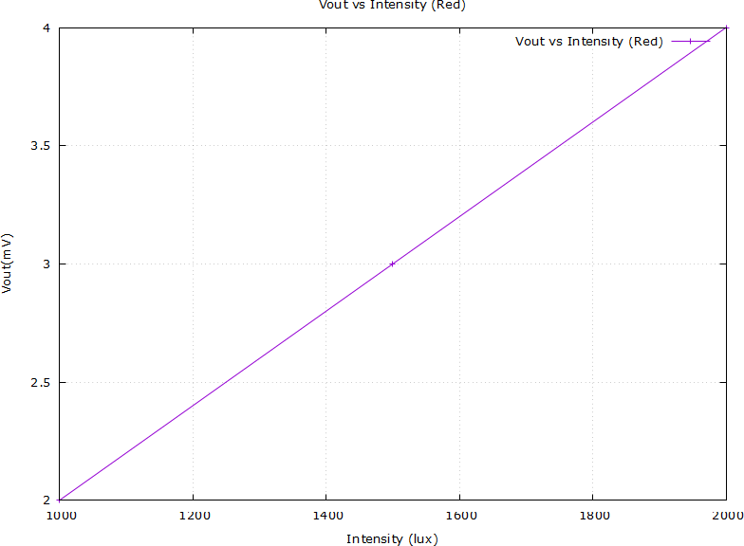

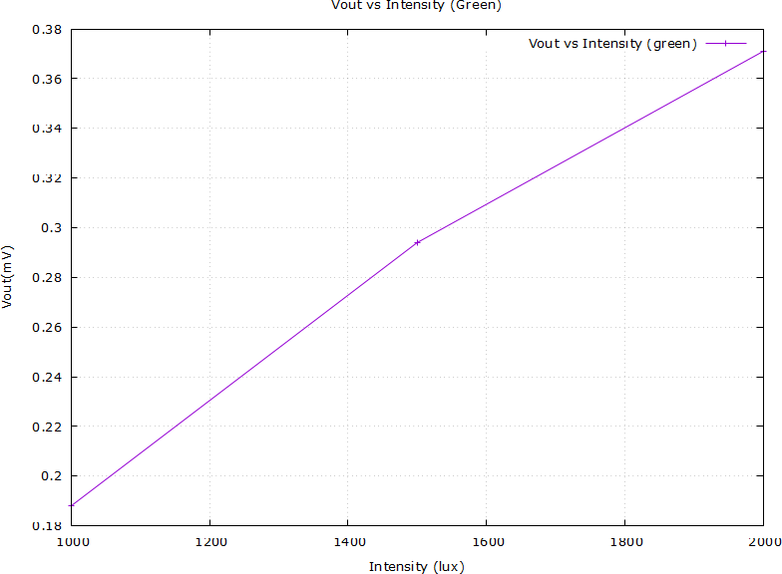

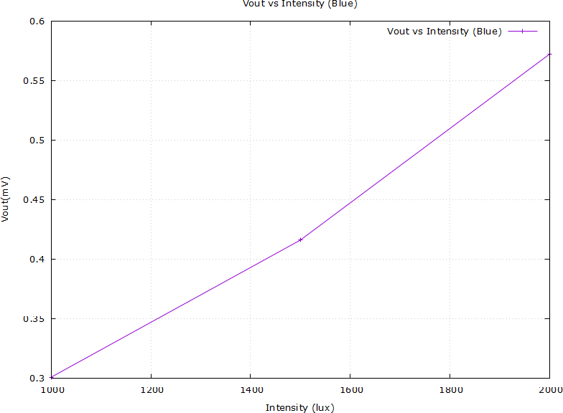

* + 1. **Efficiency**

|  |  |  |  |  |
| --- | --- | --- | --- | --- |
| **Intensity** | **IR/Intensity** | **Red/Intensity** | **Green/Intensity** | **Blue/Intensity** |
| 1000 | 1.91E-03 | 5.90E-03 | 2.18E-02 | 9.97E-03 |
| 1500 | 1.27E-03 | 4.35E-03 | 1.31E-02 | 5.93E-03 |
| 2000 | 9.85E-04 | 3.50E-03 | 9.70E-03 | 4.02E-03 |
| Lambda | 9.50E-07 | 7.50E-07 | 5.20E-07 | 4.50E-07 |

Most efficient: Green

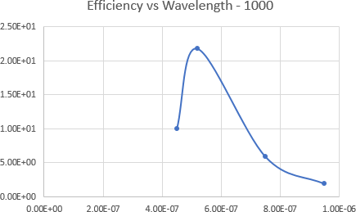

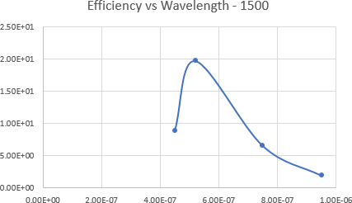

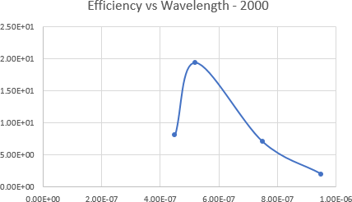

## Part 3

* + 1. **Circuit**

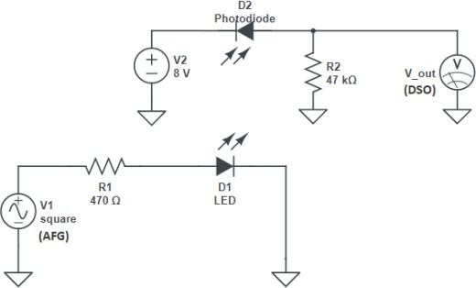

* + 1. **Data**

|  |  |  |
| --- | --- | --- |
| **Frequency (Hz)** | **Rise time (us)** | **Fall time (us)** |
| 1000 | 15.37 | 15.72 |
| 5000 | 11.37 | 11.62 |
| 10000 | 11.98 | 11.34 |
| 15000 | 12.31 | 12.15 |
| 20000 | 12.19 | 12.03 |

* + 1. **Observations and Reasoning**
       - **Distortion:** Distortion is observed to become too large at 20 kHz.
       - **Reason for Slow Photodiode Response:** A photodiode has a ”detection bandwidth” associated with it, which determines the speed at which its output can vary in response to a varying input signal. This bandwidth depends on two factors:
         1. Junction capacitance in the diode.
         2. Transit time of the photocurrent in the junction.

# Completion Status

The experiment was thoroughly conducted and successfully completed within the lab setting. All objec- tives were met, and the procedures were carried out as planned, yielding the expected results.