Lab Report: MOS Capacitor C-V Characteristics

Hardik Khariwal

October 2024

# Introduction

This report presents the experimental analysis of the C-V characteristics of MOS capacitors using both square and circular MOSCAP structures. The report includes a detailed study of MOSCAP parameters, such as oxide ca- pacitance, oxide thickness, doping density, flat band voltage, flat band ca- pacitance, Debye length, and Debye capacitance.

# Measurement of C-V Characteristics

The experiment involves the measurement of the C-V characteristics of a MOS capacitor (MOSCAP) for both positive and negative DC voltage values. For the measurement, square MOSCAPs of 2mm side length and circular MOSCAPs of 2mm diameter are used. The data is collected by varying *VDC* and tabulating *Vout*, AC gain, and capacitance (*CDUT* ).

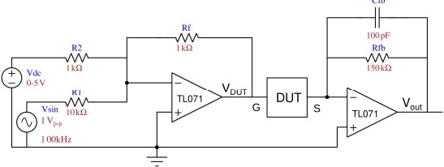

Figure 1: Circuit

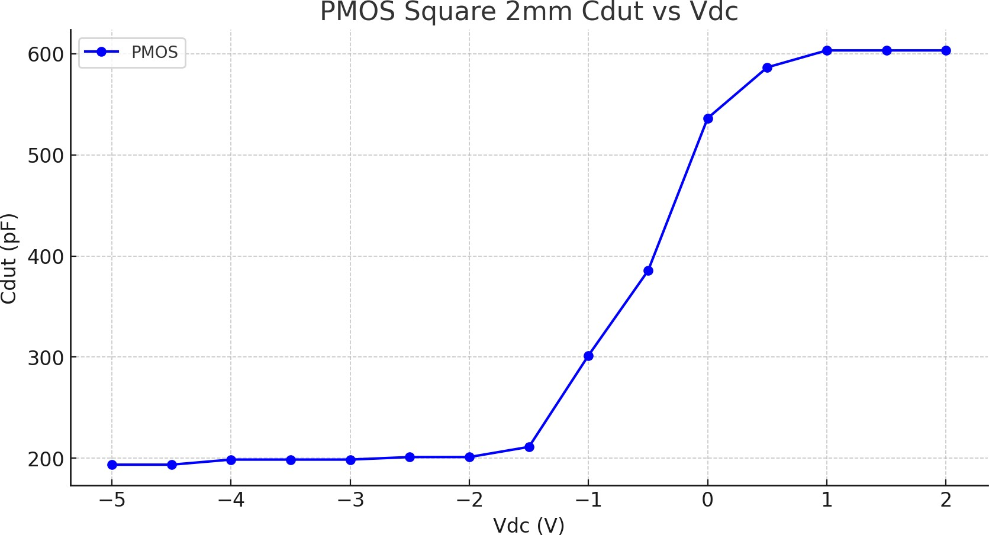

# C-V Data Tables and Graphs

## PMOS Data

Table 1: C-V Data for PMOS - Square (2mm)

|  |  |  |  |  |  |
| --- | --- | --- | --- | --- | --- |
| *VDC* (V) | *VDUT* (pp) | *Vout* (pp) | AC Gain | *CDUT* (pF) | Multiplier |
| -5 | 0.16 | 0.308 | 1.925 | 193.58 | 100.56 |
| -4.5 | 0.16 | 0.308 | 1.925 | 193.58 | 100.56 |
| -4 | 0.16 | 0.316 | 1.975 | 198.61 | 100.56 |
| -3.5 | 0.16 | 0.316 | 1.975 | 198.61 | 100.56 |
| -3 | 0.16 | 0.316 | 1.975 | 198.61 | 100.56 |
| -2.5 | 0.16 | 0.32 | 2.0 | 201.12 | 100.56 |
| -2 | 0.16 | 0.32 | 2.0 | 201.12 | 100.56 |
| -1.5 | 0.16 | 0.336 | 2.1 | 211.18 | 100.56 |
| -1 | 0.12 | 0.36 | 3.0 | 301.68 | 100.56 |
| -0.5 | 0.12 | 0.46 | 3.83 | 385.49 | 100.56 |
| 0 | 0.12 | 0.64 | 5.33 | 536.33 | 100.56 |
| 0.5 | 0.12 | 0.7 | 5.83 | 586.61 | 100.56 |
| 1 | 0.12 | 0.72 | 6.0 | 603.37 | 100.56 |
| 1.5 | 0.12 | 0.72 | 6.0 | 603.37 | 100.56 |
| 2 | 0.12 | 0.72 | 6.0 | 603.37 | 100.56 |

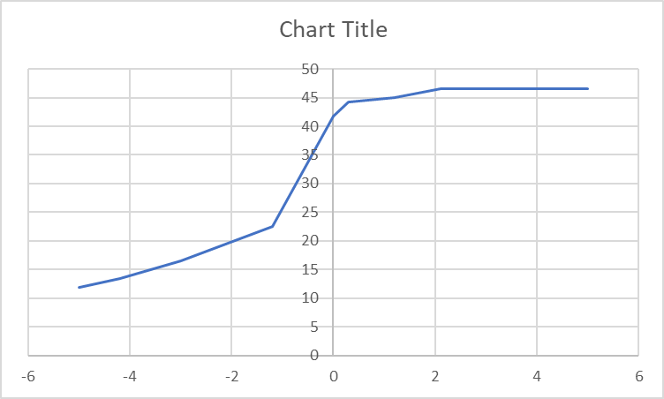

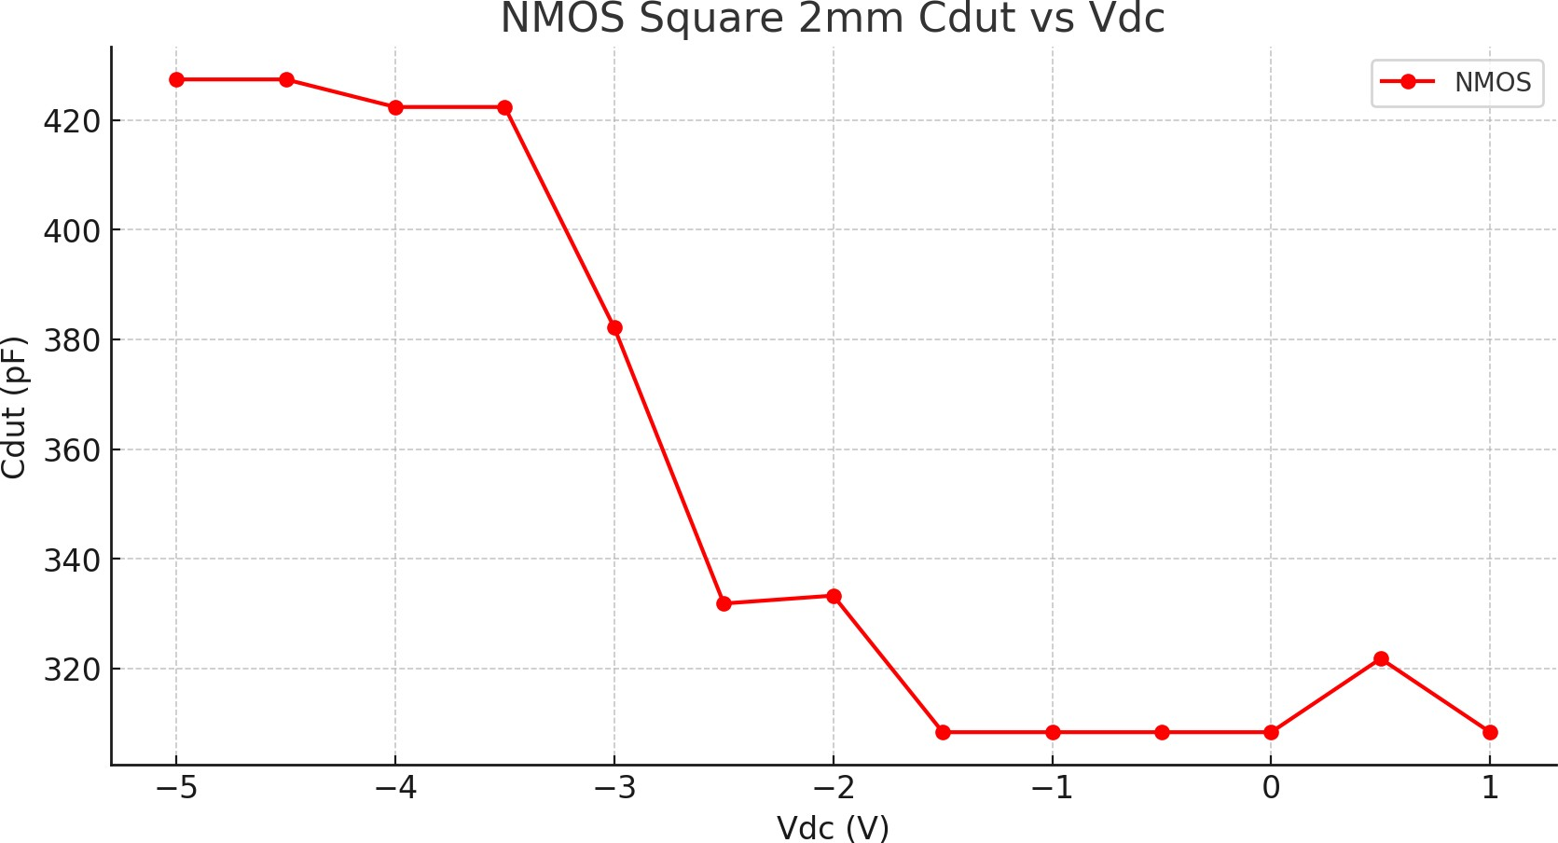

## NMOS Data

Table 2: C-V Data for NMOS - Square (2mm)

|  |  |  |  |  |  |
| --- | --- | --- | --- | --- | --- |
| *VDC* (V) | *VDUT* (pp) | *Vout* (pp) | AC Gain | *CDUT* (pF) | Multiplier |
| -5 | 0.16 | 0.68 | 4.25 | 427.39 | 100.56 |
| -4.5 | 0.16 | 0.68 | 4.25 | 427.39 | 100.56 |
| -4 | 0.16 | 0.672 | 4.2 | 422.36 | 100.56 |
| -3.5 | 0.16 | 0.672 | 4.2 | 422.36 | 100.56 |
| -3 | 0.16 | 0.608 | 3.8 | 382.13 | 100.56 |
| -2.5 | 0.16 | 0.528 | 3.3 | 331.85 | 100.56 |
| -2 | 0.14 | 0.464 | 3.314 | 333.29 | 100.56 |
| -1.5 | 0.12 | 0.368 | 3.067 | 308.39 | 100.56 |
| -1 | 0.12 | 0.368 | 3.067 | 308.39 | 100.56 |
| -0.5 | 0.12 | 0.368 | 3.067 | 308.39 | 100.56 |
| 0 | 0.12 | 0.368 | 3.067 | 308.39 | 100.56 |
| 0.5 | 0.12 | 0.384 | 3.2 | 321.80 | 100.56 |
| 1 | 0.12 | 0.368 | 3.067 | 308.39 | 100.56 |

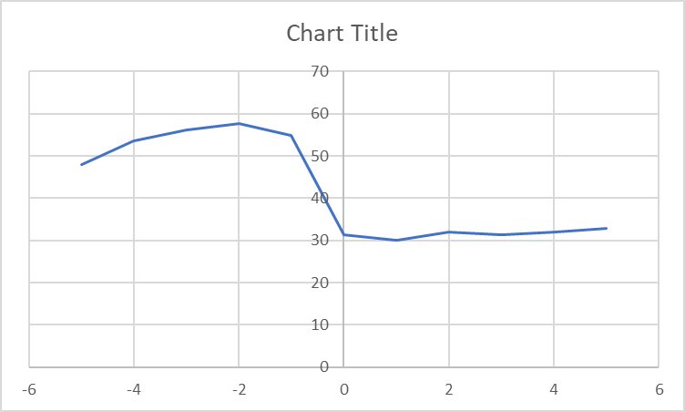

# C-V Characteristics Analysis

## Oxide Capacitance (*Cox*)

The oxide capacitance *Cox* is calculated using the formula:

*Cox*

= *εox · A*

*t*

*ox*

Where:

* *A* = 4 mm2 (Area for square MOSCAP with side length 2mm).
* *εox* = 3*.*45 *×* 10*−*11 F/m (Permittivity of oxide).
* *tox* is the oxide thickness to be calculated.

Given the measured *Cox* = 193*.*58 pF, we rearrange the formula:

*tox* =

*εox · A* =

*Cox*

3*.*45 10*−*11 4 10*−*6

= 0*.*713 *µ*m*.*

*× × ×*

193*.*58 *×* 10*−*12

## Doping Density (*NA*)

The doping density *NA* can be calculated using:

*tdep*

= 2 *εsi kT*

*qNA q*

s

*·*

* ln *NA*

Where:

*ni*

* + *εsi* = 1*.*04 *×* 10*−*10 F/m (Permittivity of silicon).
  + *q* = 1*.*6 *×* 10*−*19 C (Electronic charge).
  + *kT/q* = 0*.*0259 V (Thermal energy at room temperature).
  + *ni* = 1*.*5 *×* 1010 cm*−*3 (Intrinsic carrier concentration).

The extracted doping density was *NA* = 4*.*9 1015 cm*−*3 for the square MOSCAP.

*×*

# Summary of Results

The C-V measurements and calculations show that the oxide capacitance is higher for the PMOS structure compared to NMOS. The oxide thickness was estimated at approximately 0.713 micrometers for the square MOSCAP structure. Furthermore, the doping density was extracted from the depletion region analysis, yielding *NA* = 4*.*9 *×* 1015 cm*−*3.