EE 236: Electronic Divice Lab Lab No. 7

Hardik Khariwal, 22B3954

September 24, 2024

# Contents

1. BJT Parameters in CB configuration 2

1.1 Circuit Design . . . . . . . . . . . . . . . . . . . . . . . 2

* 1. Characteristics readings for different *Ie* . . . . . . . . . 3

1.2.1 *Ie* = 3mA . . . . . . . . . . . . . . . . . . . . . 3

1.2.2 *Ie* = 6mA . . . . . . . . . . . . . . . . . . . . . 4

1.2.3 *Ie* = 9mA . . . . . . . . . . . . . . . . . . . . . 5

* 1. Plots of characteristics of CB configuration for different

*Ie* . . . . . . . . . . . . . . . . . . . . . . . . . . . . . . 6

1.3.1 *Ie* = 3mA . . . . . . . . . . . . . . . . . . . . . 6

1.3.2 *Ie* = 6mA . . . . . . . . . . . . . . . . . . . . . 6

1.3.3 *Ie* = 9mA . . . . . . . . . . . . . . . . . . . . . 7

* 1. Readings and plot for *Ic* and *Ib* for different *VBE* . . . . 8

1. Frequency response of BJT vs HBT 10
   1. Frequency response of BJT in CE configuration 10
   2. Frequency response of HBT in CE configuration 12

# BJT Parameters in CB configuration

* 1. **Circuit Design**

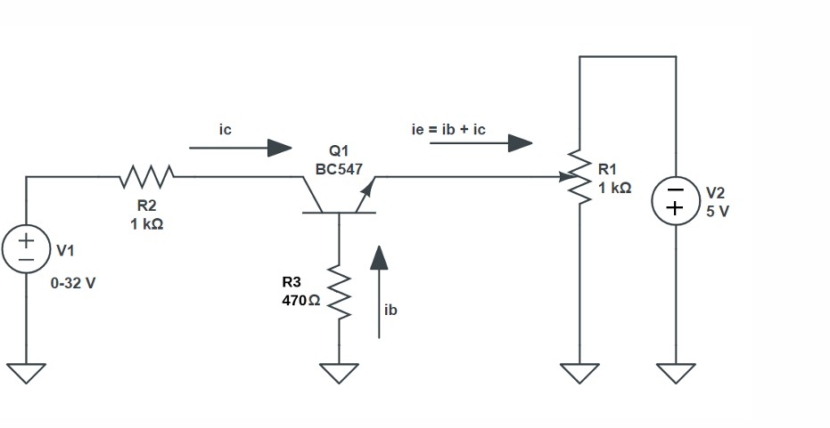

Figure 1: Circuit Diagram

* 1. **Characteristics readings for different** *Ie*
     1. *Ie* **= 3mA**

|  |  |  |  |
| --- | --- | --- | --- |
| *VCB* (V) | *IC* (mA) | *α* | *β* |
| -0.687 | 0.98 | 0.3267 | 0.4851 |
| -0.677 | 1.42 | 0.4733 | 0.8987 |
| -0.666 | 1.85 | 0.6167 | 1.6087 |
| -0.650 | 2.28 | 0.7600 | 3.1667 |
| -0.625 | 2.70 | 0.9000 | 9.0000 |
| -0.556 | 3.09 | 1.0300 | -34.3333 |
| -0.137 | 3.16 | 1.0533 | -19.7500 |
| 0.354 | 3.18 | 1.0600 | -17.6667 |
| 0.849 | 3.17 | 1.0567 | -18.6471 |
| 1.045 | 3.17 | 1.0567 | -18.6471 |
| 1.243 | 3.17 | 1.0567 | -18.6471 |
| 1.441 | 3.18 | 1.0600 | -17.6667 |
| 1.638 | 3.18 | 1.0600 | -17.6667 |
| 1.836 | 3.18 | 1.0600 | -17.6667 |
| 2.820 | 3.19 | 1.0633 | -16.7895 |
| 3.800 | 3.19 | 1.0633 | -16.7895 |
| 4.800 | 3.20 | 1.0667 | -16.0000 |
| 5.790 | 3.20 | 1.0667 | -16.0000 |
| 6.770 | 3.22 | 1.0733 | -14.6364 |

Table 1: Values of *VCB*, *IC*, *α*, and *β*

* + 1. *Ie* **= 6mA**

|  |  |  |  |
| --- | --- | --- | --- |
| *VCB* (V) | *IC* (mA) | *α* | *β* |
| -0.715 | 1.38 | 0.2300 | 0.2987 |
| -0.711 | 1.81 | 0.3017 | 0.4320 |
| -0.705 | 2.24 | 0.3733 | 0.5957 |
| -0.700 | 2.67 | 0.4450 | 0.8018 |
| -0.694 | 3.10 | 0.5167 | 1.0690 |
| -0.686 | 3.52 | 0.5867 | 1.4194 |
| -0.676 | 3.95 | 0.6583 | 1.9268 |
| -0.663 | 4.38 | 0.7300 | 2.7037 |
| -0.643 | 4.80 | 0.8000 | 4.0000 |
| -0.385 | 5.45 | 0.9083 | 9.9091 |
| 0.600 | 5.46 | 0.9100 | 10.1111 |
| 1.590 | 5.47 | 0.9117 | 10.3208 |
| 2.560 | 5.48 | 0.9133 | 10.5385 |
| 3.550 | 5.49 | 0.9150 | 10.7647 |
| 4.540 | 5.50 | 0.9167 | 11.0000 |

Table 2: Values of *VCB*, *IC*, *α*, and *β* for *Ie* = 6mA

* + 1. *Ie* **= 9mA**

|  |  |  |  |
| --- | --- | --- | --- |
| *VCB* (V) | *IC* (mA) | *α* | *β* |
| -0.734 | 1.89 | 0.2100 | 0.7900 |
| -0.733 | 2.30 | 0.2556 | 0.7444 |
| -0.730 | 2.76 | 0.3067 | 0.6933 |
| -0.726 | 3.18 | 0.3533 | 0.6467 |
| -0.724 | 3.62 | 0.4022 | 0.5978 |
| -0.719 | 4.05 | 0.4500 | 0.5500 |
| -0.718 | 4.49 | 0.4989 | 0.5011 |
| -0.712 | 4.91 | 0.5456 | 0.4544 |
| -0.709 | 5.35 | 0.5944 | 0.4056 |
| -0.693 | 6.16 | 0.6844 | 0.3156 |
| -0.676 | 7.02 | 0.7800 | 0.2200 |
| -0.647 | 7.89 | 0.8767 | 0.1233 |
| -0.548 | 8.70 | 0.9667 | 0.0333 |
| 0.377 | 8.77 | 0.9744 | 0.0256 |
| 1.400 | 8.79 | 0.9767 | 0.0233 |
| 2.230 | 8.92 | 0.9911 | 0.0089 |
| 3.090 | 9.08 | 1.0089 | -0.0089 |
| 4.060 | 9.10 | 1.0111 | -0.0111 |
| 4.860 | 9.29 | 1.0322 | -0.0322 |
| 5.850 | 9.30 | 1.0333 | -0.0333 |

Table 3: Values of *VCB*, *IC*, *α*, and *β* for *Ie* = 9mA

* 1. **Plots of characteristics of CB configuration for different** *Ie*
     1. *Ie* **= 3mA**

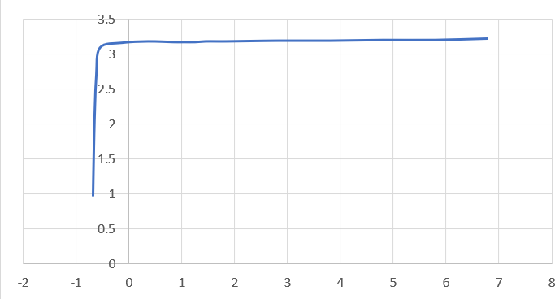

Figure 2: *Ic* vs *Vcb* for *Ie* = 3mA

* + 1. *Ie* **= 6mA**

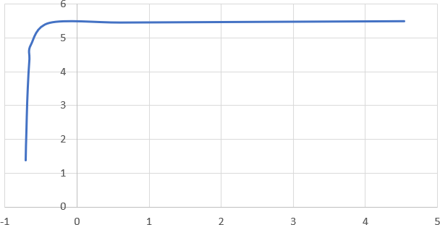

Figure 3: *Ic* vs *Vcb* for *Ie* = 6mA

* + 1. *Ie* **= 9mA**

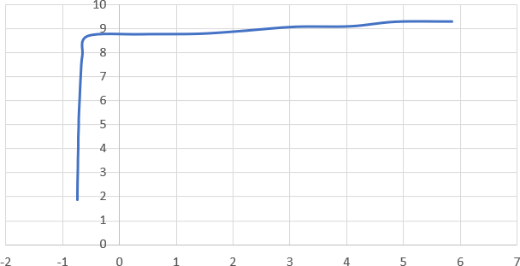

Figure 4: *Ic* vs *Vcb* for *Ie* = 9mA

* 1. **Readings and plot for** *Ic* **and** *Ib* **for different**

*VBE*

Taking *VBC* = 4*V*

|  |  |  |
| --- | --- | --- |
| *VBE* (V) | *IC* (mA) | *IB* (mA) |
| 0.001 | 0.000 | 0.00000 |
| 0.023 | 0.002 | 0.00002 |
| 0.060 | 0.002 | 0.00002 |
| 0.440 | 0.003 | 0.00003 |
| 0.543 | 0.029 | 0.00029 |
| 0.553 | 0.040 | 0.00040 |
| 0.582 | 0.121 | 0.00121 |
| 0.600 | 0.235 | 0.00235 |
| 0.613 | 0.379 | 0.00379 |
| 0.621 | 0.539 | 0.00539 |
| 0.640 | 1.101 | 0.01101 |

Table 4: Values of *VBE*, *IC*, and *IB*

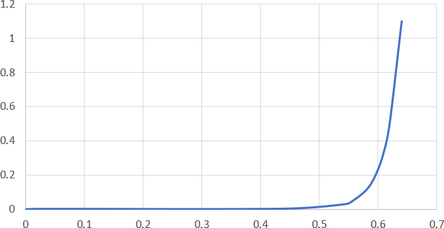

Figure 5: *Ic* vs *VBE*

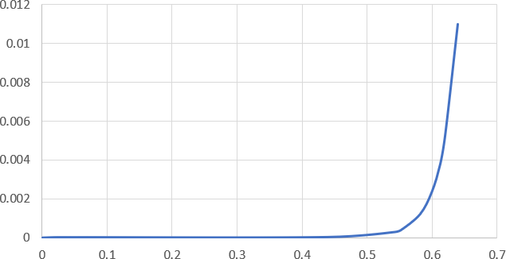

Figure 6: *Ib* vs *VBE*

# Frequency response of BJT vs HBT

* 1. **Frequency response of BJT in CE configura- tion**

|  |  |  |  |
| --- | --- | --- | --- |
| **Input Frequency (kHz)** | **Vo (mV pp)** | **log(Input Frequency)** | **dB Gain** |
| 1 | 1.86 | 3.00 | 11.41 |
| 5 | 1.84 | 3.70 | 11.32 |
| 10 | 1.84 | 4.00 | 11.32 |
| 50 | 1.82 | 4.70 | 11.22 |
| 100 | 1.80 | 5.00 | 11.13 |
| 150 | 1.78 | 5.18 | 11.03 |
| 200 | 1.74 | 5.30 | 10.83 |
| 250 | 1.70 | 5.40 | 10.63 |
| 300 | 1.64 | 5.48 | 10.32 |
| 350 | 1.58 | 5.54 | 10.00 |
| 400 | 1.54 | 5.60 | 9.77 |
| 450 | 1.46 | 5.65 | 9.31 |
| 500 | 1.42 | 5.70 | 9.07 |
| 550 | 1.36 | 5.74 | 8.69 |
| 600 | 1.30 | 5.78 | 8.30 |

Table 5: Voltage and dB Gain vs. Input Frequency

**3-dB cutoff frequency = 525kHz**

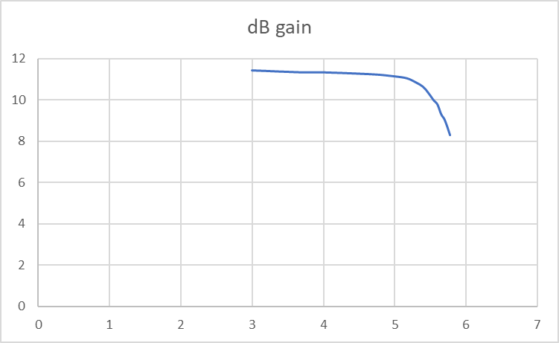

Figure 7: gain vs log(input freq)

* 1. **Frequency response of HBT in CE configura- tion**

|  |  |  |  |
| --- | --- | --- | --- |
| **Input Frequency (kHz)** | **Vo (mV pp)** | **log(Input Frequency)** | **dB Gain** |
| 1 | 1.28 | 3.00 | 8.16 |
| 5 | 1.296 | 3.70 | 8.27 |
| 10 | 1.296 | 4.00 | 8.27 |
| 50 | 1.28 | 4.70 | 8.16 |
| 100 | 1.28 | 5.00 | 8.16 |
| 150 | 1.28 | 5.18 | 8.16 |
| 200 | 1.24 | 5.30 | 7.89 |
| 250 | 1.24 | 5.40 | 7.89 |
| 300 | 1.22 | 5.48 | 7.75 |
| 350 | 1.22 | 5.54 | 7.75 |
| 400 | 1.20 | 5.60 | 7.60 |
| 450 | 1.18 | 5.65 | 7.46 |
| 500 | 1.16 | 5.70 | 7.31 |
| 550 | 1.12 | 5.74 | 7.00 |
| 600 | 1.10 | 5.78 | 6.85 |

Table 6: Voltage and dB Gain vs. Input Frequency

**3-dB cutoff frequency = 850kHz**