EE 236: Electronic Divice Lab Lab No. 5

HARDIK KHARIWAL, 22B3954 September 3, 2024

# Contents

### Dark forward characteristics at different temperatures 3

* 1. Prelab . . . . . . . . . . . . . . . . . . . . . . . . . . . 3
  2. InLab . . . . . . . . . . . . . . . . . . . . . . . . . . . 4
     1. Circuit Diagram . . . . . . . . . . . . . . . . . . 4
     2. Reading of *Vd*, *Id* and *ln*(*Id*) for different tem- peratures . . . . . . . . . . . . . . . . . . . . . 5
     3. Plots . . . . . . . . . . . . . . . . . . . . . . . . 8
     4. Observations . . . . . . . . . . . . . . . . . . . 9

|  |  |  |  |
| --- | --- | --- | --- |
| **2 Lighted I/V at different temperatures** | | | **10** |
| 2.1 Prelab . . . . . . . . . . . . . . . . . . . . . . . . . . . | | | 10 |
| 2.1.1 Plot . . . . . . . . . . . . . . . . . . . . . . . . | | | 10 |
|  | 2.1.2 | Calculated Values . . . . . . . . . . . . . . . . . | 10 |
| 2.2 | Inlab | . . . . . . . . . . . . . . . . . . . . . . . . . . . . | 11 |
|  | 2.2.1 | Circuit Diagram . . . . . . . . . . . . . . . . . . | 11 |
|  | 2.2.2 | Reading of *Vd* and *Id* for different temperatures | 12 |
|  | 2.2.3 | Plots . . . . . . . . . . . . . . . . . . . . . . . . | 15 |

2.2.4 Observations 16

# Dark forward characteristics at differ- ent temperatures

## Prelab

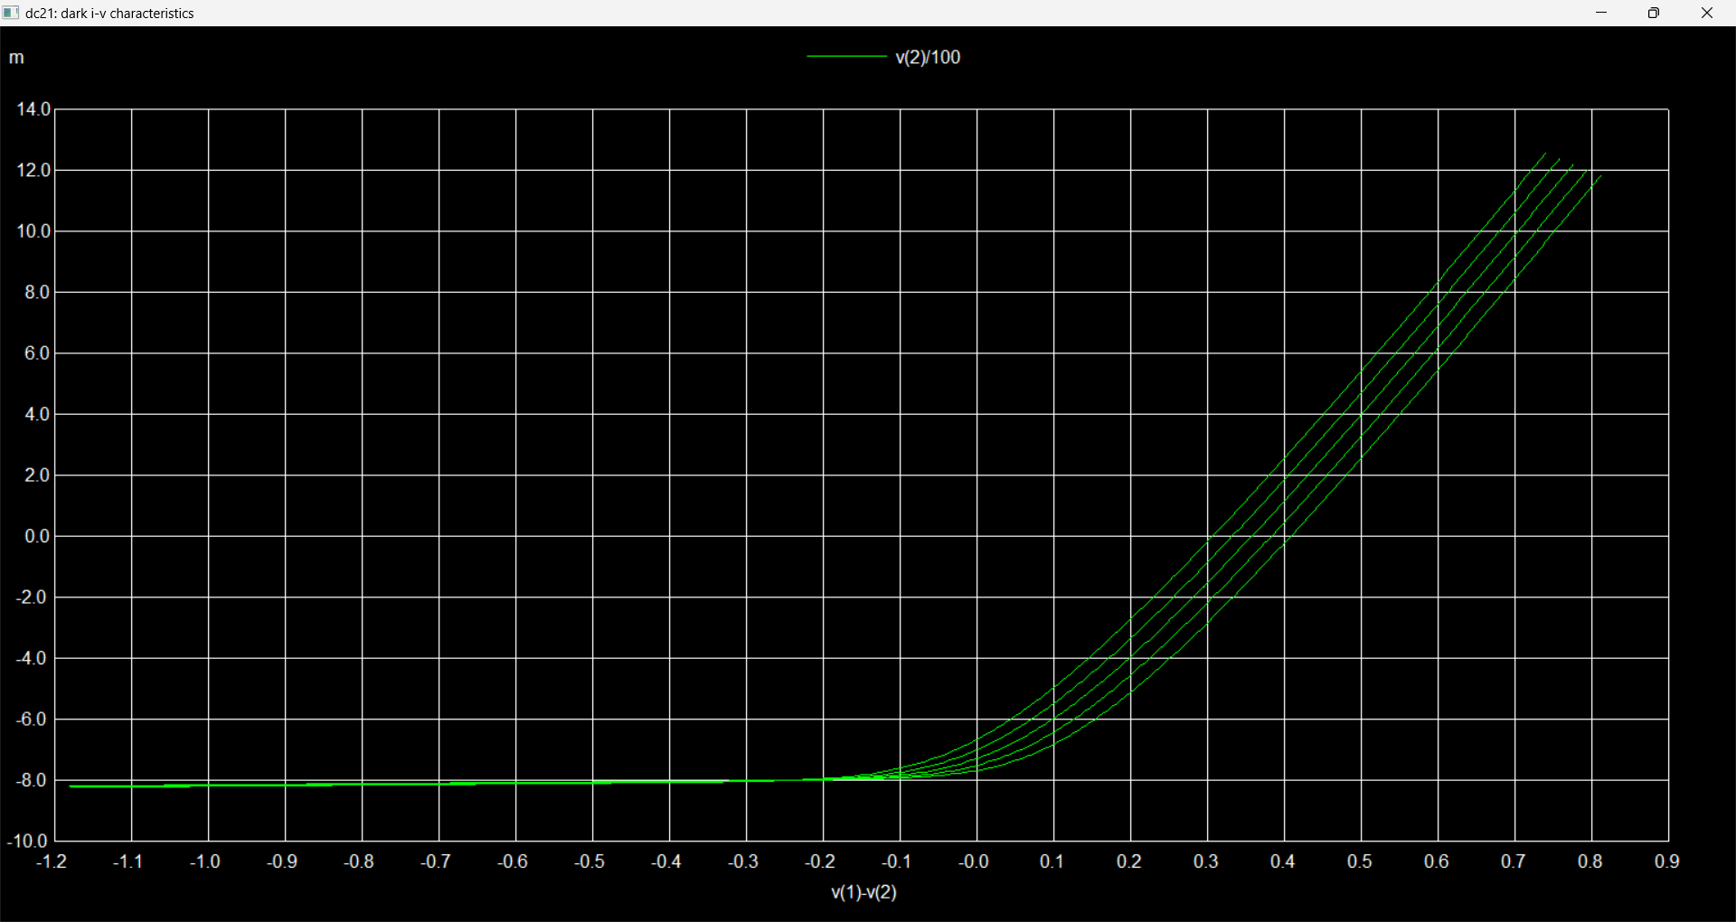

Figure 1: I-V Craracteristics for Dark

In the above diagram, the graph at the bottom represents a temperature of 35 *◦*C, increasing up to 75 *◦*C at the top.

## InLab

### Circuit Diagram

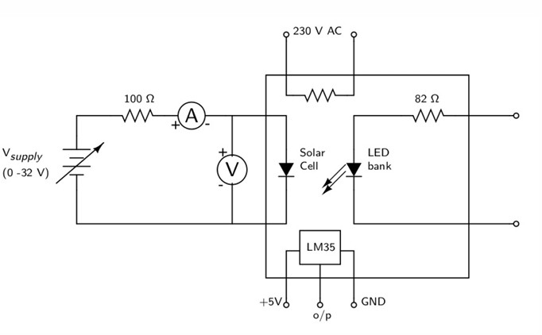

Figure 2: Circuit Diagram

* + 1. **Reading of** *Vd***,** *Id* **and** *ln*(*Id*) **for different temperatures**
* **MEASUREMENTS AT 35-DEGREE**

|  |  |  |  |  |  |
| --- | --- | --- | --- | --- | --- |
|  |  |  |  |  |  |
| 35 dark | |  | 35 light |  |  |
| v35d | i35d |  | v35l | i35l | i35l |
| 0.091 | 0 |  | 0.439 | 0.6 | -0.6 |
| 0.173 | 0.2 |  | 0.434 | 1.3 | -1.3 |
| 0.288 | 1 |  | 0.43 | 1.8 | -1.8 |
| 0.35 | 2.4 |  | 0.42 | 2.8 | -2.8 |
| 0.386 | 4 |  | 0.411 | 3.8 | -3.8 |
| 0.409 | 5.8 |  | 0.398 | 4.9 | -4.9 |
| 0.426 | 7.6 |  | 0.397 | 5.5 | -5.5 |
| 0.439 | 9.4 |  | 0.376 | 6.1 | -6.1 |
| 0.45 | 11.3 |  | 0.366 | 6.6 | -6.6 |
| 0.458 | 13.2 |  | 0.351 | 7.1 | -7.1 |
| 0.466 | 15.1 |  | 0.329 | 7.7 | -7.7 |
| 0.478 | 18.9 |  | 0.252 | 8.9 | -8.9 |
| 0.492 | 24.7 |  | 0.218 | 9.2 | -9.2 |
| 0.501 | 29.6 |  | 0.159 | 9.4 | -9.4 |
| 0.509 | 34.6 |  | 0.06 | 9.6 | -9.6 |
| 0.516 | 39.5 |  | 0.026 | 9.7 | -9.7 |
| 0.522 | 44.5 |  | 0 | 9.7 | -9.7 |

Table 1: Dark I-V Characteris- tics at 35°C

Table 2:Light I-V Characteris- tics at 35°C

* **MEASUREMENT S AT 45-DEGREE**

|  |  |  |  |  |  |
| --- | --- | --- | --- | --- | --- |
|  |  |  |  |  |  |
| 45 dark |  |  | 45 light |  |  |
| v45d | i45d |  | v45l | i45l | i45l |
| 0.199 | 0 |  | 0.419 | 0.6 | -0.6 |
| 0.279 | 1.2 |  | 0.411 | 1.4 | -1.4 |
| 0.334 | 2.6 |  | 0.404 | 2.2 | -2.2 |
| 0.368 | 4.2 |  | 0.393 | 3.4 | -3.4 |
| 0.39 | 5.9 |  | 0.384 | 4.1 | -4.1 |
| 0.42 | 9.6 |  | 0.375 | 4.9 | -4.9 |
| 0.43 | 11.4 |  | 0.359 | 5.9 | -5.9 |
| 0.438 | 13.3 |  | 0.34 | 6.8 | -6.8 |
| 0.445 | 15.3 |  | 0.316 | 7.5 | -7.5 |
| 0.452 | 17.1 |  | 0.299 | 8 | -8 |
| 0.457 | 19.1 |  | 0.276 | 8.4 | -8.4 |
| 0.462 | 21.1 |  | 0.253 | 8.6 | -8.6 |
| 0.467 | 23 |  | 0.236 | 8.9 | -8.9 |
| 0.471 | 25 |  | 0.196 | 9.2 | -9.2 |
| 0.479 | 28.9 |  | 0.169 | 9.3 | -9.3 |
| 0.485 | 32.8 |  | 0.136 | 9.4 | -9.4 |
| 0.49 | 36.8 |  | 0.078 | 9.6 | -9.6 |
| 0.494 | 39.8 |  | 0.059 | 9.6 | -9.6 |

Table 3: Dark I-V Characteris- tics at 45°C

Table 4:Light I-V Characteris- tics at 45°C

* **MEASUREMENTS AT 55-DEGREE**

|  |  |  |  |  |  |
| --- | --- | --- | --- | --- | --- |
|  |  |  |  |  |  |
| 55 dark |  |  | 55 light |  |  |
| v55d | i55d |  | v55l | i55l | i55l |
| 0.166 | 0.3 |  | 0.389 | 0.6 | -0.6 |
| 0.264 | 1.1 |  | 0.386 | 1 | -1 |
| 0.317 | 2.7 |  | 0.377 | 2.2 | -2.2 |
| 0.35 | 4.4 |  | 0.371 | 2.9 | -2.9 |
| 0.38 | 7 |  | 0.365 | 3.6 | -3.6 |
| 0.399 | 9.8 |  | 0.353 | 4.5 | -4.5 |
| 0.417 | 13.5 |  | 0.34 | 5.4 | -5.4 |
| 0.43 | 17.4 |  | 0.31 | 6.9 | -6.9 |
| 0.44 | 21.3 |  | 0.261 | 8.2 | -8.2 |
| 0.45 | 25.1 |  | 0.244 | 8.5 | -8.5 |
| 0.456 | 29 |  | 0.212 | 8.9 | -8.9 |
| 0.463 | 32.9 |  | 0.163 | 9.2 | -9.2 |
| 0.469 | 36.8 |  | 0.103 | 9.4 | -9.4 |
| 0.474 | 40.9 |  | 0.056 | 9.4 | -9.4 |
|  |  |  | 0.025 | 9.6 | -9.6 |

Table 5: Dark I-V Table 6:Light I-V

Characteristics at 55°C Characteristics at 55°C

* **MEASUREMENTS AT 65-DEGREE**

|  |  |  |  |  |  |
| --- | --- | --- | --- | --- | --- |
|  |  |  |  |  |  |
| 65 dark |  |  | 65 light |  |  |
| v65d | i65d |  | v65i | i65l | i65l |
| 0.158 | 0.4 |  | 0.375 | 0.5 | -0.5 |
| 0.25 | 1.4 |  | 0.365 | 1.2 | -1.2 |
| 0.297 | 2.7 |  | 0.356 | 2.2 | -2.2 |
| 0.327 | 4.4 |  | 0.348 | 3 | -3 |
| 0.346 | 6.3 |  | 0.338 | 4 | -4 |
| 0.361 | 8.1 |  | 0.325 | 5 | -5 |
| 0.37 | 9.6 |  | 0.309 | 6 | -6 |
| 0.38 | 12 |  | 0.273 | 7.4 | -7.4 |
| 0.398 | 15.7 |  | 0.257 | 8 | -8 |
| 0.412 | 20.5 |  | 0.156 | 9.1 | -9.1 |
| 0.423 | 25.4 |  | 0.026 | 9.6 | -9.6 |
| 0.429 | 28.4 |  |  |  |  |
| 0.435 | 32.2 |  |  |  |  |
| 0.442 | 37.3 |  |  |  |  |
|  |  |  |  |  |  |

Table 7: Dark I-V Table 8:Light I-V

Characteristics at 65°C Characteristics at 65°C

### Plots

Figure 3: *Id* vs *Vd*

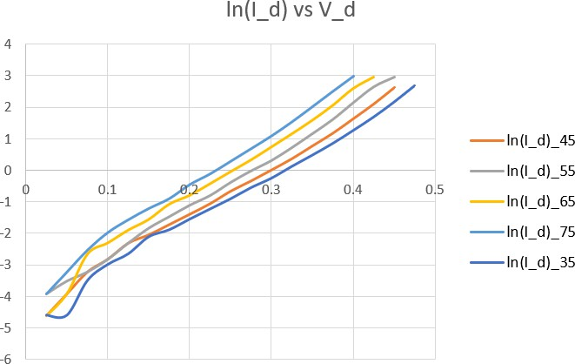

Figure 4: *ln*(*Id*) vs *Vd*

### Observations

### Table 6: Observation Table

|  |  |  |  |  |  |  |
| --- | --- | --- | --- | --- | --- | --- |
| Temperature | *Vd* for | *Vd* for | *Vd* for | *η* for low for- | *η* for high for- |  |
| *Id* = | *Id* = | *Id* = | ward bias | ward bias |  |
| 1*Ma* | 2*mA* | 5*mA* |  |  |  |
| 35°C | 0.316 | 0.364 | 0.42 | 2.255677 | 2.394703 |  |
| 45°C | 0.296 | 0.344 | 0.397 | 2.322295 | 2.278349 |  |
| 55°C | 0.276 | 0.323 | 0.375 | 2.413138 | 2.175333 |  |
| 65°C | 0.253 | 0.297 | 0.352 | 2.184457 | 2.159706 |  |
| 75°C | 0.23 | 0.275 | 0.328 | 2.155205 | 2.074933 |  |

# Lighted I/V at different temperatures

## Prelab

### Plot

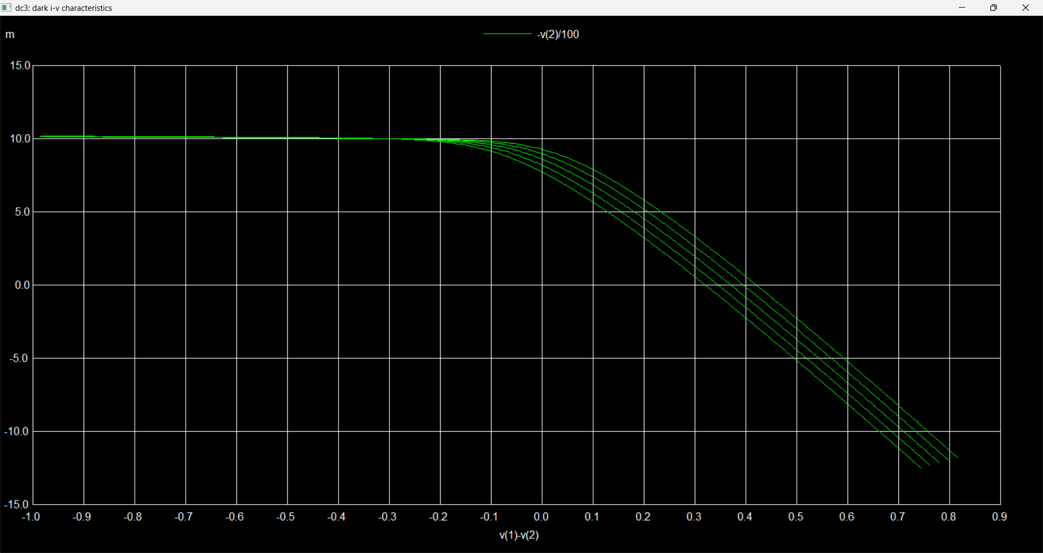

Figure 5: Lighted I-V characteristics

### Calculated Values

|  |  |  |  |  |  |
| --- | --- | --- | --- | --- | --- |
| **Temperature (°C)** | **Vm (V)** | **Im (mA)** | **Isc (mA)** | **Voc (V)** | **FF** |
| 35 | 0.2612 | -0.0076 | -0.0099 | 0.4159 | 0.4831 |
| 45 | 0.2410 | -0.0074 | -0.0099 | 0.3944 | 0.4582 |
| 55 | 0.2209 | -0.0072 | -0.0099 | 0.3728 | 0.4330 |
| 65 | 0.2005 | -0.0072 | -0.0098 | 0.3513 | 0.4182 |
| 75 | 0.2019 | -0.0061 | -0.0098 | 0.2790 | 0.4526 |

Table 7: Temperature dependence of solar cell parameters

## Inlab

### Circuit Diagram

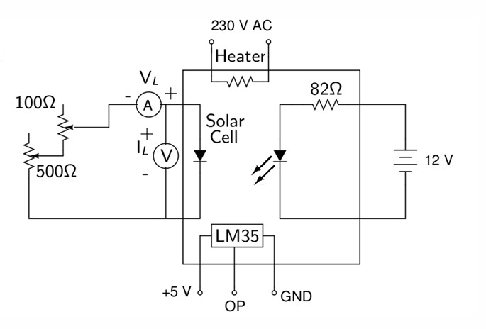

Figure 6: Circuit diagram for lighted I/V characteristics

### Plots

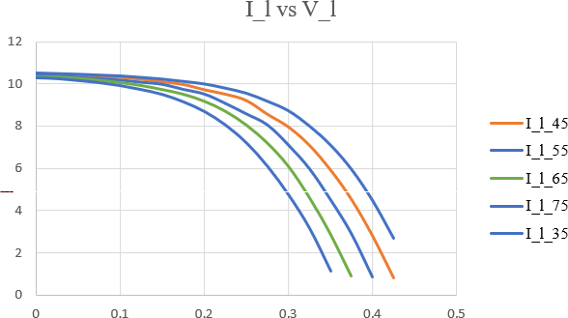

Figure 7: Caption

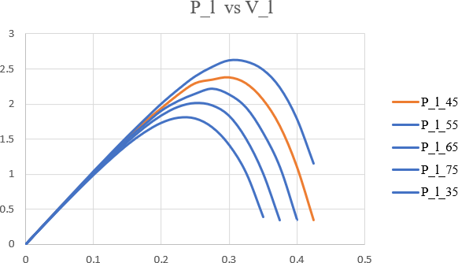

Figure 8: Caption

### Observations

|  |  |  |  |  |  |
| --- | --- | --- | --- | --- | --- |
| Temp | 35°C | 45°C | 55°C | 65°C | 75°C |
| *Isc* | 11.9378 | 12.2615 | 12.1759 | 12.0530 | 11.9037 |
| *Voc* | 0.8096 | 0.6475 | 0.6024 | 0.5570 | 0.5145 |
| *Im × Vm* | 2.6190 | 2.3850 | 2.2220 | 2.0125 | 1.8068 |
| *FF* | 0.2710 | 0.3004 | 0.3029 | 0.2998 | 0.2950 |

Table 13: Performance Metrics at Different Temperatures