

RNN-BASED SENTIMENT ANALYSIS
OF CUSTOMER REVIEWS
Deep Learning Essentials Assignment
Prepared by
Harini K
III year & V sem
113024148027/ VH14121
B.E. Computer Science and Engineering (AI & ML)
Academic Year 2026–2027

2. Problem Statement

Develop an RNN-based sentiment-analysis application using a small collection of positive and negative reviews. The system should learn sentiment patterns from the labeled review dataset and predict whether a new sentence expresses a positive or negative sentiment.

3. Objective

- Create a small labeled dataset containing positive and negative reviews.
- Preprocess and tokenize review text.
- Convert text sequences into numerical representations and pad them to a fixed length.
- Train a Simple Recurrent Neural Network for binary sentiment classification.
- Evaluate the trained model using unseen test data.
- Demonstrate sentiment prediction for new user-provided sentences.
- Understand the basic workflow of applying RNNs to sequential text data.

4. Concept Used

Natural Language Processing
Natural Language Processing (NLP) allows a computer to process and learn from human language. In this project, the input is review text.

Tokenization
Tokenization converts words in the review into integer IDs. The tokenizer builds a vocabulary from the training reviews.

Padding
Reviews have different lengths. Padding converts the sequences to a common maximum length so that they can be processed as a batch.

Embedding
The Embedding layer maps integer word IDs to dense numerical vectors. These vectors are learned during training.

SimpleRNN
A SimpleRNN processes sequence elements in order and maintains a recurrent hidden state. This allows the model to use information from earlier words while processing later words.

Sigmoid and Binary Classification
The final Dense layer uses sigmoid activation and produces a value between 0 and 1. A value of 0.5 or higher is classified as positive, while a value below 0.5 is classified as negative.

Binary Cross Entropy
Binary cross entropy is used as the loss function because the task has two target classes: positive and negative.

5. Methodology / Working Steps

1. Create a small collection of positive and negative reviews and assign labels 1 and 0 respectively.
2. Load the CSV dataset using Pandas.
3. Split the data into training and testing subsets using stratified sampling.
4. Fit a Keras Tokenizer only on the training text.
5. Convert the reviews into integer sequences.
6. Pad sequences to a maximum length of 20 tokens.
7. Pass sequences through an Embedding layer.
8. Process the embedded sequence using a SimpleRNN layer with 32 units.
9. Use a Dense layer with sigmoid activation for binary classification.
10. Train the model using Adam optimization and binary cross entropy.
11. Evaluate the model on the test set.
12. Save the trained model and tokenizer.
13. Use the saved model to classify new sentences interactively.

6. Implementation

Tools & Libraries
- Python
- TensorFlow / Keras
- Pandas
- NumPy
- Scikit-learn
- Matplotlib
- Git and GitHub

Model Architecture

Input Review
↓
Tokenizer
↓
Embedding
↓
SimpleRNN(32)
↓
Dense(1, sigmoid)
↓
Sentiment

Source Code / GitHub Repository
The complete source code is provided in the accompanying project folder. The GitHub repository should be created and maintained by the student. The repository should contain the README, source code, dataset, outputs, requirements file and this report.
Important authenticity requirement: meaningful commits should be made throughout development. The student should be able to explain every major section of the code and make a small live modification during demonstration.

7. Results & Output
The project produces two main training visualizations: training/validation accuracy and training/validation loss. It also provides an interactive prediction program for new sentences.
Example Input | Expected Sentiment
I really enjoyed this movie | Positive
The product exceeded my expectations | Positive
The service was terrible | Negative
I regret buying this | Negative
The exact test accuracy and loss should be recorded from the actual execution of src/train.py rather than manually fabricated. Because the dataset is intentionally small, the measured score should be interpreted as a demonstration of the technique rather than a production benchmark.
OUTPUT:
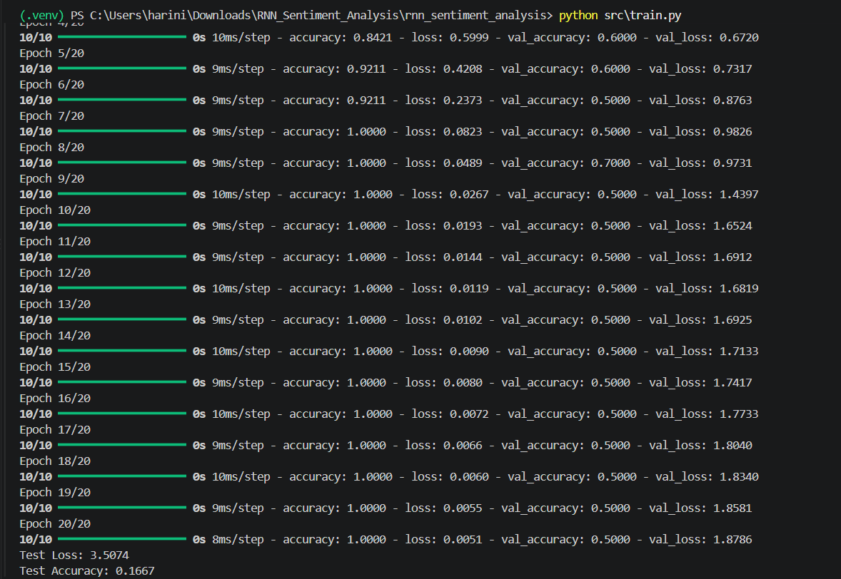
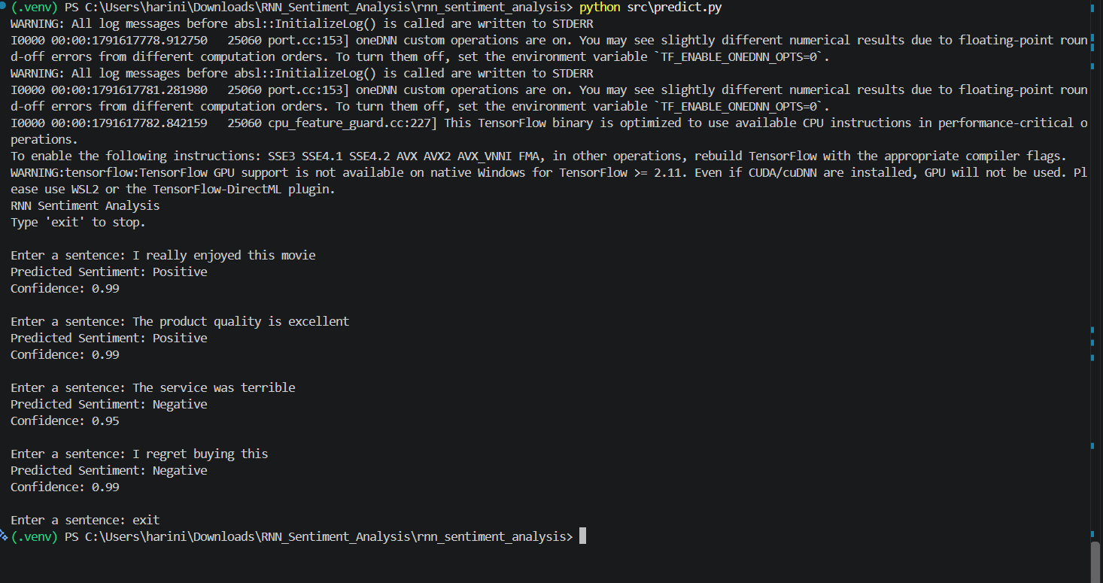
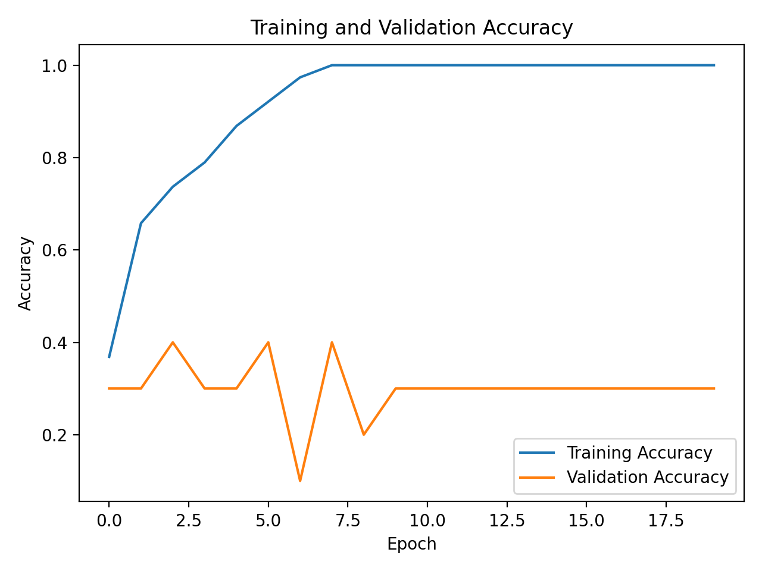
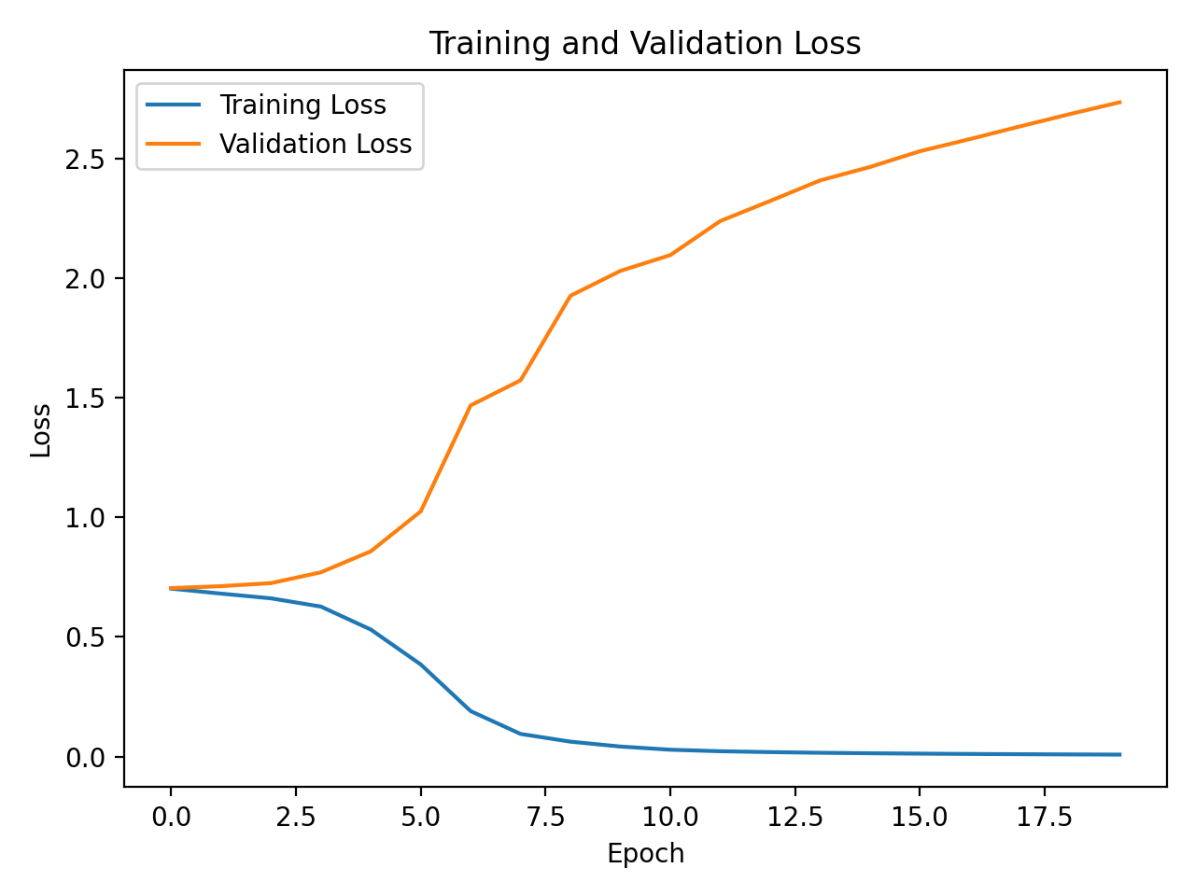

8. Analysis
The SimpleRNN model can learn basic sentiment patterns from the small labeled review dataset. The preprocessing pipeline transforms natural-language reviews into padded numerical sequences, which can be consumed by the neural network.
The model is suitable for demonstrating the core concepts of tokenization, embeddings, recurrent processing, binary classification, training, evaluation and inference. However, the small dataset limits generalization. The model may struggle with sarcasm, negation, mixed sentiment, long sentences and vocabulary that is not represented in the training data.
A larger and more diverse dataset, regularization, improved sequence modeling and more systematic evaluation would be appropriate for a real-world sentiment-analysis application.

9. Conclusion

The project successfully demonstrates an RNN-based sentiment-analysis workflow for positive and negative reviews. A SimpleRNN model is trained after text tokenization, sequence conversion and padding, and the trained model can be used to predict the sentiment of new sentences. The experiment provides practical understanding of how recurrent neural networks can be applied to sequential text data while also highlighting the importance of dataset size and diversity.

10. References

- TensorFlow / Keras Documentation: https://www.tensorflow.org/
- Scikit-learn Documentation: https://scikit-learn.org/
- Pandas Documentation: https://pandas.pydata.org/
- NumPy Documentation: https://numpy.org/
- Matplotlib Documentation: https://matplotlib.org/

