Forest Fire Risk Mapping and Simulation System (Russia, Siberia Focus)
By Student: Kharlamov Ilia
ID: 23605104
Program: Bachelor of Computer Science
Institution: Shaoxing University
Project Title: Forest Fire Risk Mapping and Simulation System (Russia, Siberia Focus)
Supervisor: Bahaa Mohamadi
Submission Date: 06/17/2025

Abstract
This project presents a GIS-based wildfire simulation platform focused on Siberian regions of Russia. Using satellite NDVI imagery and real-time weather data, it computes fire risk scores and simulates wind-driven fire spread. The system supports map rendering, data enrichment, and modular design for future scalability.
Project Aim
The goal of this project is to build an object-oriented, GIS-based simulation platform that can assess forest fire risk across various regions of Russia and simulate potential fire spread using real-world environmental data. The system acts as both an analytical tool for decision-makers and a learning platform to explore how conditions such as wind, humidity, and vegetation impact wildfire behavior.

Scope of Work

1. Geospatial Data Handling
- Load shapefiles or GeoJSON files representing administrative or ecological regions in Russia (e.g., GADM regions).
- Integrate auxiliary spatial data, such as:
  - Weather (temperature, humidity, wind speed/direction) — fetched from WeatherAPI.
  - Vegetation indices — including NDVI values from satellite imagery.

2. Object-Oriented Design
- Build reusable and maintainable Python classes:
  - IgnitionPoint – represents fire ignition points and stores weather, location, and risk.
  - Region – encapsulates spatial boundaries and metadata.
  - NDVILoader – retrieves NDVI values from raster layers.
  - FireSimulator – core algorithm that controls the simulation logic and spread dynamics.

3. Fire Risk Assessment
- Assign each ignition point a risk score based on a weighted function of:
  - Temperature
  - Humidity
  - Wind speed
- NDVI is also used to filter out areas with insufficient vegetation for combustion.

4. Map Visualization
- Render fire risk and spread simulations using Folium maps with:
  - Clustered and unclustered markers for ignition and spread points.
  - Interactive popups showing risk values, NDVI, and weather data.
  - A region overlay to show administrative boundaries.
  - Zoom-based cluster control and visual legends.

5. Fire Spread Simulation
- Model fire spread based on:
  - Wind direction and strength (directionally biased spread)
  - Environmental risk score
  - NDVI-based flammability
- The fire spreads iteratively from ignition points to new locations, simulating propagation over a number of steps.

Workflow

Data Loading
- Load forest region boundaries (GeoDataFrame) from GADM shapefiles.
- Load or query live weather data from WeatherAPI for each ignition point.
- Load NDVI data from GeoTIFFs via rasterio.

Object Initialization
- Create IgnitionPoint instances for each fire detected (e.g., NASA FIRMS data).
- Store weather, location, and derived risk attributes.

Risk Calculation
- Each ignition point calculates a risk score using a weighted model:
​$Risk Score=0.4 ×\left(\frac{Temperature}{45}\right)+0.3×\left(1-\frac{Humidity}{100}\right)+0.3 ×min⁡(\frac{WindSpeed}{10}, 1)$

Fire Simulation
- Use the FireSimulator to simulate multiple steps of spread.
- For each burning point, simulate possible spread directions influenced by wind and vegetation.
- Save the output of all spread steps to a GeoJSON file.

Map Rendering
- Load ignition and spread data from file.
- Visualize it on an interactive Folium map with clusters and popups.
- Toggle clustering based on zoom level using disableClusteringAtZoom.

Modules and Responsibilities
- config.py
  - Defines constants such as SIBERIAN_REGION_NAMES, which lists the regions of interest for simulation.
- data_loader.py
  - Loads and prepares region data from GeoJSON.
  - Ensures compatibility with simulation requirements (e.g., proper CRS and polygon geometry).
- ignition_point.py
  - Defines the IgnitionPoint class.
  - Each point includes coordinates, weather attributes (temperature, humidity, wind speed/direction).
- simulator.py
  - Contains the FireSimulator class.
  - Core method simulate_fire() uses fire risk scores and wind-aligned spread logic to simulate progression.
  - Integrates NDVI constraints to prevent fire spread in low-vegetation areas.
- ndvi_loader.py
  - Loads NDVI raster (GeoTIFF) data and returns NDVI values for geographic coordinates.
  - Used by the simulator to prevent spread in areas below a given NDVI threshold (e.g., < 0.15).
- map_renderer.py
  - Visualizes the results of the fire simulation.
  - Generates HTML maps highlighting ignition and spread points, as well as region status.
- weather_loader.py
  - Asynchronously fetches current weather data for ignition points using WeatherAPI.
  - Saves fallback values for points where the request failed.
  - Stores enriched points into GeoJSON format for simulation use.
- main.py
  - Orchestrates the end-to-end flow:
    - Loads enriched region and ignition data.
    - Filters ignition points by region.
    - Runs fire simulation.
    - Exports results to an interactive map.

Fire Spread Logic
- Spread is calculated in multiple directions per point (8 attempts).
- Directions are randomized within ±90° around the wind vector.
- Distance is biased by cosine of alignment with the wind.
- Latitude correction is used to adjust x-axis distance in degrees.
- Spread is blocked if:
  - The new location is already burned.
  - It is outside valid regions.
  - NDVI is missing or below the critical threshold.

Limitations
- Vegetation data is derived only from NDVI.
- Terrain (e.g., elevation or rivers) is not currently blocking spread.
- Wind speed is capped for risk normalization.
- No simulation of suppression or mitigation actions.

Future Improvements
- Integrate DEMs to block spread across rivers and mountains.
- Use time-based progression (e.g., 1 step = 1 hour).
- Expand ignition point attributes (e.g., cause, timestamp).
- Add GUI or web dashboard for parameter tweaking and result viewing.

Requirements
- Python 3.10+
- Libraries: geopandas, shapely, aiohttp, rasterio, folium, pandas, numpy
- WeatherAPI key (for live enrichment)
- MODIS NDVI raster (GeoTIFF) for current month

Conclusion
This project demonstrates how environmental data and spatial modeling can be combined in a Python-based framework to simulate and visualize wildfire dynamics. It offers a flexible foundation for more complex models and real-world use by fire prevention teams.
Credits
Developed by Kharlamov Ilia as a research and educational tool. Weather data provided by WeatherAPI. NDVI data sourced from MODIS (NASA).

Appendices

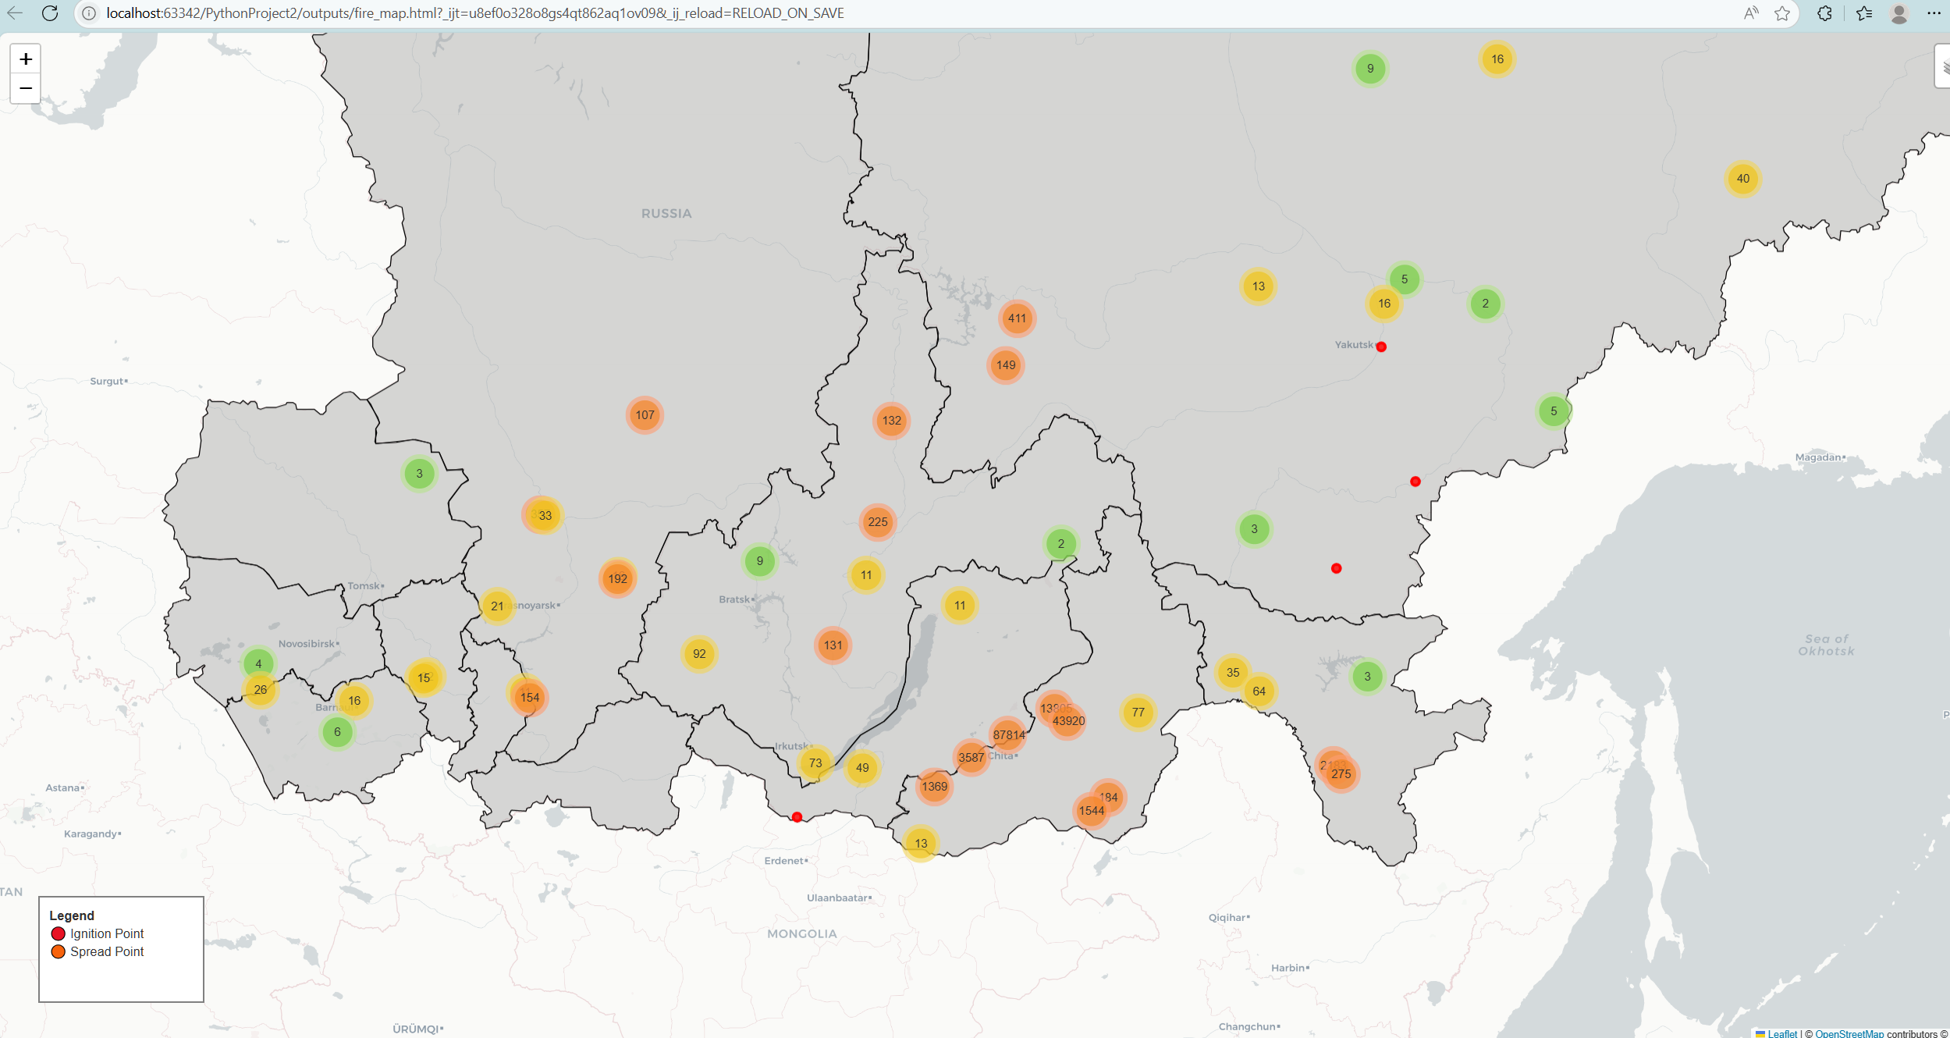
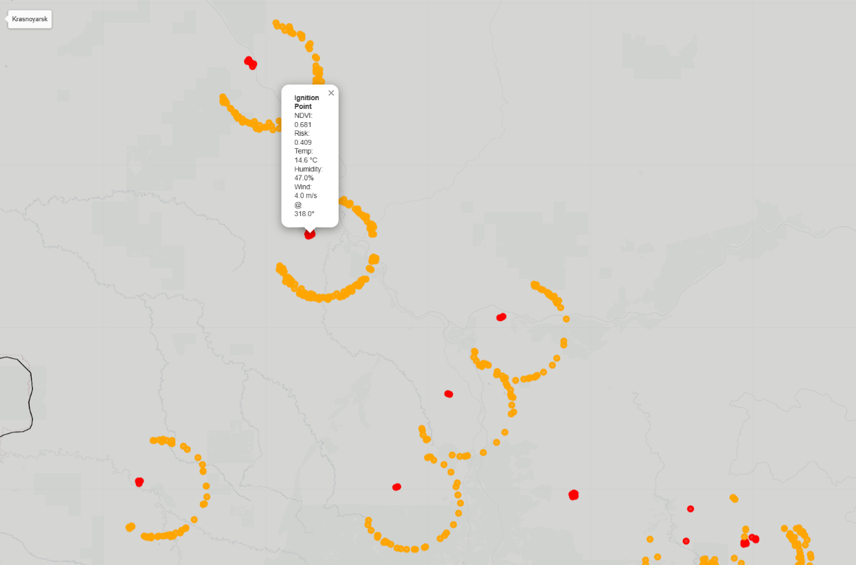
Clustering Effect
Ignitions and Spreads

