BOOK SHOP MANAGEMENT SYSTEM

Major Assignment



Submitted to Submitted by

Mr. Rashid Naseem Palwasha 7771

Due date of submission

December 27 2018

City University Of Science And Information Technology(CUSIT)  
Dalazak Road Peshawar City

**INTRODUCTION**

Book Shop Management System is a Simple project which is capable of storing the data of a small to middle book shopping store. It will take the data from the user and store it and can perform different operations like search for book availability, can see the stock of books and purchase a book in a user-friendly environment. This system is developed in Dev C++ using structure, loops ,user-defined functions and etc.

**SNAPSHOTS OF OUTPUT**

1st page:

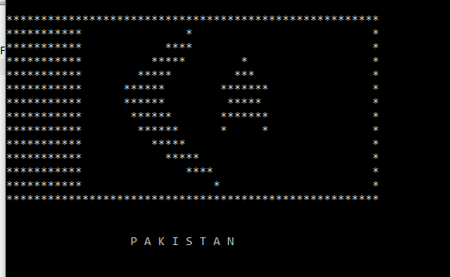

Menu Page:

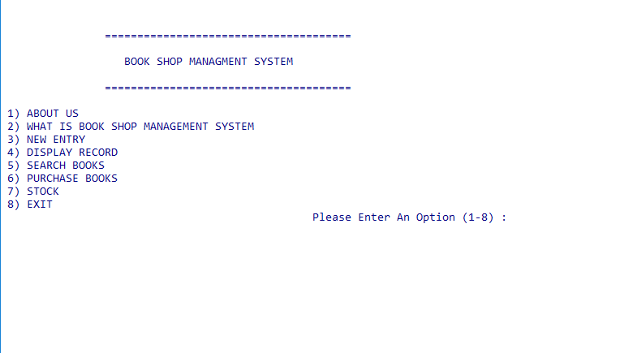

About us:

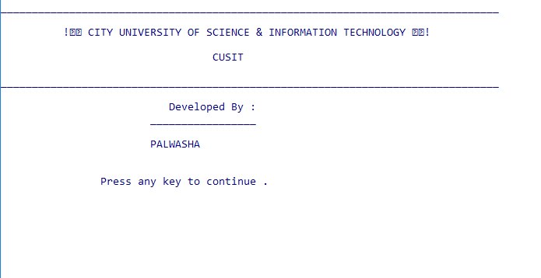

Book shop management system: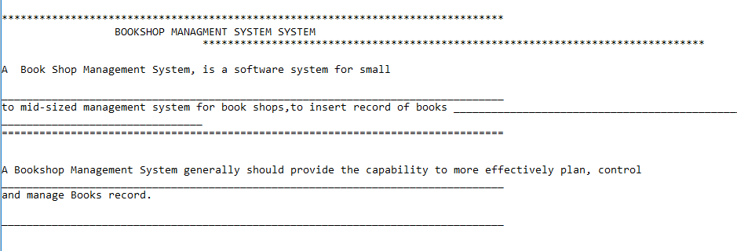

Insertion:

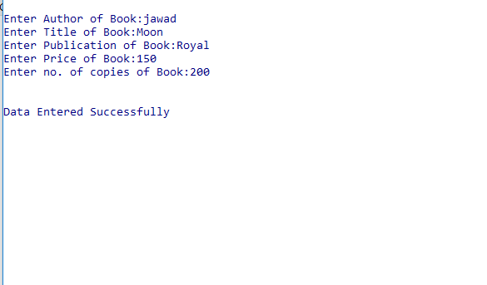

Display:

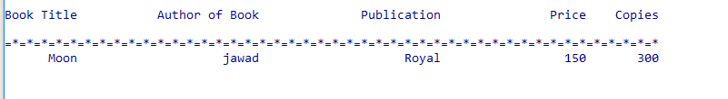

Search:

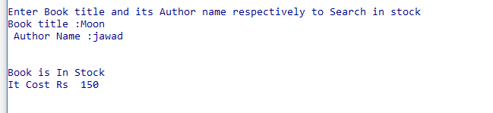

Stock:

