**Figures**

Figure 1. Conceptualization of the Cushing match-mismatch hypothesis represented by the curve in panel (a). The hypothesis postulates that a consumer should temporally ‘match’ the peak of its most energetically demanding period with the peak of resource availability and thus have the highest fitness (a,c); if there is any change to the relative timing of the interaction (e.g., because the consumer shifts its phenology earlier (b) or later (d) relative to the resource), there will be a decrease in the consumer’s fitness (i.e., a mismatch) (a). At the curve’s limits, consumer fitness should fall to zero when the change in relative timing is sufficiently large (a). Curves in panels b-d represent the seasonal changes in the abundance of the consumer (black) and resource (red) where during some part of the year abundance declines to zero.

Figure 3. Conceptualization of key assumptions, and resulting implications for climate change predictions, often made about the Cushing hypothesis when pre-climate change baselines are not defined. (a) Differences in the phenological time-series of a consumer-resource interaction, where red represents the resource and black represents the consumer, during conditions of stationarity; when the environment becomes non-stationary (shown here just after 1980) the consumer and resource each can shift in varying directions, representing the range of recent documented phenological shifts (e.g. Thackeray et al. 2016), leading potentially to shifts in synchrony. (b) Most studies in the current literature assume that consumer fitness was highest before climate change (i.e., a match) leading to a ‘synchrony baseline’. However, an alternative hypothesis put forward by Visser et al. 2012 (i.e., what they term as the ‘adaptive mismatch’ hypothesis) postulates that that, in some systems, life-history trade-offs will promote asynchrony for many or most individuals in a population. This hypothesis may lead to asynchrony as a pre-climate change baseline (see c; ‘asynchrony baseline’ (Singer and Parmesan 2010)) or a population where few individuals are matched; we show this latter possibility here (i.e. ‘adaptive mismatch hypothesis with synchrony baseline’; our representation of this hypothesis is at the population level). The implications for climate change predictions for the two hypotheses are illustrated: If the synchrony baseline is supported, then climate change will necessarily lead to declines in consumer fitness. If the ‘adaptive mismatch hypothesis’ with a synchrony baseline is supported, climate change may not lead to large declines in consumer fitness. (c) Without establishing a pre-climate change baseline and defining where an interaction falls along a curve, it is difficult to predict how climate change-driven changes to the relative timing of the interaction may affect consumer fitness. For example, with an asynchrony baseline, climate change could lead to an increase or decrease, or to varying magnitudes, in consumer fitness depending on how the relative timing of the interaction changes. For panels b and c, blue boxes represent the range of conditions detected in the system over a long time period.

Figure 1.

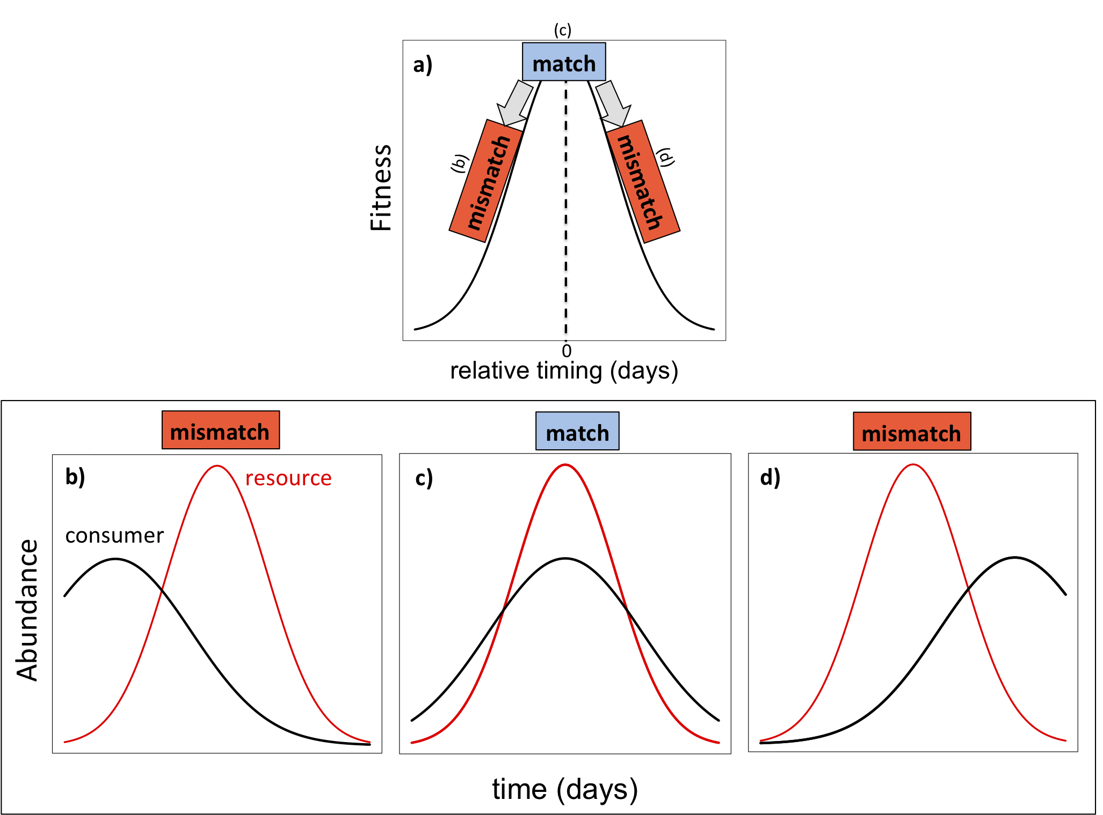

Figure 3.

