**Title:** Disconnects between ecological theory and data in phenological mismatch research

**Authors:** Heather M. Kharouba1, Elizabeth M. Wolkovich2,3,4

**Affiliations:**

1Department of Biology, University of Ottawa, Canada K1N 9B4

2Organismic and Evolutionary Biology, Harvard University, Cambridge, MA 02138

3Arnold Arboretum of Harvard University, Boston, MA, 02130

4Forest and Conservation Sciences, Faculty of Forestry, University of British Columbia, Vancouver, Canada V6T 1Z4

**Email addresses**: heather.kharouba@uottawa.ca; e.wolkovich@ubc.ca

**Running title:** Predicting phenological mismatch under climate change

**Keywords: global** warming, phenological synchrony, trophic interactions, adaptive, performance

**Abstract**

Climate change may lead to phenological mismatches, where the timing of critical events between interacting species becomes de-synchronized, with potential negative consequences. Evidence documenting negative impacts on fitness is mixed. The Cushing match-mismatch hypothesis, the most common hypothesis underlying these studies, offers testable assumptions and predictions to determine consequences of phenological mismatch when combined with a pre-climate change baseline. Here, we highlight how improved approaches could rapidly advance mechanistic understanding. We find that currently no study has collected the data required to test this hypothesis well, and 71% of studies fail to define a baseline. Experiments that clearly link timing to fitness and test extremes, integration across approaches, and null models would aid robust predictions of shifts with climate change.

Climate change is causing phenological shifts1,2,3 (i.e., changes in the timing of life history events). These shifts vary across species as well as between functional groups and trophic levels1,2,3. Such species-specific variation in response to climate change has led to changes in the relative timing of key activities among interacting species4 (phenological synchrony). Changes in phenological synchrony can have negative fitness consequences5,6,7 (phenological mismatch (Box 1)) and influence ecosystem-level properties in some contexts8. However, changes in phenological synchrony do not always influence fitness9,10 or have consistent demographic effects11. Recent theoretical12,13,14 and empirical studies15 based in single systems, as well as syntheses3,4 have worked to improve predictions about when and why mismatches are likely to occur. Yet—while there is general agreement that predicting phenological mismatch is critical for determining how pair-wise species interactions, communities, and ecosystem function (e.g. pollination) will be affected by climate change—there is still no framework to discriminate between systems where these mismatches are likely to occur or not.

Here, we argue that much of the difficulty in predicting the consequences of climate change-driven shifts in synchrony is due to a disconnect between ecological theory and current empirical approaches. We focus on the widely-cited Cushing match-mismatch, or trophic mismatch, hypothesis16,17,18,19, the most commonly applied hypothesis concerning consumer-resource interactions in this literature. We show how advances could come from direct, strong tests of the hypothesis, specifically clearly tested assumptions, tests of multiple potential mechanisms, and clearly defined baselines, when possible. Our aim is not to put forward additional hypotheses about the context in which phenological mismatch will occur, which has been reviewed extensively elsewhere20, 21, but rather to help guide the study of phenological mismatch by outlining a path forward to develop robust climate change predictions that can scale up to inference across sites and systems.

***Overview of the Cushing hypothesis***

The Cushing match-mismatch hypothesis16,17,18,19 (Fig. 1) forms the basis for many phenological mismatch studies 21,22. While the general hypothesis has been applied across different ecosystems9,23,24, it originally emerged from the marine fisheries literature as a way to explain the variation in population recruitment of fish stocks. The hypothesis postulates that the consumer should temporally ‘match’ the peak of its most energetically demanding period with the peak of resource availability (Fig. 1b) and any change to the relative timing of the interaction will result in a ‘mismatch’16,17,18,19 (Fig. 1ac).

We assume that Cushing’s19 use of the term ‘mismatch’ is focused on the ‘match’ having the highest fitness (i.e., consumer fitness is maximized at phenological synchrony, an assumption in line with previous literature, see 13,22,25); therefore, any change to the relative timing of the interaction will lead to a decrease in fitness associated with this period for the consumer (i.e., a mismatch), thus producing a concave-down curve (Fig. 1d). For example, if a consumer (e.g. adult bird) reproduces too early in the spring (Fig. 1a) and the resource (e.g. caterpillar) has not yet emerged, the offspring will risk starvation. At the curve’s limits, this component of consumer fitness should fall to zero when the change in relative timing is sufficiently large (Fig. 1d). For example, very early offspring can only survive so many days without food.

This hypothesis is based on two important assumptions. First, the resource is the major controller of consumer fitness26 (i.e., strong interaction strength, bottom-up control). Second, the consumer and resource must present a certain degree of seasonality (e.g., resource is only available for part of the year), limiting the optimal period for growth and reproduction for the consumer25, 27. If these assumptions are not met, then the Cushing hypothesis does not apply, and thus makes no predictions about fitness and relative timing.

We make three clarifications related to the way we apply the hypothesis here. First, we discuss the hypothesis as considering total fitness, either lifetime or population mean. While other perspectives have been taken22, we follow the first assumption and consider a narrow definition of fitness whereby the resource must be the dominant controller of consumer fitness, and systems where fitness is predominantly controlled by other factors would not be included13,28. Second, we follow Cushing’s definition of mismatch and its connections with fitness, which is in line with other studies13, 25, 29. Finally, although the Cushing hypothesis has been applied to other types of interactions (e.g. mutualism84), we limit our discussion to antagonistic interactions between consumers and their food resources.

***Disconnect between the Cushing hypothesis and empirical studies***

The Cushing hypothesis offers testable predictions of the magnitude and direction of population-level fitness changes in response to climate-change driven shifts in synchrony. In its original state, the hypothesis has been debated, contested and criticized, particularly in the marine literature25,31. Although a relatively simple hypothesis, it is inherently difficult to test in the field, an assertion even Cushing himself made. Indeed, the shape and strength of the relationship of the curve varies greatly across observational studies6, 11,32,33. We argue that this is because there are two key areas that make it difficult to determine whether this hypothesis is widely supported in the context of climate change. First, studies do not collect the data required to test assumptions and multiple ultimate mechanisms (i.e., rigorously testing the hypothesis) (Fig. 2). This represents the major challenge of the hypothesis and may be why support for it has been so mixed. Second, studies are not defining a pre-climate change baseline in synchrony, an action needed to apply the hypothesis to predicting the consequences of climate change for interacting species.

To put our argument in context, we systematically reviewed the phenological mismatch literature. We examined 42 observational studies that met our search criteria (see Appendix for details) for evaluating the effects of a change in relative timing on the fitness or performance (e.g., growth, development; hereafter referred to as performance) of the consumer.

*i) Testing the Cushing hypothesis*

Many mechanisms can produce the Cushing curve, and they vary across systems, space and time. Here we focus on the ultimate mechanisms related to life-history theory and food web theory. Mechanisms predicted by life-history theory (Box 1; defined in our search as those studies that collected data at the individual level (e.g., ref. 9)), for example, trade-offs between fecundity and mortality, and breeding strategies (Fig. 2), can produce the Cushing curve—as consumers maximize their fitness through ideal timing with the peak of their primary resource. For example, a species’ breeding strategy (e.g., whether a consumer provisions its offspring with resources acquired prior to reproduction or during the breeding period) influences how well-timed a consumer will be with its resource34. Alternatively, trade-offs can also move the fitness optimum away from the resource peak and/or lead to a different asymmetric shape of the Cushing curve (see discussion about ‘adaptive mismatch hypothesis13,28’ below. The Cushing hypothesis, however, is also connected to food web theory (Box 1; defined in our search as those studies that collected data only at the population or community (i.e., across species) level (e.g., ref. 33)), which focuses on predator prey dynamics and is related to the timing of a consumer to its food resource.

Identifying the ultimate mechanism(s) of the Cushing hypothesis relates to the likelihood that the key assumptions are met13 (Fig. 2). For example, if mechanisms such as density dependence or top-down population regulation are thought to be at play, then the first assumption of the hypothesis is unlikely to be met13,35. Even when both of the assumptions of the Cushing hypothesis have been met (i.e., resource fitness is the major controller of consumer fitness and both species show seasonality), identifying the ultimate mechanism is critical to predicting how interactions will respond to climate change (discussed in more detail in the next section; Fig. 2). Given the number of mechanisms related to the Cushing hypothesis and therefore the potential diversity in the outcomes in consumer performance (e.g., magnitude, direction) due to shifts in synchrony, the better our mechanistic understanding of these patterns, the more robust our predictions will be.

Studies deviate in which forces they hypothesize control the peak in the food resource (a key assumption, see Fig. 1 and 2). For example, in aquatic systems—where top-down forces are generally more influential compared to terrestrial systems36—many studies suggest that the resource peak is controlled by release from, or predation by, a consumer37,38,39. This is a very different hypothesis from others that suggest seasonality in the environment produces the resource peak40. In terrestrial systems, the relative contribution of direct vs. indirect effects on consumer dynamics remains poorly understood41 but affects whether the first assumption of the Cushing hypothesis is met.

*a) Data requirements*

Given that several mechanisms can produce the basic shape of the Cushing curve, different researchers may collect very different data depending on what mechanism they suspect underlies the curve in their particular system or what their main objective is. To accomplish a strong test of the Cushing hypothesis, equivalent data would ideally be assessed for both the consumer and resource—at the level of the individual when possible. Researchers studying the hypothesis from the lens of life-history theory require per-capita estimates of fitness (which underlie the necessary population-level metric of fitness that the hypothesis is based on), including measurements of fecundity and mortality, and how they vary across ontogeny. Such measurements allow researchers to assess fitness consequences at the level of the individual to link any fitness changes to timing.

Studies addressing the Cushing hypothesis from the perspective of food web theory require equivalent data on the consumer and resource but do not require per-capita fitness consequences for the consumer. Equivalent data for the consumer and resource can help assess the influence of the resource on the consumer (i.e. the first assumption). Without at least population-level data on the resource, it is difficult to test the second assumption of the hypothesis; for example, resource abundance can be used to determine the likelihood that consumers will encounter enough resource at the tails of their temporal distributions, thus defining the degree of seasonality in the resource (Fig. 1).

Per-capita data on the resource, when available, also extends our mechanistic understanding beyond the consumer, thus improving our ability to make predictions of climate change-driven phenological mismatches for the consumer-resource interaction in its entirety. For example, fine-scale data on the resource are needed to fully incorporate feedbacks between the consumer and resource35,42, measure interaction strength (which informs a key assumption of the hypothesis20), and accurately predict changes in resource abundance due to climate change. Together, these data help to determine the wider implications of phenological mismatches for the community43,44.

*b) Current state of the literature*

Currently the data required to provide strong tests of the Cushing hypothesis are non-existent in this literature (i.e. none of the pair-wise interactions we found had individual-level data for both the consumer and resource). Of the interactions we examined with per-capita performance data on the consumer (i.e. life history; n=27 interactions), none had equivalent measures of performance on the resource (Table S1). For the majority of these interactions (21/27), the researchers measured performance at the community level for the resource (e.g. biomass; Table S1) and many had no measure at all for the resource (6/27 interactions; Table S1). Researchers that measured population- or community-level data on the consumer (n=18 interactions) collected equivalent data on the resource and consumer (e.g. abundance). For the majority of these interactions, researchers also collected population-level (7/18) or community level data for the resource (7/18) (Table S1). Across all interactions, researchers measured per-capita performance on the resource for only one interaction32 (Table S1).

These discrepancies may partly stem from differing generation times—studies that can easily observe a resource curve shaped by predation often focus on organisms with generation times on the scale of days to weeks. For example, aquatic studies that focus on phytoplankton as the resource may observe many generations in one summer while a terrestrial study focused on caterpillars in temperate areas would generally observe a smaller number generations (e.g. 1-2, depending on latitude and the caterpillar species). When populations turn over too quickly, it can be difficult to track individuals; consequently, researchers struggle to collect robust data on per capita fitness. The fundamental difference in the scale of generation times pervades aquatic/terrestrial comparisons, particularly at lower trophic levels 36,45,46, and may drive the difference in the objectives of aquatic vs. terrestrial studies in the phenological mismatch literature. Indeed, the majority of researchers studying aquatic-based interactions in our review approached the Cushing hypothesis from the perspective of populations or communities (15/20 interactions), whereas researchers approached terrestrial-based interactions from life-history theory (22/25; Table S2).

A further divide across studies may come from the size, and population size, of the consumer, properties correlated with generation time: it can be difficult to collect per-capita fitness data when consumers are too small and numerous. In cases where individuals can be distinguished, marked and monitored, it is possible to gather per-capita data; otherwise data are more likely to be aggregated at the population or community-level. Of the life history interactions, the majority of consumers were birds (19/27) and mammals (5/27; Table S2). Comparatively, invertebrates were measured at the population or community level (11/12; Table S2) and the vast majority were aquatic (11/12; Table S2). Therefore, only certain classes of organisms are tested for each category of mechanisms and in one type of biome, further limiting generalizations across systems.

This places phenological mismatch studies on a continuum: at one end, aquatic studies focus generally on food web mechanisms, collect equivalent data on the consumer and resource but no per-capita fitness data and at the other end, terrestrial studies focus on life history theory from the lens of the consumer, collect individual-level data that can scale up to understand population-level connections between timing and fitness of the consumer, with much less information on the resource. The fundamental problem with these approaches is that researchers test only one piece of the much larger field of mechanisms that could underlie the Cushing curve. Though it is highly possible that both food web and life history theory together explain many of the consumer-resource systems studied, data limitations make it hard to assess mechanisms related to both theories at once. Consequently, most studies do not actually provide strong tests of the Cushing hypothesis, making it difficult to refute the hypothesis if no evidence is found, a prevalent issue in ecology and evolution47.

Without strong support for the Cushing hypothesis (i.e., relative timing explains substantial variation in consumer fitness and clear patterns that align with predictions), the mechanisms underlying it will likely be uncertain. This uncertainty can be caused by two reasons: (1) hypotheses that are not mutually exclusive (i.e. different mechanisms yield the same predictions). For example, the relative timing of an interaction will change in the same direction regardless of whether temperature (or some other abiotic factor) directly or indirectly affects a resource’s peak; or (2) considering multiple mechanisms yields different predictions than considering only a single mechanism. For example, researchers have pointed out how a broader perspective on life history, such as including other sources of mortality beyond those related to resource access or alternative resource types15, can lead to alternative predictions than the synchrony predicted by the Cushing curve28,48.

*ii) Testing pre-climate change conditions*

Applying the Cushing hypothesis to understanding—and ideally predicting—the consequences of climate change for interacting species requires more than testing the assumptions and underlying mechanisms of the hypothesis (Fig. 2). Researchers still need an understanding of the system dynamics before climate change and the phenological cues that affect the timing of consumer and resource levels to predict what shifts in the climate have—and will—do to the timing and fitness of the players (Fig. 2).

*(a) Identifying pre-climate change baselines*

The concept of a pre-climate change baseline (i.e., defining the range of natural variation) is rarely, if ever, considered by phenological mismatch studies; yet, establishing a baseline in a system has important implications for the Cushing hypothesis. Of the studies we considered, only 29% (12/42) of the studies began before the early 1980s, the same time that pronounced recent climate change began49. Even in this subset of studies, not all studies had more than three years of data (2/12 had only one or two years of data for inference). This is also an issue with the phenological synchrony literature4. Even those studies with time-series that extend into decades before the 1980s do not explicitly define a pre-climate change baseline in synchrony (but see ref: 23,32,50).

*(b) Implications of not identifying pre-climate change baselines*

There are several major implications of not establishing a pre-climate change baseline (Fig. 3). First, studies without a baseline are implicitly assuming conditions of stationarity (i.e., a constant underlying probability distribution) before climate change occurred51 (Fig. 3a). This is problematic when climate change has led to non-stationarity to different extents in different systems (Fig. 3a). Without a defined pre-climate change baseline in the system, we do not know whether, and to what magnitude, we should predict a divergence in synchrony due to climate change (Fig. 3a). It is then further difficult to determine how much of the observed change in the interaction can be attributed to climate change or some other driver, for example nitrogen deposition52, land use change53, or species introductions54,55,56. Thus, knowledge of the pre-climate change baseline may rule out climate change and identify other drivers, which is key for conservation management decisions for threatened species.

Second, these studies confound a pre-climate change baseline with the peak of the Cushing curve: that is, they assume that fitness was highest before climate change began because the consumer’s timing was well matched to the resource’s (i.e. the synchrony baseline48; Box 1; Fig. 3b). The resulting prediction is that climate change will necessarily change the relative timing of the interaction (i.e. non-stationarity) leading to a decline in the consumer’s fitness (Fig. 2, Fig. 3b). However, without knowledge of the pre-climate change baseline, it is difficult to predict the direction and magnitude of fitness consequences due to climate change-driven shifts in synchrony, especially when alternative conditions could be the baseline (Fig. 3b,c).

An alternative hypothesis put forward by Visser et al.57 suggests that in some contexts, ’adaptive mismatch’ (i.e. when the most energetically demanding period of the consumer is not lined up with the peak resource availability for many individuals in the population; Box 1) can occur. They postulate that in some systems, asynchrony might be adaptive due to life-history tradeoffs, where lifetime fitness is maximized but individual components of fitness48,57 are not necessarily maximized, or due to a combination of life-history trade-offs and competitive advantage from intra-specific competition58,59,60. However, whether synchrony vs. asynchrony is considered adaptive for the consumer, and thus whether fitness decreases are predicted with climate change (Fig. 3b), will depend on which fitness components have been measured in the study (e.g. reproductive success vs. lifetime fitness) and whether asynchrony is adaptive at the individual or population-level22,48,57,60. For example, fitness may increase or decrease with climate change in bird species where there is a competitive advantage of hatching early, depending on whether short-term or long-term populations responses are considered60.

In either hypothesis (i.e. synchrony vs. adaptive mismatch; Fig. 3b), a pre-climate change baseline of asynchrony (Box 1; Fig. 3c) could occur through several mechanisms. Trade-offs that can lead to asynchrony can emerge when a consumer cannot measure the timing of its resource well48. Shifts in the drivers of phenology for the consumer or resource (e.g., nutrient enrichment) could have pushed the system away from synchrony before climate change. An asynchronous baseline would also be predicted, at times, by a co-evolutionary arms race61: when the resource is ahead in the arms-race, asynchrony would the predicted baseline (Fig. 3c), this would then shift back towards synchrony when the consumer is winning the arms race. In systems where asynchrony or some type of transient conditions might be the baseline state, anticipating the effects of climate change will be especially challenging as these transient conditions can lead to vastly different predictions under climate change (Fig. 3c). For example, interactions might become less (i.e., fitness increases) or even more mismatched (i.e. fitness decreases) with climate change (Fig. 3b-c).

The pre-climate change baseline is also dependent on the ultimate mechanism(s) generating the Cushing curve (Fig. 2). For example, a species that provisions its offspring with resources acquired during the breeding period (i.e., an income breeder; e.g., West Greenland caribou: *Rangifer tarandus*) is predicted to have a pre-climate change baseline of synchrony, whereas a species that provisions its offspring with resources gained prior to reproduction (i.e., a capital breeder; e.g., muskoxen*: Ovibos moschatus*) is more likely to have a baseline of asynchrony34. Therefore, researchers need an understanding of the system dynamics before climate change began.

*(c) Identifying proximate cues*

For climate change to lead to phenological mismatch, the underlying assumption is that changes in climate will drive changes in the relative timing of species interactions. Therefore, predicting how climate change will affect the relative timing of a consumer and resource, and potentially the fitness of the consumer, will also depend on the identification of the proximate phenological cues of the consumer and resource (Fig. 2). For example, climate change is likely to lead to fitness declines for a consumer that has a pre-climate change baseline of synchrony and that shares different environmental cues with its resource (Fig. 2). Currently, relatively little is known about the similarity of cues for interacting species across trophic levels62.

**Towards robust forecasting of phenological mismatch**

While the Cushing hypothesis provides testable predictions regarding the consequences of phenological mismatch in response to climate change, it is uncertain how much support there is for it. Moving the field of phenological mismatch forward (i.e., from documentation towards forecasting) requires higher quality data that enables the testing of fundamental hypotheses and defining of key baselines. Below, we highlight how new approaches can improve testing of the Cushing hypothesis. These approaches also provide the framework for building the required depth in evidence across studies to determine general quantitative patterns in phenological mismatch and their underlying mechanisms, an approach not currently possible given the state of the field.

*(i) Testing assumptions and mechanisms of the Cushing hypothesis*

By having the potential to test multiple mechanisms and define key baselines, the integration of long-term pre-climate change data and an experimental approach in a single system represents the ‘gold standard’. However, in the absence of long-term pre-climate change data, the integration of observational data across a long time-series or a spatial gradient in climatic conditions, and thus variation in the relative timing of the interaction, with an experimental study can provide a powerful approach to test multiple hypotheses (Box 2). For example, Samplonius et al.15 combine descriptive and experimental data to test many confounding factors and key assumptions of the Cushing hypothesis in their system (e.g., ontogenetic dietary shifts, habitat quality). Consequently, they advanced the field by providing a strong test of the Cushing hypothesis, demonstrating that this hypothesis is pertinent in their system, and ruling out competing hypotheses related to habitat quality.

Independent of whether observational data is available, experiments can be used to test multiple mechanisms, for example they can disentangle direct from indirect effects or abiotic mismatches from phenological ones63,64. Experiments provide a high degree of inference about mechanisms that descriptive data alone cannot provide. For example, Berger et al.65 manipulated several factors in lake mesocosms to separate the direct effects of light and temperature on spring plankton dynamics from effects mediated through the consumer. They showed that temperature had little effect on zooplankton phenology and performance, suggesting that climate change is unlikely to result in phenological mismatch in this system. The extrapolation of their results to the lake ecosystem are uncertain, however, given the lack of long-term data in the system and the uncertainty regarding phenological cues for *Daphnia* in the field65.

Baselines themselves can also be used to test multiple mechanisms (see next section for discussion about defining baselines). Researchers with long-term data in systems where multiple attributes of the environment have changed at different points can leverage this variation to test which driver is most closely associated with shifts in phenological synchrony and their associated consequences through time. For example, many lakes experienced large changes in nutrient inputs in the 1960s and 1970s (e.g., Lake Washington52, Esthwaite Water66), before the onset of recent climate change in the early 1980s. Researchers can test different breakpoints with their long-term data to determine where the non-linearity or non-stationarity most likely began (Fig. 3a), thus providing evidence for which factor is likely to be the major driver of changes in phenological synchrony. For example, studies have shown that changes in nutrient inputs have had larger impacts on plankton dynamics in Lake Washington than warming over the past three decades67,68.

Higher temporal resolution data in some systems may help with teasing apart different mechanisms and testing the assumptions of the Cushing hypothesis. Regardless of aim, ideally sampling frequency should be relative to the life history of the species of interest. For example, testing any mechanism related to life history theory requires data about ontogeny. In the great tit-winter moth system, caterpillar biomass sampling is usually conducted a few times a week69. Given that the larval stage of the winter moth life cycle is typically 4-6 weeks70,71, this sampling frequency allows researchers to obtain an accurate estimate of growth and development for this life cycle stage. In the lower trophic levels of aquatic systems, where there is often a quick turnaround between producers and consumers, determining how strong of an influence producers have on consumers and vice versa (i.e., whether the first assumption of the Cushing hypothesis is supported37) can be difficult. In cases where there are multiple short, potentially overlapping, generations, determining the seasonal order of the consumer vs. producer is necessary to assess the degree of dependence of the consumer on the producer.

Higher temporal resolution data will also help determine the seasonal availability of the consumer and resource, the other key assumption of the Cushing hypothesis (Fig. 1a-c). For example, temperate aquatic and terrestrial systems differ in how most organisms survive the winter. While many terrestrial plants and herbivores have dormancy phases during the winter, in aquatic systems some zooplankton are never in complete dormancy (i.e., they remain at low densities), and thus do not fully meet the assumption of the hypothesis. Nevertheless, some aquatic studies have been successful in achieving daily sampling frequency of lower trophic levels72, suggesting that—though more challenging—critical assumptions of the Cushing hypothesis can be tested in aquatic systems.

*ii) Defining baselines*

Researchers with long-term data have the potential to test whether synchrony vs. asynchrony was the pre-climate change baseline (Fig. 2; Fig. 3). By testing for a clear peak in fitness across years in relation to the relative timing of the interaction (i.e. evidence for the synchrony baseline or adaptive mismatch hypothesis) in the pre-climate change data, researchers can place their system on the Cushing curve (Fig. 3). Whenever possible, incorporating the most energetically expensive part of the consumer’s annual cycle or estimating when the measured phenological phase occurs relative to the most expensive part (e.g., food demands of the great tit, *Parus major*, chicks are highest 9 days after hatching, the phenological phase most commonly monitored73,74,75) will help define a peak in consumer fitness. If there is no clear peak in fitness, then well-designed experiments (where possible) that have the ability to reveal the limits of the curve (i.e. where consumer fitness reaches zero) can be used to reject the hypothesis of an asynchrony baseline. Knowledge of when/if different resources are available15 and whether the interaction type changes throughout the season76,77  can also help describe the limits of the curve.

Where long-term data are not available, there is no perfect solution to the challenge of defining a baseline. Researchers with multiple years of data may be able to use inter-annual variation in abiotic conditions (e.g., temperature) to define a baseline, where closer-to-mean conditions represent a proxy for a historical baseline and, for example, cooler vs. warmer years act as alternatives to pre- and post- climate change, respectively68,78. However, extrapolation from short-term datasets only work if the species responses’ to varying climate themselves are not in flux, a criterion difficult to meet in many systems already48,75. Null modeling to simulate historical data4, 79,80 can help put the magnitude of observed changes in phenology and performance since significant climate change began into context and to quantify how much variation may be due to noise (i.e., factors other than climate change4).

*(iii) Testing alternative hypotheses*

Moving the field of phenological mismatch forward also requires a better understanding of systems where the Cushing hypothesis is not supported. In systems where the assumptions of the Cushing hypothesis were not met or are too difficult to test (e.g., planktonic food web at the Plymouth L4 site, UK33), researchers can test alternate hypotheses related to the forces structuring species interactions (Fig. 2); for example, density-dependence13, time-dependence81, top-down control36, bet-hedging82, size-mediated priority effects83, interaction strength13,20, ontogenetic variation and stage-structure species interactions76. Testing multiple hypotheses, and any data that helps define how systems have and are shifting (even when assumptions and mechanisms related to the Cushing hypothesis are not met or cannot be tested), and what mechanisms may drive those shifts, contributes valuable information for improved forecasting. An improved knowledge of the prevalence of mechanisms in different systems will advance our predictions of phenological mismatch for pair-wise interactions and resulting ecological consequences.

*iv) Final thoughts on forecasting*

Given the complexity involved, accurately forecasting phenological mismatch in response to climate change is a major test of ecological theory and methods. It requires a mechanistic understanding of the processes involved to ensure robust predictions of changes in consumer performance. Previous work has identified factors that will help predict ***when*** a mismatch is more likely to lead to a population decline but this work is largely theoretical. While we have outlined how to work around data limitations, the best tests of mismatch theory will come from data-rich systems where the energetic links between consumer and resource populations are well understood. With such information in hand, researchers can then consider forecasting longer-term demographic responses due to mismatch with continued climate change. Forecasting of phenological synchrony can be built off climate projection forecasts whenever phenological cues for both species are well known62,84. Forecasting longer-term demographic responses to phenological mismatch will require data about lifetime fitness for the consumer and comprehensive data on the resource, a standard that, to our knowledge, has yet to be met by any empirical study to date.

As more information is gathered across habitats and diverse consumer-resource interactions, forecasting should eventually move beyond a system-specific approach and towards forecasting diverse systems through a multi-level modeling approach based on our mechanistic understanding of what drives mismatch. Such modeling would be built on mechanistic studies of the Cushing hypothesis that carefully measure the fitness, phenologies, interactions and other still-unknown important attributes of systems. The models would then allow researchers to measure currently unknown but critical attributes of species, sites, and ecosystems that control the shape, strength and uncertainty surrounding the Cushing curve. But progress towards such an approach requires the ability to combine knowledge from across diverse systems into one complex but well-defined mechanistic model. As we have outlined above, most current data in the field make it hard or impossible to compare across systems. Given intrinsic differences between aquatic and terrestrial systems, progress may be accelerated if these systems are considered separately before being combined. Nevertheless, without improved methods to test multiple mechanisms and define pre-climate change baselines, the goal ofgeneral predictions of the ecological consequences of shifts in phenological synchrony will remain well out of reach.

**Correspondence: to** Heather M. Kharouba, 30 Marie-Curie, University of Ottawa, Ottawa, ON, Canada, K1N 9B4, 613-562-5800 x6740; heather.kharouba@uottawa.ca

**Acknowledgements**

We thank Kathryn Cottingham, Mary O’Connor, Johan Ehrlen, Kjell Bolmgren and Steve Travers for interesting discussions and to Ian Breckheimer, Ailene Ettinger, Deirdre Loughnan, and three anonymous reviewers for constructive feedback on the manuscript. HMK thanks the professor writing retreats offered through the Centre for Academic Leadership at the University of Ottawa for support in writing this manuscript.

**Author Contribution statement**: All authors conceived of the ideas, contributed to the writing and editing of the manuscript. HMK collected and analyzed the data.

**Data availability statement**: The data supporting the results are archived in Dryad accessible at: .

**References**

1. Ovaskainen, O., et al. Community-level phenological response to climate change. *P. Natl. Acad. Sci. USA* **110**, 13434-13439 (2013).

2. CaraDonna, P. J., Iler, A. M. and Inouye, D. W. Shifts in flowering phenology reshape a subalpine plant community. *P. Natl. Acad. Sci. USA* **111**, 4916-4921 (2014).

3. Thackeray, S. J., et al. Phenological sensitivity to climate across taxa and trophic levels. *Nature* **535**, 241 (2016).

4. Kharouba, H. M., et al. Global shifts in the phenological synchrony of species interactions over recent decades. *P. Natl. Acad. Sci. USA* **115**, 5211-5216 (2018).

*Shows that the relative timing of interacting species has changed substantially in recent decades*.

5. Post, E. and Forchhammer, M. C. Climate change reduces reproductive success of an Arctic herbivore through trophic mismatch. *Philos. T. Roy. Soc. B* **363**, 2367-2373 (2007).

*Demonstrates the ecological consequences of trophic mismatch for this migratory herbivore due to climate change.*

6. Plard, F., et al. Mismatch between birth date and vegetation phenology slows the demography of roe deer. *PLoS biology* **12**, e1001828 (2014).

7. Doiron, M., Gauthier, G. and Lévesque, E. Trophic mismatch and its effects on the growth of young in an Arctic herbivore*. Global Change Biol.*  **21**, 4364-4376 (2015).

8. Burkle, L. A., Marlin, J. C. and Knight, T. M. Plant-pollinator interactions over 120 years: loss of species, co-occurrence, and function. *Science* **339**, 1611-1615 (2013).

9. Vatka, E., Orell, M. and RytkÖnen, S. Warming climate advances breeding and improves synchrony of food demand and food availability in a boreal passerine. *Global Change Biol.* **17**, 3002-3009 (2011).

10. Burthe, S., et al. Phenological trends and trophic mismatch across multiple levels of a North Sea pelagic food web*.* *Marine Ecol. Prog. Ser.*  **454**, 119-133 (2012).

11. Reed, T. E., Jenouvrier, S. and Visser, M. E. Phenological mismatch strongly affects individual fitness but not population demography in a woodland passerine. *J. Anim. Ecol.* **82**, 131-144 (2013).

12. Gienapp, P., Reed, T. E., and Visser, M. E. Why climate change will invariably alter selection pressures on phenology. *P. Roy. Soc. B- Biol. Sci.* **281**, 20141611 (2014).

13. Johansson, J., Kristensen, N. P., Nilsson, J.-Å. and Jonzén, N. The eco-evolutionary consequences of interspecific phenological asynchrony--a theoretical perspective. *Oikos* **124**, 102-112 (2015).

*Reviews theoretical work related to Cushing’s hypothesis and proposes that phenological mismatch is not necessarily an expected outcome based on evolutionary theory.*

14. Bewick, S., Cantrell, R. S., Cosner, C. and Fagan, W. F. How resource phenology affects consumer population dynamics. *Am. Nat.* **187**, 151-166 (2016).

15. Samplonius, J. M., Kappers, E. F., Brands, S. and Both, C.Phenological mismatch and ontogenetic diet shifts interactively affect offspring condition in a passerine*. J. Anim. Ecol.* **85**, 1255-1264 (2016).

*Provides a strong test of the Cushing hypothesis by testing many confounding factors and key assumptions in their system and demonstrates that this hypothesis is relevant in their system.*

16. Hjort, J., Fluctuations in the great fisheries of northern Europe viewed in the light of biological research. *ICES* (1914).

17. Cushing, D.H. The regularity of the spawning season of some fishes. *ICES J. Mar. Sci.* ***33***, 81-92 (1969).

*Proposes the match-mismatch hypothesis to explain the inter-annual variation in the population recruitment of temperate fish species based on observations of their spawning periods.*

18. Cushing, D. H. The natural regulation of fish populations. HardenJones, F. R. *(ed.)* *Sea Fisheries Research*. Elek Science, 399-412 (1974).

19. Cushing, D.H. Plankton production and year-class strength in fish populations: an update of the match/mismatch hypothesis. In *Advances in marine biology* (Vol. 26, 249-293). Academic Press (1990).

20. Miller-Rushing, A. J., Høye, T. T., Inouye, D. W. and Post, E. The effects of phenological mismatches on demography. *Philos. T. Roy. Soc. B* **365**, 3177-3186 (2010).

21. Renner, S. S. and Zohner, C. M. Climate change and phenological mismatch in trophic interactions among plants, insects, and vertebrates. *Annu. Rev. Ecol. Evol. S.* **49**, 165-182 (2018).

22. Visser, M. E., and Gienapp, P. Evolutionary and demographic consequences of phenological mismatches. *Nature ecology & evolution* **3**, 879-88 (2019).

23. Arula, T., Gröger, J., Ojaveer, H. and Simm, M. Shifts in the spring herring (*Clupea harengus membras*) larvae and related environment in the Eastern Baltic Sea over the past 50 years. PloS one **9**, e91304 (2014).

*Tested for the presence of a shifting regime and its implications on the relative timing on a fish-invertebrate interaction.*

24. Winder, M. and Schindler, D. E.Climate change uncouples trophic interactions in an aquatic ecosystem*.**Ecology* **85**, 2100-2106 (2004).

25. Durant, J. M., Hjermann, D. Ø., Ottersen, G. and Stenseth, N. C. Climate and the match or mismatch between predator requirements and resource availability. *Climate Res.* **33**, 271-283 (2007).

26. Cury, P, Shannon, L and Shin, YJ. The functioning of marine ecosystems: a fisheries perspective*.* *Responsible fisheries in the marine ecosystem* 103–123, (2003).

27. Durant, J. M., et al. Timing and abundance as key mechanisms affecting trophic interactions in variable environments. *Ecol. Lett.* **8**, 952-958 (2005).

28. Johansson, J. and Jonzén, N. Game theory sheds new light on ecological responses to current climate change when phenology is historically mismatched. *Ecol. Lett.*  **15**, 881-888 (2012).

*Shows that based on game theory, several outcomes beyond negative consequences are predicted by the Cushing hypothesis.*

29. Kerby, J., Wilmers, C. and Post, E. Climate change, phenology, and the nature of consumer--resource interactions: advancing the match/mismatch hypothesis. Ohgushi, T., Schmitz, O. J. & Holt, R. D. *(ed.)* Trait-mediated indirect interactions: ecological and evolutionary perspectives, Cambridge University Press Cambridge, UK, 508-525 (2012).

30. Kudo, G. and Ida, T.Y. *Early onset of spring increases the phenological mismatch between plants and pollinators*. Ecology **94**, 2311-2320 (2013).

31. Leggett, W. and Deblois, E. Recruitment in marine fishes: is it regulated by starvation and predation in the egg and larval stages? *Neth. J. Sea Res.* **32**, 119-134 (1994).

32. Philippart, C. J., et al. Climate-related changes in recruitment of the bivalve *Macoma balthica. Limnol. Oceanogr.*  **48**, 2171-2185 (2003).

33. Atkinson, A., et al. Questioning the role of phenology shifts and trophic mismatching in a planktonic food web. *Prog. Oceanogr.* **137**, 498-512 (2015).

34. Kerby, J. and Post, E. Capital and income breeding traits differentiate trophic match--mismatch dynamics in large herbivores. *Philos. T. Roy. Soc. B*  **368**, 20120484 (**2013).**

35. Durant, J.M., et al. Extension of the match-mismatch hypothesis to predator-controlled systems. *Mar. Ecol. Progr. Ser.* **474**, 43-52 (2013).

36. Shurin, J. B., Gruner, D. S. and Hillebrand, H. All wet or dried up? Real differences between aquatic and terrestrial food webs. *P. Roy. Soc. B- Biol. Sci.* **273**, 1-9 (2005).

37. Carpenter, S. R. and Kitchell, J. F. The trophic cascade in lakes. *Cambridge University Press*, 1996.

38. Shurin, J. B. and Seabloom, E. W. The strength of trophic cascades across ecosystems: predictions from allometry and energetics. *J. Anim. Ecol.* **74**, 1029-1038 (2005).

39. Borer, E. T., Halpern, B. S. and Seabloom, E. W. Asymmetry in community regulation: effects of predators and productivity. *Ecology* **87**, 2813-2820 (2006).

40. Hampton, S. E., Scheuerell, M. D. and Schindler, D. E. Coalescence in the Lake Washington story: interaction strengths in a planktonic food web*. Limnol. Oceanogr.*  **51**, 2042-2051 (2006).

41. Boggs, C. L. and Inouye, D. W. A single climate driver has direct and indirect effects on insect population dynamics*.* *Ecol. Lett.* **15**, 502-508 (2012).

42. Thackeray, S. J.Mismatch revisited: what is trophic mismatching from the perspective of the plankton?*J. Plankton Res.* **34**, 1001-1010 (2012).

43. Nakazawa, T. and Doi, H. A perspective on match/mismatch of phenology in community contexts. *Oikos* **121**, 489-495 (2012).

44. Revilla, T. A., Encinas-Viso, F. and Loreau, M. (A bit) Earlier or later is always better: Phenological shifts in consumer--resource interactions. *Theor. Ecol.* **7**, 149-162 (2014).

45. Borer, E., et al. What determines the strength of a trophic cascade? *Ecology* **86**, 528-537 (2005).

46. Gruner, D. S., et al. A cross-system synthesis of consumer and nutrient resource control on producer biomass*. Ecol. Lett.* **11**, 740-755 (2008).

47. Betini, G. S., Avgar, T. and Fryxell, J. M. Why are we not evaluating multiple competing hypotheses in ecology and evolution? *Roy. Soc. Open Sci.*  **4**, 160756 (2017).

48. Singer, M. C. and Parmesan, C. Phenological asynchrony between herbivorous insects and their hosts: signal of climate change or pre-existing adaptive strategy? *Philos. T. Roy. Soc. B* **365**, 3161-3176 (2010).

*Proposes that before climate change the fitness of some consumers may not have been at its maximum (i.e. asynchrony baseline) and that phenological mismatch due to climate change should not necessarily be the null hypothesis.*

49. Solomon, S. IPCC (2007): Climate change the physical science basis (2007).

50. Adrian, R., Wilhelm, S. and Gerten, D. Life-history traits of lake plankton species may govern their phenological response to climate warming. *Global Change Biol.* **12**, 652-661 (2006).

51. Wolkovich, E., Cook, B., McLauchlan, K. and Davies, T. Temporal ecology in the Anthropocene. *Ecol. Lett.* **17**, 1365-1379 (2014).

52. Edmondson, W. Sixty years of Lake Washington: a curriculum vitae. *Lake Reserv. Manage.* **10**, 75-84 (1994).

53. Sala, O. E., et al. Global biodiversity scenarios for the year 2100**.** *Science* **287**, 1770-1774 (2000).

54. Ricciardi, A., Neves, R. J. and Rasmussen, J. B. Impending extinctions of North American freshwater mussels (Unionoida) following the zebra mussel *(Dreissena polymorpha)* invasion. *J. Anim. Ecol.* **67**, 613-619 (1998).

55. Fritts, T. H. and Rodda, G. H. The role of introduced species in the degradation of island ecosystems: a case history of Guam. *Ann. Rev. Ecol. Syst.* **29**, 113-140 (1998).

56. Verschuren, D., et al. History and timing of human impact on Lake Victoria, East Africa. *P. Roy. Soc. Lond. B Bio.* **269**, 289-294 (2002).

57. Visser, M. E., te Marvelde, L. and Lof, M. E. Adaptive phenological mismatches of birds and their food in a warming world. *J. Ornith*. **153**,75-84 (2012).

*Proposes that in some systems, life-history trade-offs will promote asynchrony for many or most individuals in a population and that maximum fitness does not occur at the resource peak (i.e. adaptive mismatch hypothesis).*

58. Wiklund, C. and Torbjörn F. Why do males emerge before females?. Oecologia **31**, 153-158 (1977).

59. Iwasa, Y et al. Emergence patterns in male butterflies: A hypothesis and a test. *Theor. Popul. Biol*. **23**, 363–379 (1983).

60. Johansson, J., Smith, H.G. and Jonzén, N. Adaptation of reproductive phenology to climate change with ecological feedback via dominance hierarchies. *J. Anim. Ecol.* **83**, 440-449 (2014).

61. Thompson, J.N., The coevolutionary process. University of Chicago Press (1994).

62. Chmura, H. E., et al. The mechanisms of phenology: the patterns and processes of phenological shifts. *Ecol. Monogr.* **89** e01337 (2018).

63. Bauerfeind, S. S. and Fischer, K. Increased temperature reduces herbivore host-plant quality. *Global Change Biol.* **19**, 3272-3282 (2013).

64. Rudolf, V. H. and Singh, M. Disentangling climate change effects on species interactions: effects of temperature, phenological shifts, and body size. *Oecologia* **173**, 1043-1052 (2013).

65. Berger, S. A., Diehl, S., Stibor, H., Sebastian, P. and Scherz, A. Separating effects of climatic drivers and biotic feedbacks on seasonal plankton dynamics: no sign of trophic mismatch. *Freshwater Biol.* **59**, 2204-2220 (2014).

66. George, D. The effect of nutrient enrichment and changes in the weather on the abundance of Daphnia in Esthwaite Water, Cumbria. *Freshwater Biol.* **57**, 360-372 (2012).

67. Law, T., Zhang, W., Zhao, J. and Arhonditsis, G. B. Structural changes in lake functioning induced from nutrient loading and climate variability. *Ecol. Model.* **220**, 979-997 (2009).

68. Francis, T. B., et al. Shifting regimes and changing interactions in the Lake Washington, USA, plankton community from 1962-1994. *PloS one* **9**, e110363 (2014).

69. Vatka, E., Rytkönen, S. and Orell, M.Does the temporal mismatch hypothesis match in boreal populations?*Oecologia* **176**, 595-605 (2014).

70. Holliday, N. Population ecology of winter moth (*Operophtera brumata*) on apple in relation to larval dispersal and time of bud burst. *J. Appl. Ecol.* 803-813 (1977).

71. Tikkanen, O.-P., Niemelä, P. and Keränen, J. Growth and development of a generalist insect herbivore*, Operophtera brumata,* on original and alternative host plants. *Oecologia* **122**, 529-536 (2000).

72. Wiltshire, K. H., et al. Resilience of North Sea phytoplankton spring bloom dynamics: An analysis of long-term data at Helgoland Roads. *Limnol. Oceanogr.* **53**, 1294-1302 (2008).

73. Henrich-Gebhardt, S. G. Temporal and spatial variation in food availability and its effects on fledgling size in the great tit. *Population biology of passerine birds*, 175-185 (1990).

74. Kelleri, L.F. and Van Noordwijk, A. J. Effects of local environmental conditions. *Ardea* **82**, 349-362 (1994).

75. Visser, M. E., Holleman, L. J. M. and Gienapp, P. Shifts in caterpillar biomass phenology due to climate change and its impact on the breeding biology of an insectivorous bird. *Oecologia* **147**, 164-172 (2006).

76. Yang, L. H. and Rudolf, V.H.W. Phenology, ontogeny and the effects of climate change on the timing of species interactions. *Ecol. Lett*. **13**, 1-10 (2010).

77. Borcherding, J., Beeck, P., DeAngelis, D. L. and Scharf, W. R. Match or mismatch: the influence of phenology on size-dependent life history and divergence in population structure. *J. Anim. Ecol.*  **79**,1101-1112 (**2010).**

**78.** Gullett, P., Hatchwell, B. J., Robinson, R. A. and Evans, K. L. Phenological indices of avian reproduction: cryptic shifts and prediction across large spatial and temporal scales. *Ecol. Evol.* **3** 1864-1877 (2013).

79. Dornelas, M., et al. Assemblage time series reveal biodiversity change but not systematic loss*. Science* **344**, 296-299 (2014).

80. Sgardeli, V., Zografou, K. and Halley, J. M. Climate change versus ecological drift: assessing 13 years of turnover in a butterfly community. *Basic Appl. Ecol.* **17**, 283-290 (2016).

81. Pakanen, V.-M., Orell, M., Vatka, E., Rytk{\"o}nen, S. and Broggi, J.. Different ultimate factors define timing of breeding in two related species. PloS one, **11**, e0162643 (2016).

82. Lof, M. E., Reed, T. E., McNamara, J. M. and Visser, M. E. Timing in a fluctuating environment: environmental variability and asymmetric fitness curves can lead to adaptively mismatched avian reproduction. *P. Roy. Soc. B- Biol. Sci.* **279**, 3161-3169 (2012).

83. Rasmussen, N. L., Van Allen, B.G., and Rudolf, V.H.W. Linking phenological shifts to species interactions through size-mediated priority effects. *J. Anim., Ecol.*, 83, 1206-1215 (2014).

84. Chuine, I. and Régnière, J. Process-based models of phenology for plants and animals. *Annu. Rev. Ecol. Evol. S.* **48**, 159-182 (2017).

90. van Asch, M. and Visser, M. E. Phenology of forest caterpillars and their host trees: the importance of synchrony. *Annu. Rev. Entomol.* **52**, 37-55 (2007).

91. Tikkanen, O.-P. and Julkunen-Tiitto, R. Phenological variation as protection against defoliating insects: the case of *Quercus robur* and *Operophtera brumata*. *Oecologia* **136**, 244-251 (2003).

92. Visser, M.E., Van Noordwijk, A.J., Tinbergen, J.M., and Lessells, C.M. Warmer springs lead to mistimed reproduction in great tits *(Parus major). Philos. Trans. R. Soc. London B* **265**, 1867-1870 (1998).

93. Charmantier A, et al. Adaptive Phenotypic Plasticity in Response to Climate Change in a Wild Bird Population. *Science***320**, 800-803 (2008).

*Demonstrates that in this population of the great tit (Parus major), through phenotypic plasticity, birds’ laying dates have remained synchornized with the timing of caterpillar emergence*

94. Deacy, W. W., et al. Phenological synchronization disrupts trophic interactions between Kodiak brown bears and salmon. *P. Natl. Acad. Sci. USA* **114**, 10432-10437 (2017)

95. Senner, N. R., Stager, M. and Sandercock, B. K. Ecological mismatches are moderated by local conditions for two populations of a long-distance migratory bird*. Oikos* **126**, 61-72 (2017).

**Box 1. Glossary**

**Cushing match-mismatch hypothesis**- postulates that the consumer should temporally ‘match’ the peak of its most energetically demanding period with the peak of resource availability and any change to the relative timing of the interaction will result in a ‘mismatch’16,17,18,19 (Fig. 1).

**Phenological synchrony-** is based on the phenological differences between pair-wise interacting species and is a measure of the overlap between two events, each of which has a temporal distribution. Synchrony implies that thepeak of the most energetically demanding period of the consumer with the peak of resource availability completely overlaps. Importantly, this term does not incorporate fitness consequences for either species.

**Phenological mismatch** - decreases in consumer fitness associated with changes in the relative timing of key life history activities among interacting species. Importantly, this mismatch occurs between interacting species; it does not occur with the abiotic environment, and we consider it as relating to total fitness.

**Baseline-** a representative or benchmark time series of conditions that describes the species interaction. A baseline incorporates the historical range of variability in the relative timing of the interaction.

**Synchrony baseline-** a hypothesis that before climate change, the most energetically demanding period of the consumer was at the same time of peak resource availability, and thus consumer fitness was at its maximum (i.e. a match).

**Asynchrony baseline** - a hypothesis put forward by Singer and Parmesan48 that before climate change, the most energetically demanding period of the consumer was not timed to the peak resource availability, and thus consumer fitness was not at its maximum. This could occur for various reasons (e.g., co-evolutionary arms race, other transient dynamics).

**Adaptive mismatch** **hypothesis-** a hypothesis put forward by Visser et al.57 that postulates that, in some systems, life-history trade-offs will promote asynchrony for many or most individuals in a population and that maximum fitness does not occur at the resource peak.

**Stationarity-** any stochastic process with a constant underlying probability distribution

**Life-history theory-** the study of the causes and consequences of the diversity of life history strategies based on evolutionary theory. In our literature search, we define life history studies as those that collected data at the individual level (e.g., ref. 9)).

**Food web theory-** the study of the patterns, causes and consequences of food-web structure. In our literature search, we define food web studies as those that collected data only at the population or community (i.e., across species) level (e.g., ref. 33)).

**Box 2. Case study illustrating the benefits of integrating experimental and observational data in a single system.**

To test multiple mechanisms and define key baselines, the integration of long-term pre-climate change data and an experimental approach in a single system (i.e. a pair-wise interaction) represents the ‘gold standard’. This would ideally be done across multiple populations to test the generality of the findings92,93. To the best of our knowledge, this has not yet been done. However, the system described here represents a good example of how the integration of experimental and long-term observational data for a single system can provide evidence for the Cushing hypothesis and highlight weakness in our predictions.

In this study, the performance data for an insect herbivore (winter moth; *Operophtera brumata*) and its main host plant (common oak; *Quercus robur*) are not available for more than 10 years from a single location90; however, different researchers manipulated the timing of the interaction between early instar larvae and bud break in two related experiments to test for support for the Cushing hypothesis. Here we show the results from those experiments (panel **a;** raw data obtained from Fig. 3 in Tikkanen and Julkunen-Tiitto91; see Appendix for more details) where the authors manipulated the number of days that neonates (i.e. early instar larvae) spent without food (green triangles; first experiment) and the emergence times of larvae relative to budburst (red points; second experiment)**.** These experimental results provide strong support that the first assumption of the Cushing hypothesis is met in this system, much stronger support than provided by the 10 years (from 1996-2005) of observational data shown in panel b (panel **b;** horizontal error bars represent the lower and upper quartiles of the data; raw data was obtained from Fig. 2 in van Asch and Visser90; see Appendix for more details).

However, these observations (panel b) of inter-annual variation in the timing between larval emergence (median egg hatch) relative to bud break (median bud opening) provide inference on the proximate phenological cues of the consumer and resource; namely, that the herbivore and host plant differ in some cues (Fig. 2). However, these observational data only cover 10 years, they are all post-climate change, include only a small portion of the x-axis of the Cushing curve, and do not include any performance data of *O. brumata*. This makes it difficult to define the pre-climate change baseline and thus accurately predict how the performance of *O. brumata* will be affected by changes in phenological synchrony due to climate change (Fig. 3).

A synthesis of the findings from the two approaches (i.e. observational and experimental) in any system can shed light on the state of our knowledge of that system and can guide future research (e.g., where an interaction is currently placed along the curve or how little of the curve is sampled with a post-climate change time-series). In well-known systems such as the one reviewed here, modelling pre-climate change baselines based on knowledge of phenological cues using a hindcasting approach94,95, process-based phenological models84, and/or phenologically explicit consumer-resource models14 could help to fill in information about the interaction before climate change began. Experiments could help define the parameters of a process-based model that could then elucidate that mechanisms may—or may not—appear feasible for the interaction84.

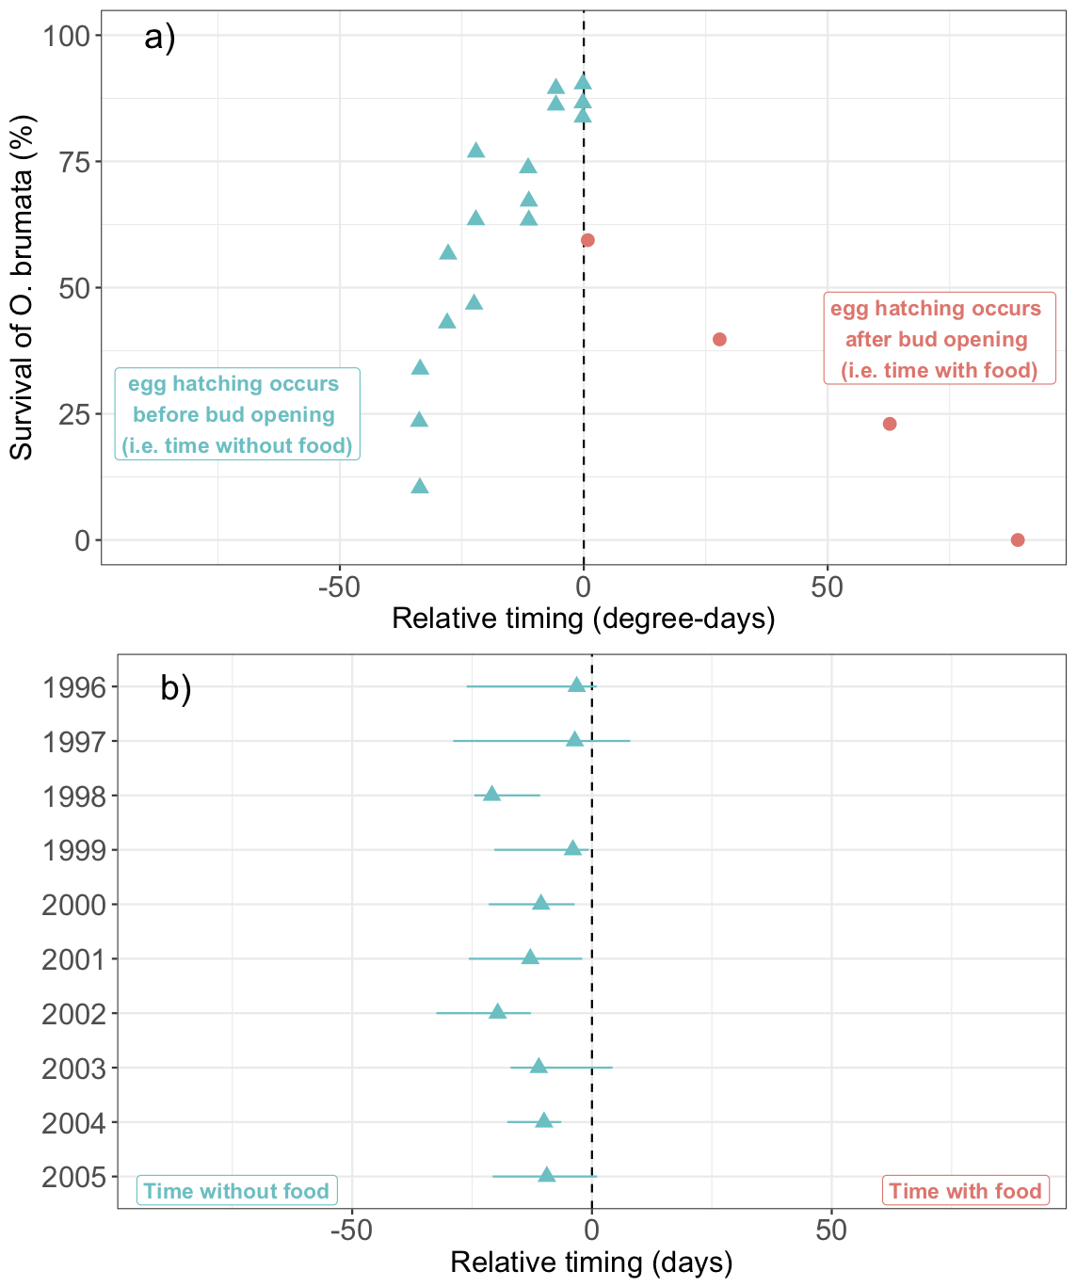

**Figures**

Figure 1. Conceptualization of the Cushing match-mismatch hypothesis. The hypothesis postulates that a consumer should temporally ‘match’ the peak of its most energetically demanding period with the peak of resource availability (b) and thus have the highest possible relative fitness (d); if there is any change to the relative timing of the interaction (e.g., because the consumer shifts its phenology earlier (a) or later (c) relative to the resource), there will be a decrease in the consumer’s fitness (i.e., a mismatch) (d). At the curve’s limits, consumer fitness should fall to zero when the change in relative timing is sufficiently large (d). Curves in panels a-c represent the energetic demand of the consumer (solid line) and the seasonal changes in the availability of the resource (dotted line).

Figure 2. A simplified flow diagram for forecasting climate change effects on consumer fitness as predicted by the Cushing hypothesis. First, both major assumptions must be met; if, for example, consumer density is the major controller of consumer fitness, then the Cushing hypothesis is not supported and alternative hypotheses can be tested. If both assumptions are met, forecasting requires both knowledge of the ultimate mechanisms (which often relate to testing the first assumption) and the pre-climate change baseline. In some cases, the mechanism predicts the pre-climate change baseline (i.e., in both our examples, bottom); we colour mechanisms in whether they predict both pre-climate change synchrony and asynchrony depending on specifics (purple), synchrony (blue) or asynchrony (red). Note that multiple mechanisms may operate in many systems, and that this figure is in no way exhaustive, but rather serves to highlight a pathway that researchers can take.

Figure 3. Key assumptions and resulting implications for climate change predictions, when pre-climate change baselines are not defined. (a) Phenological time-series of an interacting consumer and resource (doy is day of year) during conditions of stationarity; when the environment becomes non-stationary (shown here just after 1980) the consumer and resource each can shift in varying directions, as currently documented3. (b) Most studies using the Cushing hypothesis assume that consumer fitness was highest before climate change and occurred at the resource peak (i.e., a match) leading to a ‘synchrony baseline’. Alternatively, in a population where some individuals are matched with the resource peak but not at maximum fitness, a synchrony baseline may also occur (i.e. ‘adaptive mismatch’ hypothesis (AMH)57 with synchrony baseline’). If the ‘synchrony baseline’ or ‘AMH with synchrony baseline’ are supported, then climate change could cause declines in consumer fitness if both species share similar environmental cues and they shift together (though smaller declines in consumer fitness may be expected under AMH). Note that the AMH curve57 with asynchrony baseline is not shown and that not all possible climate change scenarios are shown. (c) With an asynchrony baseline, climate change could lead to an increase or decrease in consumer fitness depending on how the relative timing of the interaction changes. Dots represent the fitness of a population at a given point in time under different baseline scenarios. Arrow width represents degree of change in fitness.

Figure 1.

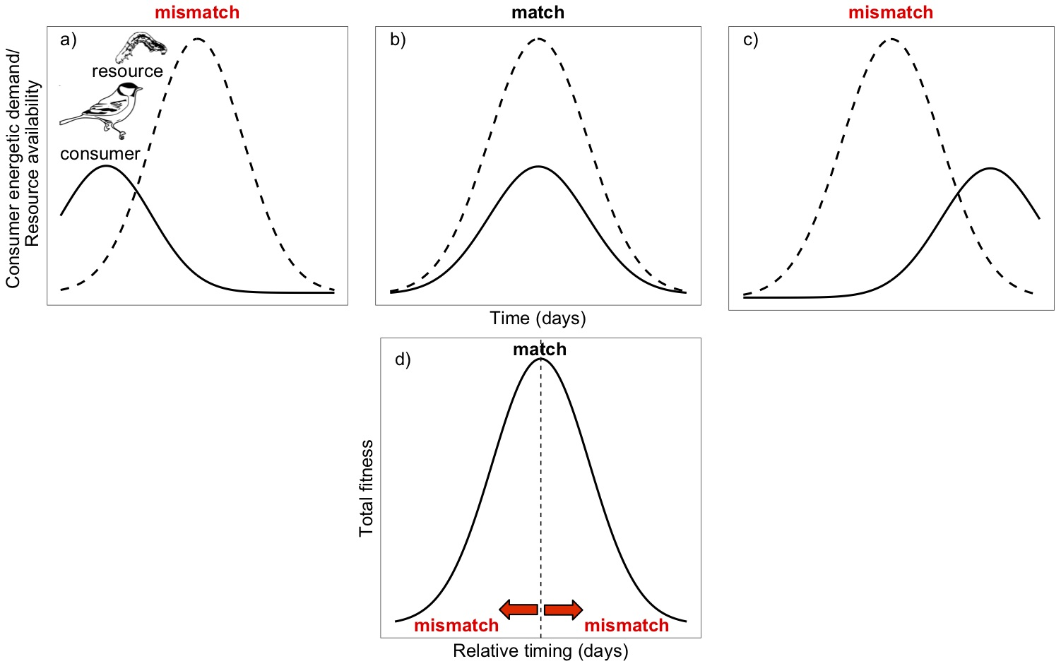

Figure 2.

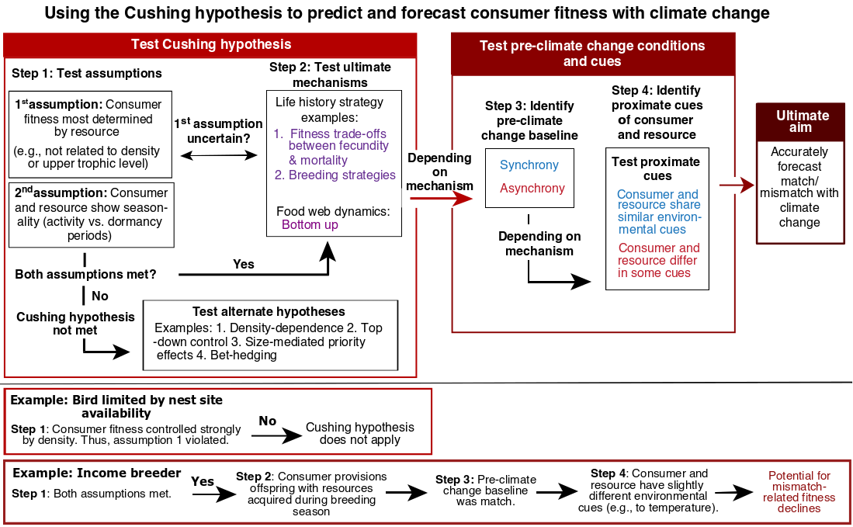

Figure 3.

