Working title: Trophic phenological mismatch: Disconnects between underlying ecological theory and climate change responses

***Abstract***

Empirical testing of appropriate theory is necessary to move beyond documenting impacts of climate change on species to predicting the consequences of those changes on communities.

***Introduction***

Climate change is causing phenological shifts (i.e. timing of life history events) that vary across species in different functional groups and trophic levels (REF). Such species-specific variation in response to climate change has led to changes in the relative timing of key activities (phenological synchrony) among interacting species (REF; Kharouba et al). In some contexts (REF) but not others (REFS), these changes have caused fitness consequences and have influenced ecosystem-level properties. While there have been theoretical (REF) and empirical studies (REF) based in single systems, we still have no ability to predict the outcomes of shifts in synchrony due to climate change.

Here, we argue that part of the difficulty in predicting the consequences of climate change-driven shifts in synchrony is a disconnect between ecological theory and current approaches in the trophic synchrony literature. We argue that there are methodological inconsistencies across studies and conceptual reasons that have made it difficult to test the relevant ecological theory in the context of climate change. We show how advances could come from clear definitions of baselines and direct tests of the underlying theory, when possible. Our aim is not to put forward additional hypotheses about when and by what magnitude changes in the relative timing of an interaction may lead to consequences for the consumer or resource, or what factors might contribute to change in the relative timing of an interaction, but rather to help guide the study of phenological mismatch.

We focus on the widely-cited Cushing match-mismatch or trophic mismatch hypothesis (1974), the most commonly applied hypothesis to consumer-resource interactions in this literature. Although the Cushing hypothesis has been applied to other types of interactions (e.g. mutualism), we limit our discussion to consumer-resource (i.e. antagonistic). We review the current approach in the trophic mismatch literature and then outline the divide between the hypothesis and empirical studies.

***Overview of the main ecological theory***

The most common ecological theory that underlies these studies is the Cushing match-mismatch hypothesis, which predicts a concave down curve between consumer fitness and relative timing between the consumer and its resource (1974; Figure 1). It emerged from the marine fisheries literature as a way to explain the variation in population recruitment of fish stocks but has had broader implications for the ecological literature since then, especially given recent climatic changes. Based on life-history theory, it postulates that there should be selective pressure for the consumer to ‘match’ the timing of the peak of its most energetic phase with that of the timing of its peak resource availability (Figure 1). Given this strong selective pressure, if there is any change to the relative timing of that interaction, there will be a decrease in fitness for the consumer (i.e., a mismatch), thus producing a concave down curve (Figure 1). For example, if a consumer emerges too early in the spring and the resource has not yet emerged, the consumer will risk starvation. At the limits, consumer fitness should fall to zero when there is a large enough change to relative timing (Figure 1). For example, the early-emerging consumer can only survive so many days without food.

Two important requirements must be met in order to apply the Cushing hypothesis. First, the resource is the major controller on the consumer (i.e., strong interaction strength, bottom-up control; Cury et al, 2003) and vice versa for the resource. Second, the consumer and resource must present a certain degree of seasonality (e.g., vegetation only being available for part of the year; Durant et al. 2005) (Durant et al. 2007), limiting the optimal period for growth and reproduction. If neither of these assumptions is met, then fitness consequences due to changes in the relative timing of the interaction will be weak or non-existent.

***Disconnect between theory and empirical studies***

In its original state, the hypothesis has been debated, contested and criticized, particularly in the marine literature (Durant et al. 2007, Leggett and DeBlois 1994*). In part because, although a relatively simple hypothesis, it is inherently difficult to test in the field, an assertion even Cushing himself made. When explicitly tested, there has been unequivocal support for it (ref in Durant et al. 2007: Gotceitas et al. 1996; Nooker et al. 2005). However, when not explicitly tested (i.e., climate change studies), the shape and strength of the relationship between consumer fitness and the relative timing of the interaction varies greatly (e.g., AO001, HMK003, HMK025, HMK054). *Others have suggested that this is because of data limitations and the model’s implication of complex multitrophic dynamics (Kerby chapter, Durant et al. 2007).* We argue that there are additional key ~~methodological and~~ conceptual reasons that make it difficult to determine whether this hypothesis is widely supported in the context of climate change. We first introduce the current objectives of the trophic mismatch literature, and then discuss We now talk about these reasons: X, Y and Z.

To put our points in context, we reviewed the phenological mismatch literature. We examined 41 ~~long-term~~ observational studies that evaluated the effects of a change in relative timing on the fitness or a performance of the consumer (i.e., the trophic mismatch literature; see Appendix for details). These studies largely focused on: i) documenting how climate change is affecting the timing of a trophic interaction; ii) how those changes in synchrony have affected the consumer’s (and less frequently the resource’s) fitness; and iii) advancing the theory necessary to predict long-term demographic changes due to changes in synchrony. The ultimate goal of these studies was to predict the impacts of climate change on ecological communities *(*hereafter called ‘climate change’ studies). These studies have encompassed terrestrial, marine and freshwater ecosystems as well as large latitudinal gradient. There have also been studies that aim to understand the underlying processes related to timing (e.g., coevolution, life history trade offs, food web dynamics) that drive consumer or resource dynamics (hereafter called ‘fundamental studies’), independently of climate change. Combined, these studies have improved our understanding of the importance of the relative timing of an interaction for consumer fitness.

*i) Fundamental theory*

For ‘climate change’ studies, the Cushing hypothesis offers a testable, generally applicable hypothesis for predicting the magnitude and direction of (*long-term*) demographic changes in response to climate-change driven shifts in synchrony (Figure 2). However, progress on the Cushing hypothesis requires a combination of an understanding of how organisms directly respond to the environment with tests of a diversity of ecological and evolutionary theory. To date, much research in the biological impacts of climate change literature focused on direct relationships between organisms and the environment (Cleland et al. 2007 (TREE) and something by Korner?; Pau et al. 2011?). This represents the major challenge of the hypothesis and, possibly, why support for it has been so mixed. We now discuss the mechanisms underlying the Cushing curve and X.

*a) Mechanisms*

Many mechanisms can produce the Cushing curve, and they most likely vary across systems, space and time. For example, mechanisms arising from **life-history theory** could produce the Cushing curve—as consumers maximize their fitness through ideal timing with their primary resource—and this forms the theoretical basis for the original hypothesis. The Cushing curve, however, is also connected to **food web theory**, since it is about the timing of a consumer to its food resource. However, studies deviate in what forces they hypothesize to control the peak in the food resource (a critical component of the Cushing curve, see our FIGX). For example, in aquatic systems—where top-down forces are generally more common compared to terrestrial systems—many studies suggest that the resource peak is controlled by release from, or predation by, a consumer (CITES?). This is a very different hypothesis from others that suggest seasonality in the environment produces the resource peak (CITES). In terrestrial systems, the relative contributions of bottom-up vs. top-down effects on consumer dynamics remains poorly understood (e.g. Boggs and Inouye).

The diversity of ecological theory that could produce the basic shape of the Cushing curve makes trophic mismatch an exciting research area, but it also means that different researchers may collect very different data, depending on what mechanism they suspect underlies the curve in their particular system or what their main objective is. Researchers studying the curve from the lens of life history theory require per capita estimates of fitness, including mechanisms of fecundity and mortality and how they vary across ontogeny, in order to assess fitness consequences at the level of selection (i.e., the individual) and to directly link any fitness changes to timing. To test multiple mechanisms, ideally these metrics would be assessed for both the resource and consumer, but such data are extremely rare in this literature. [*Of the studies we examined, 1/8 life history studies measured fitness/performance of the resource, and none included per-capita data for the resource*]. Part of this may stem from how resource is defined or measured(?) in the ‘life-history studies’ we reviewed. The resource in many of these studies is measured at a population or even community level (7/8 studies) rendering it impossible to get equivalent measures of fitness between the consumer and resource. Making predictions about the overall consequences of climate change driven changes in synchrony on the full interaction will be difficult since our mechanistic understanding ends at the consumer level.

Studies addressing the Cushing curve from the perspective of food web theory often collect more equivalent data on the resource and consumer (5/7 studies), but do not assess per capita fitness consequences for the consumer (0 studies so far). Part of this difference may stem from differing generation times—studies that can easily observe a resource curve shaped by predation often focus on organisms with generation times on the scale of days to week. For example, aquatic studies that focus on phytoplankton as the resource may observe many generations in one summer while a terrestrial study focused on caterpillars would generally observe a comparably smaller number generations (1-2(?), depending on latitude and species for caterpillars). Such deviations across systems, however, may fall away at the level of vertebrate consumers (e.g., fish and birds). Nevertheless, the fundamental difference in the scale of generation times pervades aquatic/terrestrial comparisons (Gruner et al. 2008, Borer et al. 2005). The disparities across systems may also underlie a focus more on mechanisms related to food web theory in aquatic studies (e.g., AO001, HMK049). A further divide across studies may come from the size of the consumer: when consumers are too small or turn over too quickly to track, researchers struggle to collect robust data on individual fitness.

This places the trophic mismatch studies on a continuum: at one end, studies focus generally on food web mechanisms, collect equivalent data on the consumer and resource but no per-capita fitness data and at the other end, studies focus on life history theory from the lens of the consumer, collect individual-level data on the timing and fitness of the consumer, with much less information on the resource. The fundamental problem with these approaches is that researchers test only one piece of the much larger field of mechanisms that could underlie the Cushing curve. If they find their mechanisms explain little of the variation they observe, they often do not have the data to test alternative hypotheses. This is a rising issue in the field (and one that permeates ecology), and researchers have pointed out how a larger perspective on life history, such as including other sources of mortality beyond those related to resource access, can lead to alternative predictions than the synchrony predicted by the Cushing curve (CITES, Singer & Parmesan, Johannsson & Jonzen).

The fundamental outcome of the various mechanisms that can produce the Cushing curve is a current field where it is difficult to partition variation in the collected data to multiple hypotheses, because critical data on the resource or consumer are not collected. Consequently, most studies do not actually provide strong tests of the Cushing hypothesis, making it difficult to refute the hypothesis if no evidence is found. Though it is highly possible that both food web and life history theory together explain many of the consumer-resource systems studied, data limitations make it hard to assess both hypotheses at once. Unless researchers are extremely clear about the mechanistic hypotheses they are testing, progress could be slow.

*iii) Pre-climate change baseline*

The concept of pre-climate change baseline (i.e., defining the range of natural variation) is rarely, if ever, considered by trophic synchrony studies; yet, establishing one in a system has important implications for the Cushing hypothesis in climate change studies. Of the studies we considered, only 20% of the studies began before the early 1980s, the same time as pronounced recent climate change began. This is a similar proportion to the trophic synchrony literature, which does not necessarily consider the ecological consequences of shifts in synchrony (Kharouba et al. 2018). In these cases, it is not known what the pre-climate change baseline *should* be and thus whether there has been a divergence in synchrony due to climate change (Figure 2a). Even those studies with longer time-series that extend into earlier decades than the 1980s do not explicitly define a pre-climate change baseline in synchrony (e.g. AO001, HMK050).

There are two implications of not establishing a pre-climate change baseline. First, these studies are implicitly assuming conditions of stationarity (i.e., constant underlying probability distribution) before climate change occurred (Wolkovich et al. 2014). This is problematic when climate change has led to non-stationarity to different extents in different systems (Wolkovich et al. 2014). Without a defined pre-climate change baseline in the system, it is difficult to determine how much of the observed change in the interaction can be attributed to climate change, some other driver like nutrient enrichments in lakes versus natural variation. Identifying the key driver of change for threatened species is key for the prioritization of conservation management decisions.

Second, these studies are confounding a pre-climate change baseline with the peak of Cushing curve: the hypothesis that fitness was highest before climate change because the consumer’s timing was well matched to the resource’s (Figure 2b; Singer and Parmesan 2010). The resulting prediction is that climate change will necessarily change the relative timing of the interaction (i.e. non-stationarity) leading to a decline in the consumer’s fitness. However, without knowledge of the pre-climate change baseline, it is difficult to predict the direction and magnitude of fitness consequences due to climate change-driven shifts in synchrony (Figure 2c). An alternative hypothesis put forward by Singer and Parmesan (2010) suggests that in some contexts, ‘asynchrony’ (i.e. when the most energetically demanding phase of the consumer is not lined up with the peak resource availability) may be the pre-climate change baseline. They suggest that this can arise due to a pre-existing life history strategy. In systems where asynchrony might be the baseline state, our ability to anticipate the effects of climate change will be even more challenging (Figure 2bc).

Establishing a pre-climate change baseline also has implications for fundamental studies that want to understand the underlying processes of consumer-resource dynamics. Recognizing that these dynamics are occurring in the context of climate change, our current reality is key. None of the studies we categorized as fundamental included time-series that began before the 1980s and none attempted to define a pre-climate change baseline with another approach (e.g., HMK012, HMK046). The pre-climate change baseline determines whether the system should currently be in equilibrium or is only transient. For example, life-history trade-offs often end up in some sort of equilibrium but if climate change has pushed the system off of baseline, then the system might currently be under transient dynamics rather than at equilibrium (Figure 2). This is a similar condition for co-evolution, it predicts an arms-race but that arms-race varies a lot under stationary climate versus non stationary climate (ref). To this end, an understanding of the system’s pre-climate change baseline state is important for providing context and designing studies.

*b) Assumptions of the hypothesis*

It is unclear in which contexts (or systems) we should even expect to find support for the Cushing hypothesis given that we are lacking knowledge of the basic biological details needed to test this relationship. The key assumption of the Cushing hypothesis is that the resource is a major control of consumer dynamics; yet, studies only rarely include evidence that this is the case. The author’s definition of ‘interacting species’ and the degree to which the two species interacted (i.e. interaction strength) varied across studies the studies we examined. Only rarely was enough detail provided to be able to quantify the strength of the interaction

**Conclusions**

*We have wonderful concluding statements to make here! And then make the point that -* Climate change offers a pseudo-experiment for the Cushing hypothesis.

***A path forward (~~new integrative framework??)~~***

In order to move the field of trophic mismatch forward with the ultimate aim of predicting the consequences of shifts in synchrony due to climate change, we discuss and prioritize steps future studies can take. We group our suggestions into three classes in decreasing priority: gold, silver and bronze standards.

1. Gold standard:
   1. Long-term observational study (i.e. one that starts before early 1980s) that (1) shows clear evidence of baseline conditions (aka stationarity); and (2) has independent and equivalent phenological and fitness measurements for both resource and consumer. Where such data have not been collected before the early 1980s, there is no perfect solution to this challenge. However, null modeling may be an alternative. More on this… ?
   2. Integrating observational and experimental studies. Where not all required data is available across a long time-series, conduct experiments to supplement. Figure 3
2. Silver standard: *Comprehensive observational studies or experiments.*

In some systems, it may not be possible to find long-term data. In these cases (and in the gold standard studies), scientists should strive to have:

1. Higher resolution phenological data. In aquatic systems, there is quick turnaround between producers and consumers- temporal sequencing is difficult to determine therefore sampling frequency is important; AND- some zooplankton not in complete dormancy, some remain at low densities.
2. Full extent of resource variation (e.g. Deacy et al. 2017). Clarity on diet breadth would help calculate interaction strength and thus determine whether one of the main assumptions of the Cushing hypothesis is supported. Interaction strength can influence the degree to which the relative timing of an interaction responds to climate change and the magnitude of those consequences for consumer fitness.
3. Bronze standard: *Detailed descriptions of system and being explicit about assumptions related to system and Cushing hypothesis.*

In systems when unable to meet the gold and silver standards outlined above, or in addition to those approaches, studies should strive to:

1. Determine or model (?) whether the pre-climate change baseline in the system is not, or is unlikely to be (if unknown), necessarily the same as the peak of the Cushing curve (i.e., peak fitness) (Figure 2).
2. Address the key assumption that the resource is (or is likely to be) the major control on the consumer.
3. Be specific about how phenological phase relates to the Cushing curve. Ideally, the most energetically expensive part of the consumer’s phenology would be measured (e.g.) but when not known or not specified, be explicit that a phenological phase proxy is used instead of actual key event (e.g. use lay date for chick activity) and include an estimate of the time lag between the proxy and phase of interest.
4. Discuss the relative importance of the measure of fitness used in the life history of the species. For example, if adult body size is measured but most mortality occurs in the juvenile stage.
5. Be explicit when possible about which mechanism(s) is likely driving the curve.

**To Do:**

* Finish survey of observational studies
* What to do with experimental studies?
* Any additional tables or figures?

**Acknowledgements**

We thank Johan Ehrlen, Kjell Bolmgren and Steve Travers for interesting discussions in a previous working group. HMK thanks the professor writing retreats offered through the Centre for Academic Leadership at the University of Ottawa for support in writing this manuscript and *Harvard that supported travel to work with EMW*.

**References**

Gruner et al. 2008, A cross-system synthesis of consumer and nutrient resource control on producer biomass;

Borer et al. 2005, What determines the strength of a trophic cascade?

—--------

—--------

HK random notes (EMW’s have been incorporated!):

* need to track down Wootton 1990. Ecology of teleost fishes (MRT Général*QL 615 .W63 1998)*

* Nilsson 1999: http://www.internationalornithology.org/proceedings/Proc22%20IOC/Symposium/S05/S05.1.htm

* need to track down true tests of MMH- Gotceitas et al. 1996, Nooker et al. 2005

🡪 should read: Carpenter and Kitchell 1987 Am Nat- Temporal scale of variance in limnetic primary production

Cushing: Fixed timing of spawning but variation in timing of peak zooplankton production. Variation in mortality due either to vulnerability of first-feeding larvae to starvation OR because poorly fed larvae grow slowly and are more susceptible to predation (growth-mortaliy). Effects of climatic change on consumer indirect via food source.

Mismatch could result from environmental conditions that constrains migratory bird arrival? (RE001) OR from different phenological sensitivities to cues (HMK052)

Micro-evolutionary process-> life history?

For future meta-analysis: Ideal tests of the Cushing hypothesis would (1) incorporate the entire potential range of relative timing so that the limits of the system are included; (2) define a clear peak in fitness across the range of relative timing; and (3) establish a baseline. Not including baseline does not make study a weak test.

Previous studies have expanded the hypothesis to include food abundance, spatial mismatch and ecosystem level (e.g. Durant et al. 2007).

Full extent of resource variation (e.g. Deacy et al. 2017). Clarity on diet breadth would help calculate interaction strength and thus determine whether one of the main assumptions of the Cushing hypothesis is supported. Interaction strength can influence the degree to which the relative timing of an interaction responds to climate change and the magnitude of those consequences for consumer fitness.

Think about looking at book: Natural Regulation of Animal Numbers by David Lack (1954)

**Table**

|  |  |  |  |  |
| --- | --- | --- | --- | --- |
|  | | **Consumer phenology** | | |
| **Individual** | **Population** | **Community** |
| **Consumer**  **Fitness** | **Individual** | **14** |  |  |
| **Population** | **2** | **11** |  |
| **Community** |  |  | **1** |

|  |  |  |  |  |
| --- | --- | --- | --- | --- |
|  |  | **Resource phenology** | | |
|  |  | **Individual** | **Population** | **Community** |
| **Resource fitness** | **Individual** |  |  |  |
| **Population** |  | **8** |  |
| **Community** |  |  |  |

**Figures**

Figure 1. Simple conceptualization of the Cushing curve; with climate change predictions

Figure 2. Stationarity and change with climate change (a); then assumed max fitness, pre-climate change baseline (b); alternative baselines (c) … note this means (b) does not have the shallow curve fro Singer & Parmesan, but c would, yielding two examples of the major alternatives: (1) you’re on a different spot on the curve that max fitness before climate change and (2) the curve is different.

Figure 3. Case study demonstrating the integration of experimental (a) and observational data (b) relating to the Cushing hypothesis in a single system- the winter moth (*Operophtera brumata*) and oak (*Quercus robur*). (a) Experimental raw data was obtained from Tikkanen and Julkunen-Tiitto (2003) and result from two experiments (green, red points). In the first experiment, the authors manipulated the number of days that neonates (i.e. early instar larvae) spent without food (green points). In the second experiment, they manipulated the emergence times of larvae. There were four cohorts, each separated by intervals of 3-5 days. All *O. brumata* eggs originated from laboratory stock originally from Turku, Finland whereas the foliage originated from trees near Banchory, NW Scotland. (b) Inter-annual variation in relative timing between median egg hatch date of *O. brumata* and the median bud opening date of *Q. robur* from 1996-2005 in the Netherlands. Horizontal error bars represent the lower and upper quartiles of the data. Raw data from the observational study was retrieved from VanAsch and Visser 2007 Figure 2. In this system, negative values along the x-axis denote where egg hatching occurred before bud opening, whereas positive values indicate egg hatching occurred after bud opening.

Notes for HK on figure 3:

(a) great tit and winter moth

* Nilsson and Kallander 2006- compared breeding phenology of great tit between coastal and inland sites where budburst differs by a week
* Visser et al. Oecologia 2006- measured caterpillar and lay dates for 20 years (no experiment)
* Van Noordwijk et al. 1995 – 1948-1972, 1975, 1980, 1982-1986 (UK)
* Visser et al. 1998- observational study 1973-1995
* Bauer et al. 2016- observational study 1961-2007 (Czeck)

(b) winter moth and oak

* Visser and Holleman (2001)- descriptive model
* Buse and Good 1996- temperature manipulation
* Bauer et al. 2016- observational study 1961-2007 (Czeck)
* Tikkanen et al. 2003- (1) effect of starvation: neonate were incubated without food for different periods of time; (2) effect of declining foliage quality: manipulated hatch times (Scotland) cohorts differed by 3-5 days; (3) time after budburst
* Tikkanen and Lyytikainen-Saarenmaa 2002- compared hatching dates between populations, and looked at effect of foliage (Finland and Sweden)
* Tikkanen and Julkunen-Tutto (2003)- neonates reared without food for different periods of time (HMK038)
* Van Dongen 1997
* VanAsch and Visser- data in Figure 2- synchrony- 1996-2005 from netherlands
* Hunter 1990- neonate larva do not tolerate starvation for long periods (2-5 days)
* Check: Crawley MJ, Akhteruzzaman M (1988) Individual variation in the phenology of oak trees and its consequences for herbivorous insects. Funct Ecol 2:409–415
* Check: Salis et a. 2017

Figure 1.

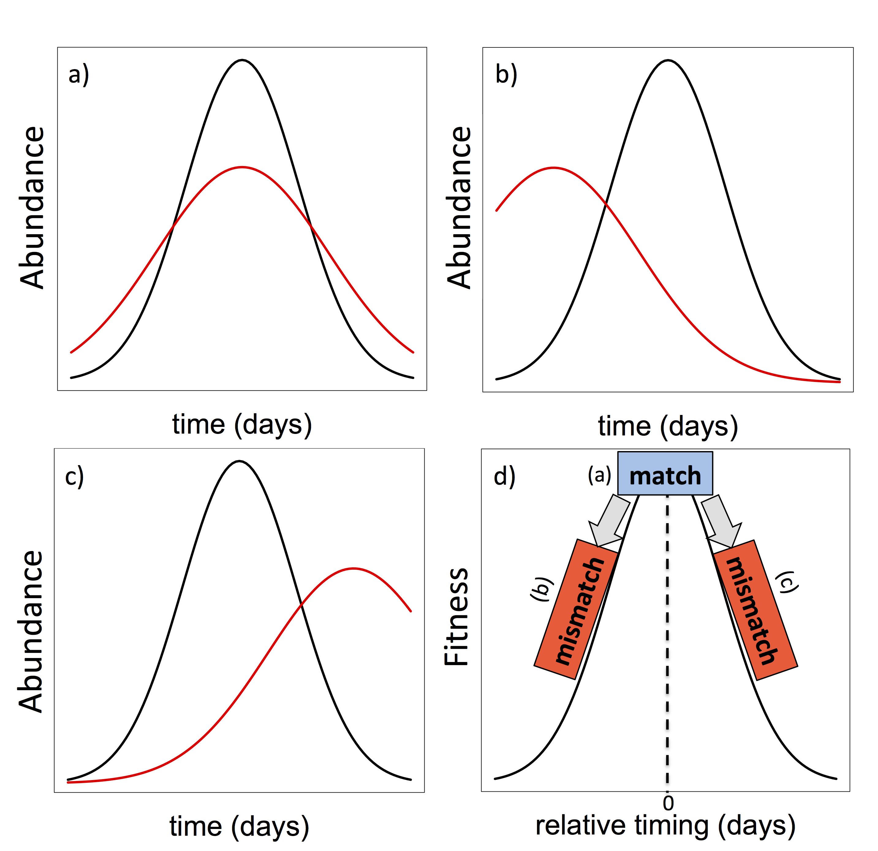

Figure 2.

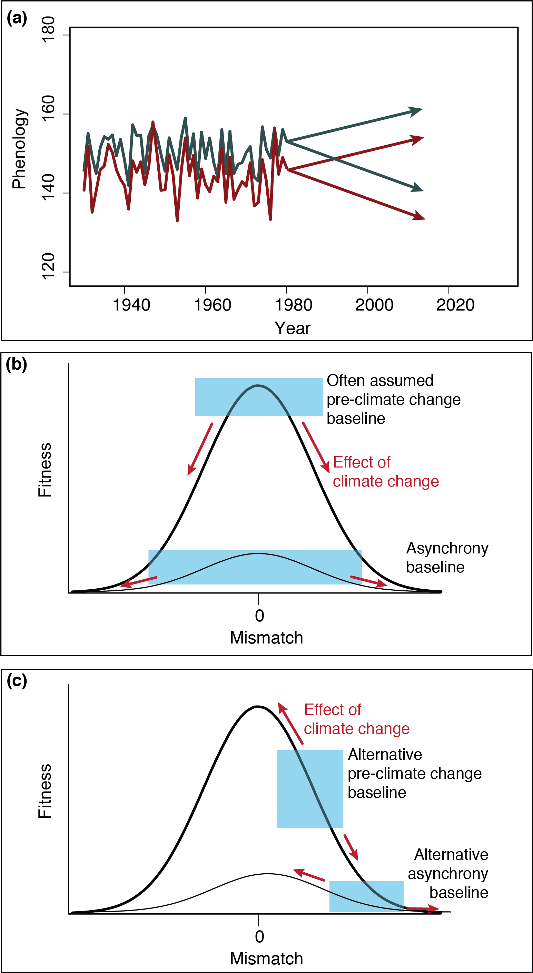

Figure 3.

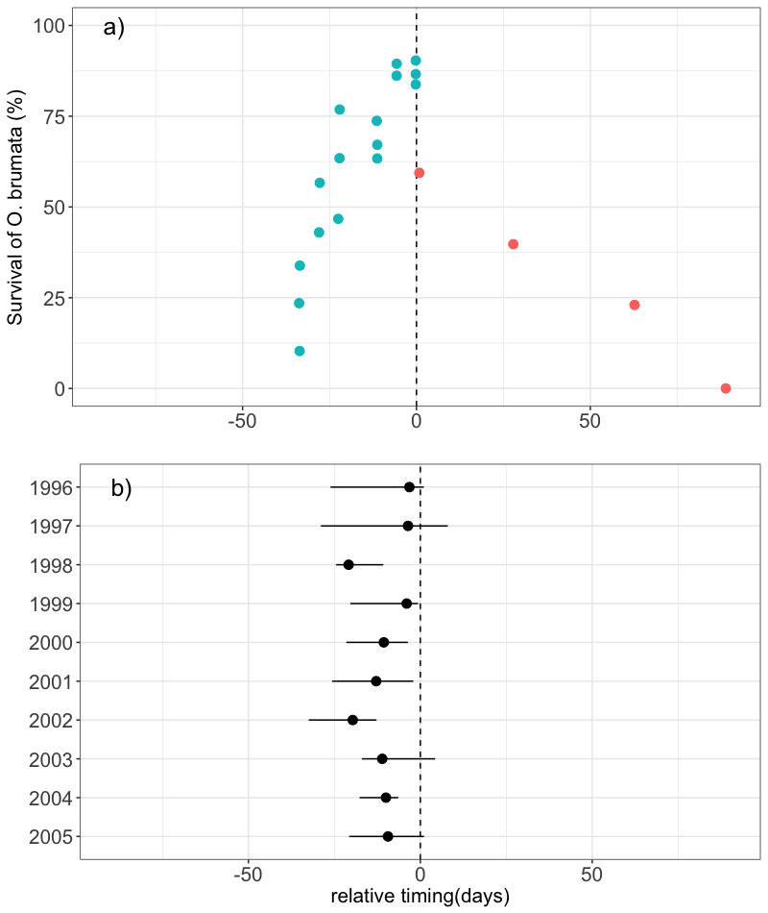

**Appendix**

*Literature search*

We located papers with data relating phenological data from trophic interactions to performance of the consumer and/or the resource by conducting keyword searches in ISI Web of Science published up to June 2017. Keywords included phenolog* AND AND mismatch* OR synchron* AND interact* AND (fitness* OR performance*). We focused on observational studies. Studies were excluded if they did not: (1) measure phenology directly (e.g. used derived measures of phenology, such as NDVI or spring temperature); (2) measure phenology of one of the species; (3) quantitatively link consumer performance to the relative timing between consumer and resource. Additionally, authors had to be explicit that the two species interacted (e.g. specifying type of interaction). To ensure a reasonable sample size and to include studies across different major biomes, we included interactions that were resolved to the family-level and below.

If more than one measure of phenology was included, we chose the one used by the authors to calculate mismatch and examine its impact on performance.

Years of study- those years with consumer and resource AND phenology and performance data (e.g. HMK051)