**Appendix S1:** Supplemental methods description

**Circumpolar analysis of the Adélie penguin reveals the importance of environmental variability in phenological mismatch**

Casey Youngflesh, Stephanie Jenouvrier,Yun Li, Rubao Ji, David G. Ainley, Grant Ballard, Christophe Barbraud, Karine Delord, Katie M. Dugger, Louise M. Emmerson, William R. Fraser, Jefferson T. Hinke, Phil O’B. Lyver, Silvia Olmastroni, Colin J. Southwell, Susan G. Trivelpiece, Wayne Z. Trivelpiece, Heather J. Lynch

*Penguin breeding phenology*

Adélie penguin breeding phenology data used in this study were collected from seven breeding sites around the Antarctic. As these data were collected from several (separate) long-term studies, it was necessary to standardize all data to a similar metric of breeding phenology. The population mean clutch initiation date (CID – the mean day at which the first egg is laid in a nest) was used. Note when referring to year *t,* this represents the austral summer spanning years *t* and *t+1*.

**Admiralty Bay** – CID data were available for individual nests from 1985-2012. Nests were checked daily to determine the date of clutch initiation, using methodologies outlined by Hinke et al. (2012). Mean CIDs were calculated from individual nest data.

**Humble Island** – CID data were available for individual nests from 1991-2010, though years 1997, 1998, 2002, 2004, and 2005 were excluded from our analysis due to concerns with data integrity. These reflect years with heavy sea-ice in the region, which made sampling over the course of that season more intermittent. Nests were checked daily, when possible, to determine the date of clutch initiation. As data may be missing non-randomly from this time series, we take caution in interpreting trends from this site. Mean CIDs were calculated from individual nest data.

**Petermann Island** – CID data were available for individual nests from 2005-2007. Nests were checked daily to determine the date of clutch initiation, using methodologies outline by Lynch et al. (2010). Due to the short duration of this time series, these data were only used to calculate mean CID for Point Géologie (see below).

**Point Géologie** – While data were available since 1952 at Point Géologie, only data since 1979, the year in which satellite-derived sea-ice data are first available, were used.

Date of first CID (the first penguin of the colony to lay) was recorded from 1979-2012. Mean CIDs were extrapolated from first CID using the relationship between the first CID and mean CID for a given first CID. To do so, we used individual nest data from Admiralty Bay, Humble Island, and Petermann Island. Means and standard deviations were calculated at these sites for individual nest CIDs. Nest CIDs that were both greater (i.e. later) than their respective colony-wide means and more than 3.5 standard deviations away from them were excluded here. This was done to prevent the few nests in the right-hand tail of the breeding distribution from impacting the mean and standard deviation of lay dates within a year – breeding distributions within a season were slightly right-skewed. In this way, late outliers would not impact the relationship between first CID and the mean CID. All nest CIDs less (i.e. earlier) than the colony-wide mean were included, as these are relevant in modeling the relationship between mean and first CID.

The mean CIDs and the standard deviations were then used to simulate 100 normally distributed datasets. Minimum and mean values were then calculated for each one of these simulated datasets. In order to determine the relationship between the minimum and mean value for a given minimum value, a linear model was used.

|  |  |  |
| --- | --- | --- |
|  | $$y \sim N(α+βX,σ^{2})$$ | (S1) |

where *y* is the mean value of the simulated data, *X* is the minimum value, and $α$ and $β$ are the intercept and slope, respectively. Coefficient estimates from this model were then used to extrapolate mean CID from minimum CID ($r^{2}=0.90)$. This regression was conducted to account for any effect of mean CID on intra-annual variation in a given year. Any inaccuracies in the relationship to the true mean CID are unlikely to affect our analysis, as all values were standardized within sites and we would expect significant shifts in first lay date to track mean lay date.

**Cape Crozier** – Peak hatch date data were recorded from 1996-2010. Peak hatch date was assumed to be analogous to mean hatch date in this case. Mean CID was determined by subtracting the mean length of Adélie penguin incubation period (39 days; Trathan and Ballard 2013) from the mean hatch date. Any inaccuracies here in the relationship to the true mean CID are unlikely to affect our analysis, as all values were standardized within sites and we would expect significant shifts in mean hatch date to track mean CID.

**Cape Royds** – Peak hatch date data were recorded from 1997-2010. Data was processed in the same way as at Cape Crozier.

**Cape Bird** – Peak hatch date data were recorded from 1996-2010. Data was processed in the same way as at Cape Crozier and Cape Royds.

**Béchervaise Island** – MeanCIDs were calculated from individual nest CID data collected from 1990-2003. Nests were checked daily to determine the date of clutch initiation, using methodologies outlined by Smiley and Emmerson (2016).

*Penguin breeding success*

Data on Adélie penguin breeding success, defined here as the number of chicks to reach the crèche stage (period prior to fledging, characterized by distinctive grouping of penguin chicks) per breeding pair, were collected at each of the study sites. Similar protocols were used to collect all field data.

**Admiralty Bay** – Breeding success data were collected from 1986-2012. See Hinke et al. (2012) for a summary of methods used to collect breeding success data in the field.

**Humble Island** – Breeding success data were collected from 1991-2003. CEMP Standard Methods (CCAMLR 2004) were used to collect data on breeding success, except that the number of chicks raised per pair was monitored across several penguin colonies, as opposed to a single one. A different, random sample of nests was used in each season.

**Point Géologie** – Breeding success data were collected from 1992-2002, and from 2004-2013. See Jenouvrier et al. (2006) for a summary of methods used to collect breeding success data in the field.

**Cape Crozier** – Breeding success data were collected from 1996-2010. See Dugger et al. (2014) for a summary of methods used to collect breeding success data in the field.

**Cape Royds** – Breeding success data were collected from 1996-2010. See Dugger et al. (2014) for a summary of methods used to collect breeding success data in the field.

**Cape Bird** – Breeding success data were collected from 1996-2010. See Dugger et al. (2014) for a summary of methods used to collect breeding success data in the field.

**Béchervaise Island** –Breeding success data were collected from1990 – 2003. CEMP Standard Methods (CCAMLR 2004) were used to collect data on breeding success.

*Phenology of the environment*

Metrics for both phytoplankton-bloom onset (sea-ice adjusted light availability) were calculated for 25 km x 25 km pixels surrounding each site. Values were calculated for each pixel within the specified radius (Fig. S1). The mean value of pixels within that specified area was then taken as the value at that site in that year.

Sea-ice adjusted light availability was calculated according to the methodology outlined in Li et al. (2016). A 10-hour day-length threshold was used as this more accurately represents bloom timing at Admiralty Bay than the 8-hour threshold used in Li et al. (2016), while also capturing bloom timing at other locations used in this study (Li et al. 2016). Bias between sea-ice adjusted light availability (bloom proxy) and actual bloom date among sites can be ignored as bloom timing was normalized across years and within sites.

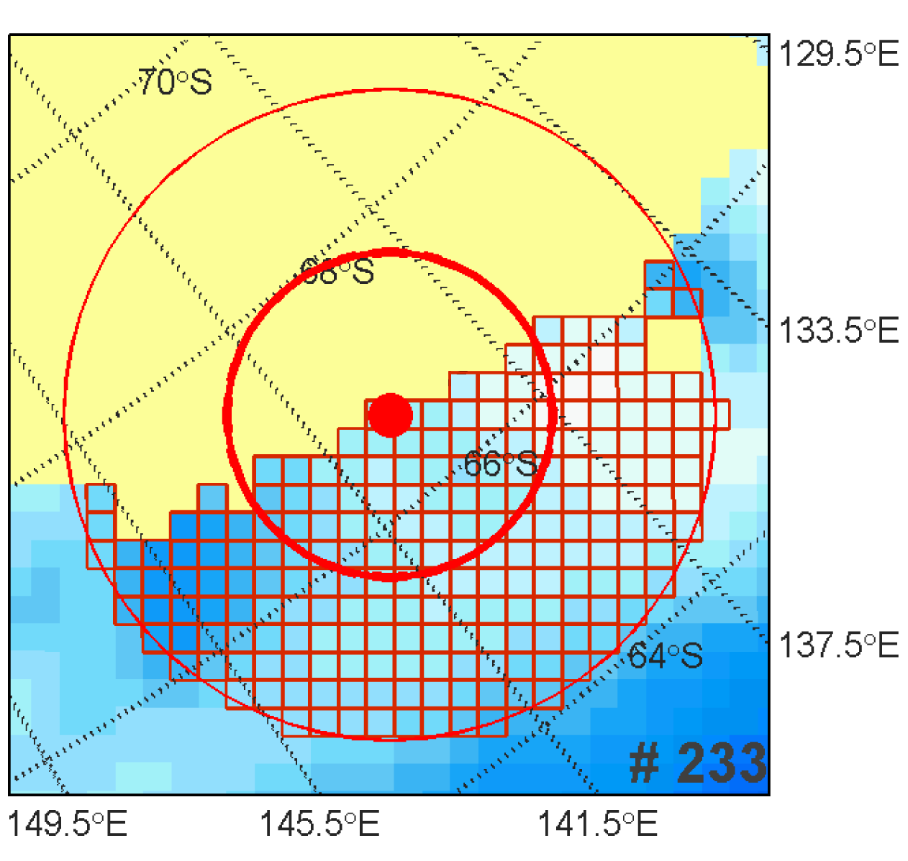

Figure S1: 25 km x 25 km pixels surrounding Point Géologie, with 150 km and 300 km radius boundaries depicted. These demarcations were made to calculate phytoplankton-bloom phenology metrics at each site used in this study.

*Model for statistical analysis of trends in phenology and Mismatch Index*

$$y_{i}\sim N(μ_{ij},{σ_{j}}^{2})$$

$$μ_{ij} = α_{j}+β_{j}*{Year}_{i}$$

$$α_{j}\sim N(μ_{α},{σ_{α}}^{2})$$

|  |  |  |
| --- | --- | --- |
|  | $$β_{j}\sim N(μ_{β},{σ_{β}}^{2})$$ | (S2) |

$$1/{σ_{j}}^{2}\sim Gamma(0.01,0.01)$$

$$μ_{α}\sim N(0,0.001)$$

$$μ_{β}\sim N(0,0.001)$$

$$1/{σ_{α}}^{2}\sim Gamma(0.01,0.01)$$

$$1/{σ_{β}}^{2}\sim Gamma(0.01,0.01)$$

where the response variable ($y$) is modeled as normally distributed with a mean $μ_{ij}$ that is a linear function of year ($i$) with location ($j$)-specific slope and intercept. The coefficients of the linear model for $μ_{ij}$ ( $α_{j}$ and $β_{j})$ are modeled as normally distributed with mean $μ_{α}$ and $μ_{β}$, and precision $1/{σ_{α}}^{2}$ and $1/{σ_{β}}^{2}$, respectively. Hyper-parameters were given uninformative normal priors, while coefficient precisions were given uninformative gamma priors. Note the second parameter specified for the normal distributions is the precision, or inverse variance, rather than variance as per formatting in JAGS (Plummer 2003).

*Model for quantile regression*

$$y=μ+ε$$

$$μ=α+β_{1}*X+β_{2}{*X}^{2}$$

$$ε \sim ALD(location=0, scale=σ, quantile=τ)$$

|  |  |  |
| --- | --- | --- |
|  | $$α\sim N\left(0,0.01\right)$$ | (S3) |

$$β_{1}\sim N\left(0,0.01\right)$$

$$β_{2}\sim N\left(0,0.01\right)$$

$$σ \sim invGamma(0.01,0.01)$$

where *y* is the response variable (breeding success), modeled as a quadratic. The errors are distributed according to an asymmetric Laplace distribution. The quadratic model parameters ($α, β_{1},β_{2}$) were each given uninformative normal priors, while the scale parameter for the asymmetric Laplace distribution ($σ$) was given an uninformative inverse gamma prior.

**LITERATURE CITED**

CCAMLR (Commission for the Conservation of Antarctic Marine Living Resources). 2004. CCAMLR Ecosystem Monitoring Program (CEMP) standard methods. CCAMLR, Hobart, Australia.

Dugger, K. M., G. Ballard, D. G. Ainley, P. O. Lyver, and C. Schine. 2014. Adélie penguins coping with environmental change: results from a natural experiment at the edge of their breeding range. Frontiers in Ecology and Evolution 2:68.

Hinke, J., M. Polito, C. Reiss, S. Trivelpiece, and W. Trivelpiece. 2012. Flexible reproductive timing can buffer reproductive success of *Pygoscelis* spp. penguins in the Antarctic Peninsula region. Marine Ecology Progress Series 454:91–104.

Jenouvrier, S., C. Barbraud, and H. Weimerskirch. 2006. Sea ice affects the population dynamics of Adélie penguins in Terre Adélie. Polar Biology 29:413–423.

Li, Y., R. Ji, S. Jenouvrier, M. Jin, and J. Stroeve. 2016. Synchronicity between ice retreat and phytoplankton bloom in circum-Antarctic polynyas: synchronicity of ice retreat and bloom. Geophysical Research Letters 43:2086–2093.

Lynch, H. J., W. F. Fagan, and R. Naveen. 2010. Population trends and reproductive success at a frequently visited penguin colony on the western Antarctic Peninsula. Polar Biology 33:493–503.

Plummer, M. 2003. JAGS: A program for analysis of Bayesian graphical models using Gibbs sampling.

Smiley, K., and L. Emmerson. 2016. A matter of timing: Adélie penguin reproductive success in a seasonally varying environment. Marine Ecology Progress Series 542:235–249.

Trathan, P. N., and G. Ballard. 2013. Adélie penguin (*Pygoscelis adeliae*). Pages 37-57 *in* P. G. Borboroglu and P. D. Boersma, editors. Penguins Natural History and Conservation. University of Washington Press, Seattle, Washington, USA.