**Empirical Analysis of Common Sorting Algorithms**

**Data structures and Algorithms (CSCI2226)**

**Kevin Harper (00816532)**

**Electrical and Computer Engineering Department**

**University of New Haven Tagliatela College of Engineering**

**September 18, 2024**

**Abstract**

Words go here.

**Introduction**

This project entails the C++ implementation and empirical time complexity analysis of six array sorting algorithms: bubble sort, selection sort, insertion sort, merge sort, quick sort, and shell sort. The input data to facilitate analysis of the time efficiencies are standard (C-style) arrays which vary in size from 50,000 to 550,000. The array members include non-duplicate random integers in the range [1, 4,000,000]. Dataset generation is performed by selecting the appropriate number of integers from this set according to a uniform distribution of integers in this range and thereafter stored in a dedicated file for recurring execution. Each sorting algorithm uses identical datasets for sorting for a comparison of run-times between sorting algorithms on the very same data and in the same order. The run-time duration of each algorithm is sampled five times per dataset size and averaged accordingly for further analysis. A program is developed which interacts with the user via a console interface, allowing options for dataset generation, sorting algorithm selection, dataset size selection, dataset type (unsorted, sorted in increasing order, sorted in decreasing order), displaying the configuration, and performing numerous consecutive sorts without requiring any additional user input. Upon performing any sort, if no file exists for the sorted datasets, the user will be prompted to store the sorted data in increasing order, decreasing order, or both for later analysis, offering true best-case and worst-case time complexity analysis of the algorithms. Topologically, the program employs the use of a superloop with an embedded switch case for option selection. The user may quit the program at any time from the main menu by configuring a “quit” character or by using the default option (‘x’). The user may also cancel their selection returning to the main menu from any other submenu using this same character.

**Theory**

* Working explanation of each algorithm: what are theoretical best and worst cases? How do the algorithms work? Include algorithm pseudocode
* Add history of algorithm.
* Add summary table of time and space complexities and use cases.
* Add summary table of chosen implementation.
* Mention a hybrid approach by mixing algorithm types.
* Talk about algorithms not considered (heap sort, counting sort, radix sort, bucket sort)
* Divide and conquer algorithms have higher spatial complexities
* Clean up code and add comments

Bubble sort

Bubble sort is a simple and easily understandable array sorting algorithm which uses a pair of nested loops. The two loops work together to compare values at adjacent indices in a pairwise fashion. The outer loop selects a value at a smaller index, and the inner loop swaps the elements so long as the element in the smaller index is larger in value than the element at the larger index. After each iteration, the largest encountered value will shift indices until the end of the array, and a pointer indicating the end of the array is decremented to reflect the increase in size of the sorted portion of the array. In each iteration, comparison takes place up until the last unsorted element. Pseudocode describing the bubble sort algorithm is shown below in figure 1.

**Figure 1.** Pseudocode representation of the bubble sort algorithm.

As indicated in figure 1 above, the common operation in bubble sort is comparison. Since the algorithm employs nested loops requiring n(n-1)/2 comparisons, its theoretical time complexity is O(n2). *mention optimized bubble sort*

Selection sort

The selection sort algorithm, like the bubble sort algorithm, also uses nested loops to sort an array. In the chosen implementation, the outermost loop initially considers the first array index to be the index containing the minimum value in the array. The inner loop then iterates through every other array index, comparing values to the initial minimum and updating the pointer to a new minimum value as necessary. When the inner loop terminates, given that the pointer to the minimum value has changed, the value at the minimum pointer location in the array is swapped with the first position in the unsorted portion of the array. As the outer loop iterates, the sorted portion of the array grows from index 0 onwards, and the inner loop iterates for fewer array indices as the beginning portion of the array is sorted.

**Figure 2.** Pseudocode representation of the selection sort algorithm.

Figure 2 shows that the most frequent operation performed in the selection sort algorithm is comparison. While swapping of values has the potential to occur frequently, comparisons are guaranteed to occur most often. As was the case for bubble sort, the number of comparisons made is n(n-1)/2. Therefore, the performance of selection sort is O(n2) as indicated by the 2 nested loops.

Insertion sort

Insertion sort uses nested loops in a similar manner to the bubble sort and selection sort algorithms. In the outer loop, each element i (for which i > 0) of the array is used as a key which is to eventually be inserted at the correct position of the array. For the remaining elements, the inner loop iterates backwards through the sorted portion of the array (indices [0:i]) making comparisons with the key value until the correct insertion position is found, simultaneously making space for the key value to be inserted by pushing sorted values to the right. When the insertion position is found via iterative comparison, the inner loop terminates, and the loop variable has been decremented to the index which the key value should be placed. Finally, the key value is placed at the correct position in the array.

**Figure 3.** Pseudocode representation for the insertion sort algorithm.

Figure 3 shows that the most frequent operation performed in the insertion sort implementation is comparison. For arrays that are nearly sorted, observe that the inner loop will terminate faster, significantly increasing the time efficiency. Again, the performance of insertion sort is O(n2) as indicated by the 2 nested loops.

Merge sort

The merge sort algorithm uses the divide and conquer approach to recursively sort an array. The base case checks if the array length is 1 or less. Otherwise, the array is recursively divided into two halves until the base case is reached. Each of the sub halves are individually sorted and merged, taking care to join them while retaining order.

**Figure 4.** Pseudocode representation for the merge sort algorithm.

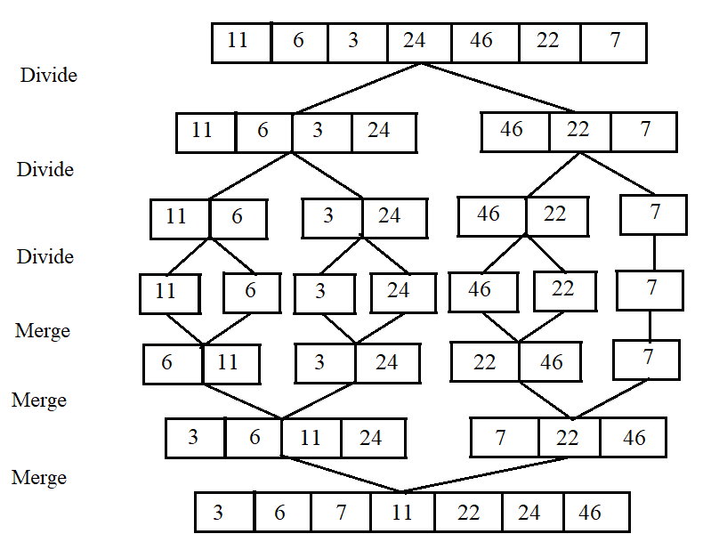

**Figure X.** https://www.educba.com/merge-sort-algorithm/

Include pseudocode for merge() sub algorithm. The actual merging of trivially sorted (length 1) arrays is where the sorting takes place. Elements in each half are placed in the correct position.

Quick sort

The quick sort algorithm, like merge sort, is based on a divide and conquer approach. The algorithm partitions an array into numerous subarrays according to a chosen scheme. Include pseudocode for partition sub algorithm as well as medianOfThree

Shell sort

The shell sort algorithm is a generalized form of the insertion sort algorithm which first sorts elements that are far apart. As the algorithm executes, the sorting interval decreases in size until a standard insertion sort is performed in the final iteration (interval size of 1). However, at this point, the array is partially sorted, which increases the efficiency of the insertion sort.

**Figure 6.** Pseudocode representation for the shell sort algorithm.

In figure 6 above, the pseudocode representation of the shell sort algorithm indicates that the outer loop progressively decreases the interval size, initially targeting array elements in the inner loop that are farther apart and gradually approaching a standard insertion sort. The chosen implementation uses Shell’s original sequence, which halves the interval size for each iteration.

**Results**

**Discussion & Analysis**

Analyze information in results section and explain why some algorithms perform better than others. Talk about results for best case and worst case.

**Conclusion**

**Citations**

[1] <https://www.programiz.com/dsa/bubble-sort>

[2] <https://www.programiz.com/dsa/selection-sort>

[3] <https://www.programiz.com/dsa/insertion-sort>

[4] <https://www.programiz.com/dsa/merge-sort>

[5] <https://www.programiz.com/dsa/quick-sort>

[6] <https://www.programiz.com/dsa/shell-sort>