**KHAMIS SAID MOHD (BITAM/9/21/004/TZ)**

GitHub Repository: <https://github.com/khasamoh/Question2.git>

**Question 2:**

qn2.html

<!DOCTYPE html>

<html lang="en">

<head>

    <meta charset="UTF-8">

    <meta http-equiv="X-UA-Compatible" content="IE=edge">

    <meta name="viewport" content="width=device-width, initial-scale=1.0">

    <title>Question 2</title>

</head>

<script>

    var data = ["syllabus.html", "p1.html", "p2.html", "style.html", "email.html", "system.html", "process.html"];

    document.addEventListener('DOMContentLoaded',()=>{

        document.querySelector('#Genarate').onclick = ()=>{

            let start = parseInt(document.querySelector('#start').value);

            let end = parseInt(document.querySelector('#end').value);

            let table = document.querySelector('#linkT');

            let msg = document.querySelector('#msg');

            if (start > end || start < 1 || end > data.length) {

                msg.textContent = "Invalid range, valid range: 1-" + data.length;

                table.innerHTML = "";

                return;

            }

            msg.textContent = "Valid Range: 1-" + data.length;

            let tableContent = "";

            for (let i = start - 1; i < end; i++) {

                tableContent += "<tr><td><a href='" + data[i] + "'>" + data[i] + "</a></td></tr>";

            }

            table.innerHTML = tableContent;

        };

    });

  </script>

<body>

    <div class="container">

        <h2>Link Generator</h2>

        <form action="">

            <label for="">Start range</label>

            <input type="number" name="" id="start" value="1">

            <label for="">Start range</label>

            <input type="number" name="" id="end" value="1"><br>

             <br>

            <button type="button" id="Genarate">Generate</button>

        </form>

        <p id="msg">Valid Range: 1-</p>

    <table id="linkT">

    </table>

    </div>

</body>

</html>

1.

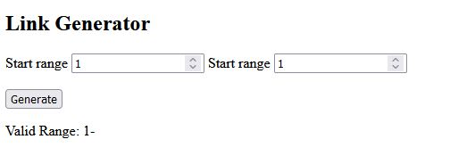

2.

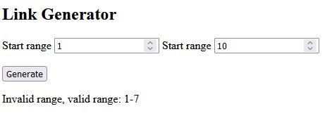

3.

