Ken Hasenbank & Artur Schmidt

# Lab 2

In the previous lab we discussed what system we will build for our next and last lab. The requirements were, that the all groups have work together, so the system should be complex enough that every group have something to do. On the other side, the system has to be realized in one day. The system has to be a distributed system, so multiple Microcontroller have to communicate via CAN with each other.

Our idea is to develop a small game. The rules are quite simple: One node, the master will light up a RGB-LED in one color and the players have to press as fast as possible the button in the same color on their controller. The LED of the master can be red, blue or green and each player has three buttons in the same color as the LED (red, blue,green). A Pointer will point on the slowest player and will reveal him as the loser of this round.

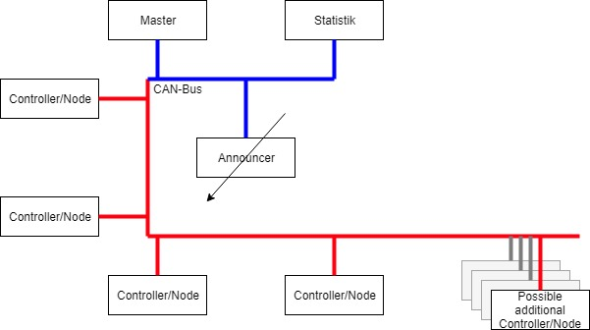

Figure 1: System overview

Figure 1 shows an overview of the System. It consists of four different components.

* **Master:** The Master is the node, which light up the LED in a random color. He transmits the Color via CAN, so every other Node knows which button color has to be pressed.
* **Statistik:** This Node collects the results from the player/controller and evaluate them. The result will be the slowest player and this result will be send to the announcer Node.
* **Announcer:** The Announcer is a little engine that points to the slowest player.
* **Controller:** Controller are the player. The Controller has three buttons (see Figure 2) and measure the time between the start signal from the master and when the correct button is pressed. The amount of controller is arbitrary.

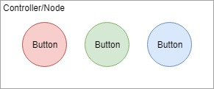

Figure 2: Controller Node