CS 362 Software Engineering 2
Instructor: Dr. Ali Aburas
Student: Khuong Luu

1. Random Tester

1.1. The development of my random testers and how I improve coverage

I don’t jump in to write test at first. Instead, I run the test and generate the report and look at the initial coverage to determine what need to be done. For each method that need to be covered, I look at what has been already covered and what not, then I address the lines and branches that has not been covered.

I improve the random testers to get the line coverage before I improve them (the random testers) to get the branch coverage.

When I look at the part where my random testers did not cover in the report, rather than blindly go fix the test, I try to determine the reason why it couldn’t by going over the test code and run the code out in my head. There were sometime I had to get the test code print out data to “debug” the test code.

It’s also helpful to look at how I test those methods in assignment 2, which is in a non-random way, to recall how this method is call and used. Then, instead of inputing hard-coded values as argument, I find a way to put randomly generated value to it.

1.2. Final coverage for each method

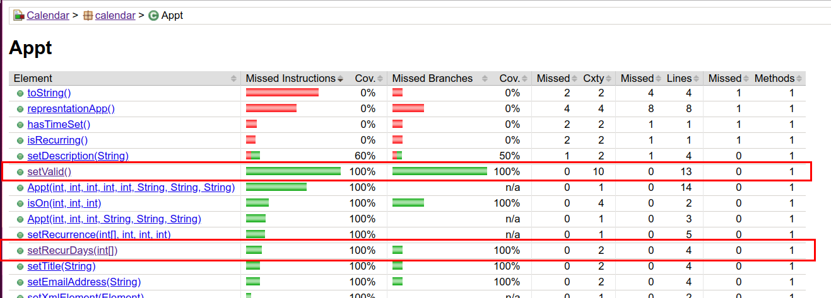

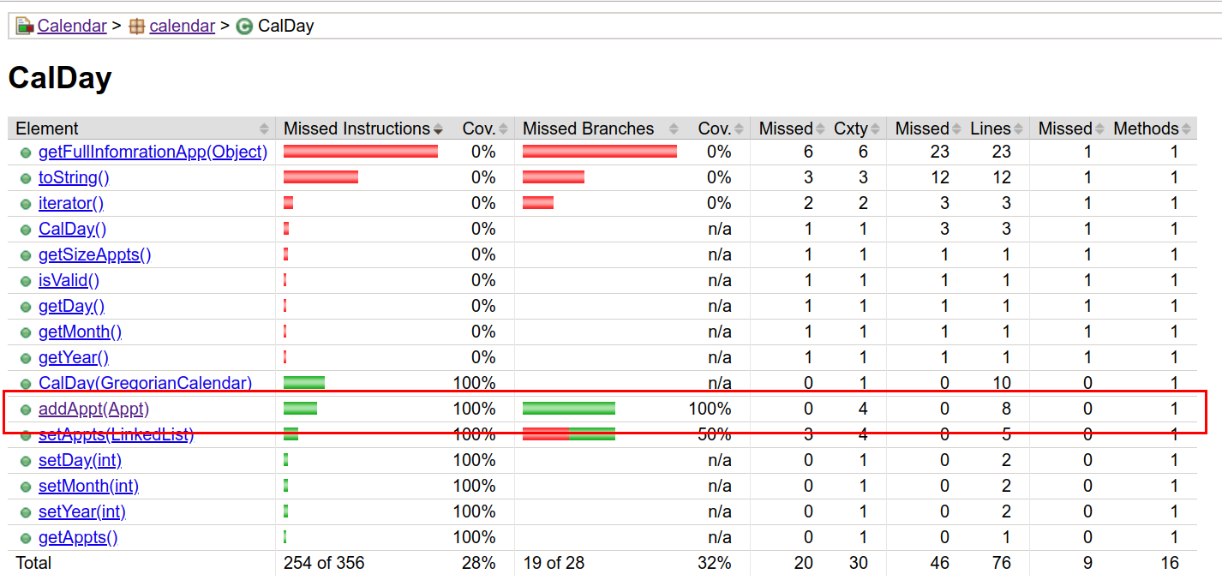

Cannot test this
DocumentBuilder db = null;
try {
db = dbf.newDocumentBuilder();
}
catch (ParserConfigurationException pce) {
throw new IOException("Invalid parser configuration." + separator +
pce.getMessage());
}

Reflection
Random test is a short and easy way to reach coverage

Sometime such as in DataHandler.getApptRange method, the value of random argument has some dependencies with each other and so the test get a bit more complicated. There are 2 ways in this case: More random value to reach the valid range in which date1 is before date2. The other way is to make a custom random method to help generate the values that comply the dependencies we want.

Potential bug
/**
* Constructor
* Creates a new CalDay which is ready for appointments to be
* added to it. Note that months are numbered 0 through 11. This does
* not check to see if a date is valid.
*/
public CalDay(GregorianCalendar cal) {

int day = cal.get(cal.DAY_OF_MONTH);
int month = cal.get(cal.MONTH);
int year = cal.get(cal.YEAR);

setDay(day);
setMonth(month+1);
setYear(year);

setAppts(new LinkedList<Appt>());

valid = true;
}

/**
* Adds an appointment to the calendar day object. The appointments are
* kept in order by start time. Note that this does not check to see if
* the appointment actually occurs on this day. This is so the recurring
* appointments can be added. The appointment can also be added twice.
*/
public void addAppt(Appt appt) {
if (appt.getValid()) {
for (int i = 0; i < getAppts().size(); i++) {
//Put the appointment in the correct order - finish this
if (((Appt)getAppts().get(i)).getStartHour() >
appt.getStartHour()) {

getAppts().add(i, appt);
return;
}
}
//The appointment hasn't been added yet, so add it
getAppts().add(appt);
}
}

What if appt is null ?

/**
* Deletes the appointment's information from the XML data tree. Does not
* write a new XML file to disk.
* @return True if the appointment is deleted successfully.
**/
public boolean deleteAppt(Appt appt) {
//Do not do anything to invalid appointments
if (!appt.getValid()) {
return false;
}

//Remove the appointment from the XML tree if applicable
Element apptElement = appt.getXmlElement();
if (apptElement == null) {
return false;
}
Node parentNode = apptElement.getParentNode();
parentNode.removeChild(apptElement);
appt.setXmlElement(null);

if (isAutoSave()) {
return save();
}
else {
return true;
}
}

2. Unit vs. Random

2.1. Between your random tests and your unit tests, how the tests differ in ability to detect faults

2.2. My test coverage from assignment 2:

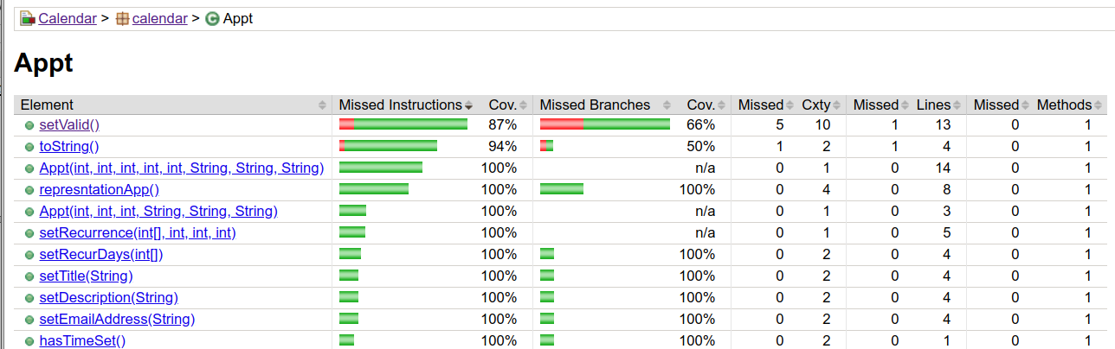
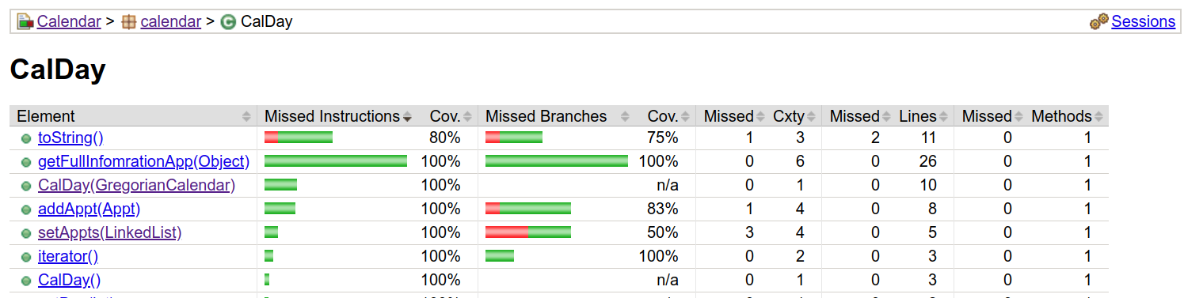
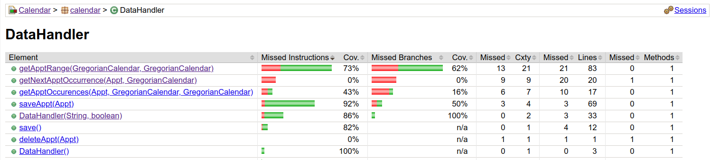

2.3. Which tests had higher coverage – unit or random?

2.4. Which tests had better fault detection capability?

