 Bonyan_logo_small

بنیان سیستم‌های هوشمند

مهر 1403

**MCI B2B CRM and Charging Platform**

**concerns/cases solutions**

**مرداد 1392**

Contents

[Introduction 3](#_Toc180249270)

[1 B2B concerns/technical queries 3](#_Toc180249271)

[1.1 Question 1 3](#_Toc180249272)

[1.2 Question 2 3](#_Toc180249274)

[1.3 Question 3 5](#_Toc180249276)

[1.4 Question 4 6](#_Toc180249278)

[1.5 Question 5 7](#_Toc180249280)

[2 MCI Billing Related cases 8](#_Toc180249282)

[2.1 Case 1 8](#_Toc180249283)

[2.2 Case 2 9](#_Toc180249284)

# Introduction

In the telecommunications industry, managing B2B subscribers requires robust CRM and billing solutions. This document focuses on implementing the B2B user structure within Oracle Siebel CRM and Oracle BRM, addressing key questions, concerns, and test cases related to their integration. By exploring these aspects, we aim to ensure seamless customer management and billing for B2B clients.

# B2B concerns/technical queries

In this section, we address the key concerns and technical queries related to B2B operations. MCI's IT team thoroughly discussed these topics. Our aim is to provide clear insights and resolutions for each issue raised.

## Question 1

Please mention the maximum number of members your system supports for a B2B account and its sub-groups when the members have a payment relationship with the account (Both full and partial payment relationships).

Kind of Payment Relation in MCI:

* **Full payment** (all usages will deduct from corporate account)
  + No limited
* **Partial Payment** (some part of usages will deduct from corporate account based on the type of payment relation)
  + APN
  + VPN
  + Pay Limit

Answer 1

Oracle BRM does not impose any restriction on the number of child accounts in a parent-child hierarchical setup. It provides the configuration option to grant quota at the corporate account level, allowing selective members to consume this quota based on specific usage types. Additionally, Oracle Siebel CRM is highly scalable, capable of supporting millions of users and handling complex client needs, depending on the underlying infrastructure and configuration.

## Question 2

In MCI there is a renewal mechanism for the packages. Please explain how your system supports the Renewal/Reserved mechanism for shared bundle packages, especially for large-scale corporates by preventing revenue loss and overdraft problems. Type of Group Offering in MCI :

* Individual (One\_Month\_2GB )
* Group Member ( Dedicated Bundle )
* Group (Shared Bundle )

Answer 2

PDC Offerings can be configured as cyclic or one-time offers. Cyclic offers can have any defined frequency, such as daily, weekly, or monthly. On the renewal date, the offer will be recycled, and the grant for the new cycle can either be independent of the previous grant or merge with it. After renewal, the grant will be consumed based on the group characteristics, allowing all or selective members to access the resources.

For large corporate clients in telecommunications, managing the renewal of shared bundles is critical for revenue assurance. Oracle Siebel CRM and Oracle BRM ensure automatic renewal and resource management for different types of bundle offerings like Individual (One\_Month\_2GB), Group Member (Dedicated Bundle), and Group (Shared Bundle).

In Oracle PDC, product and service offerings are defined for each bundle type, including renewal terms, pricing, and optional penalties for early contract termination. Automatic renewal rules are set in BRM, triggered either by time (e.g., end of the validity period) or consumption thresholds. For shared bundles, the renewal process ensures continuity and prevents overdraft by renewing resources automatically and notifying customers of bundle status via Siebel CRM.

BRM’s real-time monitoring prevents overdraft situations by setting thresholds that trigger alerts and automatic renewals, ensuring corporate clients avoid revenue loss. The reserved mechanism in shared bundles ensures specific resources are allocated to high-priority users, preventing overdraft or overuse by other members. BRM monitors usage, triggers reserved bundles when the primary bundle is consumed or expires, and sends real-time notifications through Siebel CRM.

By combining these tools, MCI can effectively manage the renewal and reserved mechanisms for shared bundles, preventing revenue loss while maintaining resource availability and service continuity for corporate clients.

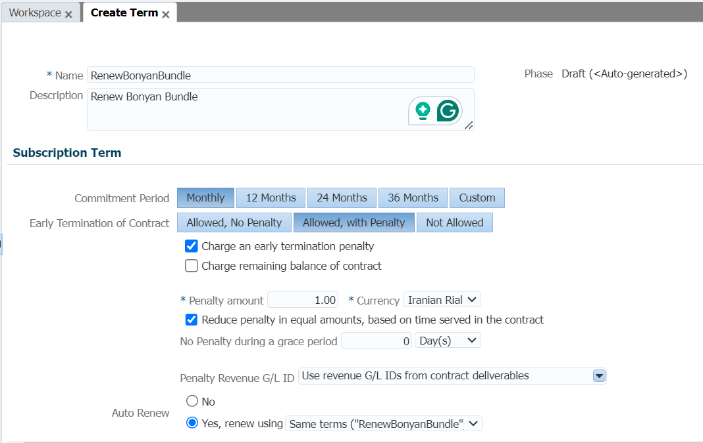

## Question 3

 Please explain your system's ability in batch creation of resource relationships. (Running batch method, Sizing in each batch, work order and reverse work order management with CRM side and …)

Answer 3

Oracle BRM does not impose any restriction on the number of child accounts in a parent-child hierarchical setup. Oracle's solution allows configuration to grant quotas at the corporate account level, with selective members in the corporate group consuming the granted quota. Specific usages can also be configured to consume quotas, ensuring flexibility in resource allocation.

PDC Offerings can be set as cyclic or one-time offers, with customizable renewal cycles—daily, weekly, or any defined frequency. Upon renewal, grants for the new cycle may either merge with previous grants or remain independent. Group characteristics control how grants are consumed, whether by all members or select members.

MCI can manage bulk quotes and orders for products and services using Siebel Bulk Ordering features. Bulk requests allow for flexible management of orders, including adding, removing, and updating products and services over time. Bulk requests can be created manually, via XML import, or through list associations within Siebel CRM. Each action set in a bulk request generates a quote or order, streamlining the management of complex orders.

PDC supports group-wise tariff definition, and short numbers can be configured in OC3C with corresponding tariffs in PDC. VPN group attributes, set at either the service or account level, allow OCS to apply inter/intra group tariffs dynamically based on the VPN package type.

Batch rating, primarily used for telephony services, processes large volumes of events like call detail records (CDRs) using Pipeline Manager. Pipeline Manager handles event rating by reading CDR files, applying rates (e.g., cents per minute), and calculating charges. The Rated Event (RE) Loader then updates account balances in BRM with these charges. Pipeline Manager is integral to handling batch ratings but does not manage recurring or one-time events.

In cases involving collections, BRM’s pin\_collection\_process applies configured collection scenarios, including notifications, barring, and more, based on a subscriber's status. Payment processes, including confirmation and reversal, can be automated through custom batch applications. Additionally, BRM generates payloads for Kafka or CSV for notice letters, which Siebel CRM uses in its approval workflows before sending letters to external channels.

## Question 4

Please explain about VPN Group (different tariffs and discounts for inter-group, intra-group, and out-of-group usages) in your system. Does your system support short number for the VPN members? Type of VPN Packages in MCI:

* Basic Biztalk package
* Bronze Biztalk package
* Silver Biztalk package
* Golden Biztalk package

Answer 4

PDC allows group-wise definition of tariffs. Short numbers can be configured in OC3C, and the corresponding tariffs in PDC.

To implement VPN groups with different tariffs and discounts for intra-group, inter-group, and out-of-group usages in Oracle BRM and Siebel CRM, follow these steps:

1. **Create VPN Group in BRM:**
   * Create corporate accounts in BRM’s Customer Center to represent VPN groups, defining group structures where sub-accounts inherit benefits from the parent group.
   * Assign members and enable short-number dialing for intra-group communications.
2. **Define Tariffs and Discounts in PDC:**
   * Create balance groups and charge offers in PDC for intra-group, inter-group, and out-of-group communication.
   * Configure charge offers with specific pricing, and apply discount offers for each usage type.
3. **Create Biztalk Packages (Basic, Bronze, Silver, Golden):**
   * In PDC, create product offerings for each Biztalk package with corresponding tariff rates and discounts.
   * Attach charge and discount offers to each package, reflecting pricing tiers (e.g., Basic offers free intra-group calls, Golden offers the highest inter-group and out-of-group discounts).
4. **Assign Packages to VPN Groups in BRM:**
   * 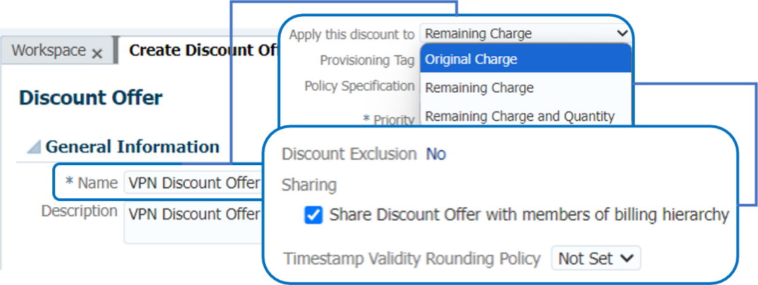Assign the relevant Biztalk package to each corporate account in BRM, ensuring that correct tariffs and discounts are applied across the VPN group members.

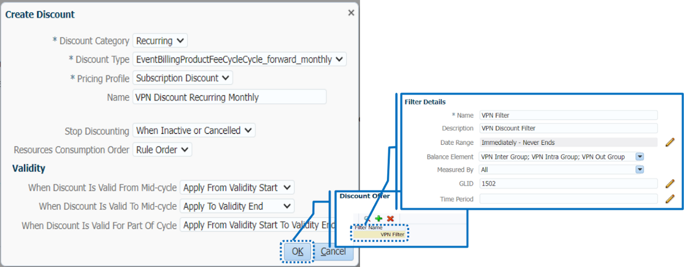

## Question 5

MCI is going to support FMC (PSTN subscribers), does your system have this ability? Especially in VPN-group.

Answer 5

Depending on the VPN package type, the VPN group will be set as an attribute at the service or account level by BRM. OCS will retrieve this attribute within the charging flow to apply the inter- or intra-group tariff.

In the scenario where MCI plans to support Fixed-Mobile Convergence (FMC) for PSTN subscribers within a VPN group using Oracle BRM and Siebel CRM, it is possible to implement this functionality. FMC enables the integration of fixed-line (PSTN) and mobile networks into a unified system, supporting both intra-group and inter-group communication.

**Key Steps:**

1. **Define VPN Groups** for both PSTN and mobile subscribers under the same corporate account in BRM.
2. **Create multi-service tariffs** to handle fixed-to-mobile, mobile-to-fixed, and mobile-to-mobile communications, ensuring appropriate inter- and intra-group tariff application.
3. **Apply discounts** for communication within and across VPN groups for both PSTN and mobile users.
4. **Enable short-number dialing** within the VPN group for seamless communication between fixed-line and mobile networks.
5. **Converged billing** allows unified billing and discount management for both PSTN and mobile services under the same account, with real-time monitoring of usage.

Oracle Siebel CRM provides a unified customer view and management interface for both PSTN and mobile services, allowing for easy integration and management of VPN groups.

# MCI Billing Related cases

## Case 1

MCI payment processing rule/Business:

AR receives a payment request through API from payment gateway. API will allocate the payment against an open invoice. It will persist all the payments in a database object and also mark the status as confirm or unconfirm and also the payment amount. Within 3 days when it receives confirmation through a file, a custom batch application will read the file and mark the database object as confirm. There is another batch process for payment reversal. This batch will check the database object for all the unconfirm payment which are older than 3 days and reverse all such payment.

Payment Confirmation:

Development of custom batch application is required to process the above file format as per the solution mentioned in case:1.

Bill ID/Payment ID:

Bill Id and payment Id will be to allocate the payment against a specific bill or invoice as per the solution mentioned in MCI payment processing rule/Business.

## Case 2

There is a feature called payment term within BRM. At the time of customer and billing profile creation, CRM/upstream passes the payment term to BRM. If CRM does not pass the payment term then BRM assign the default payment term. Based on the payment term, BRM assign a due date against a bill. Subscriber is expected to pay the billed amount within the due date. If subscriber fails to pay, it is picked and processed by a BRM OOB batch job i.e. pin\_collection\_process. This job will tag the subscriber is collection and depending on the collection configuration, it will apply specific collection scenario i.e. notification, barring etc.

<https://docs.oracle.com/cd/E16754_01/doc.75/e16698/col_collections_utilities.htm>

Upon confirmation of a collection action, BRM’s pin\_collection\_process generates a notification payload in Kafka. This payload is then processed by Oracle OC3C, which sends the notification, using a pre-configured template, to the SMSC for delivery to the end subscriber.

Additionally, pin\_collection\_process updates the subscriber's lifecycle state. Depending on this state, various restrictions can be applied, such as barring outgoing calls (Onnet, Allnet, or Offnet), data usage for specific rating groups, or outgoing SMS. For incoming barring, BRM sends a payload to the HLR, instructing the MSC to block incoming calls. BRM can also be configured to either apply or waive rental charges while the subscriber is in a specific collection state.

The pin\_collection\_process can generate a Kafka payload or CSV file for MCI systems to issue notice letters. This payload can include relevant details such as MSISDN and outstanding amounts.

For notice letter approval, the pin\_collection\_process generates a database object that is accessed by Siebel CRM for approval. A customization is required to enable this approval process before sending the notice letter through external channels.