Laboratory Experiment Report

Goal-Based Intelligent Agent for Smart Home Temperature Control

1. AIM
To design and implement a goal-based intelligent agent in Python that monitors and regulates room temperature within a predefined comfortable range by controlling an Air Conditioner (AC).

2. OBJECTIVE
1. To understand the concept of a goal-based intelligent agent and its interaction with an environment.
2. To simulate an environment where temperature fluctuates and an agent perceives these changes.
3. To implement decision-making logic using upper and lower threshold values (hysteresis) to achieve a desired goal.
4. To evaluate and visualize the performance of the intelligent agent over discrete time steps.

3. THEORY
Intelligent Agent: An autonomous entity that observes through sensors and acts upon an environment using actuators to achieve specific goals.
Agent Environment: The external space or system with which the agent interacts. In this experiment, it is a simulated room with fluctuating temperature.
Perception & Action: The agent receives data (temperature) as perception, processes it, and outputs an action (turning the AC ON or OFF).
Goal-based Agent: An agent that acts to achieve a specific goal state. Rather than simple condition-action rules, it considers whether its actions will help attain the goal.
The interaction follows this conceptual model:
Environment → Perception → Agent → Decision → Action → Environment
In the smart home scenario, the agent's sole goal is to maintain the room temperature within a predefined comfortable range, modifying the environment through its actions.

4. CASE STUDY
Scenario: A smart home temperature control system.
Comfortable temperature range: 20°C – 24°C.
The agent receives the current room temperature from the simulated environment.
Decision Rules:
- • If temperature >= 25°C → Turn AC ON
- • If temperature <= 23°C → Turn AC OFF
- • If temperature is between 23°C and 25°C → Maintain the previous AC state
This range introduces hysteresis, which prevents the AC from rapidly switching ON and OFF when the temperature hovers exactly at the threshold, ensuring energy efficiency and component longevity.

5. SYSTEM DESIGN
Environment: Represents the room and maintains the current temperature.
Sensor / Perception: Provides the current room temperature to the agent.
Intelligent Agent: Analyzes the temperature and decides the required action.
Actuator: Represents the air conditioner.
Goal: Maintain a comfortable room temperature.
Flow Diagram:
Room Environment
↓
Temperature Sensor
↓
Intelligent Agent
↓
Goal Evaluation
↓
Decision
↓
AC ON / AC OFF
↓
Room Temperature Changes
↓
Feedback

6. ALGORITHM
1. Start the program.
2. Initialize the room temperature.
3. Define the comfortable temperature range.
4. Initialize AC status.
5. Read the current room temperature.
6. Compare the temperature with the desired range.
7. Turn AC ON if the temperature reaches the upper threshold.
8. Turn AC OFF if the temperature reaches the lower threshold.
9. Maintain the previous AC state between the thresholds.
10. Update the room temperature based on the AC state.
11. Repeat the process for a fixed number of time steps.
12. Record temperature and AC status.
13. Plot the temperature variation.
14. Display the result.
15. Stop.

7. PSEUDOCODE
CLASS RoomEnvironment:
INIT temperature
METHOD get_temperature():
RETURN temperature
METHOD update_temperature(ac_status):
IF ac_status == ON:
temperature = temperature - decrement_value
ELSE:
temperature = temperature + increment_value
CLASS TemperatureAgent:
INIT lower_threshold, upper_threshold, ac_status = OFF
METHOD perceive(environment):
RETURN environment.get_temperature()
METHOD decide(temperature):
IF temperature >= upper_threshold:
ac_status = ON
ELSE IF temperature <= lower_threshold:
ac_status = OFF
ELSE:
KEEP ac_status
METHOD act():
RETURN ac_status
LOOP for N time steps:
current_temp = agent.perceive(room)
agent.decide(current_temp)
current_ac = agent.act()
room.update_temperature(current_ac)
RECORD current_temp, current_ac

8. IMPLEMENTATION
The experiment is implemented in Python using the Object-Oriented Programming paradigm. It simulates the RoomEnvironment and TemperatureAgent components utilizing standard Python logic along with NumPy and Matplotlib for data processing and visualization.

9. SIMULATION & 10. DATA COLLECTION
The simulation runs for 30 time steps. At each step, the temperature and AC status are recorded in arrays for visualization and tabular display.
Time Step | Temperature (°C) | AC Status
1 | 22.00 | OFF
2 | 22.46 | OFF
3 | 22.67 | OFF
4 | 22.98 | OFF
5 | 23.27 | OFF
6 | 23.76 | OFF
7 | 24.23 | OFF
8 | 24.79 | OFF
9 | 25.02 | ON
10 | 24.55 | ON
11 | 24.24 | ON
12 | 23.85 | ON
13 | 23.35 | ON
14 | 23.04 | ON
15 | 22.66 | OFF
16 | 23.12 | OFF
17 | 23.54 | OFF
18 | 23.83 | OFF
19 | 24.26 | OFF
20 | 24.79 | OFF
21 | 24.99 | OFF
22 | 25.51 | ON
23 | 24.93 | ON
24 | 24.50 | ON
25 | 24.13 | ON
26 | 23.45 | ON
27 | 23.02 | ON
28 | 22.68 | OFF
29 | 22.92 | OFF
30 | 23.46 | OFF

11. VISUALIZATION
The graphs below illustrate the temperature variation and AC status over 30 time steps. The shaded green region represents the optimal comfortable temperature range.
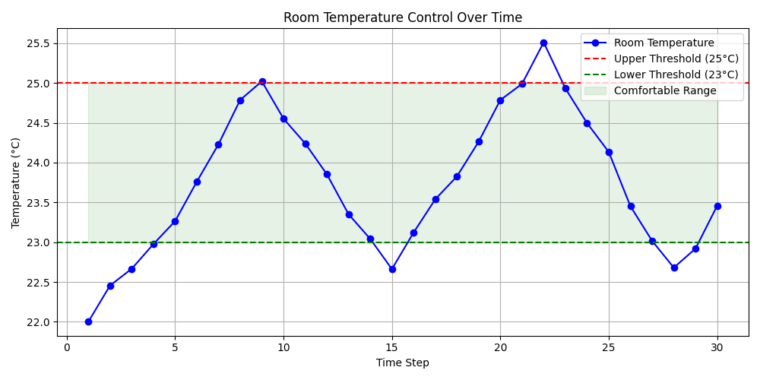
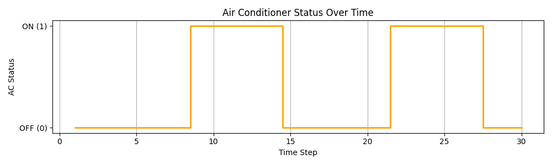

12. COMPLETE PYTHON CODE
import random
import numpy as np
import matplotlib.pyplot as plt
class RoomEnvironment:
def __init__(self, initial_temperature):
self.current_temperature = initial_temperature
def get_temperature(self):
return self.current_temperature
def update_temperature(self, ac_status):
# Add random variation for realism
variation = random.uniform(-0.2, 0.2)
if ac_status == 1: # AC is ON
self.current_temperature -= (0.5 + variation)
else: # AC is OFF
self.current_temperature += (0.4 + variation)
class TemperatureAgent:
def __init__(self, lower_threshold, upper_threshold):
self.ac_status = 0 # 0 for OFF, 1 for ON
self.lower_threshold = lower_threshold
self.upper_threshold = upper_threshold
def perceive(self, environment):
return environment.get_temperature()
def decide(self, temperature):
if temperature >= self.upper_threshold:
self.ac_status = 1
return "Turning AC ON"
elif temperature <= self.lower_threshold:
self.ac_status = 0
return "Turning AC OFF"
else:
return "Maintaining AC " + ("ON" if self.ac_status == 1 else "OFF")
def act(self):
return self.ac_status
def main():
random.seed(42) # For reproducible results
room = RoomEnvironment(initial_temperature=22.0)
agent = TemperatureAgent(lower_threshold=23.0, upper_threshold=25.0)
time_steps = 30
history_temp = []
history_ac = []
print("Simulation Started...")
print("-" * 50)
for step in range(1, time_steps + 1):
# Agent perceives the environment
temp = agent.perceive(room)
# Agent makes a decision
action_desc = agent.decide(temp)
# Agent acts
ac_state = agent.act()
# Store data
history_temp.append(temp)
history_ac.append(ac_state)
print(f"Step {step:2d} | Temperature: {temp:.2f}°C | AC: {'ON' if ac_state == 1 else 'OFF':3s} | Action: {action_desc}")
# Environment reacts to the action
room.update_temperature(ac_state)
print("-" * 50)
print("Simulation Completed.")
# Visualization
steps = np.arange(1, time_steps + 1)
# Plot 1: Temperature variation
plt.figure(figsize=(10, 5))
plt.plot(steps, history_temp, marker='o', linestyle='-', color='b', label='Room Temperature')
plt.axhline(y=25.0, color='r', linestyle='--', label='Upper Threshold (25°C)')
plt.axhline(y=23.0, color='g', linestyle='--', label='Lower Threshold (23°C)')
plt.fill_between(steps, 23.0, 25.0, color='green', alpha=0.1, label='Comfortable Range')
plt.xlabel('Time Step')
plt.ylabel('Temperature (°C)')
plt.title('Room Temperature Control Over Time')
plt.legend()
plt.grid(True)
plt.tight_layout()
plt.show()
# Plot 2: AC Status variation
plt.figure(figsize=(10, 3))
plt.step(steps, history_ac, where='mid', color='orange', linewidth=2)
plt.yticks([0, 1], ['OFF (0)', 'ON (1)'])
plt.xlabel('Time Step')
plt.ylabel('AC Status')
plt.title('Air Conditioner Status Over Time')
plt.grid(axis='x')
plt.tight_layout()
plt.show()
if __name__ == "__main__":
main()

13. EXPECTED OUTPUT
The console outputs the discrete time steps. Note: Numerical values are illustrative and actual values may vary depending on the simulation variations.
Step 1 | Temperature: 22.00°C | AC: OFF | Action: Turning AC OFF
Step 2 | Temperature: 22.35°C | AC: OFF | Action: Turning AC OFF
...
Step 10 | Temperature: 25.40°C | AC: ON | Action: Turning AC ON
Step 11 | Temperature: 24.80°C | AC: ON | Action: Maintaining AC ON
...
The first graph should demonstrate the temperature fluctuating within and around the comfortable range (23°C - 25°C). The second graph should show a step plot toggling between 0 (OFF) and 1 (ON) correlated with the temperature crossing the thresholds.

14. RESULT
The goal-based intelligent agent successfully monitors the simulated room temperature and controls the AC according to the defined temperature goal, preventing extreme temperatures.

15. CONCLUSION
The experiment effectively demonstrated the functioning of a goal-based intelligent agent. The agent perceives the environment through the simulated temperature value, evaluates it against the objective function (comfortable temperature thresholds), and makes deterministic decisions to turn the AC ON or OFF. The feedback loop established by these actions modifying the environment dictates the agent's subsequent decisions, showcasing how intelligent agents interact continuously to achieve a steady state.

16. APPLICATION
1. Smart home temperature control and intelligent thermostat devices.
2. HVAC (Heating, Ventilation, and Air Conditioning) automation in commercial buildings.
3. Energy management systems aimed at reducing power consumption.
4. Industrial IoT-based automation systems where maintaining environmental parameters is critical.

