/\*\*

\* Title : Heaps and AVL Trees

\* Author : Khasmamad Shabanovi

\* ID: 21 701333

\* Section : 2

\* Assignment : 3

\* Description : Report (Question 1)

\*/

PART 1

1. Before deletions:

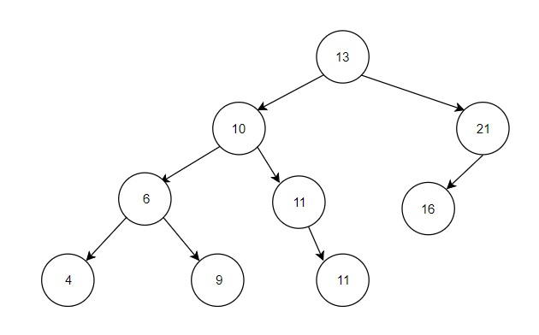

After deletions:

