Silent Island: A Quest for Survival

Game Proposal

Kevin Haston

2021

TABLE OF CONTENTS

Overview

Brief Description

Objective

Category

Target Audience/ Platform

Art and assets / price

World Creation

World Description

Types of units

Types of Zombies

Types of Structures

Types of abandoned structures

Types of materials

Types of food

Game Play

Game Play Description

Basic Player Turn

Basic Zombie Turn

Attacking

Defending

Building

Farming

Scavenging

User Interface

All Menus

# Overview

## **Brief Description:**

A turn based, isometrically viewed, zombie survival game. The game takes place on a island that was over taken by Zombies some time ago. The back story of this still needs to be written, but the play will discover the story by collecting letters that are scattered around the island. The game will open on a wrecked small town located somewhere on the island and the player will only have 2 -3 units to start rebuilding with.

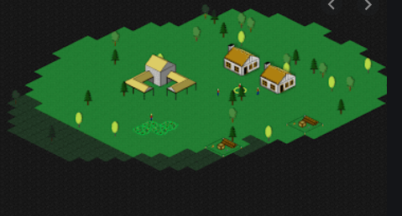

## Objective:

The player will need to build a city by scavenging, farming, building, crafting, and training units. Once the city is large enough and has the minimum requirements to sustain itself, the game will be complete.

List of Minimum Requirements:

1. Population – Need enough people to sustain the city.
2. Militia – A group dedicated to defending the city.
3. Food Production – Farms can be set up to continually supply food.
4. Walls – The city must be completely walled in.
5. Town Hall
6. TBA

## Category:

Survival, Turn-Based Strategy,

## Target Audience/ Platform:

PC and Web Based, no mobile support as the interface may be too complicated.

## Art and assets / price:

|  |  |  |
| --- | --- | --- |
| Assets | Link | Price |
| Ground, Structures, Loot | https://assetstore.unity.com/packages/3d/props/low-poly-ultimate-pack-54733#description | $60 |
| Zombies | https://assetstore.unity.com/packages/3d/characters/toony-tiny-zombies-pack-100508 | $10 |
| People | https://assetstore.unity.com/packages/3d/characters/toony-tiny-citizens-megapack-99854 | $20 |
|  |  |  |

# World Creation

## World Description:

The player can randomly spawn a new world or continue their current one. The maps will be stored on txt files and look something like this:

|  |  |  |  |  |  |  |  |  |  |  |  |  |  |  |  |  |  |  |  |  |  |  |  |  |  |  |  |  |  |  |  |  |  |  |  |  |  |  |  |  |  |  |  |  |  |  |  |  |  |  |  |  |  |  |  |  |  |  |  |  |  |  |  |  |
| --- | --- | --- | --- | --- | --- | --- | --- | --- | --- | --- | --- | --- | --- | --- | --- | --- | --- | --- | --- | --- | --- | --- | --- | --- | --- | --- | --- | --- | --- | --- | --- | --- | --- | --- | --- | --- | --- | --- | --- | --- | --- | --- | --- | --- | --- | --- | --- | --- | --- | --- | --- | --- | --- | --- | --- | --- | --- | --- | --- | --- | --- | --- | --- | --- |
|  | Key:   |  |  |  | | --- | --- | --- | | Unicode Key: Maps | | | | Character | Definition | Short Cut | | . | Water |  | | 0 | Land |  | | * | Rock |  | | ^ | Tree |  | | 1 | Abandoned House |  | | 2 | Abandoned Factory |  | | 3 | Abandoned Vehicle |  | | 4 | This is an empty tile around a Factory |  | | & | Loot Box |  | | "|" | Vertical Road |  | | "-" | Horizontal Road |  | | └ | Curve: Up/ Right | ALT + 2496 | | ┘ | Curve: Up/ Left | ALT +2521 | | ┌ | Curve: Down / Right | ALT + 2522 | | ┐ | Curve: Down / Left | ALT + 2495 | | ┴ | T: Up | ALT + 2497 | | ┬ | T: Down | ALT + 2498 | | ├ | T: Right | ALT + 2499 | | ┤ | T: Left | ALT + 2484 | |

The ground of the world will be made on a grid system comprised of something like 250 X 250 ground tiles. Each ground title will have the following attributes.

* Location Array - [x, y] a length int two array that will hold the location of the tile.
* terrainIsPassable Bool - This will be set to true when something is on the title that should stop a unit or zombie from moving through it.
* hasPlayer –
* hasZombie –
* hasLoot -
* 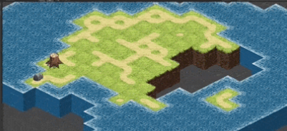

When the game starts the world should generate by randomly placing the tiles, then loot, then structures, then pick a place for the user to start.

## Types of units:

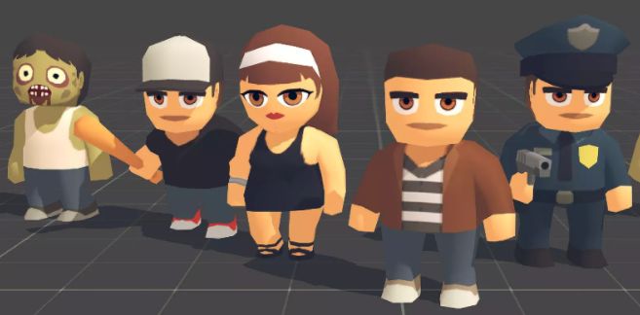

All units will have these basic attributes.

* Action Points – These will be used to move, attack, build, all actions.
* Action Points Limit – The unit can only save so much.
* Hit Points – Current hit points.
* Hit Points Limit – Most hit points allowed.
* Attack – Strength of attack.
* Attack Range – How many ground tiles away the player can attack.
* Defense – Strength of defense.
* Sight – Number of ground titles the unit can see in any direction.

They will be able to perform certain tasks and get attribute upgrades depending on their chosen profession. Here is a list of types of units.

* Basic Unit:
* Farmer:
* Soldier:

## Types of Zombies:

For simplicity’s sake right now, we will only have one zombie type.

* Basic Zombie

## Types of Structures:

A structure will be defined as an interactable game object that the play will need to build and then use. Zombies will target and destroy structures. The game will not spawn any structures by itself. Here are the structures that will be available at this point in the game and the interactions available to the player.

|  |  |  |  |
| --- | --- | --- | --- |
| Name | Interaction | Material Required | Picture |
| Farm Plot | Plant Crops  Harvest Crops |  |  |
| Living Quarters 1  Living Quarters 2  Living Quarters 3 | This is required to house citizens. If it is added, then the population cap will increase.  This can be upgraded for less cost of materials. | 10 Wood and 5 stone.  + 5 wood  + 5 wood |  |
| Wood Fence 1  Wood Fence 2  Stone Wall | This will keep zombies out, and the player will be able to upgrade it | 1 wood  + 2 wood  + 2 stone |  |
| Medical Tent  Medical Hut  Hospital | Automatically Heals units close enough to it. | 10 wood  + 10 wood  + 10 wood and 10 stone |  |
|  |  |  |  |
| Town Hall | Draft ordinance – This is one of the last objective in the game. | City must have Walls, Hospital, a certain minimum citizens, enough food, … |  |

## Types of Abandon Structures:

These will be all the structures placed on the map from the game. The only interaction the play will have with these is to scavenge and, in some cases, scavenging can result in death. Successful Scavenging will also increase Skill Points.

|  |  |  |
| --- | --- | --- |
| Name | Picture | Potential to scavenge. |
| House |  | Food, Survivors, Zombies, |
| Factory |  | Food, Survivors, Zombies, Wood, Stone |
| Vehicle |  | Food |
| Loot Box |  | Food, Zombies, Wood, Stone |

## Types of Material

Currently there is only wood and stone. This can be harvested from Trees and Rocks, respectively.

## Types of Food

We can make this more interesting in the future but for now we will just call it all food.

# Game Play

## Game Play Description:

Each Round will consist of 3 turns. The Players Turn, Zombies Turn, and the Update Turn. Round will take 1 hour of time. (To be updated if needed.)

## Player’s Turn:

During the players turn each unit will have Action Points (AP) and the player can decide to spend these points or let them save up. The player can also skill points (SP). When the player is satisfied, they will hit the end turn button.

The player should be able to click on all the following objects with these responses.

|  |  |
| --- | --- |
| **Object** | **Response** |
| Unit | TBA |
| Zombie | Structure Menu should pop up to offer generic information about this item. |
| Structure | Structure Menu should pop up to offer generic information about this item. |
| Abandoned Structure | Structure Menu should pop up to offer generic information about this item. |
| Tree | Structure Menu should pop up to offer generic information about this item. “This is a tree. Any unit can harvest it for wood.” |
| Rock | Structure Menu should pop up to offer generic information about this item. “This is a rock. Any unit can harvest it for stone.” |
| Ground Tile | 1. If the title is empty, then the tile should show it is selected. 2. If the title has a Structure, Abandoned Structure, tree or rock then the Structure Menu should pop up. If a Unit is on the tile and it is the players turn then that Unit should be selected, otherwise the tile can be selected. |

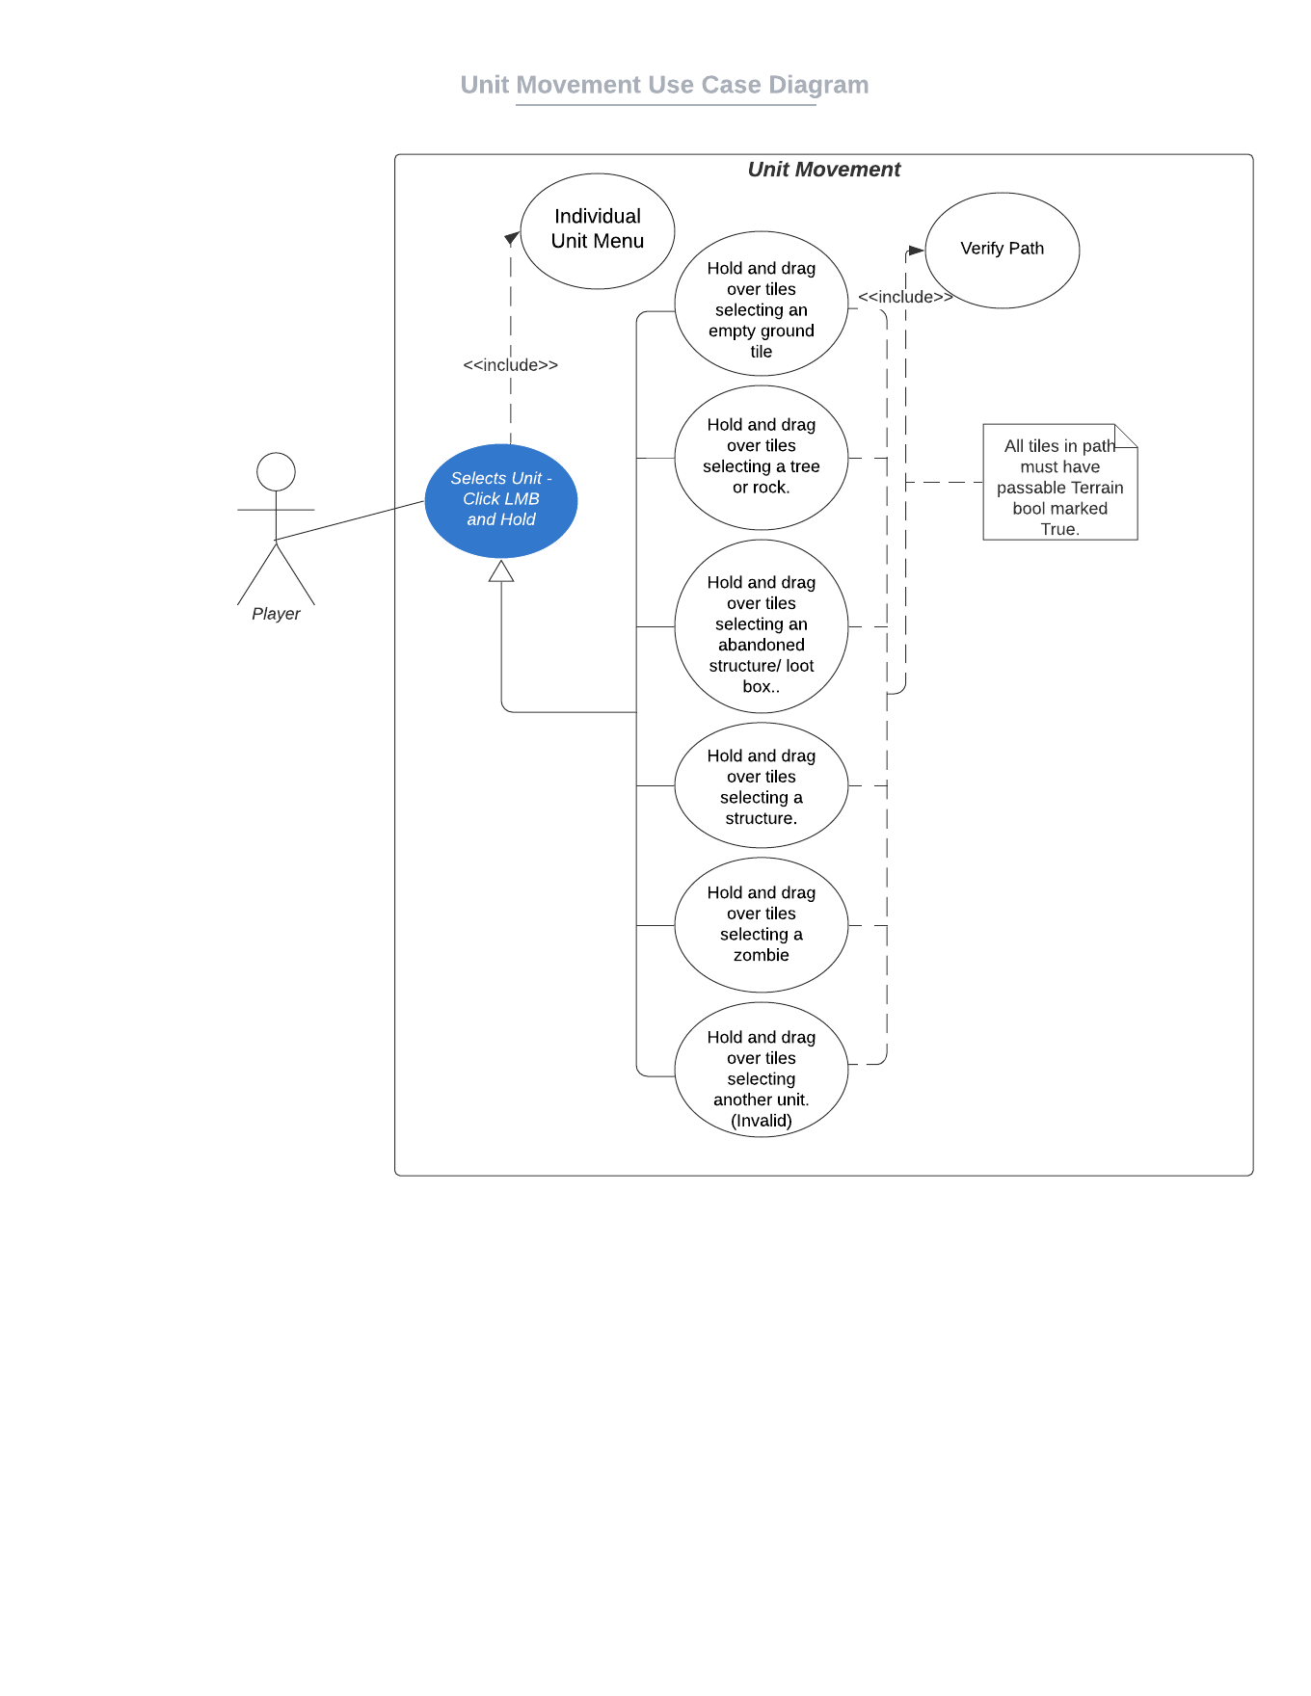

## Zombie Turn:

Zombies will also have action points to spend and will do so one by one.

## Update turn:

During this turn, Action Points, Health Points, and all other updates will be made. Farm Plots may mature, zombies will spawn.

# User Interface

## All Menus

In no order, here are the Menus we will need.

* **Basic Information Menu**
  + Day # Information
  + End Of Turn Button
  + Skill Points
  + Food/ Food Burned per day
  + Citizens/ Population Cap
* **Individual Unit Menu** – This will hold information about the unit and allow the unit to spend AP.
  + Move
  + Attack
  + Harvest – Trees and Rocks
  + Interact with Structure.
  + Build Structure
  + Scavenge
* **Structure Menu** - This will hold information about a structure and abandoned structures. Wall, Fence, House, Car, Farm Plot, etc. The player can not interface with the structure directly. See the next menu.
* **Interact with Structure Menu** – This will be allowed to open from the Individual Unit Menu if the individual is in range of the structure. It is where the interactions like, repair, take, use, on a farm plot, wall etc. Can be found.
* **Settings** – Settings – You know
* **Skill Tree Menu**