Space Mold

A mobile game where you play as Space Mold, a happy multicellular structure floating through space. Your happiness is interrupted when you realize you are on a collision course with a planet known to the locals as EARTH. The planet seems to be filled with a multitude of organisms all participating in the struggle for survival; in your current state you do not stand a chance. Time to use your mold wits, mold luck, and any other mold attribute you can find to prepare for impact!

**Key**

Green: Has Been Built in Unity

Blue: Documentation Complete

Red: Documentation Incomplete

## Scene 1: Start Screen

These variables need to be added to the Global Controller to be passed through the game from scene to scene.

Float SoundLevel

Float MusicLevel

## Scene 2: Cut Scene Explaining Origin Story

The art will be created by an artist and cut scene created by me.

Cut Scene (scene 1):

Picture of Space Mold floating through space with happy, carefree expression on face. The image of the Mold should be separate so that I can create motion.

Caption: “Life use to be simple back when I was a happy multicellular mold structure floating through space. Your typical Space Mold.”

Cut Scene (scene 2):

Picture of Space Mold from behind floating towards Earth. Mold should be separate so that I can create motion.

Caption: “But life can’t be all fun and games. When I realized I was on a collision course with a dangerous planet the locals call Earth, I knew it was time to get tough or die.”

Cut Scene (scene 3):

Picture of Space Mold floating through space surrounded by satellite debris. The mold should be reaching for a part with a determined look on his face. Space Mold and debris should be separate images so that I can create motion.

Caption: “If I can get crafty with the junk floating out here in space, I may just be able to survive the crash landing. Heck, if I get really crafty, I might even be able to thrive...”

## Scene 3: Prepare for game play

(Switch Back and Forth between Scene 3 and 4 for all x days before impact)

## Scene 4: Main game play

(Switch Back and Forth between Scene 3 and 4 for all x days before impact)

From this screen the player will be able to click a button, let’s say for this example they click Space Dust. And then select a button that is adjacent to it. If the two components do not combine to make anything than the buttons will disappear. If the two components do combine to make something than the new component will appear on the button that was clicked second and the first button will disappear.

When the player discovers a new component a pop up will occur inform the player what the new component is.

If the player clicks the Recipe Book:

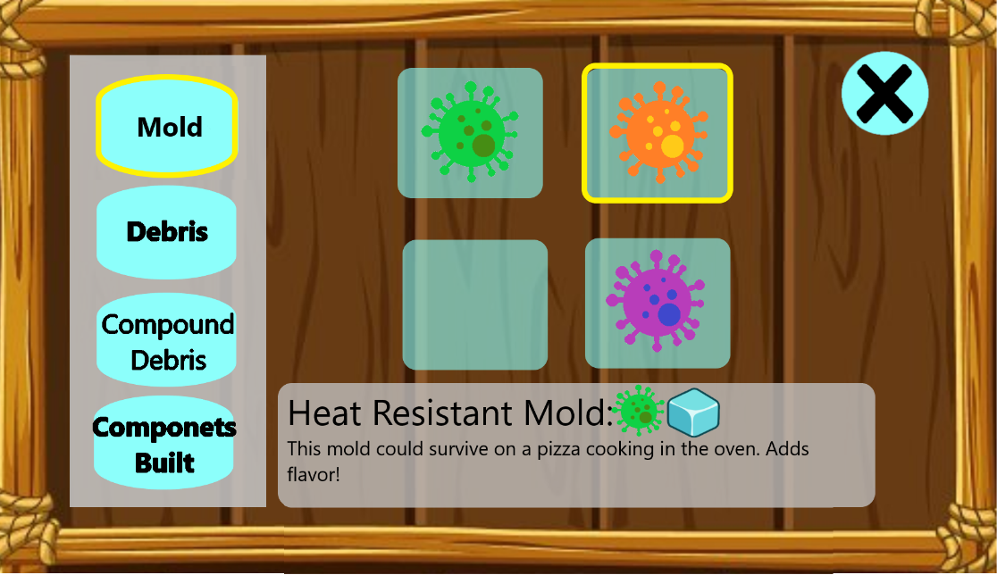

Settings panel is the same all as the it was on the start screen.

## Scene 5: Cut Scene Showing Impact

At the end of the final wave of game play this cut scene will play.

Cut Scene (scene 1):

Picture of mold falling to space. Mold should be separate image so I can create motion.

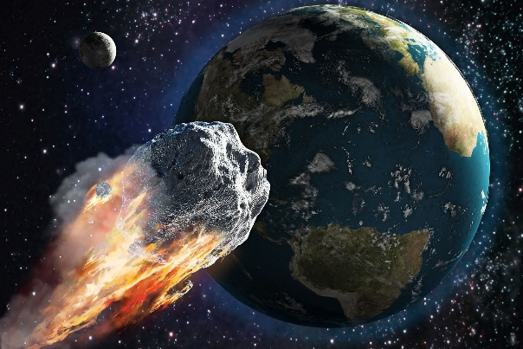

Caption: “AHHHHHHH”

Cut Scene (scene 2):

Cartoon explosion on top of the previous image of earth. I can animate a sprite sheet explosion.



Audio: Explosion

## Scene 6: End of Game Stats

(The player should be invested to see how their Space Mold stood up against Earths Defenses)

## Data on Materials and Components in Game

|  |  |  |
| --- | --- | --- |
| Space Debris Materials in Game | | |
| Raw Debris | | |
| Cosmic Dust | The dust that makes up everything… |  |
| Radiation | Good ole friendly radiation! |  |
| Strange Goo | It is strange and it is gooey. |  |
| Ice | Ice, it is cold. |  |
| Empty Rocket Engine | Satellite Part:  An empty rocket engine is an expensive paper weight. |  |
| Battery | Satellite Part:  Hey, it doesn’t have any charge! |  |
| Antenna | Satellite Part: |  |
| Lens | Satellite Part |  |
| Solar Panel | Satellite Part |  |
| Satellite dish | Satellite Part:  An good example of a paraboloid! |  |
| Propeller | Satellite Part:  What is a propeller doing out here? |  |

|  |  |  |
| --- | --- | --- |
| Compound Debris | | |
| Radiated Dust | Cool! Its glowing dirt. | Cosmic Dust + Radiation |
| Acid | Don’t get it on your face! | Radiated Dust + Strange Goo |
| Frozen Goo | The strange Goo has been frozen, cool… | Strange Goo + Ice |
| Laser | Light amplification by stimulated emission of radiation | Battery Pack + Lens |
| Mountable Spike | Ouch, the sharp end hurts! | Strange Goo + Antenna |
| Mountable  Dish | Maybe we can pick up MTV | Strange Goo + Satellite Dish |
| Mountable Lens | Great, goo on a lens… | Strange Goo + Lens |
| Glasses | They maybe the wrong prescription but they sure are trending. | Mountable Lens + Mountable Lens |
| Rechargeable Battery Pack | Handy for powering home appliances. | Solar Panel + Battery |
| Active Rocket Engine | It is a rocket engine. Who doesn’t want a rocket engine? | Radiated Dust + Empty Thruster |
| Mountable  Propeller | Hey, it can spin! | Propeller + Mountable Spike |

|  |  |  |
| --- | --- | --- |
| Mold Materials in Game | | |
| Space Mold | Standard Space Mold, it is gooey, gummy and smells like space. | N/A |
| Heat Resistant Mold | It is cold and slimy to the touch. | Frozen Goo + Space Mold |
| Electric Mold | It is ALIVE! | Rechargeable Battery Pack + Space Mold |
| Poison Mold | Don’t eat it, it is poisonous. | Acid + Space Mold |

|  |  |  |
| --- | --- | --- |
| Components to Create in Game | | |
| Heat Shield | Very handy for entering an atmosphere. | Mountable Satellite Dish + Heat Resistant Mold |
| Defense System | Everyone should have a personal defense system! | Mountable Spike + Poison Mold |
| Attack System | The best offense is a good ATTACK SYSTEM | Laser + Electric Mold |
| Cool Factor | When entering a new environment, it is important to make a good impression. | Space Mold + Glasses |
| Mobility Package | Nothing fancy, but it should get you from A to B. | Active Rocket Engine + Electric Mold |
| Climate Controller | Keeps you cold in the summer and warm in the winter. | Mountable Propeller + Heat Resistant Mold |