Effects of Meditation on Student Academic Performance and Behavior

Khatmin Thant
University of North Carolina at Chapel Hill, School of Education
EDUC 698: Internship in Human Development and Family Science
Dr. Kara Hume
May 5, 2025

Problem Statement
The area of most concern to virtually all educators at Carrboro Elementary School (CES) is the amount of testing the students are required to take. This statement reigns even more true for 3rd graders, who start the test taking process. Ideally, elementary school students at CES have limited amounts of testing, focusing more on the retention of lessons, either with frequent low-stakes exams or a minimal amount of high-stakes assessments. The time saved from taking high-stakes and low-stakes assessments can allow teachers to implement more meditation exercises, which has the probability of teachers being more engaged with their students, improving reading comprehension, and overall student academic success (Muller et al., 202).
However, the reality of it all is that these students are taking frequent high-stakes assessments and state testing. Out of the 180 school days, third graders will have tested almost 118 times by the end of the academic year, ranging from Beginning of Grade testing (BOG’s), End of Grade testing (EOG’s), “check-in” testing which are just as strenuous as the BOG’s and EOG’s, among many other tests that are teacher made. Overtesting has led to many problems with stressors impacting these students being able to be mitigated by efforts in the classroom (Brown, 2017). Stress management techniques used by children and adolescents are helpful in reducing anxiety, stress, and depressive symptoms, leading to more improved social skills and academic achievement (Zisopoulou and Varvogli, 2023). The COVID-19 pandemic has also affected the students in a way that is extremely noticeable to teachers. Having two years without social interaction has jeopardized the students academically, socially, and emotionally, with the impact still hitting the current third grade students today, increasing teacher responsibility and increasing the risk of burning out. The COVID-19 pandemic, although five years ago, has resulted in behavioral challenges, academic challenges, and social challenges, with other literature saying that it was equivalent to students who were significantly disrupted by natural disasters such as Hurricane Katrina (Pietro, 2023).
These students could be recommended to take their time and stretch their limbs or take breaks in the hopes of reducing the impacts of overtesting. Too much testing leads to a variety of problems, including student fatigue, test anxiety, lack of effort, practice effects, and false positives. All in all, overtesting poses a significant problem not just nationally, but locally, especially at CES, with me witnessing every single part of the problem. The goal of this project is to create a tool that helps both students and families to incorporate various mindfulness exercises both in school and at home, while also bringing to light the harmful effects of overtesting on students which can hopefully serve as a tool for administrators as well.
Literature Review
Frequent Testing and High Stakes Testing
Vaessen et al. studied university students, however the findings are still very applicable to the elementary age group. They measured university students’ perceptions of graded frequent assessments, just like the assessments students at CES have, as well as “relations between perceptions of frequent assessments, intrinsic motivation and grades” (Vaessen et al., 2016). This study found that most students valued these frequent assessments as a motivator for studying, with a “modest number” of students experiencing either positive or negative effects from the grade they received. Vaessen et al. found that “the perception of negative effects (lower self-confidence and more stress) negatively mediated the relation between grades and intrinsic motivation” with potential mitigation efforts possibly being implemented through communication with students regarding the purpose of these assessments (Vaessen et al., 2016). This would mean that feeling like grades lower self-confidence and add on to stress make students feel less motivated, but, explaining to the students why these assessments matter could potentially mitigate those feelings. CES has third through fifth graders partaking in high stakes testing frequently . The impact of these high stakes assessments has the potential for students to feel unmotivated while losing confidence in their own test taking abilities. The limitations however on the conclusion is that communicating with students on the reason for these assessments will not magically cause them to stop experiencing these negative effects. It can easily be refuted with the other resources pulled into this literature review.
High stakes testing are tests that hold a heavier weight as compared to lower stakes, these are the tests that are recorded for data sets and more importantly, hold a higher impact on grades for students. High stakes testing has the potential for negative emotional impacts. Receiving a bad grade on a high stakes test could result in feelings of disappointment and loss of motivation to study for the next one, especially at the frequency the students at CES have experienced. French, Dickerson, and Mulder published an article reviewing the benefits and drawbacks of high-stakes examinations (French, S., Dickerson, A. L., & Mulder, R. A., 2023). This study reviews the arguments for and against high-stakes examinations on the themes of “memory recall and knowledge retention; student motivation and learning; authenticity and real-world relevance; validity and reliability; academic misconduct and contract cheating; stress, anxiety and wellbeing; and fairness and equity” (French et al., 2023). They found that not many of the perceived academic benefits of high-stakes testing have strong evidence to support them. This study also found that the benefits of these high-stakes testing is more rooted in opinion and pragmatism, with the drawbacks of these exams actually having a high amount of substantial evidence. French et al., concluded that having a heavy reliance on these high-stakes exams is “poorly justified by the balance of empirical evidence” (French et al., 2023).
Low Stakes Testing/Overtesting
The problem with frequent, high-stakes testing is that it can result in quicker burnout for the students, experiencing the effects of overtesting fully and thoroughly. This intervention does not aim to get rid of testing altogether, but provide proven alternatives so the rate of burnout does not last. Sotola and Crede in 2020 published a meta-analysis review titled “Regarding Class Quizzes: a Meta-analytic Synthesis of Studies on the Relationship Between Frequent Low-Stakes Testing and Class Performance.” Using data from 52 independent samples from real classes, they found that there was an association between the use of quizzes and academic performance. They also found that performance on these quizzes is strongly correlated with academic performance, with quiz performance strongly predicting a later exam performance, and the use of quizzes is associated with a large increase of passing a class. (Sotola and Crede, 2020). Although this study isn’t about the consequences of high-stakes testing, it does support the idea that more frequent low-stakes testing is better for academic performance.
Overtesting and the effects of such on students has obviously led to negative consequences. Plenty of support can be made on standardized tests and previous literature does recognize that testing in schools is necessary, however, there is danger in too much testing. The main problems include student fatigue, practice effects, and false positives (Brown, 2017). Test anxiety interferes with a student’s ability to perform well on assessments, a lack of effort being shown because of the frequency, students not retaining the purpose of a test because of studying the same test before assessment day, and false positives happening due to frequent testing (if a student was given enough tests, the likelihood of false positives goes up) (Brown, 2017). Testing anxiety is characterized by “sleeplessness, lack of appetite, fear, and even physical symptoms” which interferes with a student’s performance. These “practice effects” are a direct result of overtesting, explaining that when an assessment is given out so often students end up practicing the right answers, and are “no longer challenged by the questions,” negating the true value of a test. False positives also result, that “the likelihood of false positives goes up with every assessment given” and “the negative effect of too much type 1 error is that teachers will make the wrong decisions about students’ instructional needs” (Brown, 2017). The consequences of overtesting have pretty significant drawbacks, getting more specific towards student learning and academic performance.
As discussed previously, test anxiety has significant negative impacts on students. So much so that multiple different literatures have made their own conclusions on test anxiety. 238 studies since 1988 up until 2018 were synthesized to “explicate predictors, correlates, and relationships with the test anxiety construct” (Embse et al., 2018). The results found that test anxiety was “significantly and negatively related to a wide range of educational performance” which include assessments such as standardized tests, university exams, and GPA. This study found that self-esteem was also a significant and strong predictor of testing anxiety, with perceived difficulty and high-stakes consequences also relating to higher test anxiety (Embse et al., 2018). The higher the stakes on the exam, the higher the consequence. CES has these higher stakes which impacts the current curriculum, what needs to change, and what needs to be hammered in more. However, critiques have been made by multiple teachers who explain that these changes by the district are not helpful whatsoever, therefore impacting the students in a big way.
Benefits of Stress Management
Stress management is incredibly important for not just adults, but students as well, especially those undergoing the amount of academic stress as CES. Stress has been studied and thoroughly reviewed in previous literature, including that the prevalence of stress rates in both elementary and secondary education students have been increasing, with students suffering from anxiety and other stress-related disorders (Zisopoulou and Varvogli, 2023). Various different techniques are “deemed to be effective to treat stress and a variety of stress-related disorders such as anxiety disorders, depression, post-traumatic stress disorder, OCD, headaches, among many, many others. This study concluded that stress management techniques used by children and adolescents are helpful in reducing anxiety, stress, and depressive symptoms, leading to more improved social skills and academic achievement (Zisopoulou and Varvogli, 2023). Stress management techniques can be extremely helpful in the classroom setting for students, improving their own wellbeing. Symptoms of anxiety and improving both social skills and academic achievement are all bases that need to be touched on at CES.
Taking short breaks throughout the day is seen as beneficial for both overall mental and health wellbeing. (Muller et al., 2021) recognizes that this fact has not been explored when looking towards school lessons, therefore implementing a “mindfulness intervention” and investigating the results. The study found that the physical activity intervention used actually improved the students’ attention, with the mindfulness intervention improving reading comprehension compared to the controls (Muller et al., 2021). The physical activity intervention lasted 10 minutes, consisting of a 2-minute warm up, 4-minute cardio, 2-minute exercises with a partner, and a 2-minute cool down with 10 seconds of rest in between. The mindfulness intervention was also 10-minutes, with the students being introduced to mindfulness, participating in breathing exercises, guided attention exercises, and a “body scan” (Muller et al., 2021). The results measured “indicated that self-esteem moderated the relationship between groups and attention improvement,” concluding that these “classroom-based short physical and mindfulness breaks could support attention and reading comprehension, which are known to support overall academic success” (Muller et al., 2021). The interventions used can be replicated in this current intervention/resource to truly see if the results of their findings can be similar to the results of this intervention.
Methods
Participants
The participants of this guided meditation will be a “traditional” third grade class at Carrboro Elementary School. The participants were chosen through an internship placement from UNC Chapel Hill. The teacher of this classroom teaches two classes, with both classes participating in the guided meditation before the start of each class for equity reasons. The students of these classes consist of a total of 36 students, 15 of which are girls and 21 of which are boys. CES follows a dual language style of learning with classes being either dual language or traditional. The participants of this study are all in “traditional,” meaning most of these students are native English speakers. There are 32 white students, two Black students, two Asian students, and no Hispanic/Latinx students, with a few students falling under the “EC” or “Exceptional Children” category, needing further academic assistance from other teachers due to lack of ability to read or write. Participants of this study will remain anonymous to ensure confidentiality including both students and faculty.
Although the class size of the participants is quite small, the collection of test score data can contribute to the overarching idea that guided meditation or practicing mindfulness proves to be beneficial for student wellbeing. This study is being done on a specific population; however, results could be applied and replicated for all other grade levels, traditional and dual language, potentially proving to be beneficial to teachers, administration, and all other faculty leading classrooms. The results of this study also aims to help families of these students as well as the students’ themselves on an individual basis in learning to control their behaviors during a moment of negative feelings such as feeling overwhelmed or frustrated.
Procedures
This intervention has the intention of improving the experiences and wellbeing of students at Carrboro Elementary School. First, after thoroughly researching different methods, terminology, and benefits of potential solutions, a survey form via Google Forms was sent out to get the perspective of the teacher on guided medication and practicing mindfulness, along with any concerns or expectations from the results of this study. This survey included Likert scale questions, open-ended questions for concerns, and multiple choice questions asking how confident the teacher feels about the intervention working and what they expect. Then, after collecting data from the pre-survey, the intervention began for the period of time before their next assessment at a period of two weeks. This intervention included having the students watch guided meditation videos from sources such as YouTube, every time before class has started.This would happen every single morning, explaining to students that the reason for this intervention is to hopefully stop the feelings of being overwhelmed during an assessment and answering randomly to get the assessment over with, as well as to reduce the amount of stress they might feel. After the video is finished, I ask how the students felt about that particular video, what they would want next time, any critiques, and if there are any positives about this. This data will be collected on the post-survey that students take after the intervention. An assessment based on last year’s second quarter reading third grade check-in will be used to collect data from the students. Students were told that this is a practice assessment and not one that will impact their overall grade; however, they were told to take the assessment as seriously as possible. This assessment will be compared to this year’s second quarter reading third grade check-in, with similar questions. Once the assessment has passed and scores have been released, comparisons will be made between pre-intervention scores and the post-intervention scores. Finally, once the intervention is finished, students will receive a Google Survey to record their thoughts on the guided meditation exercises at the start of each class. Questions include “how did you feel about the meditation?” and “How likely are you to do this on your own?” Depending on the results, a resource will be developed, compiled of multiple different guided meditation practices for both parents and students, including steps to take when their student is frustrated.
Evaluation
After the intervention has taken place and the resource developed, a post-survey will be distributed to the same individuals that received the pre-survey, asking if their expectations have been met, a sliding scale for confidence, and open-ended questions to gauge any results not measured before. Because a pre-survey was only given to the teacher of the classroom, only they will receive the post-survey. The scale on every Google Survey will be from 1-5, with 1 being not confident at all, to 5 being completely confident in the intervention. Students will also receive a post-survey on how the intervention made them feel as well as questions on if they see themselves using this intervention once again. Feedback received from this survey will be used to adjust the resource and intervention methods to further improve said resource. The mean test score of the class pre and post intervention will be analyzed as well as analyzing the differences between test scores of each student, which will all be put into a figure or table.
Results

Assessment Score Comparison
The assessment showed higher academic reading scores during the practice assessment as compared to the student’s last reading check-in. The mean test score during the last reading check-in for the second quarter was 62.21%; as compared to the practice reading assessment which showed a mean test score of 76%. On an individual basis, the biggest improvements were students C, E, J, M, O, T, Z, and AC, having an increase of around 30% or more compared to the check-in. Other students have shown slight improvements in their test scores as well. Some students’ scores did decline.
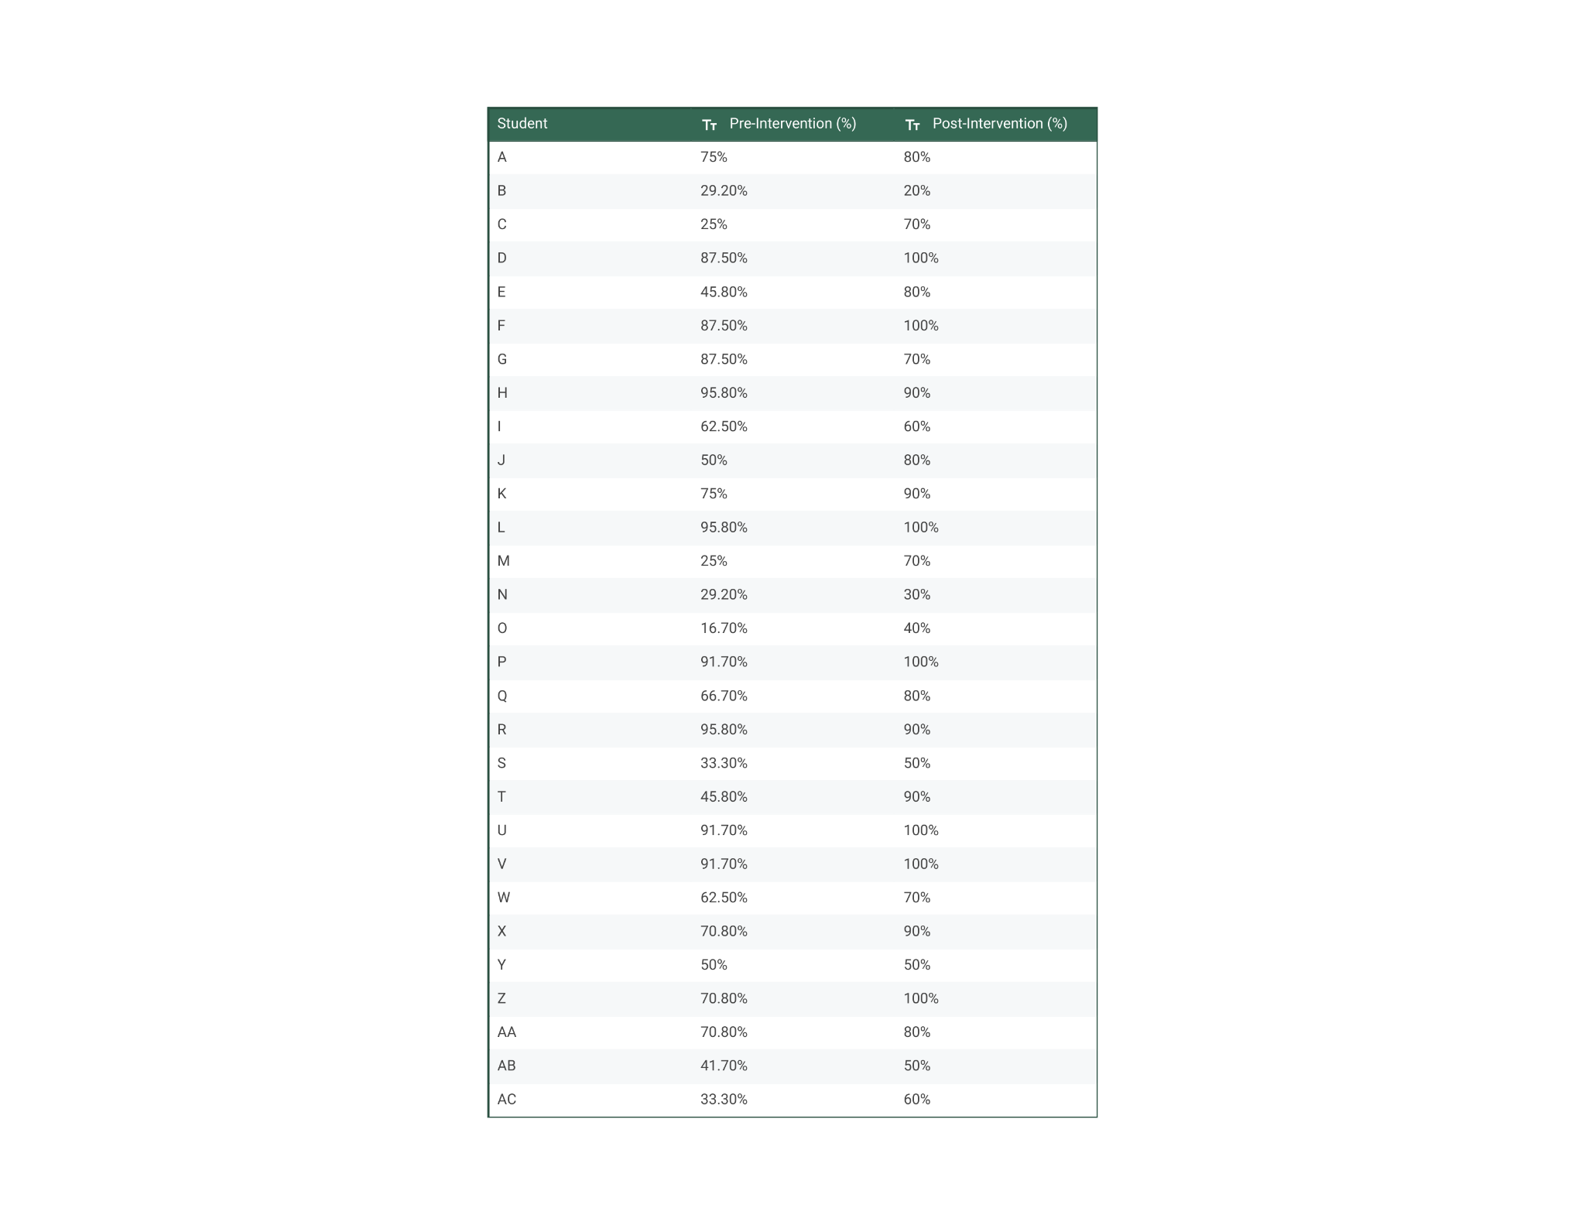

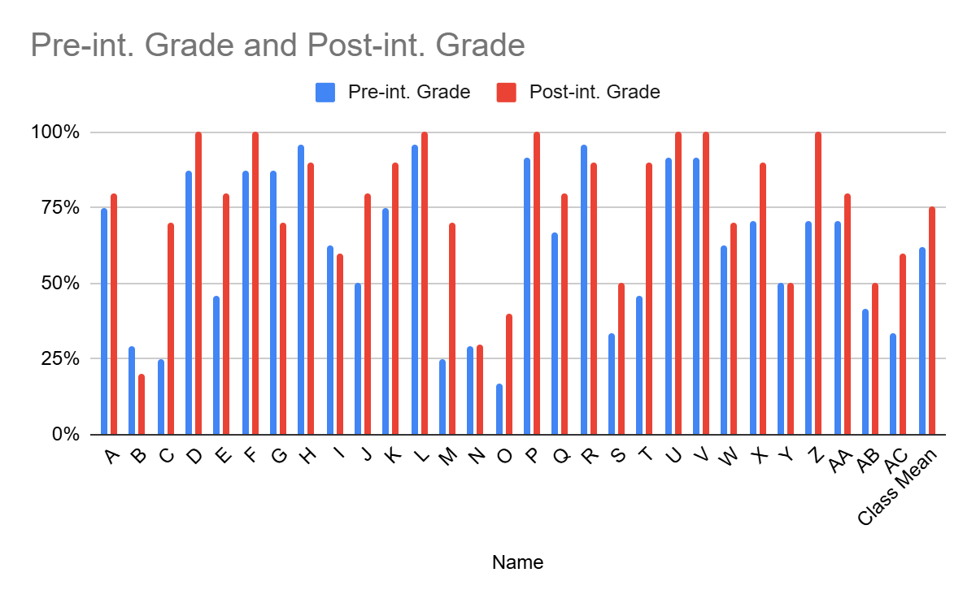

Teacher Response Pre vs. Post Intervention
The teacher in this classroom was given a pre-survey and post-survey. The results of the pre-survey indicate a confidence in this intervention, with a 4 out of 5 on a Likert scale measuring confidence in the intervention. The problems addressed are all behavioral, with less concern over test scores. The post-intervention survey results confirm the success of the intervention. The teacher answered that the issues addressed were resolved with students becoming less anxious and that they enjoyed the intervention in general.
Table 1: Pre-survey Table 2: Post-survey
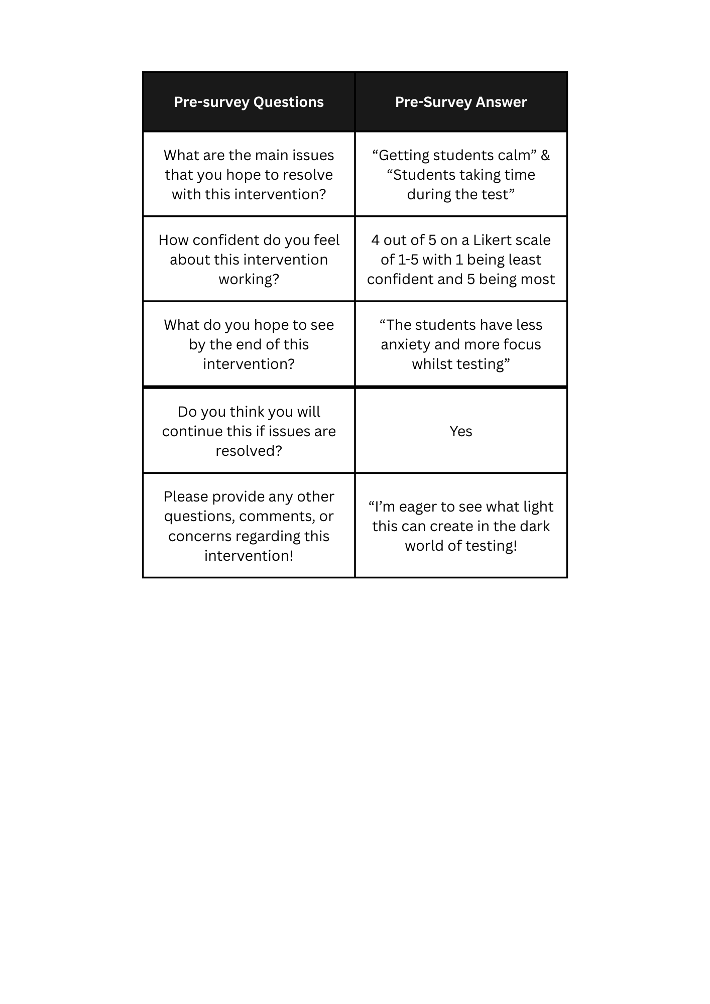
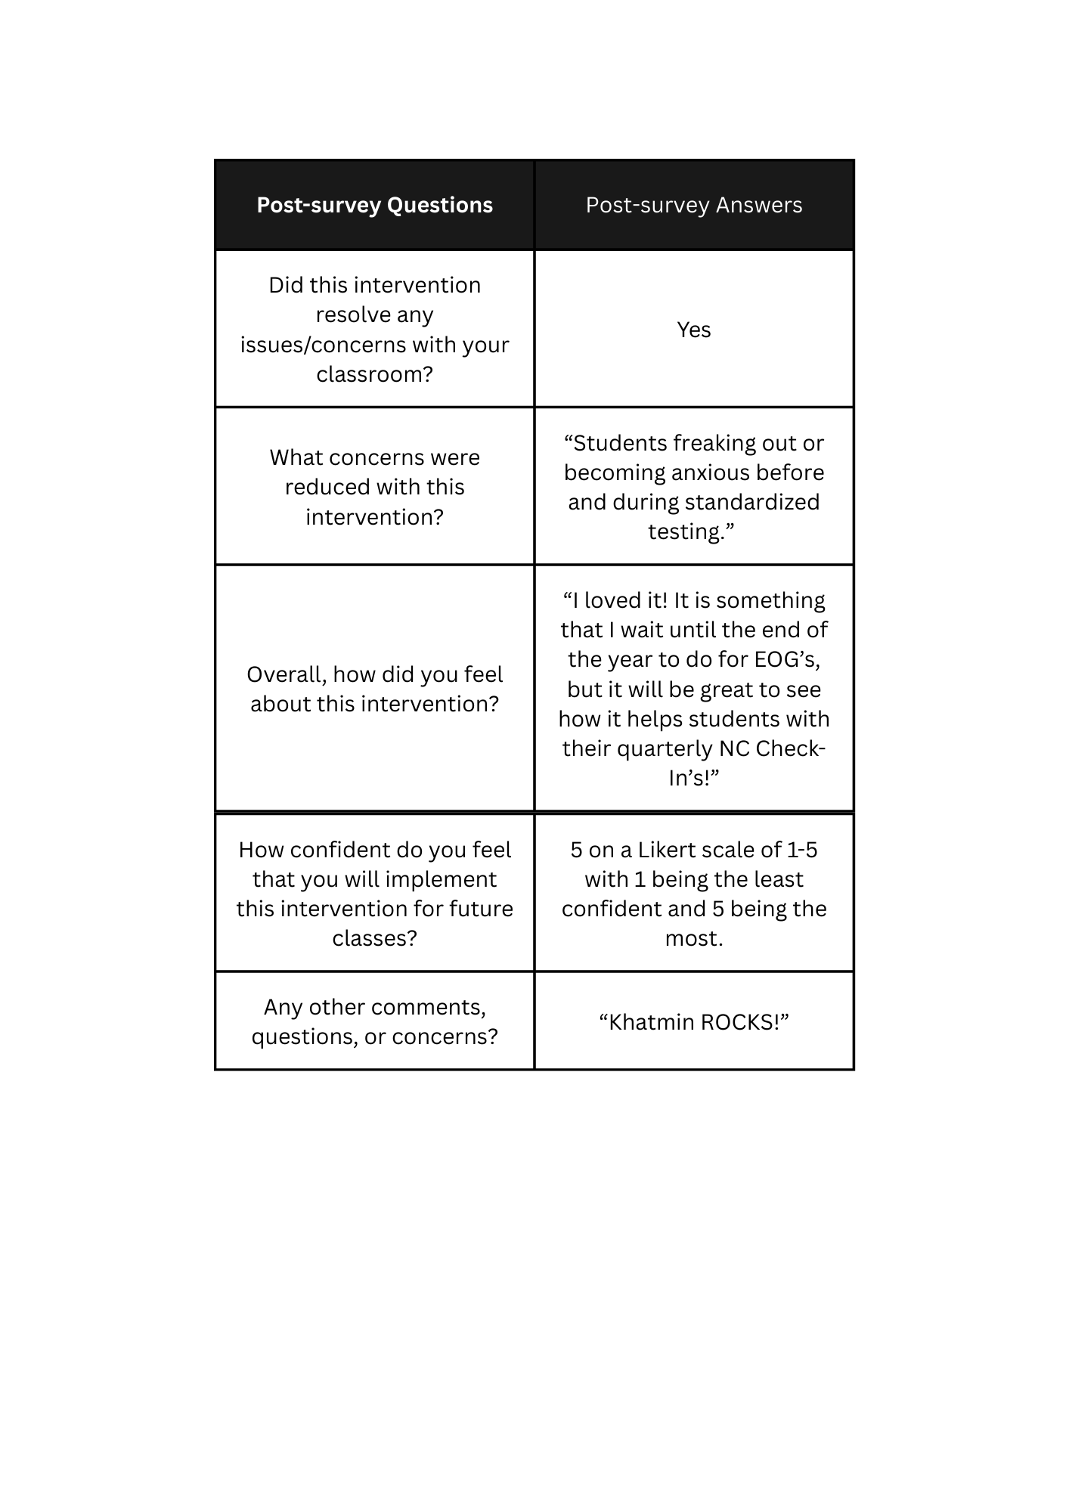

Student Survey Responses
The student post-intervention survey had mixed reviews however, most students enjoyed the intervention. Most students reported feel “calm”, “peaceful”, and “sleepy” during the intervention as well as 52.9% of students reporting that they liked meditating. 82.4% of students reported that they would try it again however, only 35.3% of students answered that they thought meditating helped them.
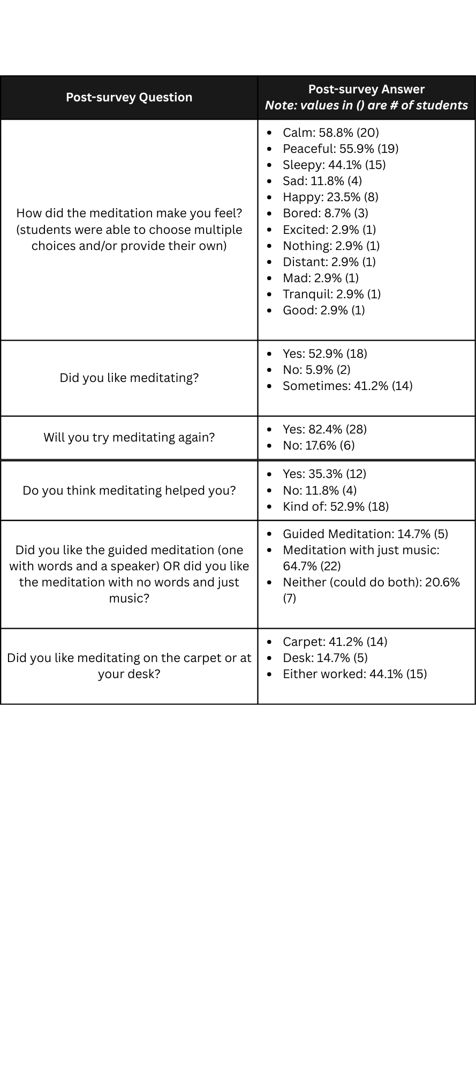
Overall, the intervention appeared successful from both teacher and students. Although plenty of student test scores increased, there were some students that had a decrease in scores as compared to the last check-in. Looking beyond test scores, the intervention improved feelings of anxiety before major testing with a majority of students reporting that the meditation was enjoyable and made them feel “calm” and “peaceful.”
Discussion
Implications
Teacher and student survey evaluations of the intervention alludes to the fact that it can play a role in increasing academic test scores, and reducing feelings of overwhelm and stress , in the classroom. The teacher's response confirms that the intervention worked for addressing such behaviors and the teacher is confident that they will implement the intervention again before the End of Grade (EOG) assessment. In terms of student response, surveys had a higher rate of “yes” answers, suggesting they enjoyed the meditation and that they would continue to practice it after the intervention had passed. Students also gave majority positive feedback when asked their opinions on the intervention (refer to Appendix B).
These results suggest that even if the intervention did not increase academic scores, qualitative results such as feelings towards the intervention lean toward success. These results also build on previous literature results concluding that taking short meditation breaks in class improved attention and reading comprehension (Muller et al., 2021). This intervention has the potential to work beyond one traditional, third-grade class at Carrboro Elementary School to decrease rates of stress and other stress-related disorders such as anxiety (Zisopoulou and Varvogli, 2023). Other resources similar to this one could also be implemented at other schools for testing-age students.
Limitations
There are several limitations in regard to this intervention. This intervention was conducted in one, third grade classroom with a limited number of students as compared to the entire school population which is approximately 500 students. Results would be stronger if the intervention were implemented more broadly. Other limitations include the amount of time the intervention took place, which was for 2 weeks which could also explain why a majority of students felt like the intervention “kind of” worked for them. However, mostly all students were engaged in meditation when the intervention was taking place. A pre-survey was also not given to students, which would have strengthened the findings.
The assessment portion could also be considered another limitation, being unable to use the entirety of last year’s assessment and instead, used half. Considerations for student absences would also make a strong case for limitations, since the data lacked information for seven students due to absences. Data on six students could not be used pre-intervention. A major limitation also includes the time each class conducted their meditation. The first class did their meditation first in the morning, as soon as they came in; whereas the other class did their meditation after lunch and recess in the afternoon, potentially contributing to a confounding variable of energy levels. Though there are plenty of limitations, the intervention can still be replicated if taken on a higher scale.
Conclusion
The results of this intervention at Carrboro Elementary School suggest that implementing meditation into the classroom has the potential to increase academic scores as well as decrease anxiety and stress. By creating a resource in addition to the intervention, families at the school can implement it at home with their student. This project emphasizes the importance of taking short breaks during class time to decrease the amount of stress and anxiety students feel. Having access to the resource and the intervention could help mitigate the issues students face before, during, and after times of assessments big or small. Continuation of this intervention by Carrboro Elementary School or other schools should also consider making resources for families that do not speak primarily English in their household, as many do at Carrboro Elementary School because of its dual language model.

References
Brown, R. (2017, March 23). avoiding overtesting. Illuminate Education. https://www.illuminateed.com/blog/2017/03/avoiding-too-much-testing-in-schools/
French, S., Dickerson, A. L., & Mulder, R. A. (2023). a review of the benefits and drawbacks of high-stakes final examinations in higher education. Higher Education, 88. https://doi.org/10.1007/s10734-023-01148-z
Müller, C., Otto, B., Sawitzki, V., Kanagalingam, P., Scherer, J.-S., & Lindberg, S. (2021). short breaks at school: effects of a physical activity and a mindfulness intervention on children’s attention, reading comprehension and self-esteem. Trends in Neuroscience and Education, 25, 100160. https://doi.org/10.1016/j.tine.2021.100160
Sotola, L. K., & Crede, M. (2020). regarding class quizzes: a meta-analytic synthesis of studies on the relationship between frequent low-stakes testing and class performance. Educational Psychology Review, 33. https://doi.org/10.1007/s10648-020-09563-9
Vaessen, B. E., van den Beemt, A., van de Watering, G., van Meeuwen, L. W., Lemmens, L., & den Brok, P. (2016). students’ perception of frequent assessments and its relation to motivation and grades in a statistics course: a pilot study. Assessment & Evaluation in Higher Education, 42(6), 872–886. https://doi.org/10.1080/02602938.2016.1204532
von der Embse, N., Jester, D., Roy, D., & Post, J. (2018). test anxiety effects, predictors, and correlates: a 30-year meta-analytic review. Journal of Affective Disorders, 227(1), 483–493. https://doi.org/10.1016/j.jad.2017.11.048
Zisopoulou, T., & Varvogli, L. (2022). stress management methods in children and adolescents – past, present, and future. Hormone Research in Paediatrics, 96(1). https://doi.org/10.1159/000526946
Appendix A
Teacher Pre-Survey Questions
The teacher's pre-survey included four different questions and a question for any other comments or concerns. These questions included:
- What are the main issues that you hope to resolve with this intervention?
- How confident do you feel about this intervention working?
- What do you hope to see by the end of this intervention?
- Do you think you will continue this if issues are resolved?
Teacher Post-Survey Questions
The teacher’s post-survey also included four different questions with an additional question for any other comments or concerns. These questions included:
- Did this intervention resolve any issues/concerns with your classroom?
- What concerns were reduced with this intervention?
- Overall, how did you feel about this intervention?
- How confident do you feel that you will implement this intervention for future classes?
Student Post-Survey Questions
Students were given a six-question post-survey on how they felt about this intervention. This survey was meant to get more qualitative data, gathering their honest opinions on the intervention to back up the quantitative data of the test scores. These questions include:
- How did the meditation make you feel?
- Did you like meditating?
- Will you try meditating again?
- Do you think meditating helped you?
- Did you like the guided meditation (one with words and a speaker) OR did you like the meditation with no words and just music?
- Did you like meditating on the carpet or at your desk?

Appendix B
Open-ended Student Survey Responses
The student post-survey also included a question with any other additional comments the students had wished to say that they were not able to in the prior questions. The included comments are direct quotes from the students’ post-surveys:
- “Meditating helped me start my day”
- “I enjoyed being next to my friends while meditating. Though I was not playing with them, it gives me a sense of peace to be so close to them. I might not have enjoyed meditation with out the sense of peace from them. I also thought I should mention that I much did not enjoy meditation at our tables. It was not comfortable, removing some of that sense of peace. I also should mention that I enjoy guided meditation because without the speaker I might fall asleep. Otherwise, I loved meditation and therefore have nothing else quite worth mentioning about some of the cons of the meditation!”
- “It was great!”
- “For the first question I sometimes get sad because I think of my hamster who is DEAD”
- “It was fun”
- “I enjoyed meditating”
- “I could do meditation without music”
- “I would like meditation with just music on the carpet without everyone laying down”
- “Khat should graduate”
- “The meditation helped me clear my mind and focus on being positive. It also helped me take a break from any worries I have”
- “I also liked the guided meditation with words too.”
- “im tired but then no”
- “on the question that said did you like meditating I would say mostly if it was an option.”
- “I liked medatating because it makes me forget my worries and it is quite peaceful.”
- “I hit desk because I don’t really sit on the carpet”
- “I liked it but think i would like to do it only on mondays, Fridays, and any day we have a test”
- “mditating is good”
- “The meditating did not make me much calmer”
- “i like meditating”
- “i think that for me meditation isn’t very enjoyable and if one of my future teachers did it, like in 4th grade, if there was the option i wouldn’t do it.”

Appendix C
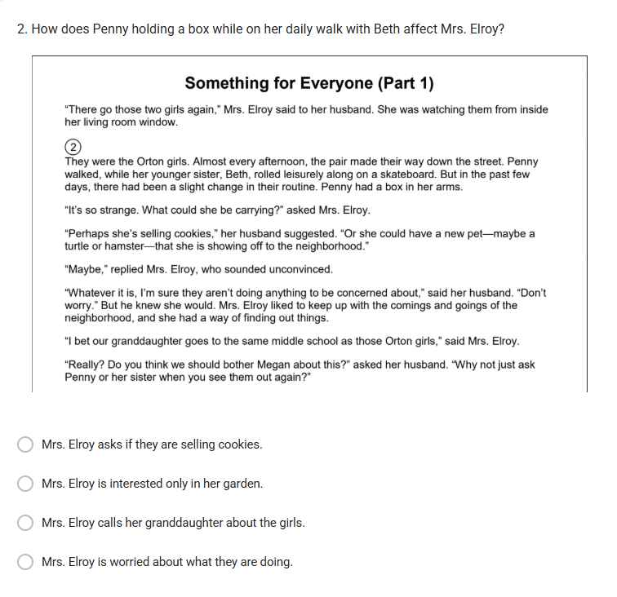
Figure A1
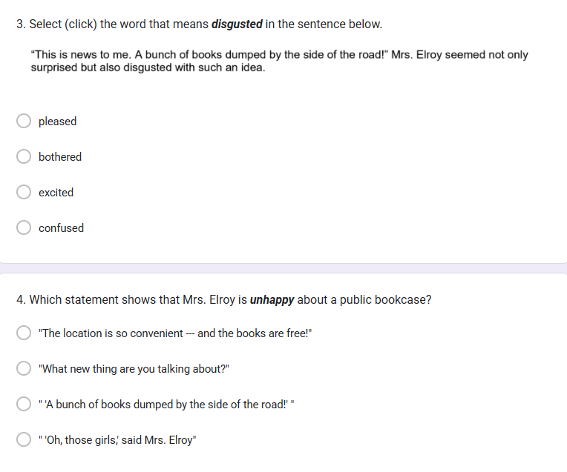
Student Post-intervention Assessment

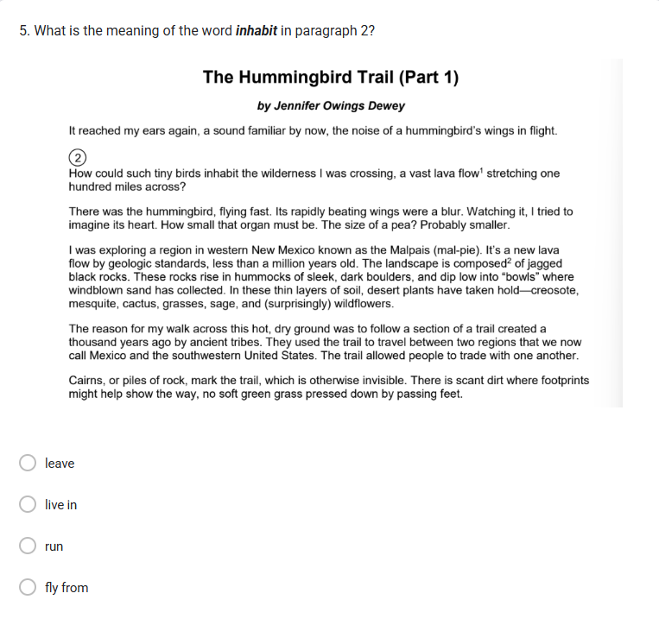
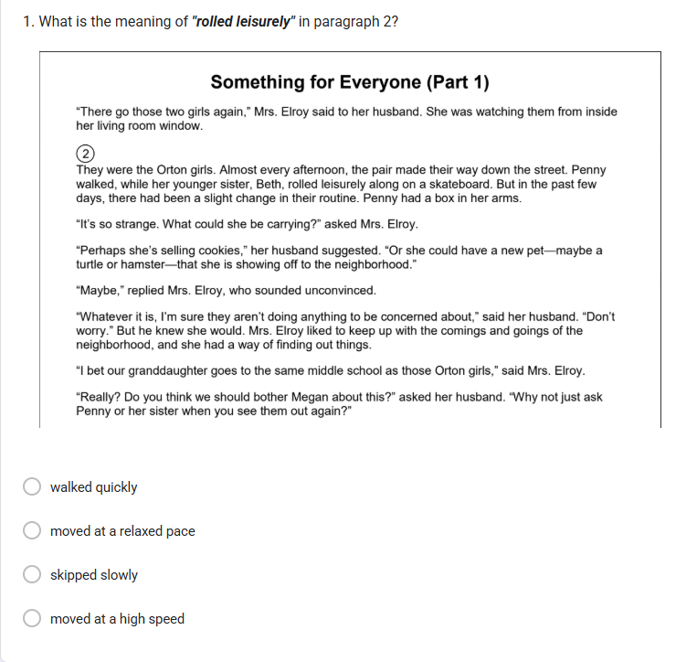


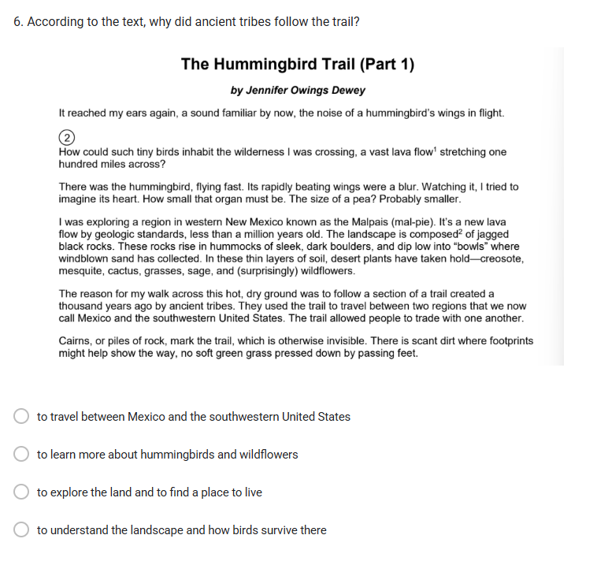

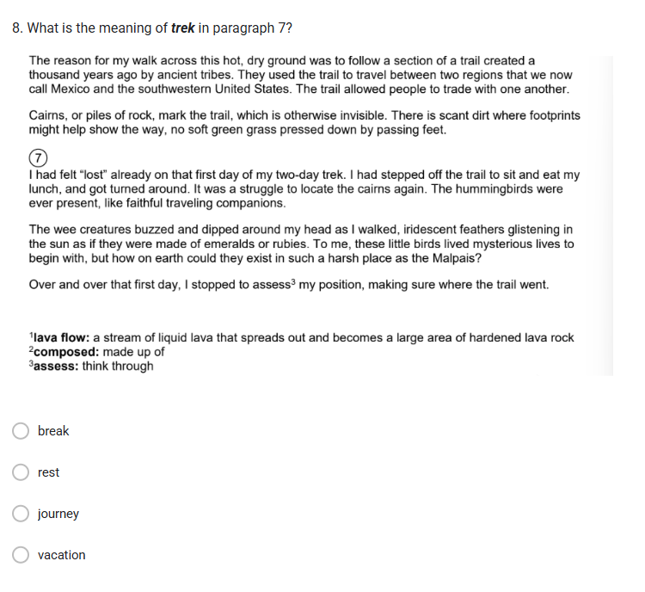
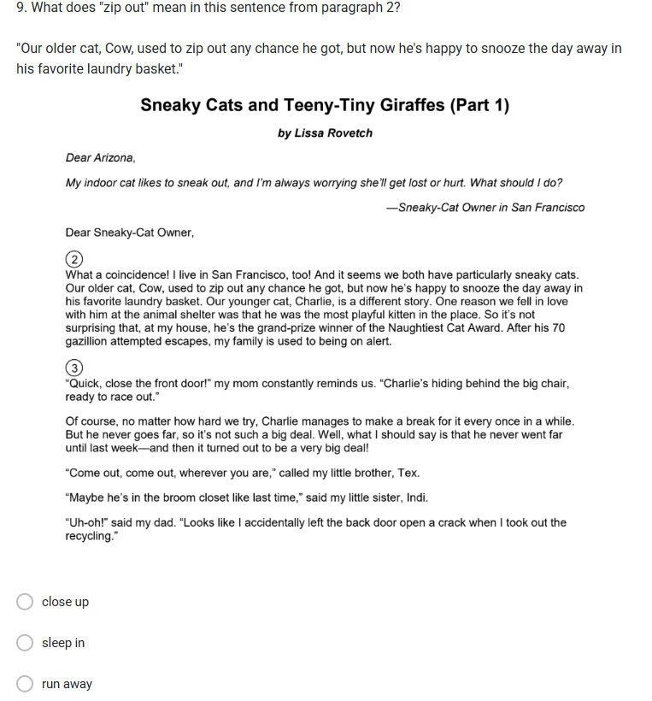

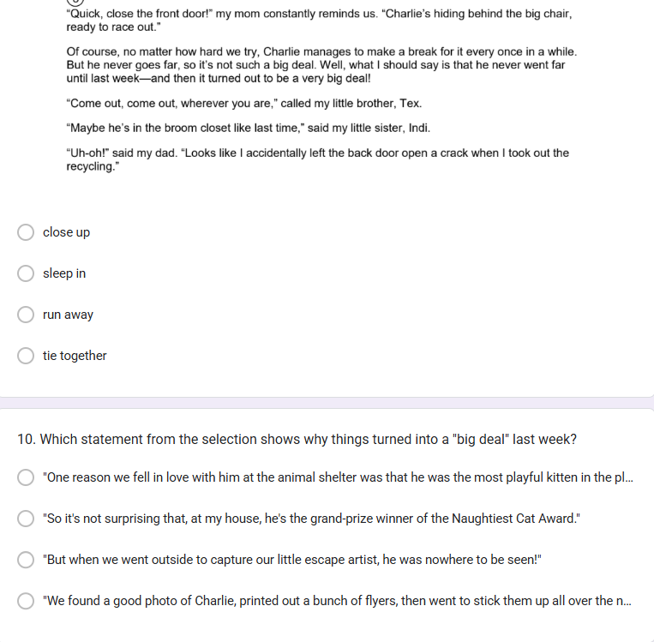

Appendix D
Figure A2
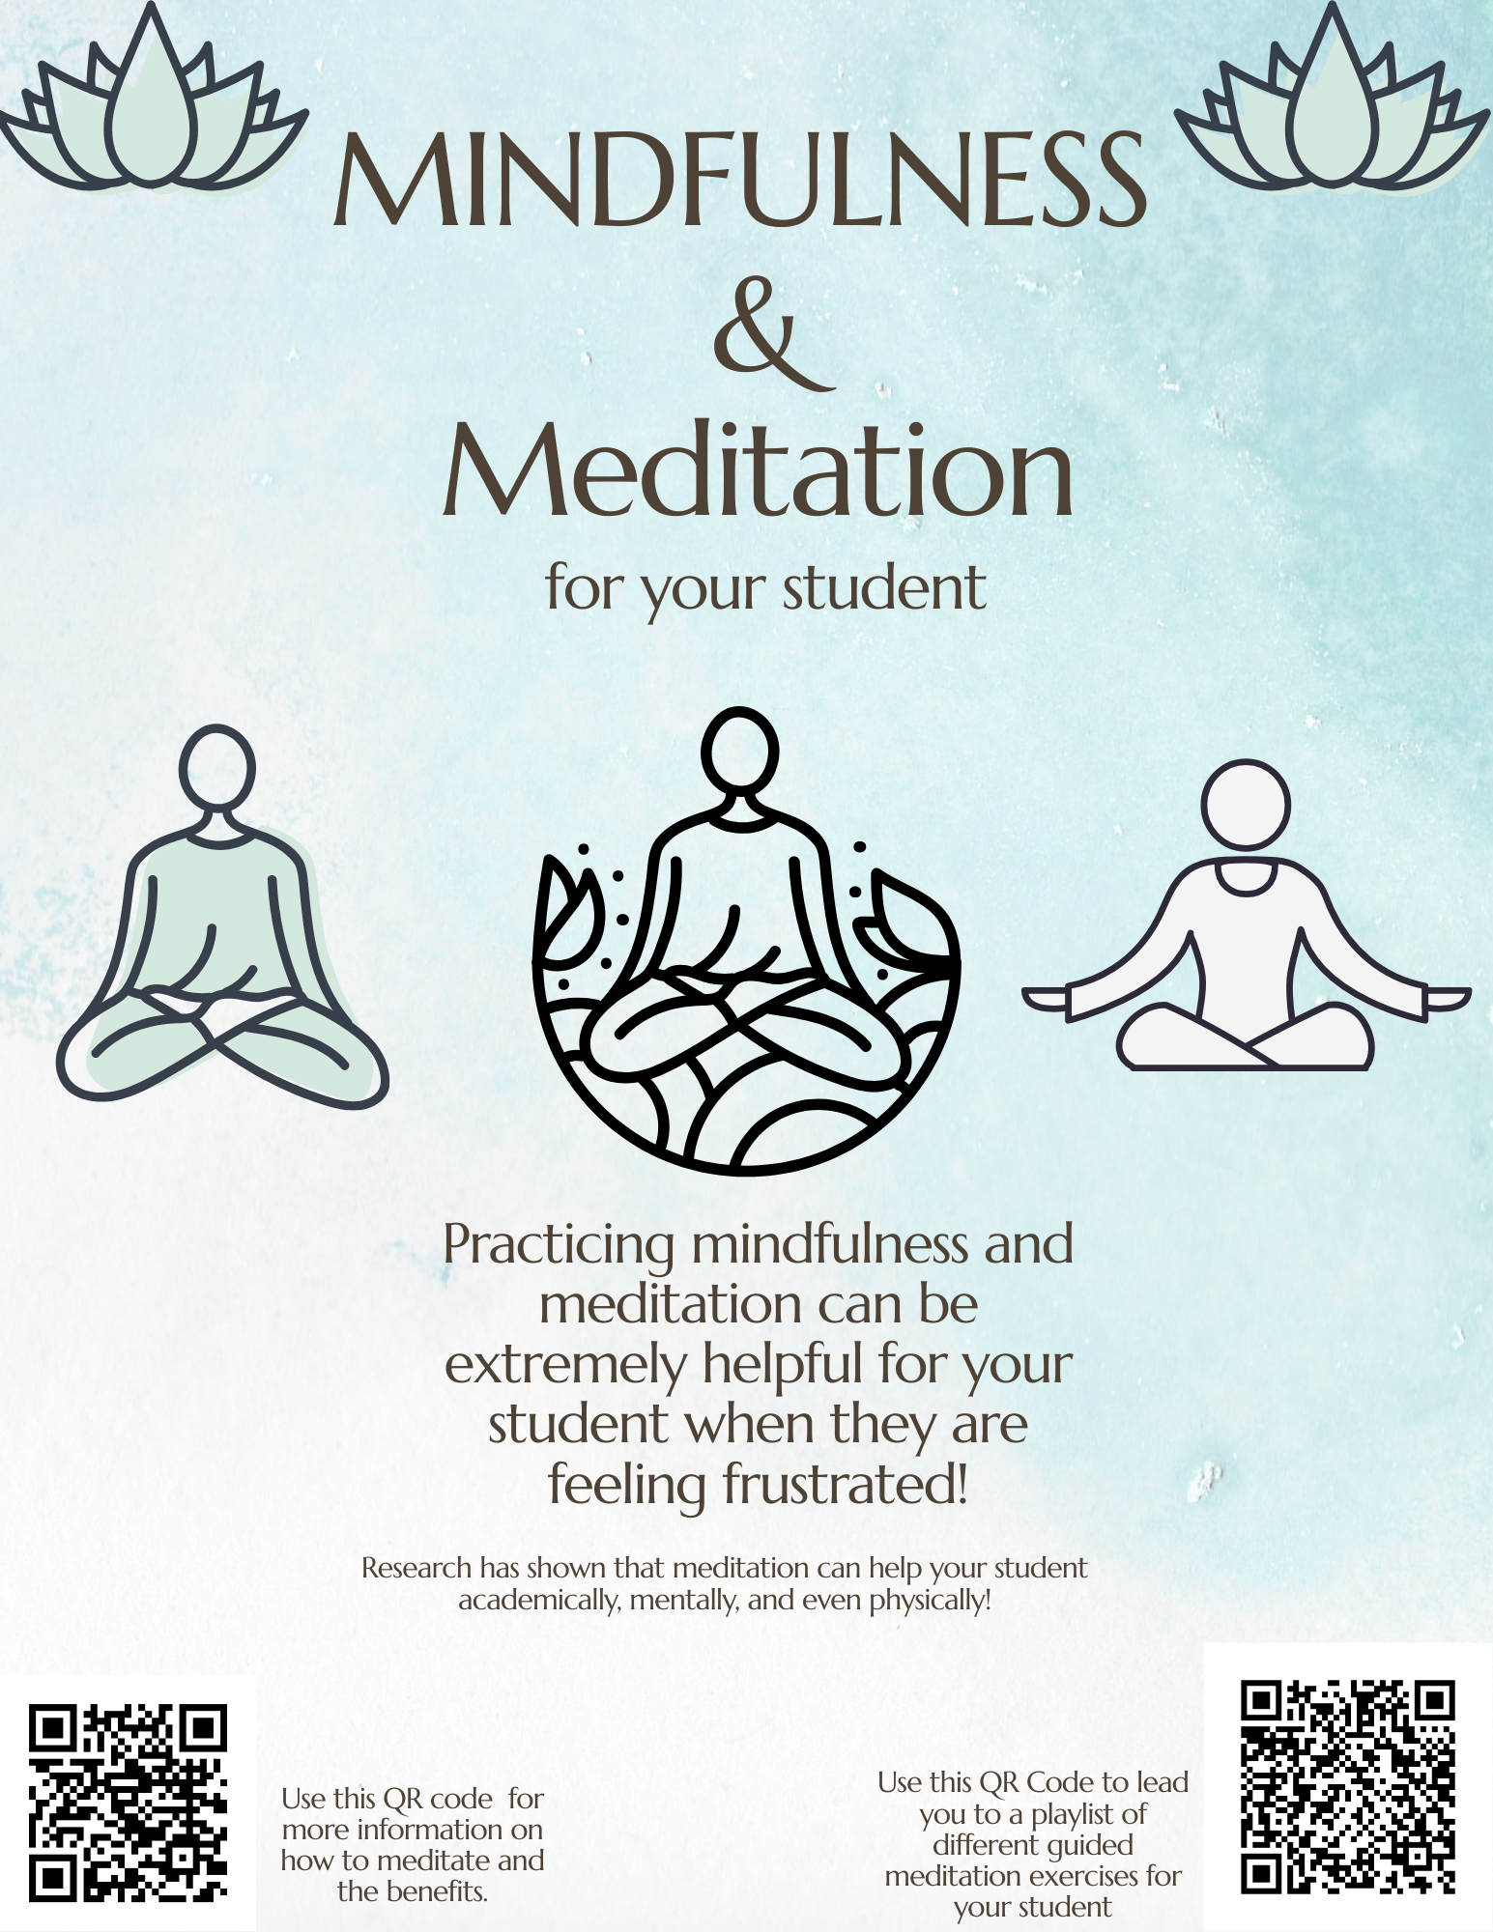
Resource

